The Summer Townet Survey
Delta Smelt Index Calculation Protocol
And
Protocol Appendices No. 12 and 13

V. Afentoulis
1/11/2010

Excerpted From:

Quality Assurance Protocol
California Department of Fish and Game
Central Valley Bay Delta Branch,
Long Term Monitoring Program

Part II. Striped Bass Townet Survey

Prepared by Project Staff
California Department of Fish and Game
4001 N. Wilson Way
Stockton, CA 95205

Third Revision: December 7, 2005
Second Revision: November 19, 2002
First Revision: November 30, 1988

Section:
VIII. Data Editing, Storage, and Reporting Editing Field Sheets Prior to Key Entry 13
C. Data Reporting Requirements 14
2. Information Reported 15
- Abundance Index for Delta Smelt 16

“Abundance Index for Delta Smelt –
Delta smelt indices were not originally calculated when the TNS began in 1959, and as a result delta smelt were not measured prior to 1973. Therefore, the delta smelt index is calculated differently than the striped bass index. The delta smelt index is the mean of the first two survey indices rather than an interpolation requiring knowledge of mean lengths. The index is calculated by the following procedures:
i. Catches are summed over the number of tows for each station.
ii. The sum is multiplied by a weighting factor representing volume of water (thousands of acre-feet) at that station (Appendix 13).
iii. The weighted catches are summed over stations by survey (station 340 has been excluded since it was not sampled in all years). This sum is the survey index.
iv. The survey indices for surveys 1 and 2 are averaged, and that number is the abundance index.”

The following excerpt describes adjustments made to the index calculation to reflect the different method of sampling used in ‘59-‘60 and in 1961.

Section:

IX. Data Adjustments 16
A. Converting Surface Tows Data to Diagonal Tows Data 16

“During 1959 and 1960, only surface tows were made. In 1961, Chadwick (1964) made two diagonal tows (the first and the third tows) and one surface tow per station. Chadwick (1964) developed ratios of diagonal to surface catches for specific stations and station combinations (Appendix 12). These ratios were applied to all appropriate surface tow data for 1959-61 to make the data comparable to the diagonal tows made in all other years. The data were stored in STORET after these adjustments were made.”

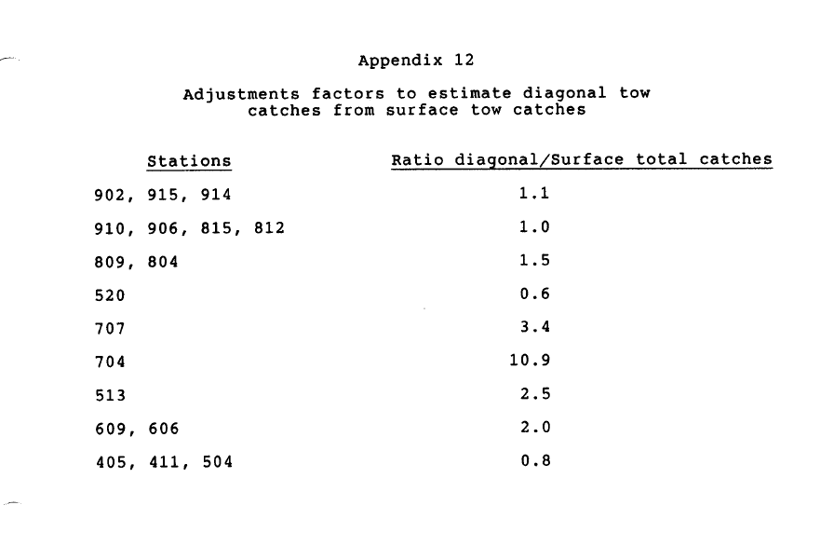
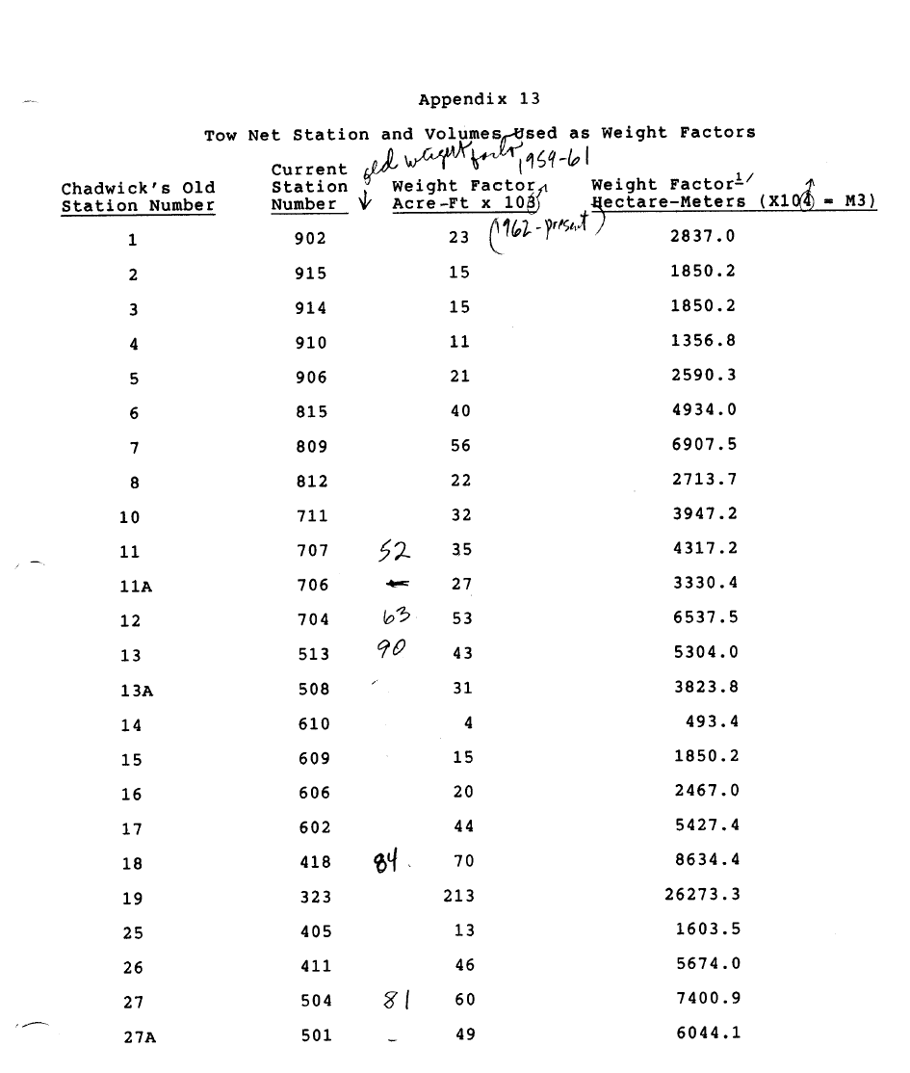
Appendix 13 continued on next page.
