CAPT,

Based on the photos sent, there does not appear to be significantly more oil then what I've seen at other nearby beaches when seep washes ashore. The patties seem to be of average size, maybe slightly bigger. The coverage at the surfline does look denser, which is still likely a result of the seeps. We had a report today from a NOAA vessel conducting underwater work at Platform HOLLY. They used an underwater acoustic device that observed oil seeping from the sea floor. I spoke w/ the vessel and they stated it was not a significant amount, but wanted to report it due to its proximity to the platform. I spoke with the operator on HOLLY and he stated that the platform sits on a seep line. The recent shutdown of Las Flores due to capacity issues (too full, no pipeline) has caused the platforms in the area to shut in. He stated that when the platforms are shut in for a period of time, pressure grows in the seeps causing a greater release. I have heard this many times before, so it may explain a heavier oiling of seep in those areas. I do not currently have the scientific proof to back this up, but can see if BSEE can provide a POC if you would like. As far as a SCAT team goes, it would not hurt to have them look; but I do not know what they would accomplish if the beach has been cleared already. It may also be outside the precedence that LCDR is speaking about below. In my opinion, the best method would be to obtain the results from the sample taken by OSPR, hopefully confirming that it is not related/natural seep. We could also take a sample, but it may just cause another conflict w/ the states sample, one conclusion may be the best for this. Please let me know if you want me to contact BSEE/OSPR for the recommendation above and I will see what we can come up with.

V/R,

Jeff Fry, LT

USCG MSD Santa Barbara

111 Harbor Way

Santa Barbara, CA 93109-7430

Work: 805-962-7430

Fax: 805-962-7968

-----Original Message-----

From: Williams, Jennifer F CAPT

Sent: Wednesday, June 24, 2015 3:43 PM

To: Reilly, Greg LCDR; Fry, Jeff A LT

Cc: Matthews, Romulus P LCDR

Subject: RE: Private Land Manager Concerns

Greg,

You can reach out to MSD Santa Barbara and have them investigate. (LT Jeff Fry is the supervisor)

Jeff, Since they called the ICP, please make sure you keep me advised of your assessment and if you recommend another SCAT eval.

v/r

CAPT Williams

-----Original Message-----

From: Reilly, Greg LCDR

Sent: Wednesday, June 24, 2015 3:38 PM

To: Williams, Jennifer F CAPT

Subject: Private Land Manager Concerns

Captain,

Two gentleman that manage the Las Varos & Edwards Ranch were at the media event today. They discovered tar balls in a quantity and consistency that they do not feel is consistent with natural seep. They submitted a NRC report at 2109 on 19 Jun, #1120351. A Coast guard representative and Division of Oil & Gas rep contacted the reporting party by phone, and a CA Fish & Wildlife rep did a site visit and took a sample. However, they are concerned that the UC would not send a SCAT team to investigate and have been making contacts throughout the UC to the same.

They sent pictures of the beach and the tarballs to me following our discussion (large file size, so I did not attach). At this point, I would like to send the info to your Sector IMD and CA OSPR and ask both to look into the case to determine if it was handled appropriately. Alternately, we could send a SCAT team to take a look from UC, but that sets a precedent that we have been trying to avoid.

If you approve, I will send to your Sector IMD Chief and to my CA OSPR Liaison and ask both of them to look into it from their end. Pls advise.

V/r,

-Greg

Greg Reilly

Lieutenant Commander, U.S. Coast Guard

Refugio Incident Liaison Officer (LOFR)

510.289.7775 / [gregory.w.reilly@uscg.mil](mailto:gregory.w.reilly@uscg.mil)

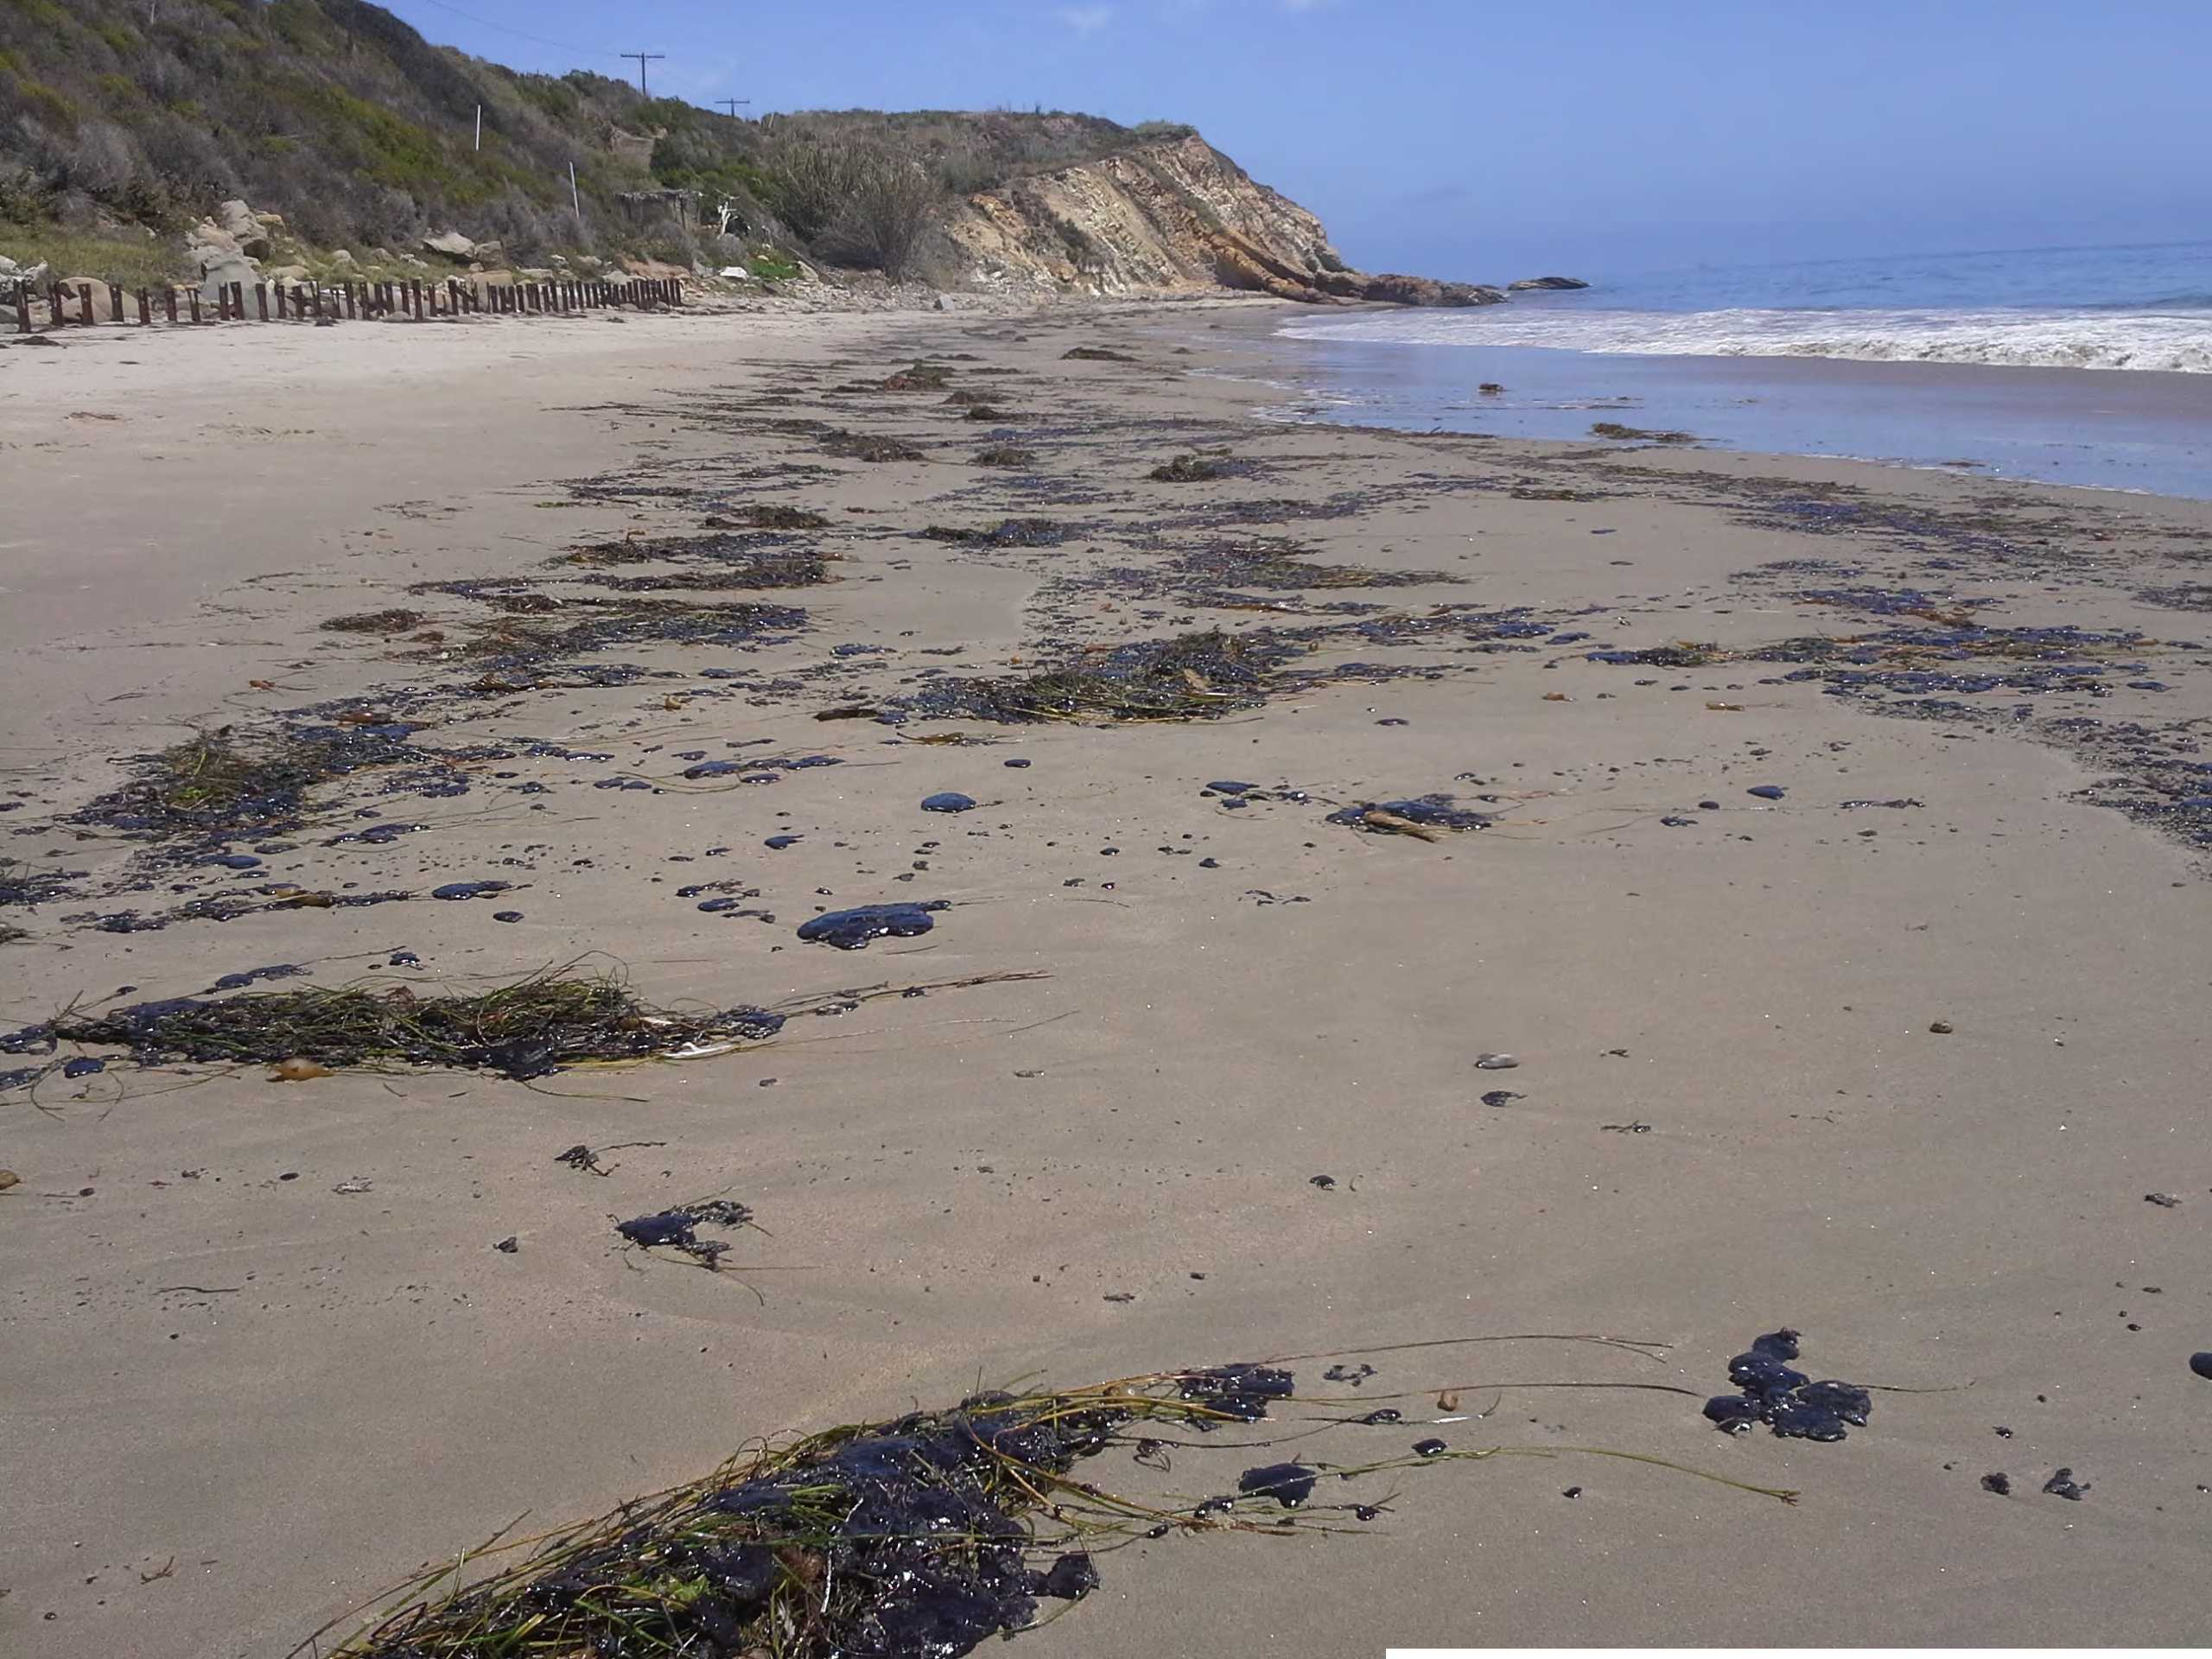

4ft tap4ft tap

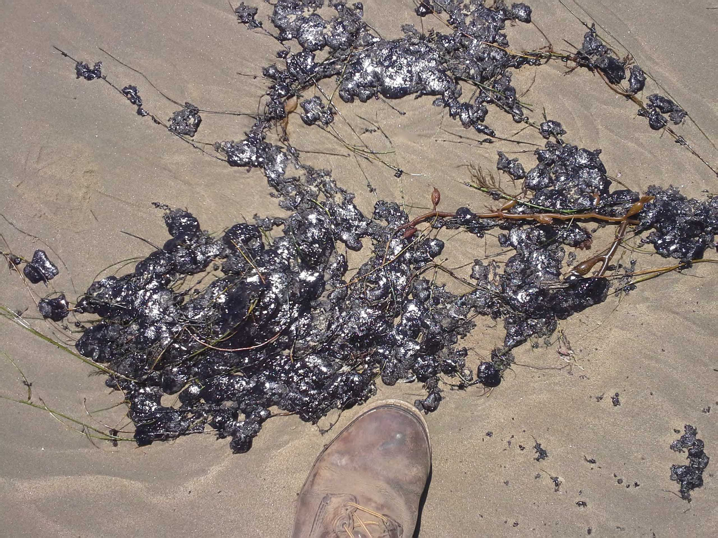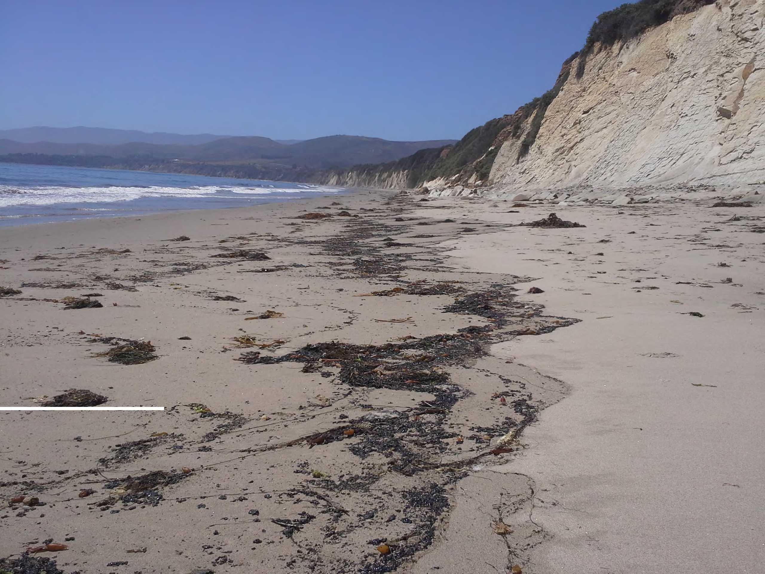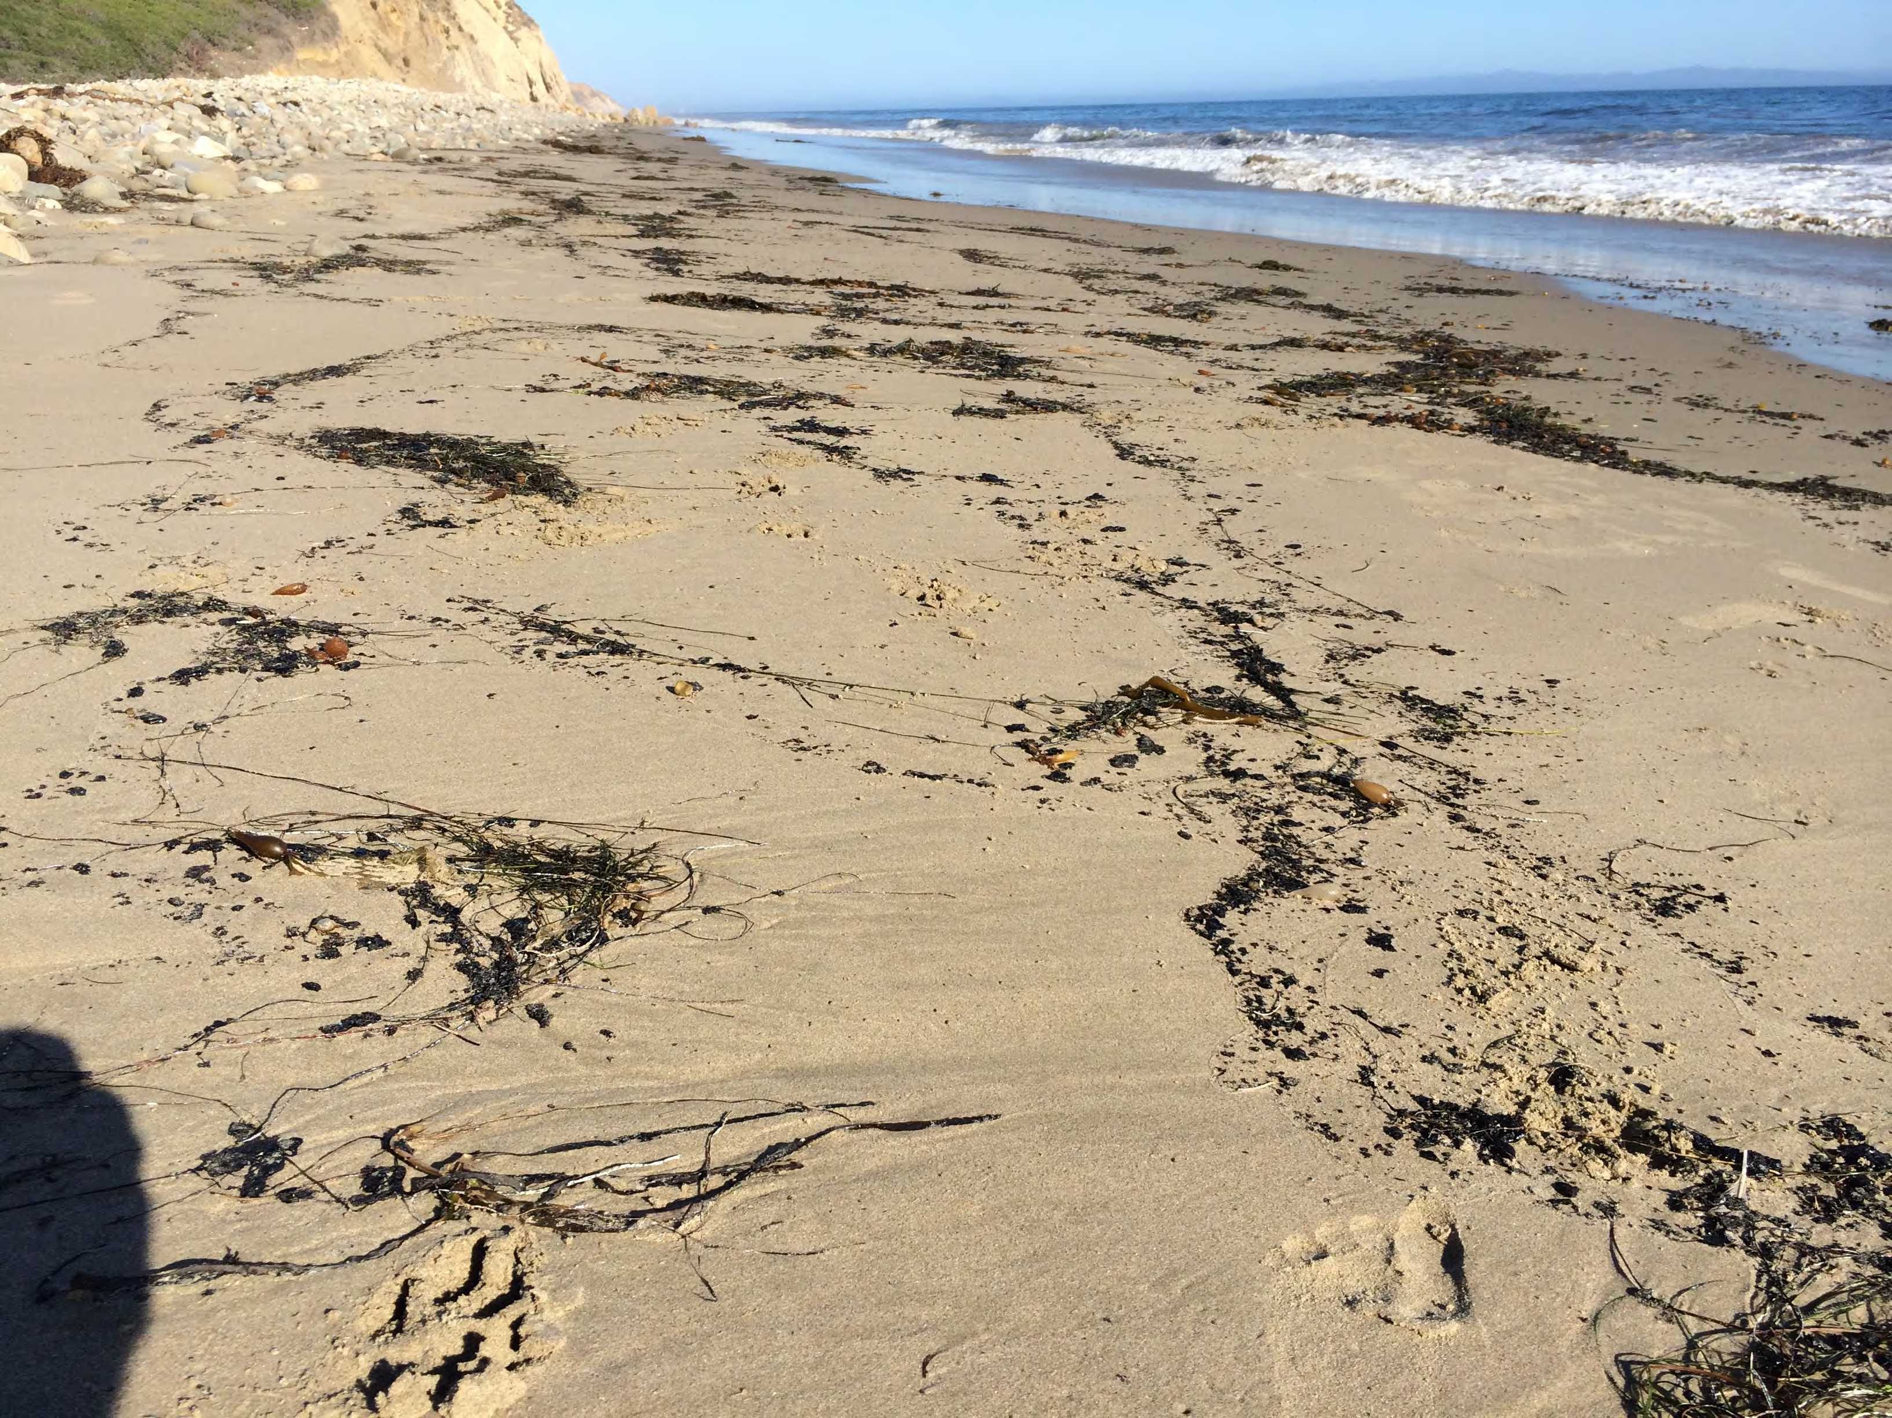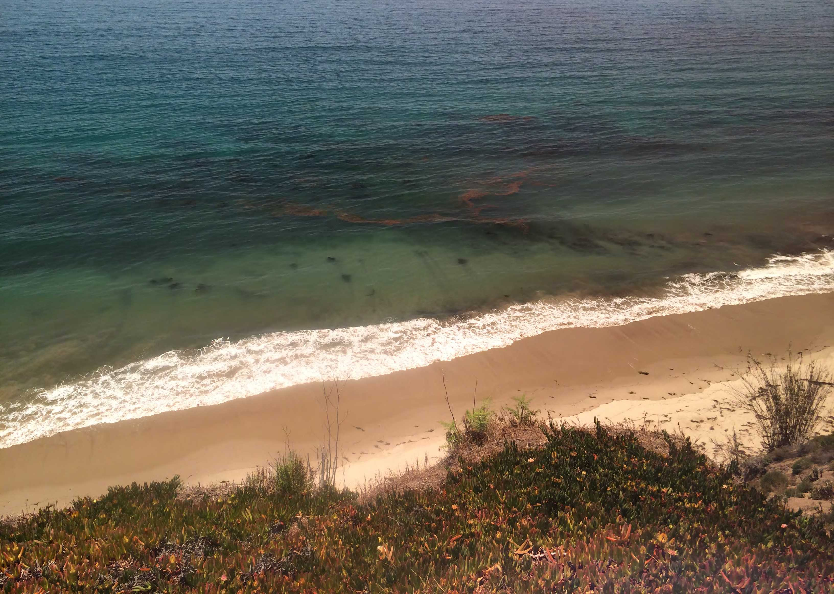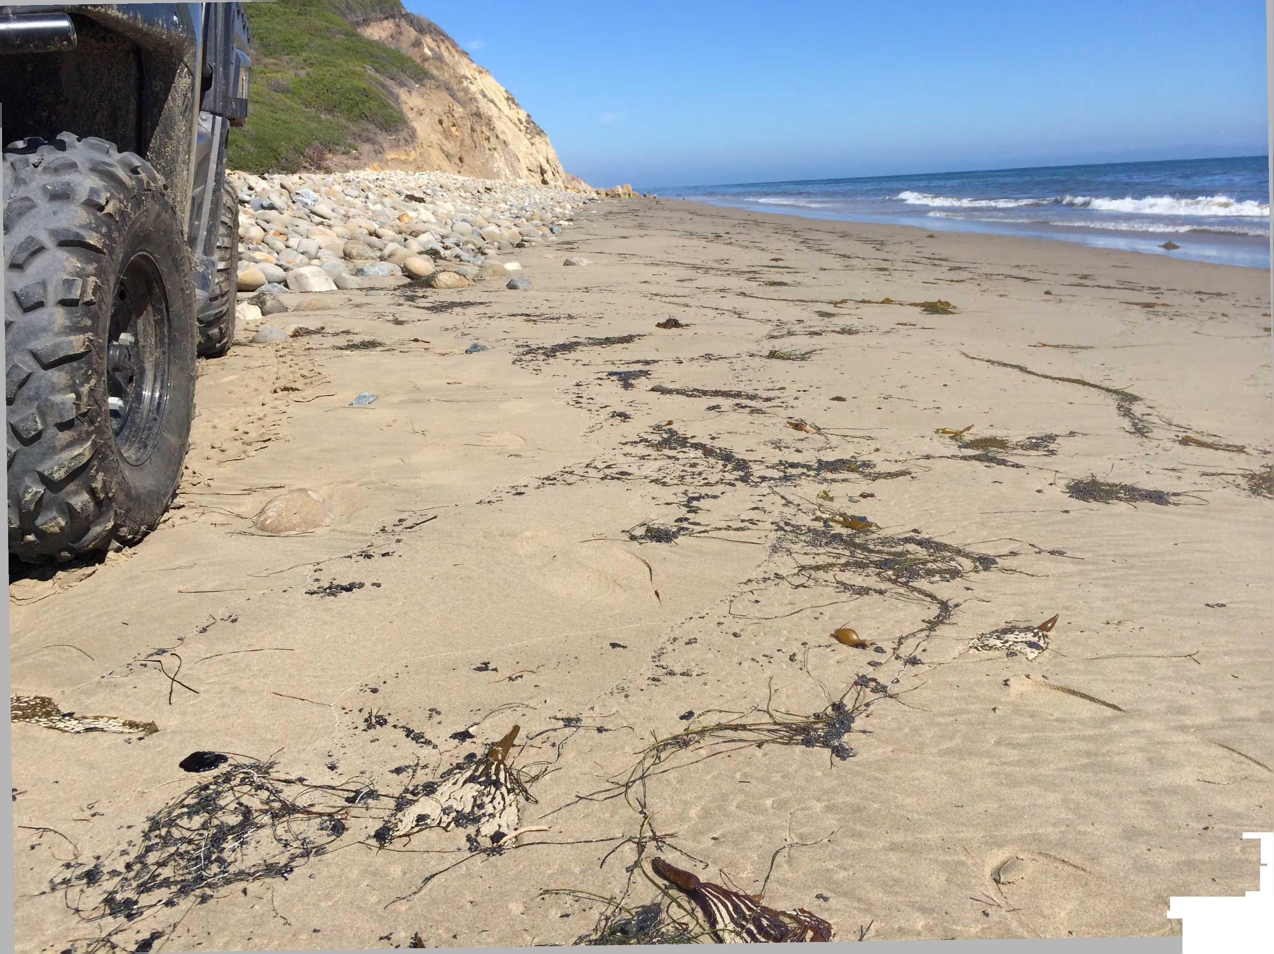

-

*W%m* -

\*