DRAFT
2011 TRIENNIAL REPORT ON THE
CALIFORNIA DEPARTMENT OF FISH AND GAME’S
MARINE INVASIVE SPECIES PROGRAM

Submitted to the
CALIFORNIA STATE LEGISLATURE
as required by the Coastal Ecosystems Protection Act of 2006

Prepared and submitted by the California Department of Fish and Game,
Office of Spill Prevention and Response
Marine Invasive Species Program

September 2011

Program Manager

Stephen Foss

EXECUTIVE SUMMARY

California’s Marine Invasive Species Act of 2003 extended the Ballast Water Management Act of 1999, to address the threat of non-native aquatic species (NAS) introductions. Under this Act, the California Department of Fish and Game (DFG) is required to conduct a study of California coastal waters for new introductions of NAS that could have been transported into state waters in ballast or through hull-fouling and assess results of the effectiveness of the Marine Invasive Species Program (MISP) in controlling NAS introductions from ship-related vectors. This report fulfills the reporting mandate set forth in Public Resources Code Section 71211 and summarizes the activities and results of DFG’s MISP from July 2008 through June 2011.

A field survey of San Francisco Bay was conducted in multiple habitats at 50 sites during the spring and summer of 2010, as part of a long-term monitoring effort that includes surveys in ports, harbors, estuaries, and the outer coast. From the samples collected, 497 species were identified, of which 98 (20% of all species identified) were classified as introduced, 92 were classified as cryptogenic, and 307 were classified as native to California. An additional 388 taxa were collected which could not be identified to species level and were classified as unresolved; another 8 taxa were classified as unresolved complexes. The survey revealed 3 introduced species that are apparent new records for San Francisco Bay that likely spread from other locations in California. Caprella simia, a "skeleton" shrimp, was first discovered in California in 2000 in Long Beach Harbor. C. simia is a Japanese species that is now widespread in San Francisco Bay. A second introduced organism, Nicolea sp. A Harris, an undescribed polychaete worm, was first found in California in 2000 in San Diego Bay and Los Angeles/Long Beach Harbor. A third species, Grateloupia lanceolata, a red alga native to Japan and Korea, was found for the first time in San Francisco Bay in the Port of Oakland and in Richardson Bay. For all three species, ballast water and hull fouling were possible vectors of introduction into California.

Beginning in 2009, the MISP, in partnership with the Smithsonian Environmental Research Center (SERC) and the Genomics Lab at Moss Landing Marine Laboratories (MLML), initiated a pilot non-native species detection program in San Francisco Bay. The three-year program combines traditional morphological identification with a “next-generation” sequencing process to analyze the DNA extracted en masse from unsorted, complex, whole-community samples collected from artificial settling plates, hard-substrate quadrats, and plankton tows. If effective, this approach would allow monitoring to move forward from traditional, morphologically-based taxonomy to streamlined, community-level monitoring utilizing state-of-the-art molecular genetic tools. Initial results indicate that this approach is feasible, and would provide a cost-effective means of improving NAS tracking by increasing geographic coverage, sampling frequency, and accuracy. Preliminary results from molecular analysis suggest that morphologically-based surveys of the past may have contained significant errors, thereby undermining their intended use for detection and monitoring of non-native organisms. One of the notable discoveries made through morphological analysis included Pachychordele michaeli, a hydroid native to eastern U.S. waters. Its occurrence at Coyote Point Marina is a first record for the west coast. Molecular analysis also confirmed new records of Amphibalanus eburneus (ivory barnacle) for San Francisco Bay.

DFG staff collaborated with SERC staff on an analysis of NAS invasion history and vectors in California. Results of the analysis indicate that California, especially San Francisco Bay, plays a pivotal role in marine invasion dynamics for western North America, providing an entry point from which many species spread. Of the 290 non-native marine species (excluding fish and vascular plants) with established populations in western North America, 81% were first recorded in California. Many (31-70%) NAS in adjacent states and provinces were first reported in California, suggesting northward spread. Of the 257 non-native species established in California, 61% were first recorded in San Francisco Bay and 57% are known from multiple estuaries, also suggesting secondary spread. Results of the analysis were published in Ruiz et al. (2011).

The future direction of the MISP includes changes to the sampling program to implement previous recommendations. MISP will improve sample design of field surveys by including stratified random sampling and increased replication, with the aim of explicitly measuring and statistically testing for temporal, spatial (geographic and habitat), taxonomic, and vector differences in NAS diversity (species richness). This statistically robust sampling approach will enable us to test key questions about NAS in California and understand invasion dynamics in California. Future monitoring will focus sampling on bays or estuaries and on outer coast areas near the mouth of estuaries, to test for spill-over and also examine the rate of decline in NAS diversity (species richness) with distance from the estuary. Also, as recommended in DFG’s 2008 MISP legislative report, the program intends to routinely utilize genetic analysis in identification of sampled specimens. Multiple benefits of genetic methods have been demonstrated in our recent pilot study in San Francisco Bay, including detection of cryptic species, whole-community analysis, and quality control of morphological taxonomy.

CONTENTS
Executive Summary iv
Tables iiv
Figures v
Definitions vi
Acronyms viii
1.0 Introduction 1
2.0 Study Plan and Field Surveys 4
3.0 Special Studies 16
4.0 Database and Quality Assurance 29
5.0 Summary of NAS Occurrence in California 32
6.0 Future Direction 41
Literature Cited 43

Appendix A - A Rationale for Incorporating Molecular-Based Taxonomy in California’s Non-Native Marine and Estuarine Species Detection and Monitoring Program

Appendix B - Table: Counts of non-native species sampled per station in San Francisco Bay in 2010

TABLES

1. DFG field surveys per year. 4

2. Habitats sampled at San Francisco Bay sites in 2010 9

3. Numbers of samples per habitat and sub-region of San Francisco Bay. 10

4. Number of taxa and percent introduced species (excluding unresolved taxa) sampled at San Francisco Bay sites………………………………….13

5. Number of NAS, Samples, and NAS per Sample in Sub-bays of San Francisco Bay 14

6. Number of species by introduction status and % of Introduced per habitat in San Francisco Bay…...……………………………………………………..14

7. Morphotaxa identities resolved through matches with GenBank records......................................................................................................23

8. CANOD taxa designated or undesignated as Introduced………………....33

9. Introduced taxa added to CANOD…………………………………………...35

10. Taxonomic changes that occurred among CANOD Introduced taxa.…....38

FIGURES

1. Sampling sites for 2010 San Francisco Bay field survey in sub-regions San Pablo Bay and Suisun Bay. 6
2. Sampling sites for 2010 San Francisco Bay field survey in sub-region Central San Francisco Bay 7
3. Sampling sites for 2010 San Francisco Bay field survey in sub-region South San Francisco Bay 8
4. Number of taxa sampled per introduction status classification in the 2010 San Francisco Bay Survey 11
5. Percentage of total taxa within each classification for each habitat type sampled in San Francisco Bay, 2010. 15
6. Settling plate sampling sites for SERC/MLML Settling Plate/Molecular Detection Study. 19
7. Number of non-native species by geographic region for western North America 26
8. Locations of first records for NAS in California 27
9. Vectors for established NAS in California…………………………………..28

10. Main menu of CANOD’s public interface 30
11. Native regions of California introduced species 41
12. The number of newly reported NAS by 25-year intervals for California and western North America………………………………………………..………42

Acknowledgments

Sharon Shiba and Karen Bigham contributed to this report through writing, analysis, and data management. Thanks to Jon Geller and Greg Ruiz for reviewing portions of this report. Randy Imai and Mike Sowby made helpful comments on earlier versions of the report.

DEFINITIONS OF TERMS USED IN THIS REPORT

Ballast water: Water taken up or released by a ship to stabilize it, or to raise/lower it in the water column.

Benthic: The sea bottom or the organisms that live on or in it.

Biodiversity: Number and variety of living organisms; includes genetic diversity, species diversity and ecological diversity. For the purposes of this document, refers to biodiversity of native organisms.

Cosmoname: A scientific name used for the same, or similar-looking, taxon around the world.

Cryptic: Of or pertaining to two or more species that are morphologically similar but differ genotypically.

Cryptogenic: Taxa that are neither demonstrably native nor introduced (Cohen and Carlton 1995, Carlton 1996) because their native range or region is unknown.

Epifaunal: Of or describing organisms that live on the ocean floor or other submerged substrates such as sea anemones and barnacles.

Exotic Species: Synonym for introduced or non-native species.

Fouling: The accumulation and deposition of living organisms and certain non-
living material on hard surfaces, most often in an aquatic environment.

Genotype: The genetic makeup of an organism.

Infaunal: Of or describing organisms that live within sediment, such as clams and worms.

Intertidal: Coastal area between low and high tide.

Introduced species: A species that was intentionally or accidentally transported or released by humans into an environment outside its historical range.

Invasive species: Non-native species that do ecological or economic harm.

Morphotaxon: Species or other taxonomic level based solely on morphologic characteristics. (plural: morphotaxa)

Nonindigenous: Non-native or alien; existing outside natural geographical boundaries.

Phytoplankton: Microscopic aquatic plant-like organisms suspended in water

Plankton: A diverse group of small, usually microscopic animals (zooplankton) and plant-like organisms (phytoplankton) that freely drift in the water.

Propagule: any living biological material (particles, cells, spores, eggs, larvae, and mature organisms) that can potentially be transported from one location to another and produce new individuals.

Species Complex: A group of species that cannot be reliably distinguished as a cohesive taxon based on form and structure.

Substrate: Surface on which an organism lives.

Subtidal: A marine or estuarine environment that lies below low tide level.

Taxon (plural, Taxa): A grouping of organisms given a formal taxonomic name such as species, genus, family.

Unresolved Taxon: Specimen that could not be identified unambiguously to species level.

Vector (Introduction Vector): A means of transporting or introducing organisms from one geographical location to another, such as ballast water.

Voucher: A specimen archived in a permanent collection for future study.

Water Column: The vertical extent of a water body, from the surface to the bottom.

Zooplankton: Small (usually microscopic), free-floating or weakly swimming animals that live in aquatic environments.

ACRONYMS AND ABBREVIATIONS USED IN THIS REPORT

AIS Plan: California Aquatic Invasive Species Management Plan

CANOD: California Aquatic Non-native Organism Database

DFG: California Department of Fish and Game

MISP: Marine Invasive Species Program

MLML: San Jose State University’s Moss Landing Marine Laboratories. Includes both the Marine Pollution Studies Lab and the Genomics Lab

NAS: Non-native Aquatic Species

NEMESIS: National Exotic Marine and Estuarine Species Information System

NISA: National Invasive Species Act (1996)

OSPR: Office of Spill Prevention and Response

SERC: Smithsonian Environmental Research Center

SFSU/RTC: San Francisco State University/Romberg Tiburon Center

USFWS: United States Fish and Wildlife Service

USGS: United States Geological Survey

1.0 INTRODUCTION

Non-native aquatic species (NAS) increasingly threaten California’s
estuarine and marine habitats. San Francisco Bay has one of the highest reported numbers of invasions in the world, and new species continue to arrive. For invertebrates and algae, the non-native species richness in California coastal waters exceeds that of most regions of the world, with only the Mediterranean and the Hawaiian Islands reporting comparable numbers (Ruiz et al. 2011). Furthermore, the rate of discovery for non-native species in California shows a strong and significant increase over time, the result of several transport vectors that have been implicated in the spread of NAS. Although vessel arrivals to California have been declining since 2006 (CSLC 2011), due to the recent downturn in the economy, the ballast water and hulls of ocean-going ships remain the primary mechanisms responsible for bringing species to California in recent years (Ruiz et al. 2011).

Non-native species have been a force for change in California’s coastal waters. NAS effects include changes to the structure and function of ecosystems, declines of native and commercial fisheries, parasite interactions with native species and humans, and physical habitat alteration (Carlton 2001, Grosholz 2002). Non-native species can compete with native species; approximately 42% of the species on the federal Threatened or Endangered species lists are at risk primarily because of predation, parasitism, and competition from non-native species (Pimentel et al. 2004) and about 40% of the species forced to extinction in aquatic ecosystems are due to biological invaders (Pimentel 2003). Numerous examples of economic and ecological effects of NAS in California have been detailed in previous legislative reports and elsewhere.

California’s Marine Invasive Species Act of 2003 extended the Ballast Water Management Act of 1999, to address the threat of NAS introductions. Under this Act, the California Department of Fish and Game (DFG) is required to conduct a study of California coastal waters for new introductions of NAS that could have been transported into state waters in ballast or through hull-fouling and assess results of the effectiveness of the Marine Invasive Species Program (MISP) in controlling NAS introductions from ship-related vectors. Two previous legislative reports have been submitted since the inception of the MISP in 2000. This report fulfills the reporting mandate set forth in Public Resources Code Section 71211. Herein, we describe the purpose and history of DFG’s MISP, summarize the activities and results from July 2008 through June 2011, and discuss the future direction of our monitoring program.

1.1 Statutory Framework

In California, as the impact and source of introduced aquatic species became better understood, a program was developed to address the introductions from the ballast of ocean-going ships. The following summarizes the origins and evolution of the California effort to manage ship-mediated NAS introductions.

1.1.1 California Ballast Water Management Act

In response to the potential threat by the introduction of NAS from the ballast of ships into the marine waters of the state, the Legislature passed the Ballast Water Management Act (Chapter 491, Statutes of 1999). Three agencies were responsible for implementing the various provisions of the Act: DFG, the State Water Resources Control Board, and the State Lands Commission. DFG, as the primary agency responsible for the management of fish and wildlife and their habitats, was required to conduct a study to determine the location and geographic range of introduced species populations along the California coast. A report detailing the results of that study was completed and submitted to the Legislature in 2002 (CDFG 2002). This information along with data generated by the State Lands Commission and the State Water Resource Control Board was used to craft a new, long-term program under the Marine Invasive Species Act of 2003 (MISA). This law came into effect January 1, 2004.

1.1.2 Marine Invasive Species Act

The MISA (Chapter 491, Statutes of 2003) extended the term of the MISP (to December 2009), to control the introduction and spread of NAS in marine and estuarine waters. The Act expanded the MISP to include coastwise traffic and DFG’s Office of Spill Prevention and Response (OSPR) was required to do a baseline survey of outer coast habitats to supplement the NAS baseline data collected up to 2002. The 2003 Act also directed DFG to continue its monitoring program to determine whether new introductions have occurred since the original baseline was established.

1.1.3 Coastal Ecosystem Protection Act

The Coastal Ecosystem Protection Act (Chapter 292, Statutes of 2006) repealed the sunset provision of December 2009. The program is now ongoing, and the DFG has been given several new research and reporting responsibilities, as follows:

- Monitoring coastal and estuarine waters for new introductions of NAS that could have been transported into state waters in ballast or as hull-fouling.

- Posting data from the monitoring effort on the internet and updating the database on an annual basis, beginning July 1, 2008. The data from the monitoring efforts can be viewed at http://www.dfg.ca.gov/ospr/Science/invasive_species.aspx.

- Submitting a report to the Legislature detailing the results of the monitoring studies and an assessment of the effectiveness of the MISP in controlling introductions from ship-related vectors. The report was initially due December 31, 2008, and must be updated every three years thereafter.

1.1.4 California Aquatic Invasive Species Management Plan

In 2008, Governor Schwarzenegger signed the California Aquatic Invasive Species Management Plan (AIS Plan), which provides a framework for agency coordination and identifies actions to minimize the harmful effects of aquatic NAS in California. One of the top priorities identified in the AIS Plan is to conduct statewide assessments of the risks from specific vectors for introductions of aquatic NAS. Another high priority identified by the AIS Plan is to support early detection and rapid response actions, partly by coordinating various aquatic NAS monitoring programs throughout the State.

2.0 STUDY PLAN AND FIELD SURVEYS

The MISA of 2003 stipulated that DFG will conduct several studies, including a supplemental survey of the open coast, to augment the baseline data from the harbors and bays that was previously compiled. Table 1 lists the different field surveys and the years that they were conducted. Multiple habitats were surveyed during each survey.

The methods for these surveys were previously described elsewhere (DFG 2002, Foss et al. 2007). Results from DFG surveys are available on the internet and can be viewed at http://www.dfg.ca.gov/ospr/Science/invasive_species.aspx. Herein, we report results of monitoring from July 2008 through June 2011.

Table 1. DFG field surveys per year.
Survey | Year
 | 2000 | 2004 | 2005 | 2006 | 2007 | 2008 | 2010 | 2011
Bays and Harbors | X |  |  | X |  |  |  | X
Outer Coast |  | X |  |  | X
San Francisco Bay |  |  | X |  |  |  | X
Plankton | X |  |  | X | X
Fish | X |  |  |  |  | X

2.1 San Francisco Bay Survey
2.1.1 Survey Methods

A survey of San Francisco Bay was conducted during the spring and summer of 2010. Recent analysis has confirmed that San Francisco Bay is the most invaded estuary in California (Ruiz et al. 2011). DFG contracted with San Jose State University Foundation’s Moss Landing Marine Laboratories (MLML) as the principal investigator for the biological survey.

Literature and data reviews were complimented by field collections and laboratory analyses jointly conducted by DFG and MLML. Additional universities and specialized laboratories provided taxonomic expertise in identification of marine species.

The sampling design was virtually identical to that used in previous DFG/MLML NAS surveys conducted in California bays and harbors and outer coast habitats, and focused on whole community structure rather than singling out any one species or habitat. Multiple habitats were surveyed at 50 San Francisco Bay sites (Table 2). For the purpose of examining trends of introduced species distribution within the Bay, San Francisco Bay was divided into 4 sub-regions: South San Francisco Bay, Central San Francisco Bay, San Pablo Bay, and Suisun Bay (Figures 1-3).

Four types of habitats were surveyed: rocky intertidal, sandy intertidal, subtidal fouling and subtidal infauna. The 94 samples collected were distributed unequally through the 4 sub-regions of the bay (Table 3), but numbers of fouling and infaunal samples were balanced. Criteria used during site selection included (1) obtain good geographic distribution over sample regions, (2) target areas likely to be impacted by anthropogenic activities, (3) locate and sample sites harboring a variety of hard substrates with fouling communities (for subtidal surveys), (4) locate and sample sites with available intertidal natural rocky reef if possible (for rocky intertidal surveys), and (5) overlap with historical and/or existing survey sites if possible. Natural rocky and sandy intertidal habitat is limited within the Bay so geographic distribution for those sample sites was limited.

Methods included the use of sediment cores and grabs, quadrat clearings, and qualitative taxonomic surveys. In addition, qualitative samples were collected during the visual scans. Samples were then preserved and transported to the appropriate laboratories and taxonomists for identification and enumeration. Taxonomists also occasionally provided information about historical or ongoing ecological or monitoring research conducted at or near survey sites.

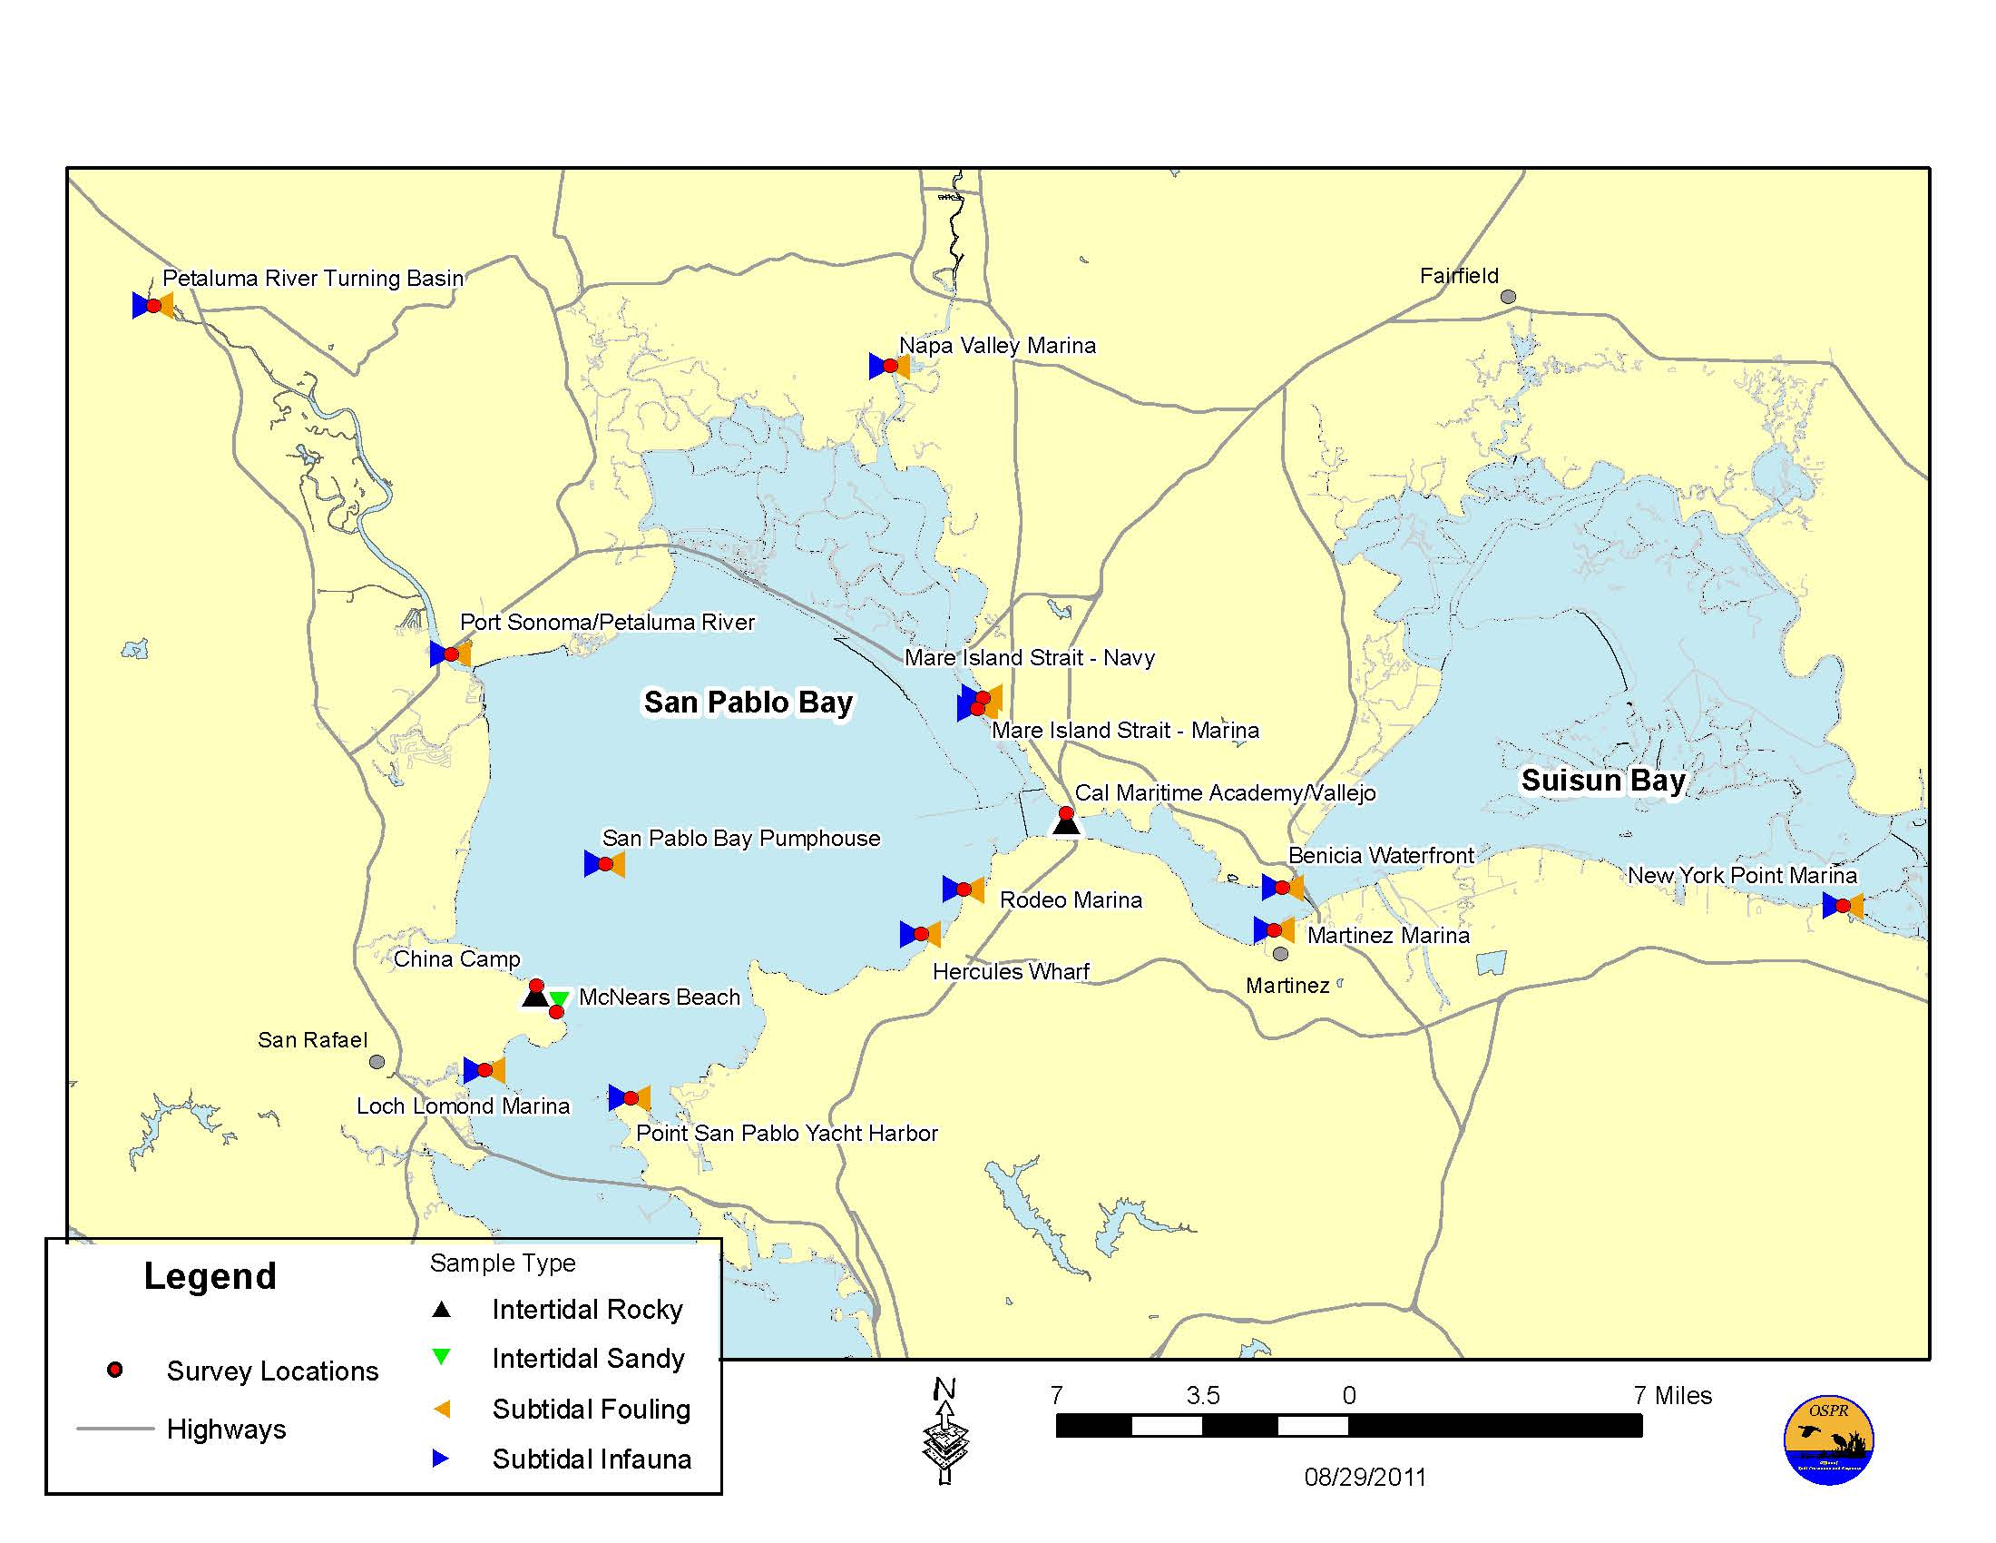
Figure 1. Sampling sites for 2010 San Francisco Bay field survey in sub-regions San Pablo Bay and Suisun Bay.

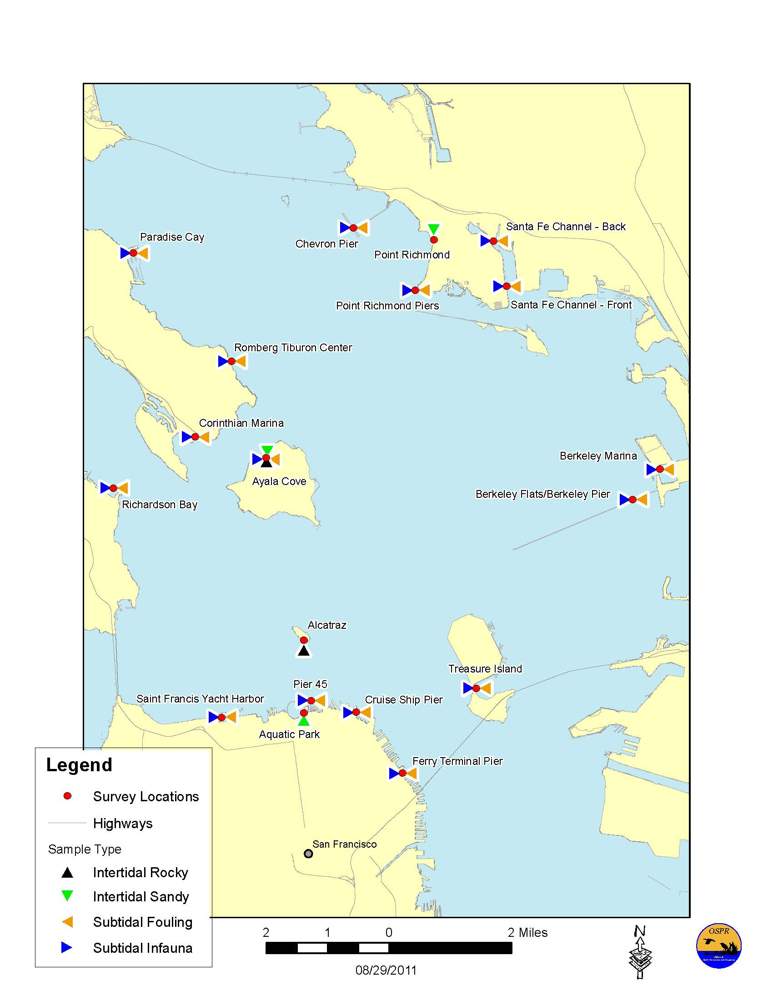
Figure 2. Sampling sites for 2010 San Francisco Bay field survey in sub-region Central San Francisco Bay.
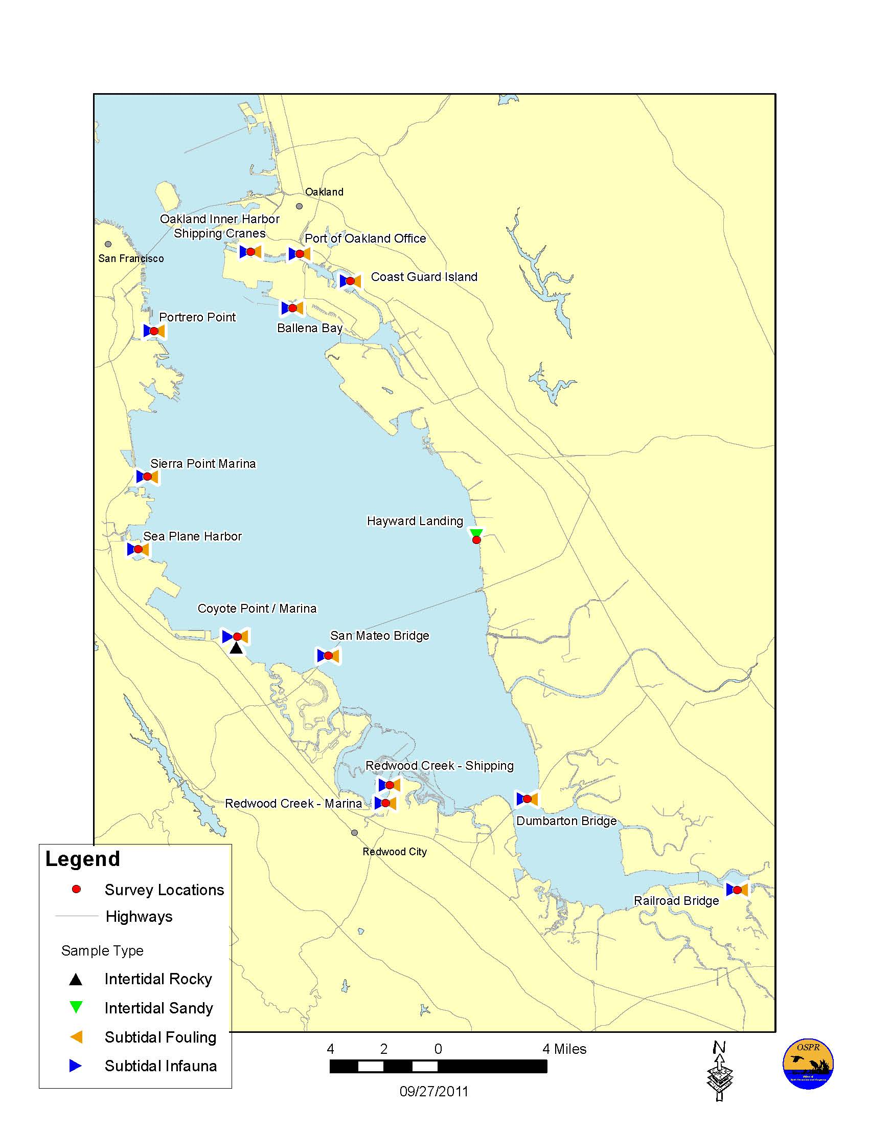
Figure 3. Sampling sites for 2010 San Francisco Bay field survey in sub-region South San Francisco Bay.

Table 2. Habitats sampled at San Francisco Bay sites in 2010.
Station Name | Intertidal Rocky | Intertidal Sandy | Subtidal Fouling | Subtidal Infauna
Alcatraz | X
Aquatic Park |  | X
Ayala Cove | X | X | X | X
Ballena Bay |  |  | X | X
Benicia Waterfront |  |  | X | X
Berkeley Flats/Berkeley Pier |  |  | X | X
Berkeley Marina |  |  | X | X
Cal Maritime Academy/Vallejo | X
Chevron Pier |  |  | X | X
China Camp | X
Coast Guard Island |  |  | X | X
Corinthian Marina |  |  | X | X
Coyote Point | X
Coyote Point Marina |  |  | X | X
Cruise Ship Pier |  |  | X | X
Dumbarton Bridge |  |  | X | X
Ferry Terminal Pier |  |  | X | X
Hayward Landing |  | X
Hercules Wharf |  |  | X | X
Loch Lomond Marina |  |  | X | X
Mare Island Strait - Marina |  |  | X | X
Mare Island Strait - Navy |  |  | X | X
Martinez Marina |  |  | X | X
McNears Beach |  | X
Napa Valley Marina |  |  | X | X
New York Point Marina |  |  | X | X
Oakland Inner Harbor - Shipping Cranes |  |  | X | X
Paradise Cay |  |  | X | X
Petaluma River Turning Basin |  |  | X | X
Pier 45 |  |  | X | X
Point Richmond |  | X
Point Richmond Piers |  |  | X | X
Point San Pablo Yacht Harbor |  |  | X | X
Port of Oakland Office |  |  | X | X
Port Sonoma/Petaluma River |  |  | X | X
Potrero Point |  |  | X | X
Railroad Bridge |  |  | X | X
Redwood Creek - Marina |  |  | X | X
Redwood Creek - Shipping |  |  | X | X
Richardson Bay |  |  | X | X
Rodeo Marina |  |  | X | X
Romberg Tiburon Center |  |  | X | X
Saint Francis Yacht Harbor |  |  | X | X
San Mateo Bridge |  |  | X | X
San Pablo Bay Pumphouse |  |  | X | X
Santa Fe Channel - Back |  |  | X | X
Santa Fe Channel - Front |  |  | X | X
Sea Plane Harbor |  |  | X | X
Sierra Point Marina |  |  | X | X
Treasure Island |  |  | X | X

Table 3. Numbers of samples per habitat and sub-region of San Francisco Bay.
Sub-Region | Intertidal Rocky | Intertidal Sandy | Subtidal Fouling | Subtidal Infauna | Total
Central Bay | 3 | 3 | 15 | 15 | 36
San Pablo Bay | 1 | 1 | 11 | 11 | 24
South Bay | 1 | 1 | 13 | 13 | 28
Suisun Bay |  |  | 3 | 3 | 6
Grand Total | 5 | 5 | 42 | 42 | 94

2.1.1 Survey Results

From the samples collected during the 2010 field survey, 497 species were identified, of which 98 (20% of all species identified) were classified as introduced, 92 were classified as cryptogenic, and 307 were classified as native to California (Figure 4). Among the cryptogenic taxa that were found, at least 5 are considered to be likely non-natives, even though we lack the certainty to characterize them as non-native. In addition, another 388 taxa were collected which could not be identified to species level and were classified as unresolved; another 8 taxa were classified as unresolved complexes. The taxa that were classified as unresolved complexes should be considered introduced to San Francisco Bay. For example, Heteromastus filiformis is a cosmoname which likely represents many species, all of which are considered non-native to California estuaries (J. Carlton, pers. comm.).

For a variety of reasons, some specimens collected in the survey could not be identified to species level. The majority of these unresolved taxa were arthropods and nematodes. Juvenile or non-reproductive specimens represented nearly half of the unresolved identifications. Unrecognized species also contributed to unresolved identifications, but very few (<0.5%) unresolved identifications were due to damaged specimens. The percentage of taxa with unresolved status was much lower in the 2010 survey, compared to the 2005 survey. Multiple factors likely contributed to this phenomenon, including improved collection methods, increased use of molecular identification techniques, and improved ability of taxonomists to identify difficult taxa.
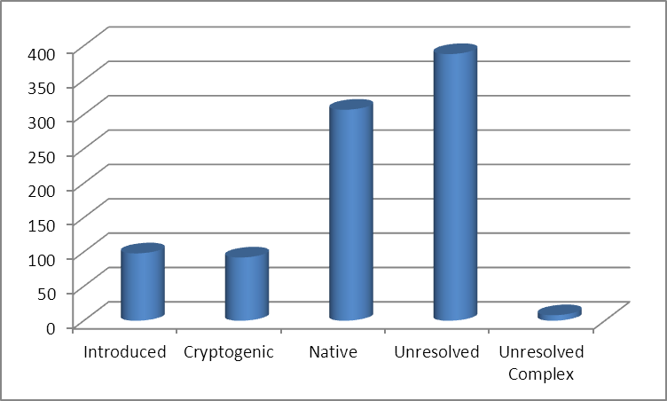
Figure 4. Number of taxa sampled per introduction status classification in the 2010 San Francisco Bay Survey.

The survey revealed 3 introduced species that are apparent new records for San Francisco Bay that likely spread from other locations in California. Caprella simia, a Caprellid, or "skeleton" shrimp, was first discovered in California in Long Beach Harbor in 2000 (Cohen et al. 2005). C. simia is a Japanese species that was probably introduced by fouling or ballast water and was considered likely to spread north (Watling and Carlton 2007). It is now widespread in San Francisco Bay. A second introduced organism, Nicolea sp. A Harris, an undescribed polychaete worm, was first found in California in 2000 in San Diego Bay and Los Angeles/Long Beach Harbor. Possible vectors include ballast water and fouling on ships or recreational boats.

Grateloupia lanceolata, a red alga native to Japan and Korea, was found for the first time in San Francisco Bay in the Port of Oakland and in Richardson Bay. The first California record of G. lanceolata was in 2003 at the University of Southern California’s Wrigley Marine Science Center on Santa Catalina Island, Los Angeles County and in 2008 it was found at Moss Landing Marina. It is likely that the import of oysters for mariculture played a role in its introduction into California. Other possible vectors include initial introduction by international shipping via ballast water (Flagella et al. 2007), by hull fouling of coastal shipping vessels (Hay 1990), or by floating plastic debris (Barnes 2002). Its successful introduction to three very different environments (the Mediterranean, southern California, and central California) suggests that this species is a “weed”, with ample reproduction, tenacious recruitment, and broad physiological tolerances as an adult (Nyberg & Wallentinus 2005).

The NAS list from the current survey was compared to a list of NAS sampled during the previous DFG survey in 2005. Seventeen organisms were sampled in 2005 that were not sampled in the 2010 survey. Excluding new records, 26 taxa were sampled in 2010 that were not sampled in 2005. Of those 26, 11 were sampled in 2004 by a Rapid Assessment Survey (Cohen et al. 2005). One possible explanation for differences in the species seen is that salinity in the estuary was lower in 2005 than in 2004 and 2010, so species with higher salinity preferences may not have been present. Delta outflow, an indicator of the volume of freshwater entering the estuary, was certainly higher in May of 2005 than in May of 2004 or 2010.

Numbers of introduced species per site ranged from 5 (at both Point Richmond and Aquatic Park) to 34 (at Port of Oakland Office). A high number of NAS (33) was also sampled at Redwood Creek Marina (Table 4). The percentage of NAS per site (excluding unresolved taxa) ranged from 6.5 % (at Alcatraz) to 65.4% (at Benicia). Other sites had relatively high percentages of NAS, including both sites at Mare Island and both sites in the Petaluma River (Table 4). More introduced species were found in the South and San Pablo bays than in the Central Bay or Suisun Bay (Table 5). However, there were more introduced species per sample found in Suisun Bay. Subtidal fouling habitats had the greatest diversity of taxa (Table 6), but also had the lowest percentage of NAS, relative to native and cryptogenic taxa. Since habitats were not sampled proportionately in each region, it is difficult to draw conclusions from comparisons between sub-regions. Appendix B shows counts of all NAS at each station.
Table 4. Number of taxa and percent introduced species (excluding unresolved taxa) sampled at San Francisco Bay sites.
Station Name | Introduced | % Introduced | Cryptogenic | Native | Total Taxa
Alcatraz | 7 | 6.5 | 16 | 85 | 108
Aquatic Park | 5 | 26.3 | 5 | 9 | 19
Ayala Cove | 27 | 16.3 | 43 | 96 | 166
Ballena Bay | 30 | 51.7 | 14 | 14 | 58
Benicia Waterfront | 17 | 65.4 | 2 | 7 | 26
Berkeley Flats/Berkeley Pier | 18 | 28.6 | 17 | 28 | 63
Berkeley Marina | 22 | 46.8 | 12 | 13 | 47
Cal Maritime Academy/Vallejo | 21 | 51.2 | 3 | 17 | 41
Chevron Pier | 20 | 26.7 | 18 | 37 | 75
China Camp | 30 | 46.9 | 7 | 27 | 64
Coast Guard Island | 26 | 45.6 | 12 | 19 | 57
Corinthian Marina | 17 | 22.7 | 19 | 39 | 75
Coyote Point | 30 | 46.2 | 12 | 23 | 65
Coyote Point Marina | 24 | 54.5 | 10 | 10 | 44
Cruise Ship Pier | 21 | 21.0 | 23 | 56 | 100
Dumbarton Bridge | 28 | 52.8 | 11 | 14 | 53
Ferry Terminal Pier | 18 | 18.0 | 25 | 57 | 100
Hayward Landing | 17 | 56.7 | 6 | 7 | 30
Hercules Wharf | 25 | 54.3 | 8 | 13 | 46
Loch Lomond Marina | 30 | 55.6 | 10 | 14 | 54
Mare Island Strait - Marina | 20 | 64.5 | 5 | 6 | 31
Mare Island Strait - Navy | 22 | 62.9 | 5 | 8 | 35
Martinez Marina | 19 | 55.9 | 4 | 11 | 34
McNears Beach | 16 | 42.1 | 13 | 9 | 38
Napa Valley Marina | 17 | 56.7 | 2 | 11 | 30
New York Point Marina | 7 | 50.0 | 0 | 7 | 14
Oakland Inner Harbor - Shipping Cranes | 20 | 29.0 | 18 | 31 | 69
Paradise Cay | 26 | 39.4 | 9 | 31 | 66
Petaluma River Turning Basin | 13 | 61.9 | 2 | 6 | 21
Pier 45 | 14 | 21.9 | 18 | 32 | 64
Point Richmond | 5 | 20.0 | 7 | 13 | 25
Point Richmond Piers | 17 | 20.0 | 25 | 43 | 85
Point San Pablo Yacht Harbor | 28 | 59.6 | 5 | 14 | 47
Station Name | Introduced | % Introduced | Cryptogenic | Native | Total Taxa
Port of Oakland Office | 34 | 46.6 | 15 | 24 | 73
Port Sonoma/Petaluma River | 19 | 61.3 | 4 | 8 | 31
Portrero Point | 25 | 30.9 | 19 | 37 | 81
Railroad Bridge | 11 | 47.8 | 6 | 6 | 23
Redwood Creek - Marina | 33 | 58.9 | 13 | 10 | 56
Redwood Creek - Shipping | 30 | 60.0 | 10 | 10 | 50
Richardson Bay | 20 | 31.3 | 14 | 30 | 64
Rodeo Marina | 30 | 53.6 | 11 | 15 | 56
Romberg Tiburon Center | 20 | 22.0 | 21 | 50 | 91
Saint Francis Yacht Harbor | 21 | 27.6 | 14 | 41 | 76
San Mateo Bridge | 27 | 47.4 | 16 | 14 | 57
San Pablo Bay Pumphouse | 26 | 56.5 | 7 | 13 | 46
Santa Fe Channel - Back | 27 | 36.5 | 23 | 24 | 74
Santa Fe Channel - Front | 26 | 42.6 | 13 | 22 | 61
Sea Plane Harbor | 24 | 52.2 | 8 | 14 | 46
Sierra Point Marina | 26 | 49.1 | 12 | 15 | 53
Treasure Island | 28 | 34.6 | 22 | 31 | 81

Table 5. Number of NAS, samples, and NAS per sample in sub-bays of San Francisco Bay.
Sub-region | Unique Introduced Species sampled | Total # Samples | Introduced Species per sample
South Bay | 79 | 28 | 2.8
Central Bay | 64 | 36 | 1.8
San Pablo Bay | 77 | 24 | 3.2
Suisun Bay | 26 | 6 | 4.3

Table 6. Number of species by introduction status and % of introduced per habitat in San Francisco Bay.
Habitat Type | % Introduced | Introduced | Cryptogenic | Native
Rocky Intertidal | 25.4 | 52 | 29 | 124
Sandy Intertidal | 31.5 | 29 | 28 | 35
Subtidal Fouling | 23.3 | 81 | 69 | 198
Subtidal Infauna | 27.6 | 43 | 42 | 71

Sandy intertidal habitats had a higher percent of introduced species (Figure 5). Epifaunal habitats (intertidal rocky and subtidal fouling) had the highest numbers of introduced species (69). Intertidal rocky habitat samples produced more total taxa than other habitats and had the highest percent of native species.

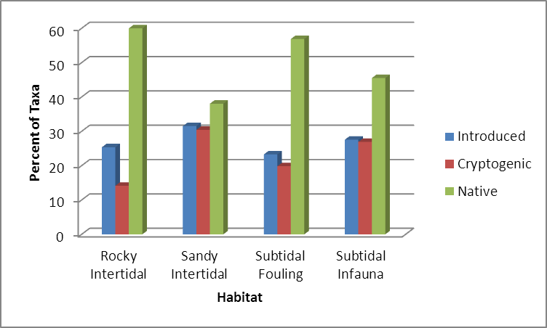
Figure 5. Percentage of total taxa within each classification for each habitat type sampled in San Francisco Bay, 2010.

2.2 Bays and Harbors Survey

A survey of San Francisco Bay was conducted during the spring and summer of 2011. Samples were collected at 52 sites in 18 bays and harbors. The methods were nearly identical to the bays and harbors survey done during 2006-2007. Taxonomic identification of collected specimens is currently underway; results will be available in summer of 2012.

3.0 SPECIAL STUDIES

DFG funded special studies designed to detect NAS or improve knowledge about geographic ranges of cryptic or poorly understood NAS.

3.1 Establishing Detection, Baseline Measures, and Efficacy of Exhaustive DNA Sequence Analysis (SERC/MLML Settling Plate/Molecular Detection Study)

3.1.1 Introduction

A combination of frequent and widespread monitoring, accurate identifications, and statistical confidence are vital to developing a true understanding of invasion processes and to enable appropriate management and policy toward prevention of, and response to non-native organism introductions. Under the current sampling strategy as described in Section 2.0 and Table 1, the probability of detecting new organisms in any one survey may often be low, given that species diversity, distribution, and abundance among marine organisms may fluctuate widely by season and years. In addition, sites and habitats where invasions are most likely to occur should be sampled with greater frequency to make accurate estimates of actual changes in invasion patterns, such as introduction rate and spread. Uncertainties about systematics, biogeography, and baseline ecological community history, combined with lengthy completion times required for morphologically-based organism identifications, present additional challenges in ascertaining the magnitude and geographic extent of species introductions in California (Carlton 2009, Geller et al. 2010). At present, the combined number of cryptogenic, unresolved, and unresolved complex taxa exceeds confirmed introduced taxa by more than fivefold.

Based on recommendations stated in the previous Triennial Report to the Legislature (DFG 2008), the MISP has engaged the Smithsonian Environmental Research Center (SERC) and the Genomics Lab of San Jose State University’s Moss Landing Marine Laboratories (MLML) to develop a robust, practical, and cost-effective alternative to current non-native organism detection and monitoring methods. A three-year collaborative pilot study was begun in July 2009 to establish the groundwork necessary to move forward from traditional, morphologically-based taxonomy and to test a streamlined, community-level monitoring approach based on next-generation molecular genetic tools (Appendix A).

The study is currently underway in the San Francisco Bay, an area long-recognized as a “hot spot” for non-native species in terms of both number and first reported occurrences. Focus was placed on the hard-substrate fouling community because most organisms of this group are relatively well described in terms of both taxonomy and biogeography (Ruiz et al. 2009). Moreover, the fouling community accounts for most of the invasions reported in California.

The overall sampling design was conceived by SERC and developed in collaboration with MLML and DFG. In addition, SERC conducted the sample and voucher collections, tracked the vouchers in a database, provided morphological taxonomic expertise, and analyzed sampling effort. MLML provided all aspects of molecular taxonomic expertise, including the development and implementation of protocols for molecular voucher collection, sample preparation, and sequence interpretation. MLML also coordinated the outsourcing of molecular analyses to subcontractors and built the DNA barcode reference library. In the ensuing months, SERC and MLML will collaborate on overall comparisons between morphological and molecular measures of species richness and produce a joint final report about the efficacy of this rapid community-level, molecular-based approach.

3.1.2 Study Methods

3.1.2.1 Sample Collections

Settling Plate Deployment. Standard surveys of sessile invertebrates were conducted at four index sites in the San Francisco Bay: San Francisco Marina (San Francisco County); San Leandro (Alameda County); Coyote Point Marina (San Mateo County); and Marina Bay Yacht Harbor (in Richmond, Contra Costa County) (Figure 6). Each site was sampled quarterly with replacement, using standard 15 cm² polyvinyl chloride (PVC) settling plates, over a two-year period. A total of ten settling plates per site were deployed per quarter, suspended at depth on a weighted rope tied to floating docks. In addition, vertical profiles of temperature, salinity, dissolved oxygen, and water transparency were recorded at each harbor per sampling event.

Settling plates were set at 1 m depths at 10 randomly-selected slips per site. At Richmond, where the water is deeper, an additional 10 plates were set at 4 m during the summer quarter of 2010 to continue testing the effect of depth on species composition.

Processing Settling Plates/Taking Voucher Specimens. Settling plate samples were first processed at the Tiburon laboratory within a few hours of retrieval in order to obtain the freshest-possible specimens for DNA analysis. Each plate was transferred to a sorting tray, photographed, and examined while the organisms were still alive.

Sessile invertebrates were identified to the lowest taxonomic group that could be assigned without further validation by a taxonomic specialist. Up to five voucher specimens of each morphotaxon were collected per plate and up to five vouchers were collected for each unique morphotaxon per site for DNA analysis. After voucher specimens were collected (as above), all biomass was removed from two plates per site for whole-community DNA extraction. A subset of voucher specimens were selected randomly for independent verification by taxonomic experts, based on morphological characters. In addition, any unique, unusual, or first records of species were also re-examined to confirm initial identification.
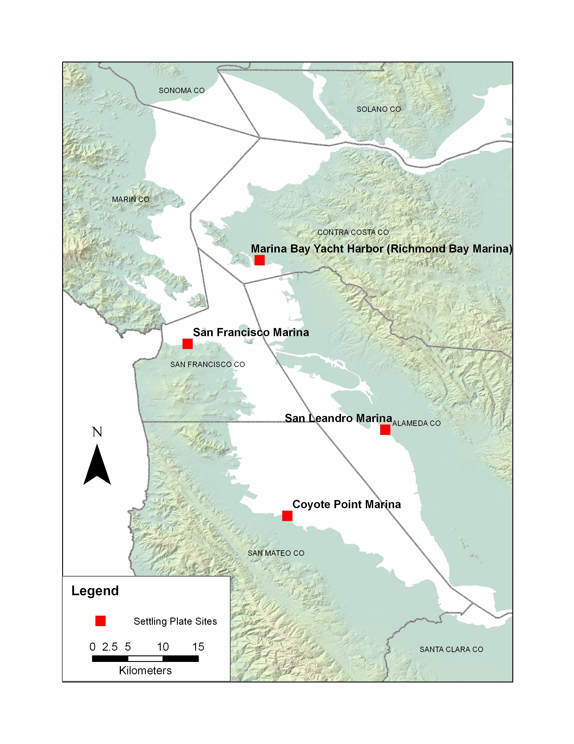Figure 6. Sampling sites for SERC/MLML Settling Plate/Molecular Detection Study.

Hard-Substrate Community Sampling. At three of the index sites, the surrounding hard substrata fouling community was sampled to test how well the settling plates captured representative native and non-native organisms. These collection events coincided with summer quarter settling plate deployments in 2009 and 2010. At each site, divers collected two replicates of 15 cm² quadrat clearings from six randomly-selected floating docks at depths of 1 and 3 m.

Plankton Sampling. Standardized plankton samples were collected at the four index sites to detect the presence of larvae of sessile invertebrates. These samples were collected on six occasions coinciding with spring to summer settling plate deployment each year.

3.1.2.2 DNA Reference Library

For each site and sampling date, three or more replicates of each morphotaxa were targeted for DNA analysis. Where possible, vouchers analyzed were taken from multiple sites and depths.

A database (DNA barcode library) was assembled from DNA sequences of sampled specimens and from queries of existing databases such as GenBank for sessile fouling community invertebrates likely to occur within San Francisco Bay. Sequences were also examined to test for the presence of cryptic species among voucher specimens. The basic steps involved in conventional DNA sequencing are summarized in Appendix A.

3.1.2.3 Whole-Community Analysis

DNA was extracted from whole-community (settling plate, hard-substrate quadrat, and plankton) samples for analysis via massively parallel pyrosequencing (MPPS; see Appendix A), a new technology capable of analyzing millions of individual DNA sequences during a single run.

Whole-community samples were planned to be analyzed in two separate arrays scheduled to run in Spring and Fall 2011. The goal of the first MPPS run was to analyze randomly-selected settling plate and plankton samples, plus a subset of settling plate samples in which unique morphotaxa were observed. Additional analyses would be contingent upon the results of the initial MPPS run: additional sites will be analyzed if most species were present in each replicate sample within a date and site. Conversely, additional replicates and fewer dates and sites will be analyzed if among-sample variation was high. The minimum goal was to complete analyses for two sites in the same summer and to strive to measure multiple sites from both collection years.

Whole-community sequences were sorted into operational taxonomic unit (OTU) groups based on levels of divergence. Each OTU was assigned a taxonomic name when possible by querying the appropriate barcode database for a matching sequence. Other sequences were assigned to higher taxonomic categories based on GenBank queries. Species composition lists were thus generated for each (settling plate, hard-substrate quadrat, and plankton) whole-community sample analyzed and were used to compare the performance of settling plates between sites and dates to represent and detect resident non-native, native, and cryptogenic species.

3.1.2.4 Analyses

Specific analyses to be performed by SERC included: 1) measuring the effect of sampling effort over time on detection and cumulative species assemblage (including number of sampling dates, depths, and within-date replicate samples) to statistically estimate confidence limits and asymptote as measure of the ability to estimate the total species pool and probability of detection; 2) comparing settling plate species composition with that observed on background hard-substrate fouling community quadrats; 3) comparing sessile invertebrate species richness and frequency observations in benthic samples with those of larval stages detected in plankton and 4) examining spatial and environmental effects upon species diversity.

Specific analyses to be performed by MLML included: 1) confirming whether settling plate and hard-substrate quadrat field identifications (morphotaxa) are consistently assigned to the same organism; 2) ground-truthing the consistency of identifications by checking whether all organisms assigned to the same morphotaxon share the same sequence; 3) testing for the presence of cryptic species; 4) querying existing barcode databases (e.g., GenBank) for phylogenetic concurrence with sequences analyzed during this study; 5) assigning tentative molecular identities to specimens that were too small or amorphous for field identification; and 6) querying the newly-assembled barcode database to determine species composition of exhaustively sequenced, whole-community samples (settling plate, hard-substrate quadrat, and plankton), as described above.

SERC and MLML will jointly evaluate the overall effectiveness of streamlined, community-level monitoring approach by comparing the accuracy of exhaustive molecular analysis against the results of traditional, morphological-based assessment. They will also examine the feasibility of expanding this approach over time to include other estuaries and communities, including soft-sediment and plankton assemblages.

3.1.3 Preliminary Study Results

3.1.3.1 Sample Collections

Settling Plates. Quarterly deployments occurring between June 2009 and June 2011 yielded a total of 330 whole-community samples, including ten extra plates set at 4 m depth at Richmond Marina in June 2010.

Hard-Substrate Community Quadrats. A total of 120 samples were collected from surrounding hard substrates at three of the four index sites during September of 2009 and 2010. Additional hard-substrate collections will be attempted during late summer of 2011 for yet-unsampled sites.

Plankton. Samples were collected 12 times over a period of two years. Samples were collected only from San Leandro Marina in April 2110 due to equipment failure. In all, 176 samples were forwarded to MLML’s Genomics Lab for whole-community (MPPS) analysis, and 44 were retained by SERC for potential morphological identifications and/or plankton density measurements.

3.1.3.2 Morphologically-Based Sample Analysis

Settling plates yielded a total of 4,314 morpho-vouchers and a total of 1,663 morpho-vouchers were collected from quadrats. Vouchers destined for molecular analysis included 3,117 collected from settling plates and 1,223 from quadrats.

A list of tentative field identifications (morphotaxa) was generated for each plate and quadrat examined. The master list of overall morphotaxa has grown, from 180 at the project’s outset, to 218. The number of new morphotaxa declined dramatically during the last two collection periods, suggesting that the entire range of the hard-substrate fouling community sessile species assemblage has likely been collected. Morphological verification and formal identification of voucher samples remain in progress through the end of this reporting period, and completion is anticipated by Fall 2011. In addition, a reference voucher collection is in preparation to aid future surveys.

One of the notable discoveries made through morphological analysis included Pachychordele michaeli, a hydroid native to eastern U.S. waters. Its occurrence at Coyote Point Marina is a first record for the west coast.

3.1.3.3 Voucher Sequencing for the DNA Reference Library

A total of 4,332 useable molecular vouchers were received to date, representing more than a dozen phyla, including unidentified eggs and various algae. A total of 516 voucher specimens have been sequenced for COI, comprising 78 distinct species thus far.

Preliminary sequencing results suggest that morphologically-based surveys of the past may have contained significant errors, thereby undermining their intended use for detection and monitoring of non-native organisms. Besides validating a majority of voucher identifications, phylogenic analyses called attention to occasional misidentifications, as well as the existence of cryptic clades within a morphological species, and more distantly-related (sister) groups. Similar patterns were observed in other taxa, but further exhaustive analysis of the entire dataset is pending.

In general, sequences belonging to a recognized species were highly similar to records acquired from the GenBank database. Several unknown morphotaxa were resolved through their close relationship to known sequences (Table 7). The collection of Amphibalanus eburneus, (ivory barnacle) from Richmond and San Francisco marinas confirmed new distribution records for the San Francisco Bay. Although one specimen had been collected from a ship’s hull around 1938 (Carlton 1979), no other occurrences had been documented in the Bay during the intervening time. More recent California observations of this North Atlantic native had been limited to Colorado Lagoon (Long Beach) and Huntington Harbour (Cohen et al. 2005, Maloney et al. 2008).

To date, the Northeast Atlantic ascidian, Botrylloides leachi, has not been detected in U.S. waters (P. Fofonoff, pers. comm. 8/9/2011). However, given its convoluted taxonomic history however, the provenance of the GenBank voucher should be investigated before concluding that B. leachi is in fact present in the San Francisco Bay.

Table 7. Morphotaxa identities resolved through matches with GenBank records. In all four cases, similarity between GenBank and morphotaxon sequences exceeded 95%.
Morphotaxon | GenBank Species | CANOD Status
Cirripedia 1 | Amphibalanus eburneus | Introduced
Gastropod 1 | Crepidula plana | Introduced
Scyphistoma | Aurelia labiata | (no CANOD entry)
Unknown nemertea | Cephalothrix simula | (no CANOD entry)

3.1.3.4 Overall Analysis

Work has commenced on verification of morphological findings, formal comparisons with molecular data, and creation of a consensus organism dataset. Staff from both sides of the project began meeting on a regular basis beginning in November 2010 to compare morphological and molecular results. The meetings were initially held at quarterly intervals, but increased in frequency with acquisition of new data. Some comparisons have already begun to a limited extent, focusing initially upon the new non-native species discoveries reported above.

Upon completion of the consensus dataset, work will begin on statistical analyses to model species accumulation and detection as a function of sampling effort over time for each site. Data analyses will continue for the duration of this project.

3.2 Marine Invasion History and Vector Analysis

In a collaborative study between DFG and SERC (also partially funded by DFG) we examined the transfer mechanisms (vectors) likely responsible for initial introductions to the state. Past analyses indicated that California, and particularly San Francisco Bay, is often the first recorded location for many non-native species on the West Coast. This study focused on analyzing California’s role in invasion dynamics for western North America.

3.2.1 Vector Analysis Methods

We generated a cumulative list of established NAS along western North America, using records from the National Exotic Marine and Estuarine Species Information System (NEMESIS) and CANOD. Both databases contained occurrence records of species, compiled from literature-based records and independent field surveys. As reported in DFG’s previous legislative report, SERC intensively reviewed the classification and status of each species, to provide quality assurance and consistency across all occurrence records through 2006. The review of introduction status included re-examination of available literature on history and biogeography of the species, and consultation with experts. NEMESIS was the sole source of occurrence records and invasion status classification for species in states and provinces outside of California.

Analysis focused on invertebrates, algae, protists, and microorganisms that were considered to have established populations in marine, estuarine, and tidal freshwater, excluding all vascular plants and vertebrates. We also excluded species that were clearly non-native but were not known to be established, such as those that became extinct, never established, or whose current population status is unknown.

For each California NAS, we characterized the vectors associated with the initial invasion record in the state, and examined temporal patterns of vector strength (the number of California invasions associated with each vector). Vectors included: (a) Ships’ Fouling (or biofouling) – the hulls and underwater surfaces of commercial, recreational, and fishing vessels; (b) Ships’ Ballast Water; (c) Eastern Oysters – transfers of Atlantic oysters; (c) Asian Oysters – transfers of the Pacific oysters; (d) Stocked Fish; (e) Live Trade – live seafood, bait, ornamental plants, aquaria, and scientific research; and (f) Other Vectors -- wetland restoration, biocontrol, dry ballast of ships, and ships’ cargo. For many non-native species, multiple vectors were considered possible, which were treated each as equally likely in our analysis.

3.2.2 Vector Analysis Results and Discussion

NAS DISTRIBUTION: Of the 290 NAS in western North America, 257 (89%) are known to be established in California (Ruiz et al. 2011). Fewer than 100 non-native species were known to occur in Oregon, Washington, or British Columbia, and only 10 non-native species are reported to be established in Alaska (Figure 7).

For most NAS along the western North American coast, California appears to be the first point of entry, as 79% of the 290 established non-native species were first recorded in California. Only 17% was reported first from Oregon to British Columbia and 0% from Alaska and 4% of species were reported first on the Pacific coast of Mexico.

For NAS in California, most (89%) were first recorded in the state, instead of other states or provinces in western North America (Figure 7). Likewise, 40-64% of NAS in other western states and provinces north of California were also first recorded in California.
Figure 7. Number of non-native species by geographic region for western North America; the number with a first record in California is indicated in black. (Ruiz et al. 2011).

The San Francisco Bay was the first location of record for 65% of California’s NAS. For the entire region of western North America, San Francisco Bay was the first recorded location in the state for 65% of the species (Figure 8). More than half (57%) of the NAS first reported in California are now known to occur in multiple estuaries.
Figure 8. Locations of first records for NAS in California; the salinity distribution of species in each group is indicated by shading. (Ruiz et al. 2011).

NAS Vectors: San Francisco Bay clearly plays a major role in the dominance of California as an entry point for NAS for many reasons. It appears that propagule supply was relatively high in San Francisco Bay, chiefly as a result of a large number of vessel visits and substantial transfers of oysters in the 1800’s. Also, the high diversity of available habitats here, especially the extensive brackish and freshwater habitats, has increased opportunities for colonization.

The vessel and oyster transfer vectors are dominant in California. More than half (56%) of species in California are considered polyvectic, that is, more than one vector was considered possible. About 48% of all taxa can be attributed exclusively to the vessel subvectors (ballast water, hull fouling, dry ballast and cargo). About 81% of NAS include vessels as a sole or possible (multiple) vector and 32% of all species include oyster transfer as a sole or multiple vector.

Although we know the major vectors responsible for bringing species to California, we are much less certain about which subvectors are the major contributors. Hull fouling (18%) and ballast water (9%) are the largest single subvectors of species with a single mechanism of introduction (Figure 9) and another 20% were attributed to both hull fouling and ballast water as the only possible vectors. However, nearly all of the species assigned to multiple vectors include hull fouling and ballast water as possible vectors, so about 60% of all California invasions include hull fouling as a possible vector, and 53% include ballast water as a possible vector.
Figure 9. Vectors for established NAS in California. The salinity distribution of species in each group is indicated by shading (marine – estuarine distribution in black; brackish water in grey; tidal freshwater in white). (Ruiz et al. 2011).

3.3 NAS Survey Data Analysis

An analysis of the 2005 MISP San Francisco Bay field survey data was completed by the Moss Landing Marine Laboratories Benthic Lab and Coastal Conservation & Research Inc. There was no relationship between sediment texture (grain size) and numbers of introduced species. Likewise, the type of hard substrate (e.g. wood, concrete, plastic) did not influence the distribution of introduced species. Hydrographic variations along the estuarine gradient apparently are more important in controlling community structure than changes in sediment and hard surface type.

3.4 Genetic Study of “Breadcrumb” Sponges

An MISP-funded genetic study of “Breadcrumb” sponges (genus Halichondria) was completed by Dr. Jon Geller at the MLML Genomics Lab. This group of sponges is among the most difficult to identify, even by leading taxonomic experts, but was suspected to be composed of at least two invasive species in California. Results revealed a new undescribed native species and two introduced species of Atlantic origin (Geller 2010). The analysis found that none of the genetically identified species correspond to the names previously used to describe these species and that species identification can be made only by genetic analysis.

- DATABASE AND QUALITY ASSURANCE

4.1 California Aquatic Non-native Organism Database
DFG manages a relational database, known as California Aquatic Non-native Organism Database (CANOD), which was developed in 2000 to record information about marine and estuarine non-native species in California. CANOD contains the name and location of every known non-native species on the California coast. The database also includes information about the vector of introduction (e.g. ballast water, hull fouling, etc.), date introduced to California, locations where species have been observed, and the native region of many non-native species. CANOD continues to be a tool to help monitor new introductions and to understand the patterns associated with those introductions.
The previous version of CANOD contained numerous tables with a complex relational structure. As a result, the user needed extensive knowledge of the database structure as well as Microsoft Access software to successfully query the database. In 2010, MLML staff created a user-friendly public interface for CANOD that allows easy access to commonly requested information.
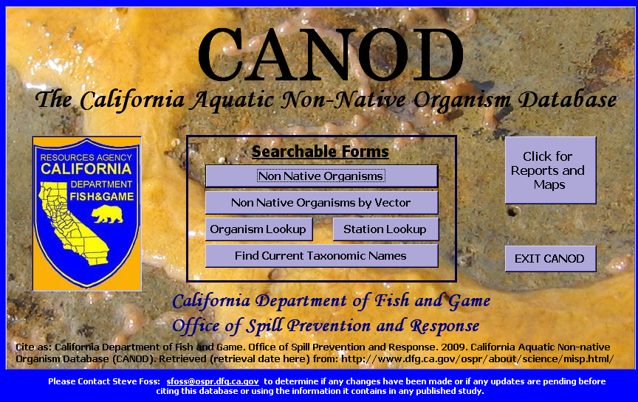
Figure 10. Main menu of CANOD’s public interface.

The Main Menu offers two main ways to view the data (Figure 10). One option is to query data through searchable forms. The searchable forms allow the user to build their own report quickly and easily. Each form allows the user to print out the current record displayed on the screen. There are five searchable forms from which to choose:
- Non-Native Organisms form enables the user to choose from a list of all non-native organisms in CANOD and view detailed information on each species, including the organism’s taxonomic hierarchy, native region, vectors, and records of known occurrences in California. The sources used to determine the introduction status and probable vectors are also listed.
- Non-Native Organisms by Vector form allows the user to search non-native species by their introduction vectors.

- Organism Lookup form provides detailed information on all organisms in CANOD including non-native, native, cryptogenic, and unresolved taxa. The form includes the following information about each species phylum, class, order, family, species complex, common name, other known names of the species (synonyms), comments regarding the synonym names, introduction status, year the species was discovered in California, the source of discovery, and additional comments regarding the introduction status.

- Station Lookup form allows the user to search all the stations in CANOD by name or view a list of all stations currently in CANOD. The form provides data associated with the station, including species found at each station, date the station was sampled, station coordinates, sub-bay, bay or watershed, county, and bioregion.

- Find Current Taxonomic Name form enables the user to search by synonym. In CANOD, the term “synonym” is defined broadly. In addition to true synonyms, provisional names and other nomenclatural anomalies such as misspellings, or misidentifications are also listed. The form will display the current taxonomic name of the species and data associated with the species, including its taxonomic hierarchy, taxonomic authority (the author who first published a valid description of the species), introduction status, and additional comments.
Data can also be viewed in a variety of pre-defined reports and maps. In this form, the user can view reports and maps, which can be exported to Excel files.

A User Manual and Data Dictionary are also available for CANOD. The User Manual provides step-by-step instructions to help navigate the user through CANOD. The Data Dictionary lists every table and field in CANOD by alphabetical order and provides detailed descriptions and metadata for each field. Both documents can be found on the Marine Invasive Species websites at http://www.dfg.ca.gov/ospr/Science/invasive_species.aspx.

CANOD is continuously being refined as new information becomes available and with each additional NAS survey completed. As such, CANOD is a dynamic database, so users should ensure that they have the most current copy of the database before making use of the data.

4.1 Collaboration and Data Sharing

DFG shares NAS data with other agencies and organizations conducting similar surveys for NAS in California coastal waters. One such collaboration was described in Section 3.2. SERC developed and maintains NEMESIS (NEMESIS 2008), a national database of marine and estuarine invasions of the continental U.S. and Alaska. Data are shared between DFG and SERC and there are ongoing efforts to standardize lists of California introduced species.

  - Quality Assurance

There have been several efforts to assure CANOD data quality since the last MISP legislative report was submitted in 2008. Recently performed quality control tasks include, but are not limited to the following:

- Geographic coordinates of station locations were plotted and reviewed to verify their accuracy.
- A new table was created to accommodate literature cited in CANOD.
- Literature-based records were reviewed to ensure that all species information was complete, correctly cited, and reflected current taxonomic names.
- Population statuses of NAS were reviewed and updated

- SUMMARY OF NAS OCCURANCE IN CALIFORNIA

5.1 State-Wide Occurrence of NAS

A total of 387 NAS have been identified from the literature and field investigations. However, due to the lack of systematic field sampling for some groups of organisms, there is uncertainty about whether some species currently have established populations. We excluded species that are known to be extinct (2), eradicated (3), never established (33), or whose current population status is unknown (25). Thus, we recognize 324 NAS with established populations in California coastal waters.

The phylum Arthropoda (crabs, shrimp, etc.) dominated the NAS list, comprising 85 (26%) of the species introduced to the marine and estuarine waters of the State. Amphipods were the most common group of arthropods identified during this study. Chordates (fish, sea squirts, etc.) were the second most numerous phylum identified, comprising 17% of the species. Many of the fish species were found in freshwater habitats, including the Sacramento-San Joaquin Delta and the location of two primary monitoring sites, the Ports of Sacramento and Stockton. About 14% of California NAS are molluscs (snails and bivalves).

Although the previous DFG report (2008) listed 307 NAS along the California coast, some of those species were subsequently re-identified or reclassified as native, cryptogenic, or unresolved, or are now considered part of species complexes (Table 7). These changes were made after extensive review and research of each species in the NAS database (Section 5.3). Furthermore, the number of NAS also increased due to the addition of literature-based records resulting mostly from the data exchange with NEMESIS (Section 5.2) and also from surveys and availability of new information (Table 8). These were not new discoveries, but rather NAS that had previously been overlooked. Finally, although the count of introduced organisms was unaffected, other introduced taxa underwent taxonomic changes and were updated in CANOD (Table 9).

Field surveys and literature sources indicate that there are 465 cryptogenic species. Many of these species are likely introduced, but there is considerable uncertainty concerning their origin. The largest group of cryptogenic species is annelids, particularly polychaete worms. Nearly 58% of cryptogenic species (269 species) were annelids. A total of 88 cryptogenic arthropods (19%) were identified.

In addition to the combined 772 species classified as introduced or cryptogenic, another 1,362 taxa were identified as unresolved. For reasons described earlier, these taxa could not be identified to the species level with any degree of certainty. Additionally, though not a focus of our field surveys or research, our database (CANOD) contains information on 1,884 native species sampled in our field surveys, including locations.
Table 8. CANOD taxa designated or undesignated as Introduced during this reporting period (July 1, 2008 to June 30, 2011).
Taxon | Former  Introduction Status | New  Introduction Status | Status Determination Source(s) | Reason(s) for Change
Phylum Heterokontophyta
Heterosigma akashiwo | Introduced | Cryptogenic | Elbrachter 1999; Gregorio & Connell 2000; Ruiz et al. 2000; Connell 2000 | Deferred to status designated in NEMESIS.
Phylum Cnidaria
Gonothyraea clarki | Introduced | Cryptogenic | Mills et al. in Cohen et al. 1998; Mills et al. 2007; J. Carlton pers. comm. 7/29/08 | Deferred to status designated in NEMESIS.
Gonothyraea loveni | Introduced | Cryptogenic | Mills et al. in Cohen et al. 1998; Mills et al. 2007; Carlton pers. comm. 7/29/08 | Deferred to status designated in NEMESIS.
Obelia bidentata | Introduced | Cryptogenic | Mills in Cohen et al. 1998; Mills et al. 2007 | Deferred to status designated in NEMESIS.
Obelia geniculata | Introduced | Cryptogenic | Mills in Cohen et al. 1998; Mills et al. 2007 | Deferred to status designated in NEMESIS.
Sarsia tubulosa complex | Introduced | Cryptogenic | Rees 1975; Mills in Cohen et al. 1998; Mills et al. 2007 | Deferred to status designated in NEMESIS.
Phylum Mollusca
Alderia modesta | Introduced | Cryptogenic | Bleakney 1988; Krug et al 2007; P. Fofonoff pers. comm. 7/22/08 | Deferred to status designated in NEMESIS.
Epitonium californicum | Introduced | Native | Dall 1917; Oldroyd 1927; Abbott 1974; McLean 2007; ITIS 2008 | Deferred to status designated in NEMESIS [as Nitidiscala californicum].
Micromenetus dilatatus | Introduced | Native | Taylor 1981; Perez et al. 2004; Sytsma et al. 2004 | Lack of evidence about exotic origin.
Pteria sterna | Introduced | Cryptogenic | Carlton 1979; Coan et al. 2000 | Deferred to status designated in NEMESIS.
Phylum Annelida
Branchiosyllis exilis complex | Introduced | Unresolved Complex | Aguado et al. 2008; L. Harris pers. comm. 2/14/2008, 9/17/08 | Deferred to status designated in NEMESIS.
Eiseniella tetraedra | Cryptogenic | Introduced | Czudi & Zicsi 2003; Blakemore et al. 2006; J. Reynolds pers. comm. 10/30/09 | Status change per J. Reynolds pers. comm. 10/30/09
Laonome sp. SF1 Norris | Cryptogenic | Introduced | Cohen & Carlton 1995; Blake & Ruff 2007; L. Harris pers. comm. 2/14/08, 7/15/08; D. Norris pers. comm. 10/16/09 | Deferred to status designated in NEMESIS.
Streblospio benedicti | Unresolved Complex | Introduced | Levin [DATE?]; Harris pers. comm. 3/1/11 | Reverted back to full species and validated non-native origin.
Phylum Arthropoda
Caprella drepanochir | Cryptogenic | Introduced | Watling & Carlton 2007 | Added per NEMESIS; adopted same status.
Crangonyx floridanus complex | Unresolved Complex | Introduced | Toft et al. 2002; Chapman 2007; Fofonoff pers. comm. 2/21/08; Slothouber-Galbreath et al. 2009 | Difficult to distinguish from congeners w/o genetic analysis; status as per NEMESIS.
Elasmopus rapax | Native | Introduced | Barnard 1962; Carlton 1979; Chapman 2007 | Status per Chapman 2007
Taxon | Former  Introduction Status | New  Introduction Status | Status Determination Source(s) | Reason(s) for Change
Gnorimosphaeroma rayi | Native | Introduced | Hoestlandt 1973; Carlton 1979; Brusca et al. 2007 | Status per Carlton 1979 and NEMESIS
Ianiropsis cf. serricaudis | Introduced | Cryptogenic | Carlton 1979; Cohen & Carlton 1995; Cohen 1996; D. Cadien pers. comm. 3/20/11 | Previously reported as Ianiropsis serricaudis; downgraded to a conditional taxon, which also prompted a status change.
Melita sp. A Cadien | Introduced | Cryptogenic | Cadien 2007; Cadien pers. comm. 7/2/08 | Per re-examination by P. Slattery and D. Cadien 6/28/08
Prokelisia marginata | Cryptogenic | Introduced | Wilson 1982; Stiling et al. 1991; Grevstad et al. 2003 | Obligate life-history association with the introduced cordgrass, Spartina alterniflora
Salmoneus sp. A Cadien | Unresolved | Introduced | Cadien 1986; Carlton & Geller 1993; Cadien pers. comm. 10/12/09 | Previously reported as Salmoneus gracilipes; downgraded to a provisional taxon, which also prompted a status change.
Stephos pacificus | Cryptogenic | Introduced | Ohtsuka & Hiromi 1987; Ruiz et al. 2000; J. Cordell pers. comm. 10/09/09 | Epibenthic, thus natural dispersal unlikely; also, distribution is disjunct.

A substantial number of species in California’s coastal waters are clearly introduced to the habitats where they were found. However, a large number of species may possibly have been introduced, but must be analyzed further.

The state-wide totals summarized in this section show the number of individual taxa recorded during the sampling effort or identified in the literature. Although we attempted to sample or record information for a broad range of habitats, it was not possible to sample in all subtidal and intertidal habitats or include all communities in the study design. As a result, the numbers presented here may, to some extent, underestimate the true populations of NAS.

Table 9. Introduced taxa added to CANOD during this reporting period (July 1, 2008 to June 30, 2011).
Taxon | California Discovery Year | Population Status | Date Added | Reason for Inclusion and/or Information Source(s)
Phylum Protozoa
Bonamia ostreae | 1966 | Not Established | 14 Jul 2008 | NEMESIS; Elston et al. 1986; Friedman et al. 1989
Haplosporidia nelsoni | 1990 | Failed | 16 Sep 2010 | NEMESIS; Friedman et al. 1989
Myxobolus koi | 1973 | Established | 14 Jul 2008 | NEMESIS; Hensley & Nahhas 1975; Light et al. 2005
Phylum Rhodophyta
Antithamnion nipponicum | n/a | Established | 14 Jul 2008 | NEMESIS; Dawson 1962; Young 1981; Cho et al. 2006
Asparagopsis armata | 1972 | Unknown | 14 Jul 2008 | NEMESIS; NiChualain et al. 2004; Andreakis et al. 2004, 2007; Maggs pers. comm. 2007
Ceramium kondoi | 1999 | Established | 15 Jul 2008 | NEMESIS; Cho et al. 2002
Dasya sessilis | 2006 | Unknown | 03 Dec 2009 | Miller pers. comm. 12/03/09
Gracilaria vermiculophylla | 1994 | Established | 14 Jul 2008 | NEMESIS; Goff et al. 1994; Bellorin 2004; Rueness 2005
Grateloupia lanceolata | 2003 | Established | 19 Aug 2008 | Miller et al. 2009
Grateloupia turuturu | 2009 | Established | 15 Sep 2009 | Hughey pers. comm. 9/8/09; Miller pers. comm. 8/28/09; Hughey et al. 2009
Neosiphonia harveyi | 1908 | Established | 15 Jul 2008 | NEMESIS; McIvor et al. 2001; Miller pers. comm. 7/14/08
Phylum Ciliophora
Conidophrys pilisuctor | 1948 | Established | 14 Jul 2008 | NEMESIS; Mohr & Leveque 1948; Carlton 1979
Lagenophrys cochinensis | 1931 | Established | 15 Jul 2008 | NEMESIS; Clamp 2006
Phylum Heterokontophyta
Ascophyllum nodosum | 2002 | Eradicated | 13 Apr 2010 | NEMESIS; Miller et al. 2004
Cutleria cylindrica | 1973 | Established | 14 Apr 2010 | Kogishi et al. 2010; Miller pers. comm. 4/14/10
Elachista nigra | 1984 | Established | 14 Apr 2010 | Kitayama et al. 2005; Miller pers. comm. 4/14/10
Phylum Magnoliophyta
Carpobrotus | 1900 | Established | 11Mar 2009 | Cohen et al. 2005; CA Invasive Plant Council (Cal-IPC)
Rumex crispus | 1891 | Established | 11 Mar 2009 | Cohen et al. 2005; Jepson Manual 1993 and Collection
Zostera japonica | 2002 | Eradicated | 15 Apr 2010 | NEMESIS; Rushton 2005; U.S. Army Corp of Engineers 2009; USGS NAS Database 2008; ISSG Database www.dfg.ca.gov/invasives
Phylum Ascomycota
Claviceps purpurea var. spartinae | 1888 | Established | 15 Jul 2008 | NEMESIS; Faber 2000; Fisher et al. 2005, 2007
Phylum Porifera
Prosuberites sp. Hartman, 1975 | 1953 | Established | 18 Aug 2008 | Carlton 1979; Cohen & Carlton 1995
Phylum Cnidaria
Amphinema sp. Rees | 1998 | Unknown | 15 Jul 2008 | NEMESIS; Rees 2000; Mills et al. 2007
Aurelia sp. 1 | 1988 | Established | 29 Jul 2008 | NEMESIS; Cohen & Carlton 1995; Greenberg et al. 1996; Dawson & Jacobs 2001; Schroth et al. 2002; Dawson 2003; Mills & Larson 2007
Corymorpha sp. A, LSM4 | 1955 | Established | 29 Jul 2008 | NEMESIS; Carlton 1979; Cohen & Carlton 1995; Carlton pers. comm. 7/29/08
Phylum Ctenophora
Vallicula multiformis | 1997 | Unknown | 14 Apr 2010 | NEMESIS; Matsumoto pers. comm. 1998; Carlton pers. comm. 2005; Mills & Haddock 2007
Phylum Platyhelminthes
Alloglossidium corti | 1947 | Established | 14 Jul 2008 | NEMESIS; Haderlie 1953; Hensley & Nahhas 1975; Cohen 1996
Atractolytocestus huronensis | 1972 | Established | 14 Jul 2008 | NEMESIS; Hensley & Nahhas 1975; Cohen 1996
Bothriocephalus cuspidatus | 1967 | Established | 14 Jul 2008 | NEMESIS; Edwards & Nahhas 1968; Scholz 1997; Light et al. 2005

Table 9 (Continued).

Taxon | California Discovery Year | Population Status | Date Added | Reason for Inclusion and/or Information Source(s)
Phylum Platyhelminthes (continued)
Corallobothrium fimbriatum | 1947 | Established | 14 Jul 2008 | NEMESIS; Haderlie 1953; Cohen 1996
Dactylogyrus extensus | 1947 | Established | 14 Jul 2008 | NEMESIS; Haderlie 1953; Cohen 1996
Khawia iowensis | 1972 | Established | 14 Jul 2008 | NEMESIS; Hensley & Nahhas 1975; Cohen 1996
Ligictaluridus pricei | 1973 | Established | 14 Jul 2008 | NEMESIS; Hensley & Nahhas 1975
Megathylacoides giganteum | 1967 | Established | 14 Jul 2008 | NEMESIS; Edwards & Nahhas 1968
Pisciamphistoma stunkardi | 1967 | Established | 14 Jul 2008 | NEMESIS; Edwards & Nahhas 1968
Stylochoplana limnoriae | 1950 | Established | 29 Jul 2008 | NEMESIS; Carlton 1979; Carlton pers. comm. 7/29/08
Phylum Nemata
Capillaria catenata | 1973 | Established | 14 Jul 2008 | NEMESIS; Hensley & Nahhas 1975
Philometroides sanguineus | 1973 | Established | 14 Jul 2008 | NEMESIS; Hensley & Nahhas 1975; Cohen 1996
Phylum Ectoprocta
Aspidelectra melolontha | 1980 | Unknown | 13 Apr 2010 | Fofonoff pers. comm. 10/23/08
Membranipora chesapeakensis | n/a | n/a | 16 Mar 2011 | McCann et al. 2007; Davidson et al. 2008; Mackie pers. comm. 3/11/11
Schizoporella errata | 2000 | Established | 06 Aug 2008 | NEMESIS; Fofonoff pers. comm. 8/02/08
Watersipora subtorquata | n/a | Established | 02 Feb 2011 | Cohen & Carlton 1995; Geller pers. comm. 2/1/08
Phylum Mollusca
Anadara ovalis | 1967 | Failed | 15 Apr 2010 | NEMESIS; Wicksten 1976; Carlton 1979
Anomia simplex | 1912 | Failed | 15 Apr 2010 | NEMESIS; Carlton 1979
Argopecten irradians | 1963 | Failed | 15 Apr 2010 | NEMESIS; Wicksten 1976; Carlton 1979
Bullia rhodostoma | 1966 | Failed | 15 Apr 2010 | NEMESIS; Carlton 1979
Guildfordia yoka | 1912 | Failed | 15 Apr 2010 | NEMESIS; Carlton 1979
Ischadium recurvum | 1921 | Failed | 15 Apr 2010 | NEMESIS; Hanna 1966; Carlton 1979
Meretrix lusoria | 1957 | Failed | 15 Apr 2010 | Hanna 1966; Carlton 1979
Nuttalia obscurata | 2001 | Unknown | 16 Sep 2010 | Wasson et al. 2005; K. Wasson pers. comm. 2007
Ostrea sinuata | 1962 | Failed | 15 Apr 2010 | Hanna 1966; Carlton 1979
Philine japonica | 1998 | Established | 14 Jul 2008 | NEMESIS; Australian Museum 1999; Behrens 2004
Philine orientalis | 1993 | Established | 14 Jul 2008 | NEMESIS; Australian Museum 1999; Behrens 2004
Phylum Annelida
Cambarincola pamelae | 1982 | Established | 14 Jul 2008 | NEMESIS; Holt 1984a; Gelder et al. 2002; Light et al. 2005
Crucigera websteri | 1910 | Unknown | 17 Jul 2008 | NEMESIS; Carlton 1979; Bastida-Zavala 2008
Eiseniella tetraedra | n/a | Established | 01 Dec 2009 | Czudi & Zicsi 2003; Blakemore et al. 2006; J. Reynolds pers. comm. 10/30/09
Laonome sp. SF1 Norris | 1989 | Established | 15 Jul 2008 | NEMESIS; Cohen & Carlton 1995; Blake 2007; Harris pers. comm. 7/15/08; Norris pers. comm. 10/16/09;
Neodexiospira brasiliensis | 1974 | Established | 18 Aug 2008 | NEMESIS; Knight-Jones et al. 1975, 1979; Fofonoff pers. comm. 7/31/08
Nicolea zostericola | n/a | n/a | 14 Apr 2010 | Blake & Ruff 2007
Ophryotrocha labronica | 1975 | Established | 14 Apr 2010 | Carlton 1985; Akesson & Paxton 2005
Phylum Arthropoda
Amphiascus parvus | 1983 | Unknown | 15 Apr 2010 | Watkins 1983; Cordell 2007; Cordell [online]
Amphibalanus albicostatus | 1930 | Failed | 14 Apr 2010 | NEMESIS; Bonnot 1935b; Henry & McLaughlin 1975; Carlton 1979
Amphibalanus reticulatus | 2003 | Unknown | 29 Jul 2008 | NEMESIS; deRiviera et al 2005
Ampithoe longimana | 1949 | Established | 14 Jul 2008 | NEMESIS; Carlton 1979; Chapman 2007
Caecijaera horvathi | 1950 | Established | 18 Aug 2008 | Carlton 1979; Brusca et al. 2001
Callinectes sapidus | 1897 | Failed | 15 Apr 2010 | NEMESIS; Carlton 1979
Calliopiella sp. 1 Chapman | 1993 | Unknown | 10 Feb 2009 | NEMESIS; Cohen & Carlton 1995
Caprella drepanochir | 2001 | Established | 07 Jul 2008 | NEMESIS; Watling & Carlton 2007
Conchopus borealis | 1993 | Established | 14 Jul 2008 | NEMESIS; Masunaga et al. 1999
Crangonyx floridanus complex | 1998 | Established | 20 Aug 2008 | NEMESIS; Toft et al. 2002; Chapman 2007; Fofonoff pers. comm. 2/21/08; Slothouber & Galbreath et al. 2009

Table 9 (Continued).

Taxon | California Discovery Year | Population Status | Date Added | Reason for Inclusion and/or Information Source(s)
Phylum Arthropoda (continued)
Crangonyx pseudogracilis | 2002 | Established | 19 Apr 2010 | Bottorf et al. 2003; Chapman 2007; Slothouber & Galbreath et al. 2009; USGS NAS; Fofonoff pers. comm.
Elasmopus rapax | 1952 | Established | 06 Oct 2009 | Barnard 1962; Carlton 1979; Chapman 2007
Epinebalia sp. A, LSM4 | 1992 |  | 30 Jul 2008 | NEMESIS; Cohen & Carlton 1995; Haney et al. 2007
Gnorimosphaeroma rayi | 1952 | Established | 07 Jul 2008 | NEMESIS; Hoestlandt 1973; Carlton 1979; Brusca et al. 2007
Harpacticella paradoxa | 2000 | Unknown | 18 Aug 2008 | Cordell et al. 2007
Limulus polyphemus | 1917 | Failed | 15 Apr 2010 | NEMESIS; Carlton 1979; Cohen & Carlton 1995
Prokelisia marginata | 1982 | Established | 08 Jul 2008 | NEMESIS; Wilson 1982; Stiling et al. 1991; Grevstad et al. 2003
Pselactus spadix | 1966 | Established | 14 Jul 2008 | NEMESIS; O’Brien 1970
Pseudosphaeroma sp. (of Bruce & Wetzer 2008) | 2000 | Established | 08 Feb 2011 | Bruce & Wetzer 2008
Salmoneus sp. A Cadien | 1985 | Extinct | 12 Oct 2009 | Cadien 1986; Carlton & Geller 1993; Cadien pers. comm. 10/12/09
Sinelobus sp. (of Cohen 2007) | n/a | n/a | 08 Feb 2011 | Cohen 2007; Cadien pers. comm. 1/12/11
Sinocorophium alienense |  | Established |  | SEE TABLE OF TAXONOMIC CHANGES
Sinocorophium heteroceratum |  | Established |  | SEE TABLE OF TAXONOMIC CHANGES
Spiniliberis quadriaculeata | 1970 | Established | 29 Jul 2008 | NEMESIS; Watling 1970, 1975; Carlton 1979; Carlton 2008
Stephos pacificus | 2001 | Unknown | 12 Oct 2009 | Ohtsuka & Hiromi 1987; Ruiz et al. 2000; Cordell pers. comm. 10/09/09
Upogebia affinis | 1912 | Failed | 15 Apr 2010 | NEMESIS; Cohen & Carlton 1995
Phylum Chordata
Ascidia sp. A Lambert | 1983 | Established | 15 Jul 2008 | NEMESIS; Lambert & Lambert 1998, 2003; Lambert pers. comm. 7/15/08
Gymnothorax | 2000 | Failed | 15 Apr 2010 | Becerra 2000
Perophora japonica | 2003 | Established | 14 Jul 2008 | NEMESIS; Lambert 2005
Symplegma reptans | 1991 | Established | 14 Aug 2009 | Lambert & Lambert 1998, 2003

Species/Taxon | Authority | Date Revised | Previous Name | Basis of Revision
Phylum Rhodophyta
Aglaothamnion tenuissimum | (Bonnemaison) Feldmann-Mazoyer | 07 Jul 2008 | Callithamnion byssoides | Per AlgaeBase, NEMESIS, and K. Miller pers. comm. 2008
Phylum Magnoliophyta
Chenopodium macrospermum var. halophilum | Hooker f. (Philippi) Standley | 15 Sep 2009 | Chenopodium macrospermum | Variety added to conform with Cohen & Carlton 1995
Phylum Cnidaria
Aurelia sp. 1 | Dawson & Jacobs 2001 | 30 Nov 2009 | Aurelia sp. 1 LSM4 | Format change.
Cladonema pacificum | Naumov 1955 | 7 Jul 2008 | C. uchidai | Per Mills et al. 2007 and NEMESIS
Pinauay crocea | L. Agassiz 1862 | 27 Jan 2009 | Pinuauy [sic] crocea | Corrected misspelled Genus
Phylum Ectoprocta
Schizoporella japonica | Ortmann 1890 | 09 Jul 2008 | S. unicornis | Per Soule et al. 2007, and P. Fofonoff pers. comm. 7/9/08, following Dick et al. 2005
Watersipora sp. (of Mackie et al 2006) | Mackie et al. 2006 | 4 Feb 2011 | Watersipora subtorquata / n.sp. Mackie et al. 2006 | Format change; acknowledges existence of new, yet-unnamed species that is genetically distinct from members of W. subtorquata complex
Phylum Mollusca
Anadara transversa | (Say 1822) | 15 Jul 2008 | Arca transversa | Per NEMESIS and Fofofnoff pers. comm. 7/15/2008
Cipangopaludina chinensis | (Reeve 1863) | 6 Aug 2008 | C. c. malleata, and includes Bellamya chinensis and Cipangopaludina malleata | Per Fofonoff pers. comm. 8/2/08
Ostrea puelchana | d’Orbigny 1842 | 10 Jul 2008 | O. sinuata | Per Coan et al. 2000 and NEMESIS
Phylum Annelida
Cirriformia sp. SF1 Norris | Norris 2006 | 03 Feb 2011 | Cirriformia cf. moorei | D. Norris pers. comm. 2/3/2011
Streblospio benedicti | Webster 1879 | 01 Mar 2011 | Streblospio benedicti complex | Per Levin and L. Harris pers. comm. 3/1/11
Phylum Arthropoda
Amphibalanus eburneus | (Gould 1841) | 07 Jul 2008 | Balanus eburneus | Per Newman 2007 and NEMESIS
Salmoneus sp. A Cadien | Cadien 1986 | 12 Oct 2009 | S. gracilipes; | Per D. Cadien pers. comm. 7/8/08 and 10/9/09
Sinocorophium alienense | (Chapman 1988) | 28 Mar 2011 | Corophium alienense | Per Bousfield & Hoover 1997, SCAMIT 2008, and Cadien pers. comm.
Sinocorophium heteroceratum | (Yu 1938) | 28 Mar 2011 | Corophium heteroceratum | Per Bousfield & Hoover 1997, SCAMIT 2008, and Cadien pers. comm.
Uromunna sp. A Wilson | Wilson | 10 Aug 2009 | Uromunna sp. A | Format change

Table 10. Taxonomic changes that occurred among CANOD Introduced taxa during this reporting period (July 1, 2008 to June 30, 2011).

5.2 Origins of Introduced Species

Figure 11 summarizes the number of introduced species that originate from various regions of the world organized by major oceanic quadrants. The majority of the species introduced to California appear to be native to the northwest Atlantic, the northwest Pacific, and the northeast Atlantic. However, there are 177 species with unknown origins, which is an increase from the number reported in the 2008 report, due mainly to an increase in the number of NAS without native region information added to CANOD. Multiple native regions have been attributed to some species. This approach has limitations, but provides a general sense of the potential regions from which the introduced species do or at least can originate. Also, data regarding the region of origin for many species was often non-specific or speculative. This area requires substantial additional research before confident conclusions can be made about regions of origin and their relationship to vectors of introduction.

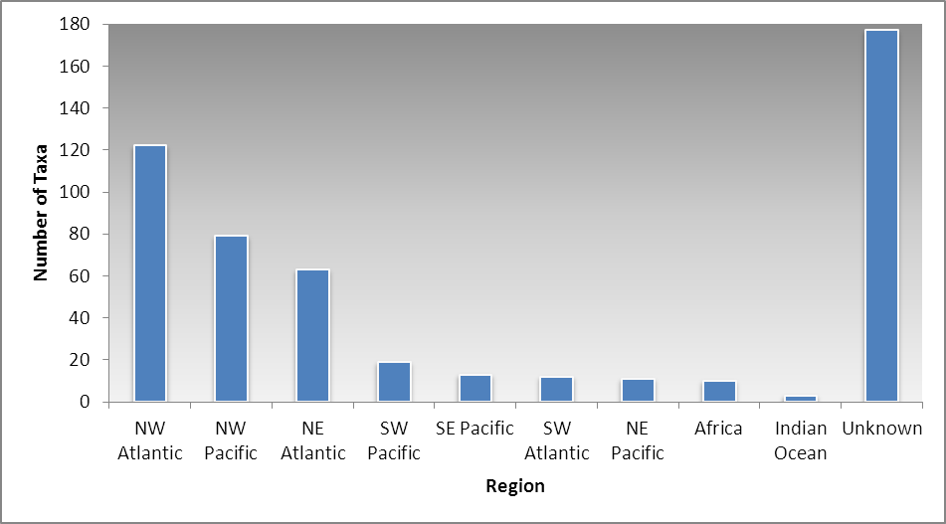
Figure 11. Native regions of California introduced species.

5.3 Rate of Introduction

The previous MISP Report to the Legislature (DFG 2008) included a discussion of non-native organism introduction history and explained the difficulties in quantifying the rate of introductions into California waters in absence of pre-anthropogenic baseline biotic inventories and subsequent monitoring at frequent intervals. It was also reported that the use of non-native organism discovery years as proxies for actual time of introduction cannot be interpreted as a reliable measure of the actual introduction rate. Moreover, given the 3 to 5-year intervals between surveys conducted thus far under the MISP, the sampling frequency is not conducive to showing introduction rate trends during the brief period since the adoption of ballast water regulations in California.

Despite the challenges in looking at short-term trends in NAS introduction rates, a long-term view shows an unmistakable trend. The SERC vector analysis shows that the rate of discovery of NAS in California (and Western North America) has substantially increased over time. Almost 40% of the total species have been reported in the last 25 years (Figure 12).
Figure 12. The number of newly reported NAS by 25-year intervals for (a) California and (b) western North America. (Ruiz et al. 2011).

Even with precautions to reduce or eliminate potential sources of new introductions, it is inevitable that new taxa will continue to be discovered (Costello and Solow 2003). Assuredly, new species will be introduced to California by a variety of vectors. Furthermore, new detection methods, such as the study described in Section 3.1 and changes to the monitoring program outlined in the following section of this report, may not only discover new organisms, but add species by revealing identities and origins of organisms currently classified as cryptogenic, unresolved, or unresolved complex.

6.0 FUTURE DIRECTION

6.1 The Role of Genetic Studies and DNA Sequencing in Species Identification

As recommended in DFG’s 2008 MISP legislative report, the program aims to increase the use of genetic analysis in identification of sampled specimens. Multiple benefits of genetic methods have been demonstrated in preliminary results of our current pilot study in San Francisco Bay, including detection of cryptic species, whole-community analysis, and quality control of morphological taxonomy. Appendix A of this report explains the rationale for incorporation of molecular taxonomy into NAS monitoring in greater detail.

The presence of cryptic species has caused considerable uncertainty about the number of NAS present in California and has hindered quantitative estimates of total NAS within geographic units. Also, taxonomic uncertainty or mistakes undermine the effort to detect real patterns of introduction and spread of NAS. Preliminary results demonstrate that genetic analysis has been able to correct identification errors, including (a) simple misidentification, (b) cryptic species (within even common and widespread “species”) that neither technicians nor experts could resolve, and (c) presence of immature or damaged individuals that lack key characters. Past DFG surveys indicate that about 30% of specimens could not be identified to species due to (b and c); the magnitude of (a) remains unknown.

NAS monitoring involves collection of thousands of specimens and traditional means of species identification is costly. But, genetic analyses are becoming increasingly efficient and cost-effective. New sequencing technology makes it feasible to process a large volume of DNA for taxonomic verification, which could not be accomplished previously for budgetary reasons. These methods can be used for community DNA analysis, such as unsorted plankton samples, further decreasing the need for labor-intensive morphological taxonomy. Analysis of invasive species in plankton can serve as a cost-efficient proxy for benthic sampling. A key to this whole-community analysis is development of a DNA barcode library for NAS. In future monitoring, molecular vouchers will be collected for each NAS to build the DNA barcode library.

6.2 Changes to Sample Design

Previous DFG surveys were designed to inventory NAS populations over a broad geographic range. However, the previous surveys were not designed to statistically measure spatial, temporal, and taxonomic differences in NAS diversity. The sample design of future monitoring will be improved by including stratified random sampling and increased replication, with the aim of explicitly measuring and statistically testing for temporal, spatial (geographic and habitat), taxonomic, and vector differences in NAS diversity (species richness). Such changes will be made possible by the speed and cost-effectiveness of genetic methods, which will enable expansion of temporal and spatial coverage and increase the number of replicates. This statistically robust sampling approach will enable us to test key questions about NAS in California and understand invasion dynamics in California.

As discussed in DFG’s 2008 MISP legislative report, past studies have detected very few NAS along exposed outer coasts, outside of bays, estuaries, and harbors (Wasson et al. 2005, Ruiz et al. 2009). Although previous surveys have detected NAS on the outer coast of California, all co-occur in bays and estuaries and were found at transition zones in close proximity to the mouths of bays and estuaries, suggesting some “spillover” from estuaries that may not be self-sustaining. Future monitoring will focus sampling on bays or estuaries and on outer coast areas near the mouth of estuaries, to test for spillover and also examine the rate of decline in NAS diversity (species richness) with distance from the estuary.

LITERATURE CITED

Ausubel, F.M., R.B. Brent, R.E. Kingston, D.D. Moore, J.G., Seldman, J.A. Smith, and K. Struhl (eds). 2002. Short Protocols in Molecular Biology: A Compendium of Methods from Current Protocols in Molecular Biology, Fifth Edition. Volume 1, Chapter 7, DNA Sequencing (N.B. – except for the introductory section, chapter subsections each have a separate set of contributors).

Barnes, D.K. 2002. Invasions by marine life on plastic debris. Nature 416:808–809.

Briski, E., M.E. Cristescu, S.A. Bailey, and J.J. McIsaac. 2010. Use of DNA barcoding to detect invertebrate invasive species from diapausing eggs. Biological Invasions [published online 09 November 2010]

Brookes, M. 1998. Get a Grip on Genetics. London, U.K.: Ivy Press/Time-Life Books. 192 pp.

California Department of Fish and Game (DFG). 2002. Report to the Legislature: A survey of introduced aquatic species in the coastal and estuarine waters of California. California Department of Fish and Game, Office of Spill Prevention and Response. Dec 2002.

California Department of Fish and Game (DFG). 2008. Report to the Legislature: Introduced aquatic species in the marine and estuarine waters of California. California Department of Fish and Game, Office of Spill Prevention and Response. Dec. 2008.

California State Lands Commission. 2011. 2011 Biennial Report on the California Marine Invasive Species Program. Produced for the California State Legislature. California State Lands Commission: Marine Facilities Division. January 2011.

Carlton, J.T. 1979. History, Biogeography, and Ecology of Introduced Marine and Estuarine Invertebrates of the Pacific Coast of North America. Ph.D. Dissertation, University of California, Davis, 904 pp.

Carlton, J.T. 1996. Biological invasions and cryptogenic species. Ecology 77: 1653-1655.

Carlton, J.T. 2001. Introduced species in U.S. coastal waters: environmental impacts and management priorities. Pew Oceans Commission, Arlington, Virginia, USA. <www.pewoceans.org>

Carlton, J.T. 2009. Deep invasion ecology and the assembly of communities in historical time. Pages 13-56 in: G. Rilov and J. Crooks (eds), Biological Invasions in Marine Ecosystems: Ecological, Management, and Geographic Perspectives. Berlin: Springer-Verlag.

Cohen, A.N. and J.T. Carlton. 1995. Nonindigenous aquatic species in a United States estuary: A case study of the biological invasions of the San Francisco Bay and Delta. U.S. Fish and Wildlife Service, Washington DC.

Cohen, A.N., L.H. Harris, B.L. Bingham, J.T. Carlton, J.W. Chapman, C.C. Lambert, G. Lambert, J.C. Ljubenkov, S.N. Murray, L.C. Rao, K. Reardon, and E. Schwindt. 2005. Rapid assessment survey for exotic organisms in southern California bays and harbors, and abundance in port and non-port areas. Biological Invasions 7:995-1002.

Costello, C.J. and A.R. Solow. 2003. On the pattern of discovery of introduced species. Proceedings of the National Academy of Sciences 100(6):3321-3323.

Darling, J.A., and M.J. Blum. 2007. DNA-based methods for monitoring invasive species: a review and prospectus. Biol. Invasions 9 (7): 751-765.

Flagella M.M., Verlaque M., Soria A. and Buia M.C. 2007. Macroalgal survival in ballast water tanks. Marine Pollution Bulletin 54:1395-1401.

Foss, S.F., P.R. Ode, M. Sowby, and M. Ashe. 2007. Non-indigenous Aquatic Organisms in the Coastal Waters of California. California Fish and Game 93(3):111-1129.

Geller, J.B. 2007. Molecular Identification. Pages 32-36 in: J.T. Carlton (ed). The Light and Smith Manual, Fourth Edition. Berkeley, CA: University of California Press.

Geller, J.B. 2010. Diversity and geographic origins of sponges in the genus Halichondria in California. Final Report. Prepared for California Department of Fish and Game, Sacramento, CA. March 2010, 24 pp.

Geller, J.B., J.A. Darling, and J.T. Carlton. 2010. Genetic perspectives on marine biological invasions. Annu. Rev. Mar. Sci. 2:401-427.

Grosholz, E. 2002. Ecological and evolutionary consequences of coastal invasions. Trends in Ecology and Evolution 17(1) 22-27.

Hay, C.H. 1990. The dispersal of sporophytes of Undaria pinnatifida by shipping in New Zealand, and implications for further dispersal of Undaria in France. Brit. Phycol. J. 25:301–313.

Hajibabaei, M., G.A.C. Singer, E.L. Clare, and P.D.N. Hebert. 2007. Design and applicability of DNA arrays and DNA barcodes in biodiversity monitoring. BMC Biology 2007, 5:24. http://www.biomedcentral.com/1741-7007/5/24.

Hebert, P.D.N., A. Cywinska, S.L. Ball, and J.R. deWaard. 2003. Biological identifications through DNA barcodes. Proc. R. Soc. Lond. Ser. B. 270:313-321.

Holloway, M. 2006. Democratizing taxonomy. Conservation in Practice. 7 (2):14-21.

Ivanova, N.V., J.R. deWaard, M. Hajibabaei, and P.D.N. Hebert. (n.d.). Protocols for High-Volume DNA Analysis. Draft Submission to the DNA Working Group, Consortium for the Barcode of Life. [downloaded 6 December 2010 from Smithsonian Institution, Consortium for the Barcode of Life website, www://barcoding.si.edu/DNABarCoding.htm]

Kae, H. 2009. Genome projects: uncovering the blueprints of biology. The Science Creative Quarterly 2009 (4):1-10. [downloaded 16 December 2010 from www://scq.ubc.ca; (article dated August 2003)]

King, M.W. 2010. DNA Sequencing. [downloaded 16 December 2010 from http://themedicalbiochemistrypage.org/molecular-medicine.htm]

Maloney, E., Fairey, R., Lyman, A., Walton, Z., Sigala, M. 2008. Introduced Aquatic Species in California’s Bays and Harbors - 2006. Final Report. Prepared for California Department of Fish and Game, Sacramento, CA. February 2008, 116 pp.

Margulies, M., M. Egholm, and 54 other authors. 2005. Genome sequencing in microfabricated high-density picolitre reactors. Nature 437:376-380.

National Exotic Marine and Estuarine Species Information System (NEMESIS).
3 Aug 2006. May 2008. <http://invasions.si.edu/nemesis/CH-IMP.jsp?Species_name=Eriocheir+sinensis>.

National Introduced Marine Pest Information System. 2008. (Eds: C.L. Hewitt, R.B. Martin, C. Sliwa, F.R. McEnnulty, N.E Murphy, T. Jones & S. Cooper). Web publication <http://crimp.marine.csiro.au/nimpis>, Date of access: 11/15/2008

Nyberg, C. and Wallentinus, I. 2005. Can species traits be used to predict marine macroalgal introductions? Biological Invasions 7:265-279.

Perkel, J.M. 2009. Sanger who? Sequencing the next generation. Science 324 (5924): 275-279 [downloaded 26 January 2011 from www.sciencemag.org/products DOI:10.1126/science.324.5924.275]

Pimentel, D. 2003. Economic and Ecological Costs Associated with Aquatic Invasive Species. Cornell University. Proceedings of the Aquatic Invaders of the Delaware Estuary Symposium, Malvern, Pennsylvania. 3-5 pp.

Pimentel, D., R. Zuniga, and D. Morrison. 2004. Update on the environmental and economic costs associated with alien-invasive species in the United States. David Pimentel, Rodolfo Zuniga and Doug Morrison. College of Agriculture and Life Sciences, Cornell University, Ithaca, NY 14850-0901. Ecological Economics 52(3):273-288.

Ratnasingham, S., and P.D.N. Hebert. 2007. BOLD: The Barcode of Life Data System (www.barcodinglife.org). Molecular Ecology Notes 7:355-364. [downloaded from 11 February 2011 from www.barcodinglife.org DOI: 10.1111/j.1471-8286.2006.01678.x]

Ruiz, G.M., P.W. Fofonoff, B. Steves, S.F. Foss, and S.N. Shiba. 2011. Marine invasion history and vector analysis of California: a hotspot for western North America. Diversity and Distributions 17:362-373.

Ruiz, G.M., A.L. Freestone, P.W. Fofonoff, and C. Simkanin. 2009. Chapter 23. Habitat distribution and heterogeneity in marine invasion dynamics: The importance of hard substrate and artificial structure. Pages 321-332 in: M. Wahl (ed), Marine Hard Bottom Communities. Ecological Studies 206. Berlin: Springer-Verlag.

Smit, S., J. Widmann, and R. Knight. 2007. Evolutionary rates vary among rRNA structural elements. Nucleic Acids Res. 35 (10):3339-3354.

Stoeckle, M., P.E. Waggoner, and J.H. Ausubel. 2005. Barcoding life, illustrated: Goals, rationale, results. V.3, January 26, 2005. [downloaded 26 January 2011 from Smithsonian Institution, Consortium for the Barcode of Life website, www://barcoding.si.edu/DNABarCoding.htm]

Tudge, C. 2000. The Variety of Life: A Survey and a Celebration of All the Creatures that Ever Lived. Oxford, U.K.: Oxford University Press. 684 pp.

Wake, D. 2004. A tree grows in Manhattan. Pages 543-544 in: Cracraft, J., and M.J. Donohue (eds). Assembling the Tree of Life. Oxford, U.K.: Oxford University Press.

Wasson, K., K. Fenn, and J.S. Pearse. 2005. Habitat Differences in Marine Invasions of Central California. Biological Invasions 7:935-948.

Watling, L., & Carlton J. T. (2007). Caprellidae. The Light and Smith Manual. Intertidal Invertebrates from Central California to Oregon. 618-629. Berkeley: University of California Press.

Wheeler, Q.D. 2004. Taxonomic triage and the poverty of phylogeny. Phil. Trans. R. Soc. Lond. Ser. B. 359:571-583.

Wilson, E. O. 2004. The meaning of biodiversity and the Tree of Life. Pages 539-542 in: Cracraft, J., and M.J. Donohue (eds). Assembling the Tree of Life. Oxford, U.K.: Oxford University Press.

Appendix A
A Rationale for Incorporating Molecular-Based Taxonomy in California’s Non-Native Marine and Estuarine Species Detection and Monitoring Program

Background

Most surveys intended to detect and monitor non-native marine and estuarine organisms have thus far depended upon traditional, morphologically-based methods to identify organisms. Samples must be analyzed by experienced taxonomists to assure accurate identifications. This process is time-consuming and can also be expensive to implement because of the sheer diversity of organisms present in each sample. Various limitations of traditional approaches are presented in Hebert, et al. (2003), Holloway (2006), Darling and Blum (2007), Geller (2007), and Briski et al. (2010). In many cases, the identity of organisms cannot be resolved through classical taxonomy alone. For instance, specimens may often be damaged during collection, and body parts bearing key morphologic features may be lost. Moreover, identifications may be unreliable for cryptic organisms and taxa that have phenotypically plastic (highly variable) characters (Stoeckle et al. 2005, Geller 2007, Geller et al. 2010, Briski et al. 2010). Worst of all, a significant proportion of the world’s extant species remain undiscovered or undescribed, even at the purely “alpha taxonomy” level (Wheeler 2004, Wilson 2004). While morphological diagnosis will always play a prominent role in taxonomy, genetic analysis is gaining increasingly wide acceptance as a useful reference tool and a source of supporting evidence (Hebert et al. 2003, Holloway 2006, Geller 2007).

The Basis of Molecular Identification

Deoxyribonucleic acid (DNA) is the physical carrier of genetic information and is present in all living cells. The arrangement of nucleotide bases in DNA controls the composition and production of proteins that form the basic building blocks of life. Similar DNA sequences are shared among members of a biological species through interbreeding. Some loci contain enough information to discriminate between taxonomic groups, including species (Brookes 1998, Tudge 2000). For most animals, including metazoan invertebrates, the 648 base-pair region at the 5’ (leading) end of the mitochondrial cytochrome c oxidase subunit I (COI or cox1) gene is widely used as the target locus for interspecific differentiation (Hebert et al. 2003, Geller 2007, Hajibabaei et al. 2007). Interspecific variation in COI is generally much greater than that measured intraspecifically. This difference makes it possible to identify an unknown specimen by comparing its sequence to that of a known species, as long as a sufficient reference database exists. The phylogenetic signal of COI is weak for sponges and anthozoan Cnidarians, but other genetic markers (e.g., subunits of ribosomal RNA) are known to contain species-specific sequences (Geller 2007, Smit et al. 2007). No single diagnostic locus has yet been identified for all plants, but several researchers are currently working toward that goal (Stoeckle et al. 2005, Holloway 2006).

In theory, a microgenomic approach is ideal because a single method can be applied uniformly across a broad range of taxonomic groups and life stages. Furthermore, the ease of implementation would allow a standardized genetic laboratory to make accurate identifications so that overburdened taxonomic specialists can devote more time to monographic and theoretical systematics (Wilson 2004, Hebert et al. 2003, Stoeckle et al. 2005, Holloway 2006, Geller 2007). Organizations such as GenBank and the Consortium for the Barcode of Life have recognized the value of including a comprehensive reference set of known-origin barcodes in their informatic databases (Stoeckle et al. 2005, Ratnasingham and Hebert 2007). Although some useful barcodes may be found in such databases, their main function is to support molecular classification rather than molecular identification. Moreover, area-specific exhaustive barcode datasets are yet incomplete (Wake 2004, Geller 2007). It is therefore becoming increasingly important to collect genetic information along with morphological vouchers, and it would not be difficult to do so in tandem with regularly scheduled surveys.

Developing a Sequence Reference Library

Sequences for molecular voucher specimens are usually analyzed by the Sanger (i.e., conventional) method. Preparations for this process include extraction of the total DNA from fresh or properly preserved tissue, then isolation and amplification of the target locus via polymerase chain reaction (PCR) using appropriate primers. The PCR product must also be verified and cleaned prior to sequencing. The PCR products are subsequently forwarded to a commercial or academic core laboratory sequencing service provider, usually in 96-well plates. Much of the preparatory work can be automated and pre-packaged reagent kits can be used to save time and maintain consistency. Further details about sample preparation may be found in Ivanova et al. (n.d.), Darling & Blum (2007), and Geller (2007).

The Sanger method (also known as the dideoxynucleotide, chain-termination, or dye-terminator method) reconstructs the original sample DNA’s sequence from fragments created from the PCR products. Thus one further enzymatic synthesis reaction is required before the plates can be analyzed in a sequencer. The Sanger reaction proceeds in a manner similar to PCR, except that instead of full copies of the target locus, fragments of various sizes are created. The chain-terminating nucleotides (ddNTPs) are incorporated randomly among the millions of DNA copies (PCR products), thus assuring that every nucleotide position in the target locus is represented by the terminal ends of the fragment set (Kae, 2009; King 2010).

Although the standard sequencer plate contains 96 wells, the number of samples that can be analyzed simultaneously may vary by make and model of the apparatus. Within each well, the DNA fragments are size-sorted by high-resolution capillary electrophoresis. Each fragment is then optically scanned and recorded on camera. The terminal nucleotide on each fragment is identified by measuring the intensity of the fluorescent signal emitted when a laser beam hits the dye. The resultant data is displayed as an electropherogram, a graphical representation of the nucleotide sequence. A typical sequencing run takes about an hour. Each sequencing template is analyzed in both forward and reverse directions to ensure consistently clear nucleotide detection throughout the target locus. The resultant pair of sequences is called a “contig” (Ivanova et al. [n.d.], Ausubel et al. 2002, Darling and Blum 2007, Geller 2007, Kae 2009, Briski et al. 2010, King, 2010. J. Geller pers. comm.). Data from the sequencer can be downloaded onto personal computers, where sequences can be assembled, aligned, sorted, edited, analyzed, and stored using specialized bioinformatics software. Internet browsers or specialized software also permit acquisition of barcodes from existing databases such as GenBank and Barcode of Life Database (BOLD), to augment the reference library.

Even the most trusted databases may contain some erroneous records, however. Such errors may be unintentionally put into currency when the sequence is taken from a cryptic species that is morphologically indistinguishable from the most common species of a species complex. The cryptic species would likely have a novel sequence that differs from that of the common species. Therefore, genetic records from all databases should be used with caution. Novel sequences should always be confirmed by thorough taxonomic scrutiny, and associated with a correct Linnaean binomial before being uses as a standard for identification.

Upon the assembly of a sufficiently robust barcode library, non-native organism detection programs can be taken to a new level of efficiency using a “next-generation” sequencing platform described below.

Using Sequences to Detect Organisms from Whole-Community Samples

“Next generation” sequencing (NGS) refers to new technologies capable of analyzing millions of individual DNA sequences during a single run. On the NGS platform, the sequencing reactions are said to be massively parallel because they take place simultaneously within millions of physical microscopic compartments (wells). Given its large capacity, the NGS array is ideally suited for exhaustive analysis of multiple, unsorted, whole-community samples (such as artificial settling plates, hard-substrate clearings, and plankton tows – each of which may be composed of a mixture of species) in one batch. As in conventional sequencing, whole-community DNA must be extracted from the sample, but a special molecular tag is added to each piece of recovered DNA in order to identify the sample from whence it came. Platforms from different manufacturers use similar methods and chemistry, though differ in particular proprietary steps. A common feature is that single molecules are sequenced after capture on a bead or other substrate. The bound molecule is then clonally amplified in an individual PCR reaction compartment (e.g., within an oil micelle, by a process called emulsion PCR).

Upon completion of clonal amplification, the plate, chip, or glass support containing the millions of substrate-bound molecules is placed the NGS instrument. The sequencing proceeds through synthesis, one nucleotide at a time, as pure solutions of the four nucleotide species are flowed over the compartments in cycles. One such process is called pyrosequencing because during the synthesis reaction, light is emitted each time a nucleotide is incorporated onto the template strand. Other systems may monitor released hydrogen ions. Each well is monitored by a sensor (light or pH, for example) which transmits signals to a computer that tracks the information and translates them into sequences (Margulies et al. 2005, Perkel, 2009). A typical NGS run takes 10 to 12 hours (J. Geller pers. comm.), though the newest models reduce this time to 2 to 3 hours.

As in conventional sequencing, NGS-derived barcodes are also analyzed using specialized bioinformatics software. The analysis includes searching for reference barcodes matching those detected from whole-community samples. This process is known as “querying the barcode database.” The query may be set to a given similarity threshold (~95%, depending on the genetic locus chosen) to account for minor within-species variations, such as natural mutations. This threshold must be chosen carefully, as an overly high threshold (e.g., ~99%), may result in false diversity due to sequencing error.

At minimum, the query would provide a rapid and accurate means of identifying organisms in whole-community samples. Optimal application of the NGS and DNA barcode approach is therefore dependent upon the acquisition of a sufficiently large sequence reference library that includes organisms likely to be present at sampled locations and habitats. Any sequence that does not match any of the known sequences in the database could potentially be a new, non-native species or a genetic variant of a species previously observed. In addition, exhaustive sequencing can be used to test the completeness and consistency of the traditional (morphological) approach by revealing species that may have gone undetected by manual sorting.

At present, one NGS instrument run capable of producing >400 base pairs per sequence costs about $10,000. On first glance, this may seem a significant sum, but is less expensive (and faster) than traditional sorting. For example, ten tagged whole-community samples could be included in one run to produce about 100,000 sequences each. A hundred whole-community samples could be analyzed in ten instrument runs for about $100,000. By contrast, the average cost of traditional sorting and taxonomy alone is about $2,000 per sample, or $200,000 per 100 samples. Moreover, it may take two or more years to complete 100 samples by traditional methods, and taxonomic uncertainties and misidentifications may not be fully addressed. Finally, a declining pool of expertise and inflation are expected to increase taxonomic costs over time.

Conversely, sequencing costs are decreasing as the technology becomes more mainstreamed in biomedicine. Current NGS costs are approximately half the rate charged two years ago. Capacity, accuracy, throughput time, and affordability are expected to improve with each new model of NGS system. For example, a newly-released massively parallel instrument reads sequences by detecting hydrogen ions and sells for 1/10 the cost of the pyrosequencing instrument in current use. Yet another manufacturer is testing a new technology that enables single-molecule sequencing without clonal amplification, which can further increase throughput and lower costs. Given these rapid advances, justification for molecular-based taxonomy continues to gain ground over traditional methods. The molecular approach will allow sampling at the finer spatial and temporal scales needed to successfully detect new non-native organisms or spread of existing populations.

Appendix B
Table: Counts of non-native species sampled per station in San Francisco Bay in 2010.

Source: California Aquatic Non-native Organism Database (CANOD), updated on May 2, 2011.

A clade is a group of biological taxa composed of a common “ancestral” species and its descendants, usually represented graphically as branches radiating from a single, basal limb.
Cryptic species are closely related and virtually identical in external appearance, but likely to be genetically distinct because they do not normally interbreed or because they are geographically separated. Interbreeding may occur when cryptic species are artificially brought into sympatry, creating a threat to the genetic integrity of native species. Cryptic species are indistinguishable even to the trained eye.
The four types of nucleotides (bases) found in DNA are adenine, thymine, cytosine, and guanine. The nucleotides are usually represented as A, T, C, and G, respectively.
A sequence is the linear order of nucleotides in DNA or ribonucleic acid (RNA). RNA is similar in composition to DNA, except that thymine is replaced by uracil (abbreviated as U). Sequencing is the process of analyzing the nucleotide order, and is performed on a special automated device generally known as a sequencer.
Interbreeding individuals and populations comprise a biological species. In contrast, distinct species do not interbreed because geographic or other barriers exist. Over time, reproductive isolation results in genetic divergence, from accumulation of mutations that are no longer shared.
A locus (singular) is a discrete region in a DNA molecule, such as a gene or portions thereof.
Metazoans are multicellular animals in which the cells are organized into tissues, including nervous tissue. Cnidarians and higher phyla belong to this group.
Mitochondrial genes are preferred over nuclear DNA for phylogenetic discrimination because the latter can be highly variable (Brookes 1998, Hebert et al. 2003, Stoeckle et al. 2005).
The Phylum Porifera is excluded from the Metazoa because the cells are not yet organized into tissue.
Ribosomal RNA (rRNA), one of the direct products of DNA, is found only in the ribosomes (protein-producing organelles) in the cell’s cytoplasm. It is presumed to have existed in the earliest forms of life. Consequently, the cumulative evolutionary history of life itself is likely to be reflected in the rRNA of extant organisms (Smit et al. 2007).
Based on a relatively short, specific section (locus) of DNA.
A loosely-based analogy is made between nucleotide sequences and the optical-scanning system (Universal Product Codes) commonly seen on retail goods (Hebert et al. 2003). The terms “barcode” and “sequence” are hence used interchangeably.
In molecular classification, sequences of two or more organisms are compared to determine whether they belong to the same or different taxonomic group. In contrast, molecular identification involves identifying an organism by matching its sequence to that of a well-described species (Geller 2007).
Named for Frederick Sanger, who developed this method during the 1970s. He won his second Nobel Prize for this achievement.
A standard method of making multiple copies of (amplifying) DNA by serial duplication.
A short DNA chain (oligonucleotide) used to prime or initiate synthesis (incorporation of additional complementary nucleotides) on a template DNA. A primer is designed such that its first 12 to 24 nucleotides are complementary to those of a specific site on the template DNA. The primer must also be of sufficient length so that the nucleotide series is unique enough to correctly recognize the target locus within the total DNA, yet short enough to form a stable bond with the template. By binding to the target site, the primer isolates the target locus by initiating synthesis only from that point, in the presence of DNA polymerase (an enzyme that catalyzes DNA replication reaction).
In addition to the standard ingredients required for PCR, low concentrations of di-deoxynucleotide triphosphates (ddNTPs, specifically ddATP, ddTTP, ddCTP, and ddGTP) are added to each well. Furthermore, each of the four ddNTP species is tagged with a different fluorescent dye to tell them apart. The ddNTPs have a hydroxyl (-OH) group on its 3’ end, whereas dNTPs have a hydrogen atom (-H) in the same position. Synthesis ceases whenever a ddNTP is incorporated onto the template, because the hydroxyl group blocks attachment of additional nucleotides.
Currently, sequencers can analyze as many as 384 samples at a time, but 96 is the more typical number. Some sequencer models may process samples in groups of 8, 16, or 48 wells at a time until the entire plate is completed, whereas others may process the full plate in one run (Ivanova et al. [n.d.]; Ausubel et al. 2002, J. Geller, pers. comm.).
The process of determining the terminal nucleotide species from the scanned signal is known as “base-calling.”
Upon addition of a nucleotide, a pyrophosphate molecule is released, converts to ATP, and triggers the luciferin-luciferase reaction. The chemicals involved in this reaction are added along with the polymerase solution flowed into wells on the pyrosequencer plate.
Similarity is calculated by making base-by-base comparisons among sequences and counting the number of like bases. It is expressed as a percentage of the total number of bases in the templates. To facilitate the cross-comparisons, the sequences must first be aligned and if necessary, edited for possible artifacts (errors).
Note: The figure of 100,000 sequences likely exceeds that required to detect rare species in a typical sample, and is thus used here for illustration purposes only. The optimal sequencing depth must be established by prior research.

