**Installing ICS and Highway Shield Symbology into ArcMap**

(Windows 10, ArcMap 10.x)

Installing the ICS style file and California highway shields style file also require special fonts to be installed for the symbology to be displayed properly in ArcMap. The following procedure shows you how to install the style files and font files on Windows 10. All the files can be found on the network here:

T:\OSPR_Data\Ospr_Tools\GIS\symbology\OSPR_ICS_Symbology\ICS_and_Highway_Shield_Symbology_2018

**Installing Font Files**

There are 19 font files that need to be copied from the T:\ drive to your system’s font folder. The system font folder can be easily opened by typing “fonts” in the search box in the task bar next to the Windows button (bottom left by default). Copy all the fonts from “T:\OSPR_Data\Ospr_Tools\GIS\symbology\OSPR_ICS_Symbology\ICS_and_Highway_Shield_Symbology_2018\Symbol_font_files” into the system font folder. If prompted to replace a duplicate file, click “Yes”.

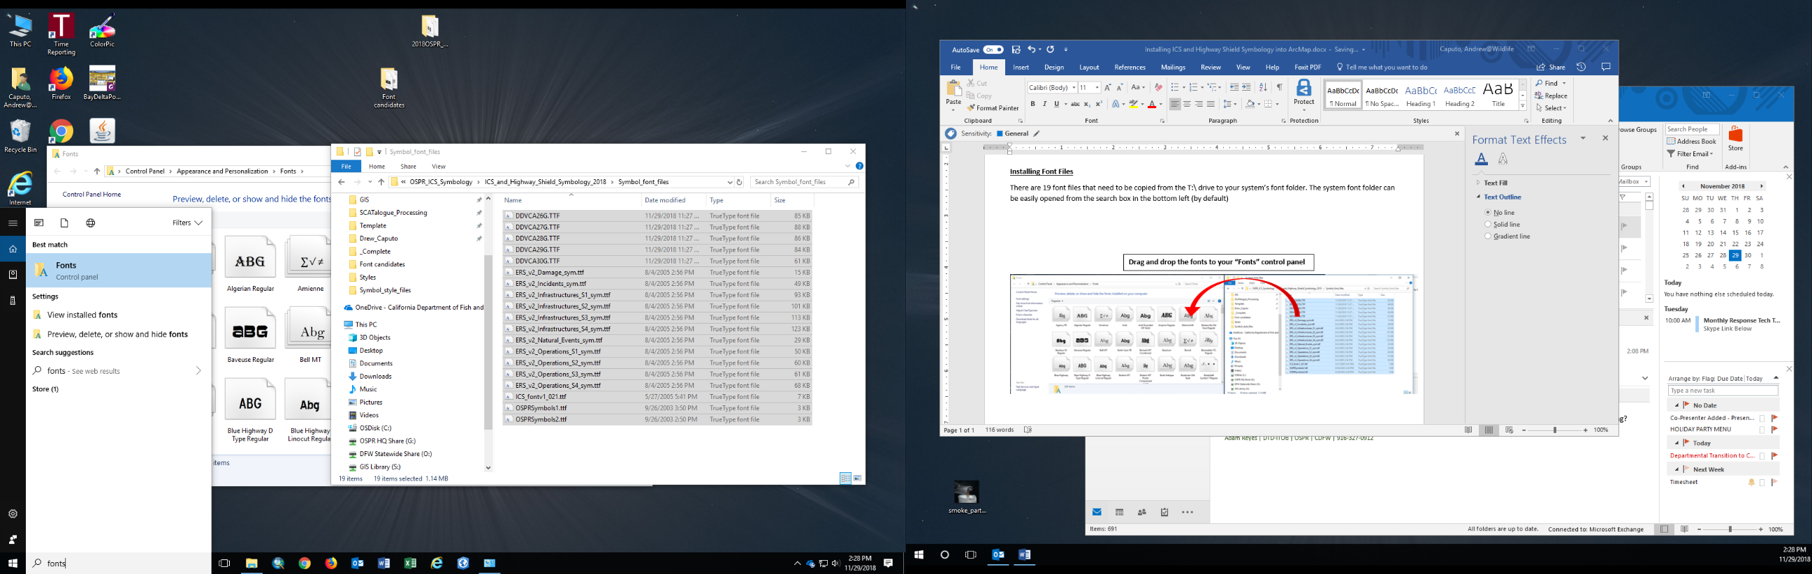

**Copy fonts from T:\ drive location to Fonts folder**

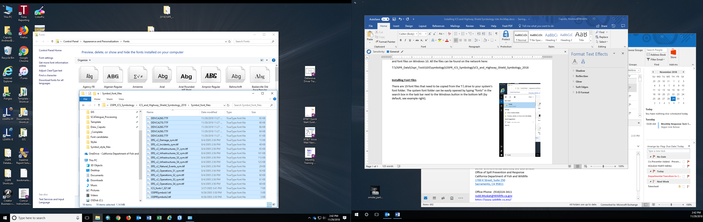

**Installing Style Files**

There are two style files associated with the installed fonts for ICS symbology and for the California highway shields which should be copied from

T:\OSPR_Data\Ospr_Tools\GIS\symbology\OSPR_ICS_Symbology\ICS_and_Highway_Shield_Symbology_2018\Symbol_style_files

into

C:\Program Files (x86)\ArcGIS\Desktop10.6\Styles

Now in ArcMap there should be two new style options that can be toggled on/off from the “Styles References” window. That window can be accessed from “Customize > Style Manager” menu, or from the “Symbol Selector” window. It is recommended to leave the “ddvca27g” style toggled off until needed as there is a large number of shields to scroll through to get to the default “ESRI” symbols you may be used to seeing when in the “Symbol Selector.”

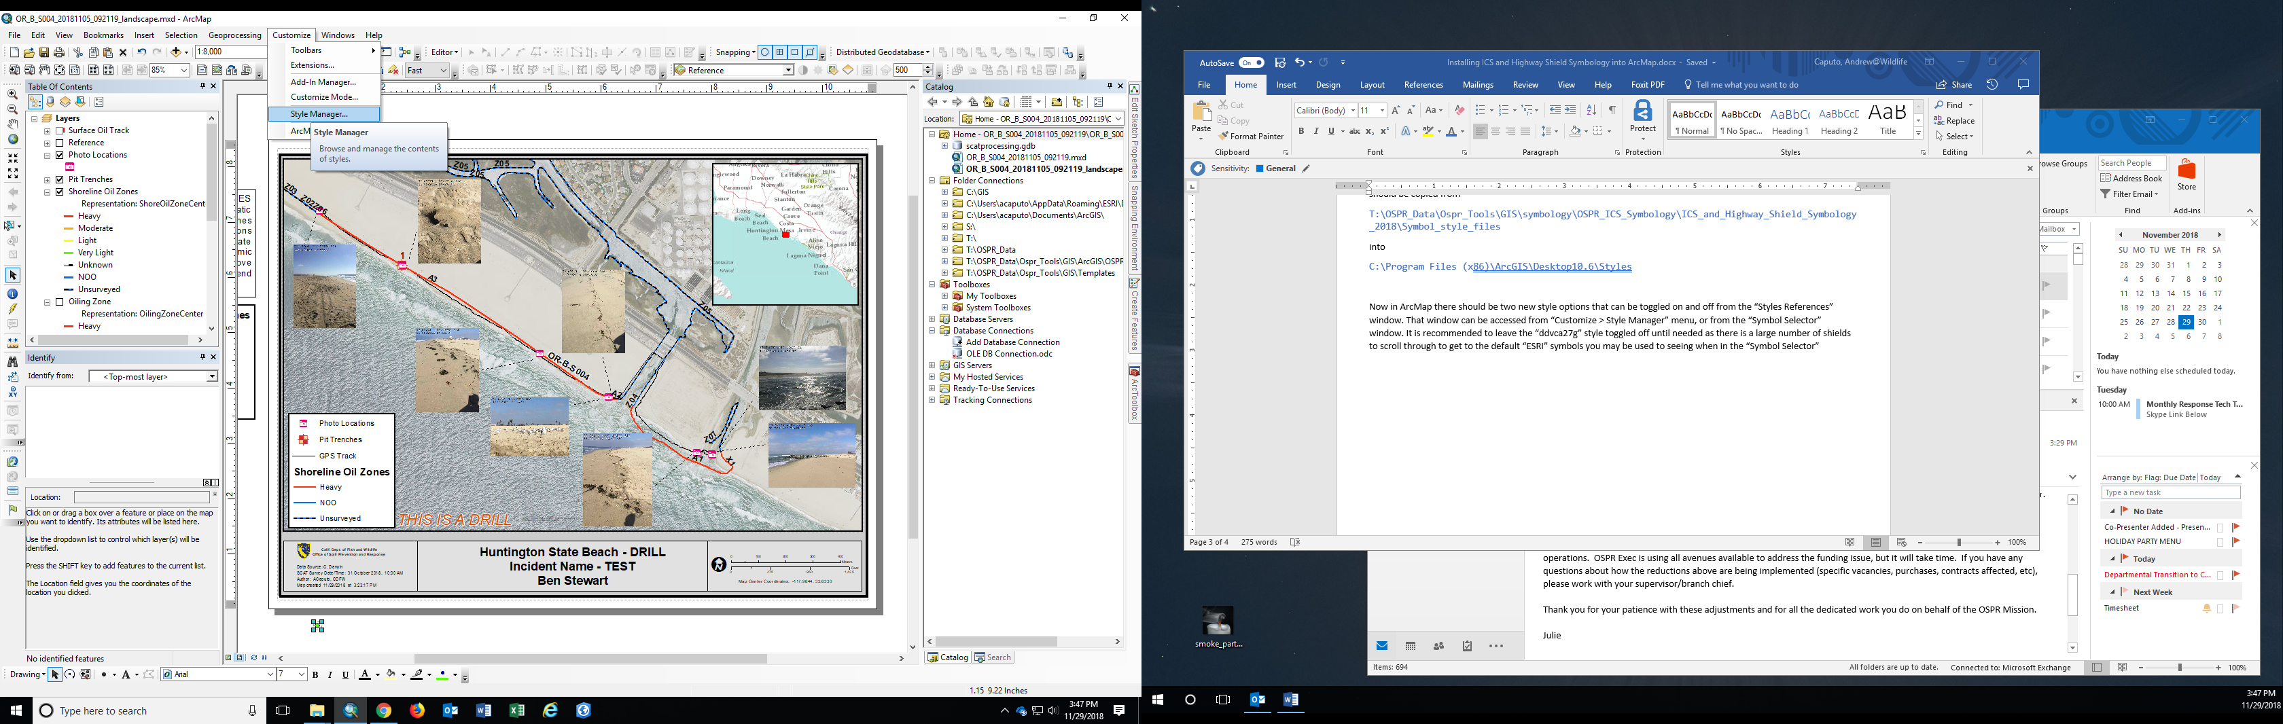

**Styles can be toggled on/off from the Style Manager or from the Symbol Selector**

