XXX River
Geographic Response Plan

Chapter 3 – Response Area Strategies and Detail Sheets
This chapter provides information on GRP response strategies and the order (priority) they should be implemented, based on potential oil spill origin points (POSOPs) and their proximity to sensitive resources. Area maps, sector maps, and information on staging areas and boat launch locations are also provided in this chapter. During a spill incident, GRP response strategies should be implemented as soon as possible. Unless circumstances unique to a particular spill situation dictate otherwise, the priority tables in Section 4.3 should be used to decide the order that GRP strategies are deployed. The downstream movement of oil and the time it takes to mobilize response resources to deploy GRP strategies must always be considered when setting implementation priorities. Information on resources at risk, sensitive areas, and flight restrictions can be found in Chapter 6 of this plan. Information on protection techniques can be found in Appendix A. Information on shoreline countermeasures can be found in Chapter 5.

3.1 Area Overview Maps
The following maps provide a geographic overview of the XXX River GRP area. Sector maps in Section 3.XX of this chapter provide more detail on the location of response strategies, notification strategies, staging areas, boat launch locations, and POSOPs. Detailed information for each location can be found in the matrices of Section 3.XX or in the chapter appendices. Priority tables for potential oil spill origin points can be found in Section 3.X.X.
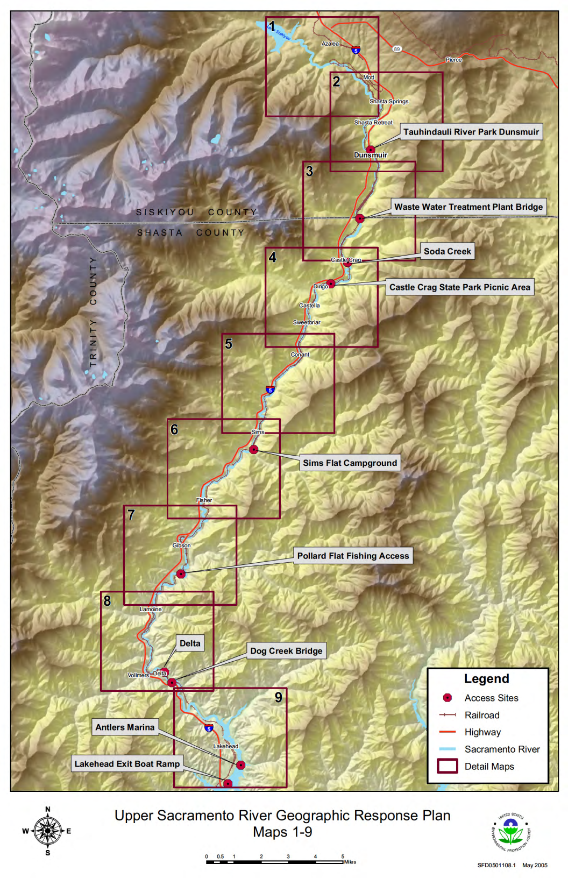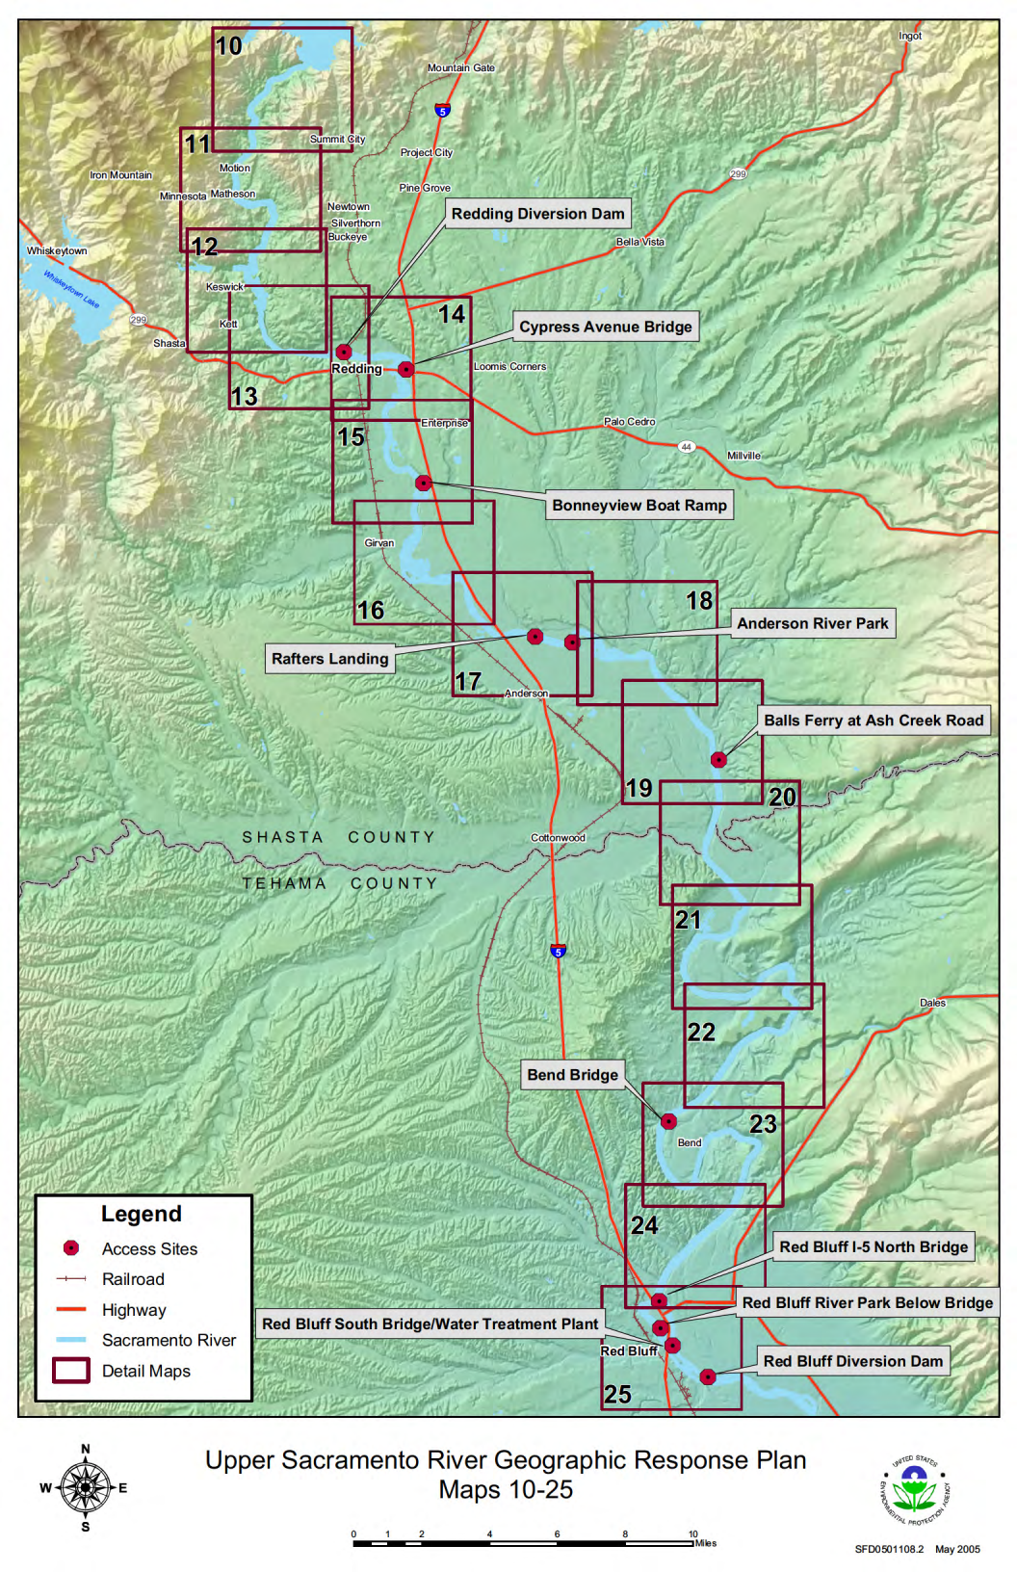

1.3 OPERATIONAL DIVISION AND/OR SEGMENT MAPS
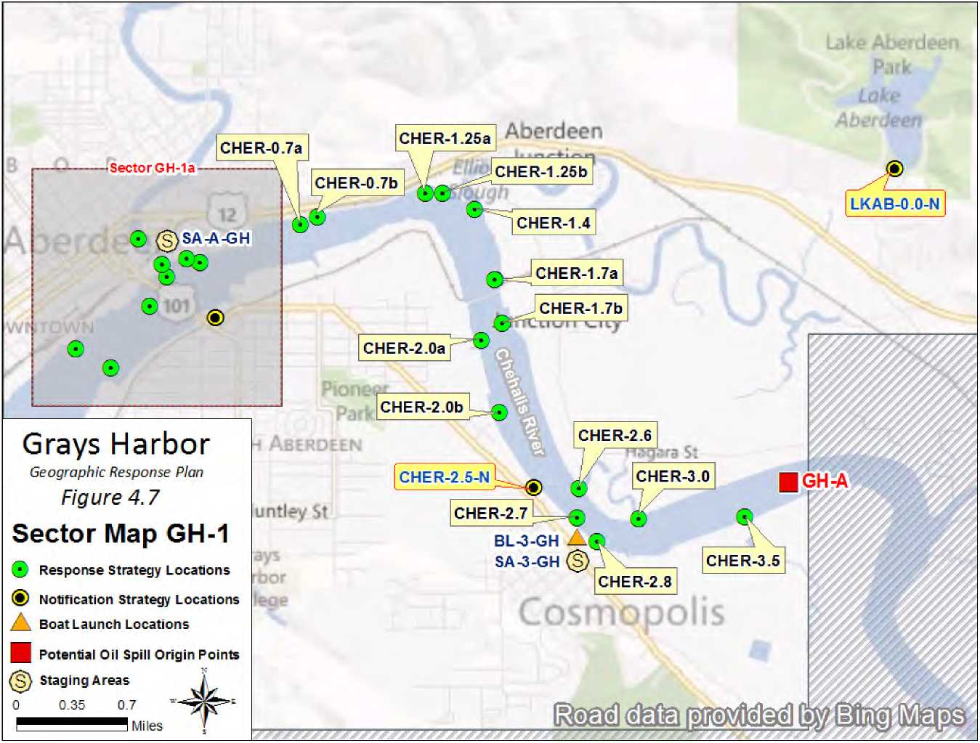
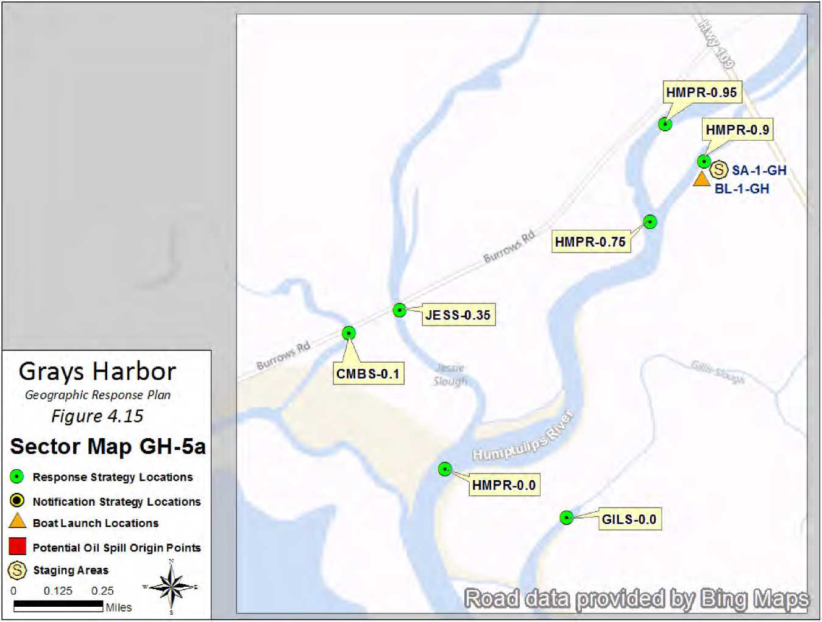

Matrices

Naming Conventions (Short Names)
Each strategy, staging area, and boat launch location in this document has been given a unique “Short Name” which includes one to six letters denoting the associated waterbody. Following the letters are numbers that specify the location. On rivers or other linear waterbodies, the location is named by river mile: the distance from the mouth of the river or creek upstream to the site location. Some short names indicate whether the site is located on river right, river left, or mid-river by an “R”, “L” or “M” after the river mile. On lakes, the numbers indicate the location by shoreline mile, typically starting at the northernmost point and increasing clockwise around the lake. In marine areas, the numbers do not have a geographic meaning. Notification strategies are indicated by an “-N” at the end of the name. Staging Areas and Boat Launches are indicated by the prefix “SA” or “BL”.
BL-CHER-33.5 L
Boat
Launch
Waterbody
River
Mile
Left
Associated river body short name designations used within the Middle Columbia include:
B=Bonneville Pool | SIH=Snake River/Ice Harbor Pool | WWR=Walla Walla River | L = River Left
D=The Dalles Pool | WIND=Wind River | YAK=Yakima River | R = River Right
J=John Day Pool | LDR=Lower Deschutes River | N = Notification Strategy | M = River Middle
M=McNary Pool | JDR=John Day River | SA = Staging Area
MSN=McNary Pool/Snake River | RC=Rock Creek | BL = Boat Launch

Response Strategy Matrices
Strategy  Name |  | Location |  | Strategy  Type |  | Boom Length |  | Boat  Req? |  | Staging Area |  | Resources At Risk |  | Comments |  | Sector  Map  (Page #) |  | Strategy  Details  (Page#)
J-216.5R |  | John Day Dam Fish Ladder NE  45.71938  -120.69634 |  | Exclusion |  | Boom 100ft |  | Yes |  | Onsite  Can stage some equipment on site, additional staging available at  SA-J-216.5R/ Railroad Island Park. |  | Fish Ladder(s) |  | Launch at  BL-J-216.5R/ Railroad Island Boat Launch. Contact John Day Dam control room (541) 298-9712 before accessing the dam |  | 57 |  | 105
J-216.55R |  | John Day Dam Locks  45.71990  -120.69606 |  | Collection |  | Boom 1000ft |  | Yes |  | Onsite  Can stage some equipment onsite with dam access, otherwise use  SA-J-216.5R/ Railroad Island Park |  | Lock and Dam |  | Must pre-notify the John Day Dam control room  (541) 298-9712 for access to the dam |  | 57 |  | 107
J-216.7L |  | John Day South Fish Ladder  45.71159  -120.68855 |  | Exclusion |  | Boom 100ft |  | Yes |  | Onsite  Can stage boom onsite or at boat launch at  BL-JDR-0.2L/  Le Page |  | Fish Ladder(s) |  | Launch boat from Le Page Park  (BL-JDR-0.2L) |  | 57 |  | 109
J-217.1R |  | Entrance to Lake Umatilla  45.72606  -120.69026 |  | Exclusion |  | Boom 100ft |  | Yes |  | Remote  Stage at  SA-J-216.5R/ Railroad Island |  | Public Recreation Site/Area, Salmonid Concentrations and Habitat, Waterfowl and Shorebird Concentrations |  | Launch from  BL-J-216.5R/ Railroad Island |  | 57 |  | 111
J-219.1L |  | John Day River  45.73162  -120.64891 |  | Exclusion |  | Boom 1200ft |  | Yes |  | Remote  Stage at  SA-JDR-0.2L/  Le Page Park |  | Resident Warmwater Fish, Salmonid Concentrations and Habitat, Sensitive Resources Nearby, Shorebird Concentrations, Wintering Waterfowl |  | Launch at  BL-JDR-0.2L/  Le Page Park |  | 57 |  | 113
J-220.7R |  | Towal Road (FBS MP-124.5)  45.75094  -120.62409 |  | Collection |  | Boom 1000ft |  | Yes |  | Onsite  Stage recovery equipment onsite, other equipment at boat launch at Le Page Park  BL-JDR-0.2L |  | Downstream Habitat, Freshwater Wildlife, Sensitive Resources Nearby |  | Launch on the opposite side of the river at  BL-JDR-0.2L/  Le Page |  | 57 |  | 115

Staging Area Matrices
Strategy  Name |  | Location |  | Position |  | Nearest Address |  | Contact |  | Strategies Served |  | Comments |  | Sector  Map  (Page #) |  | Strategy  Details  (Page#)
SA-J-216.5R |  | USACE Railroad Island boat launch |  | 45.72444  -120.69804 |  | John Day Dam Road  Goldendale, WA 98620 |  | USACE John Day pool  Natural Resource Manager  John Day Dam, OR  (541) 506-4805 |  | J-217.1R,  J-216.5R |  | Lighted staging area with 2 concrete boat rams ~ 8 degree grade |  | 57 |  | 265
SA-J-227.4R |  | Pasture Point In-Lieu Site, E of Goodnoe Rd |  | 45.70616  -120.50179 |  | Highway 14  Roosevelt, WA 99356 |  | USACE John Day pool  Natural Resource Manager  (541) 506-4805  Bureau of Indian Affairs  Oversees Tribal In-Lieu Fishing Sites  (503) 231-6702 |  | J-227.4R |  | Pasture Point In-Lieu Site with power, water, parking, lights, and a single, concrete boat launch |  | 58 |  | 267
SA-J-237.3R |  | Sundale Park (In-Lieu Site) |  | 45.71929  -120.31492 |  | Sundale Park Rd  Roosevelt, WA 99356 |  | Columbia River Inter-Tribal Fish Commission  Fishing Treaty In-lieu Site - Law Enforcement  (800) 487-3474  Bureau of Indian Affairs  Oversees Tribal In-Lieu Fishing Sites  (503) 231-6702 |  | J-237.6L,  J-237.6R |  | Staging area and boat launch with one concrete ramp 7 degree grade. This is an in-lieu site which is open to the public (at this time) |  | 58 |  | 269
SA-J-241.7R |  | Roosevelt Park (USACE) boat launch |  | 45.73105  -120.22470 |  | Roosevelt Ferry Rd.  Roosevelt, WA 99356 |  | USACE John Day pool  Natural Resource Manager  John Day Dam, OR  (541) 506-4805 |  | J-242.3R,  J-245.1R,  J-242.7L,  J-244.5R,  J-244.4R |  | Lighted staging area with double boat ramp |  | 59 |  | 271
SA-J-242.5L |  | Arlington Point Marina and Campground |  | 45.72279  -120.20633 |  | Arlington Port Rd  Port of Arlington, OR 97812 |  | Port of Arlington  Arlington Point Marina (boat launch) and Campground  Port of Arlington, OR 97812  (541) 454-2868 |  | J-240.7L |  | Paved staging area, marina, campground and boat launch |  | 59 |  | 273
SA-J-251.2R |  | Pine Creek In-Lieu Treaty Fishing Site |  | 45.79403  -120.06887 |  | Washington 14  Bickleton, WA 99322 |  | Bureau of Indian Affairs  Oversees Tribal In-Lieu Fishing Sites  (503) 231-6702  Columbia River Inter-Tribal Fish Commission  Fishing Treaty In-lieu Site - Law Enforcement  (800) 487-3474 |  | J-251R,  J-253.6L,  J-250.3R |  | Gated, paved, launch and staging area (may need bolt cutters to cut lock) |  | 60 |  | 275

Response Strategy 2-Pagers

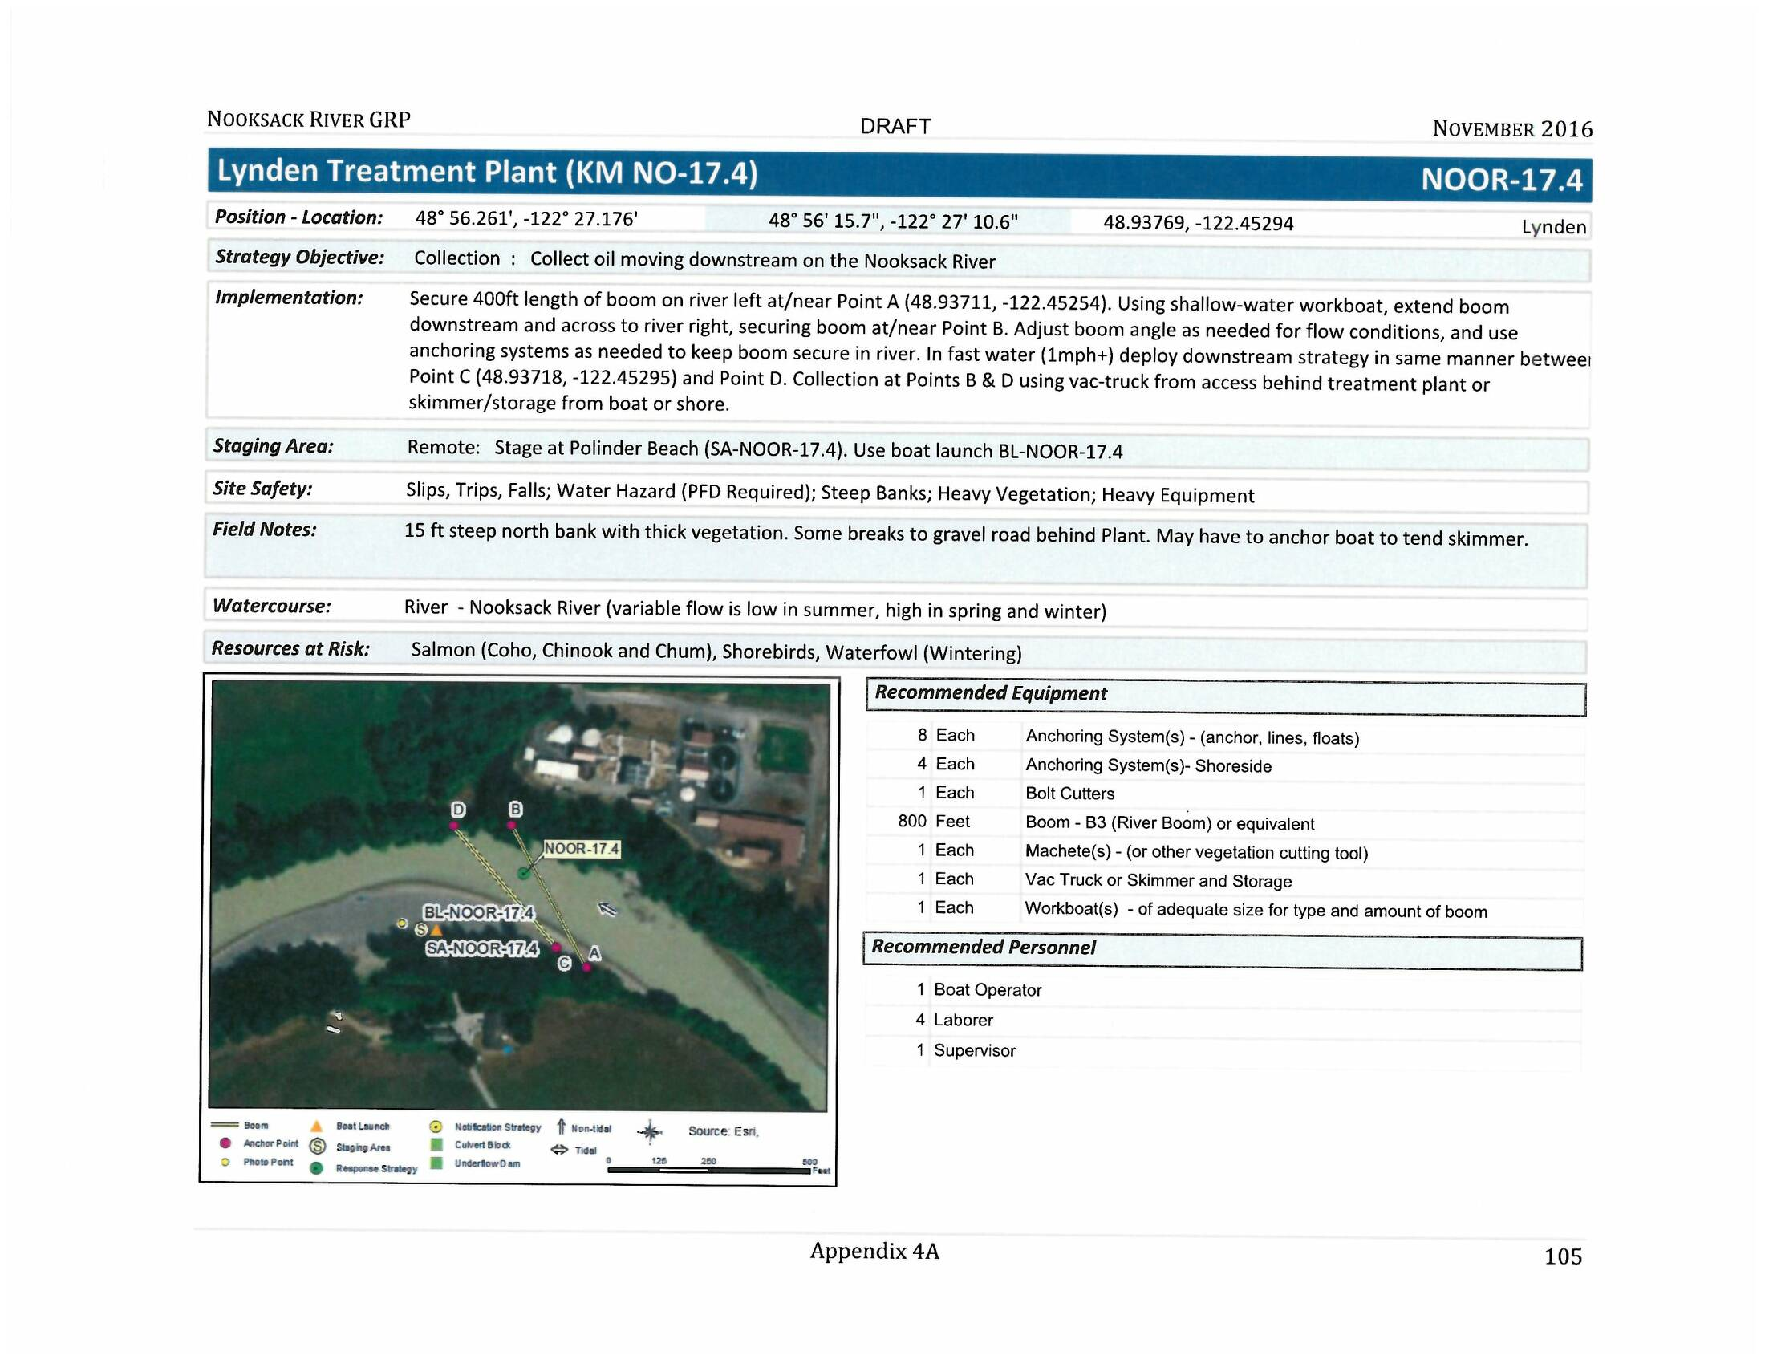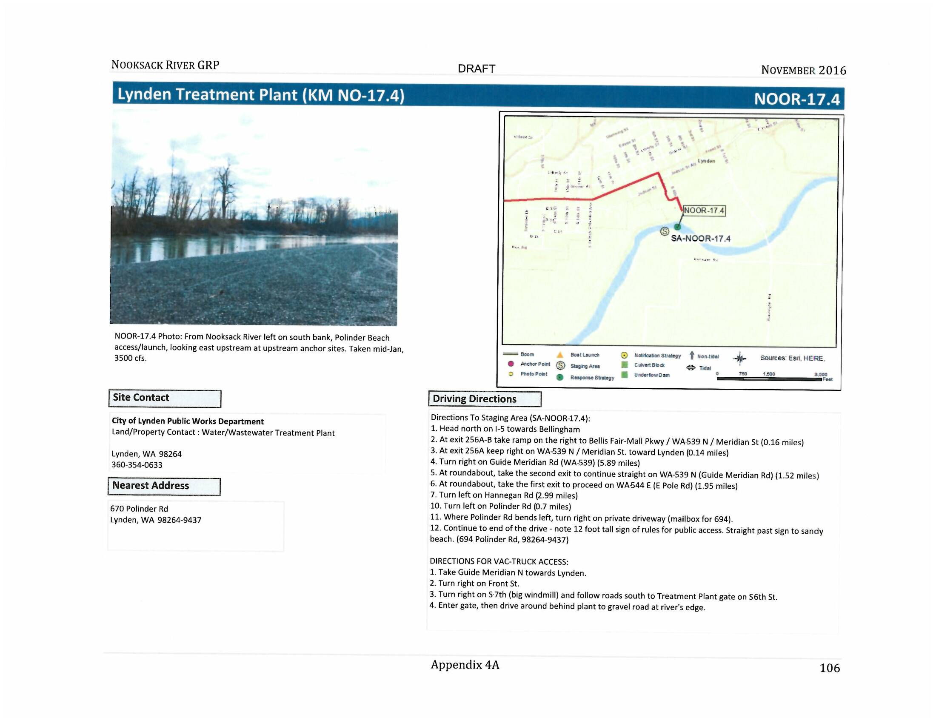
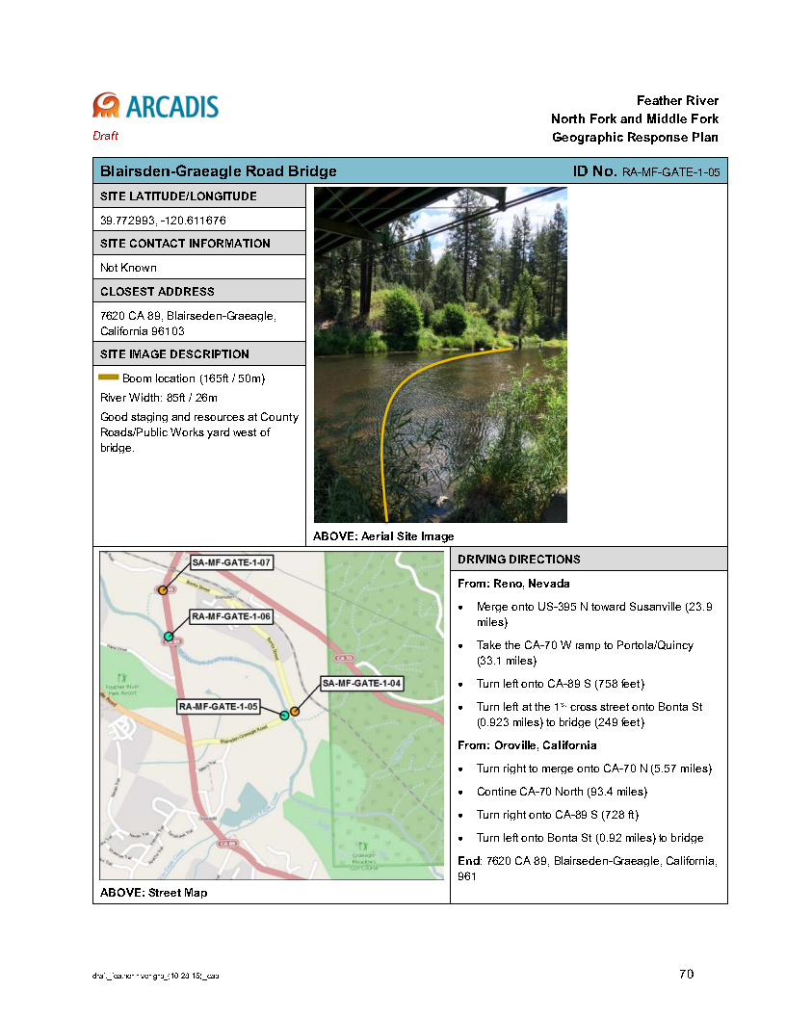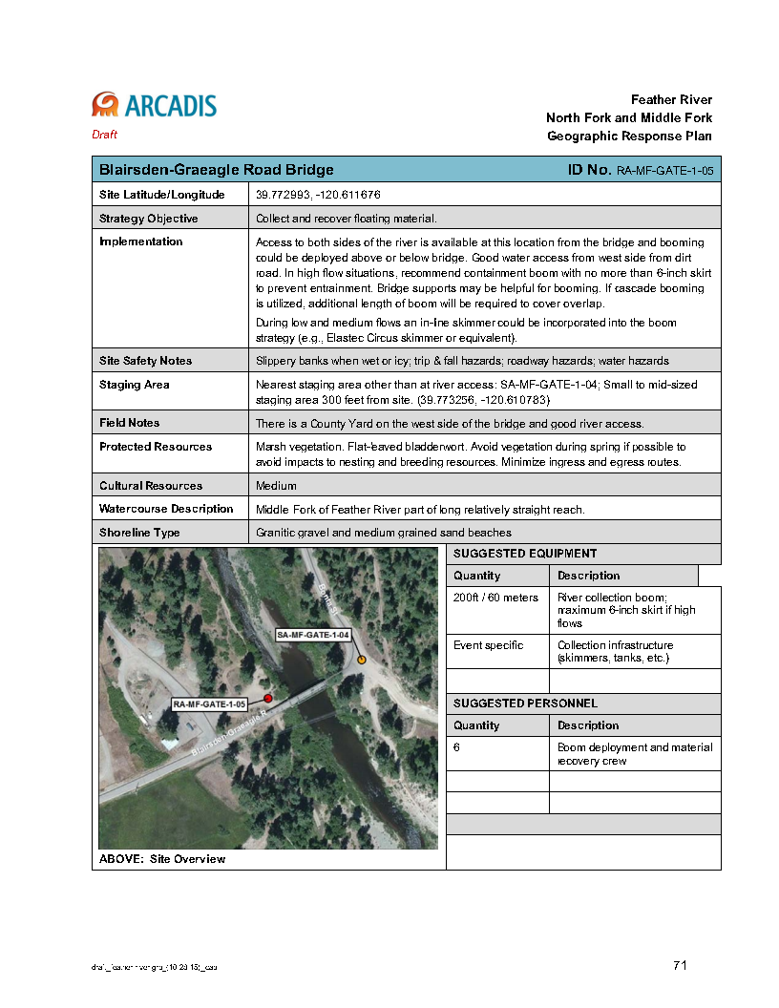
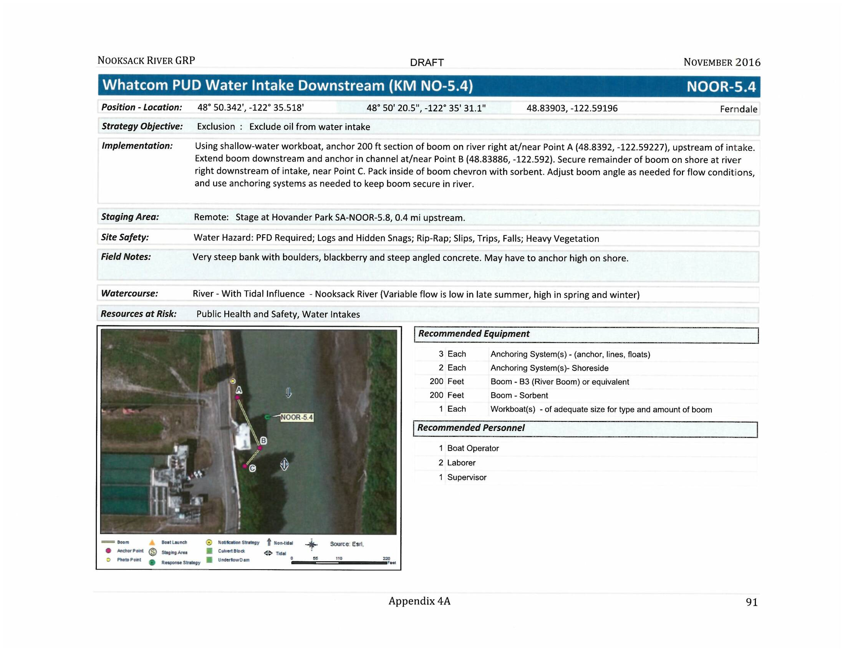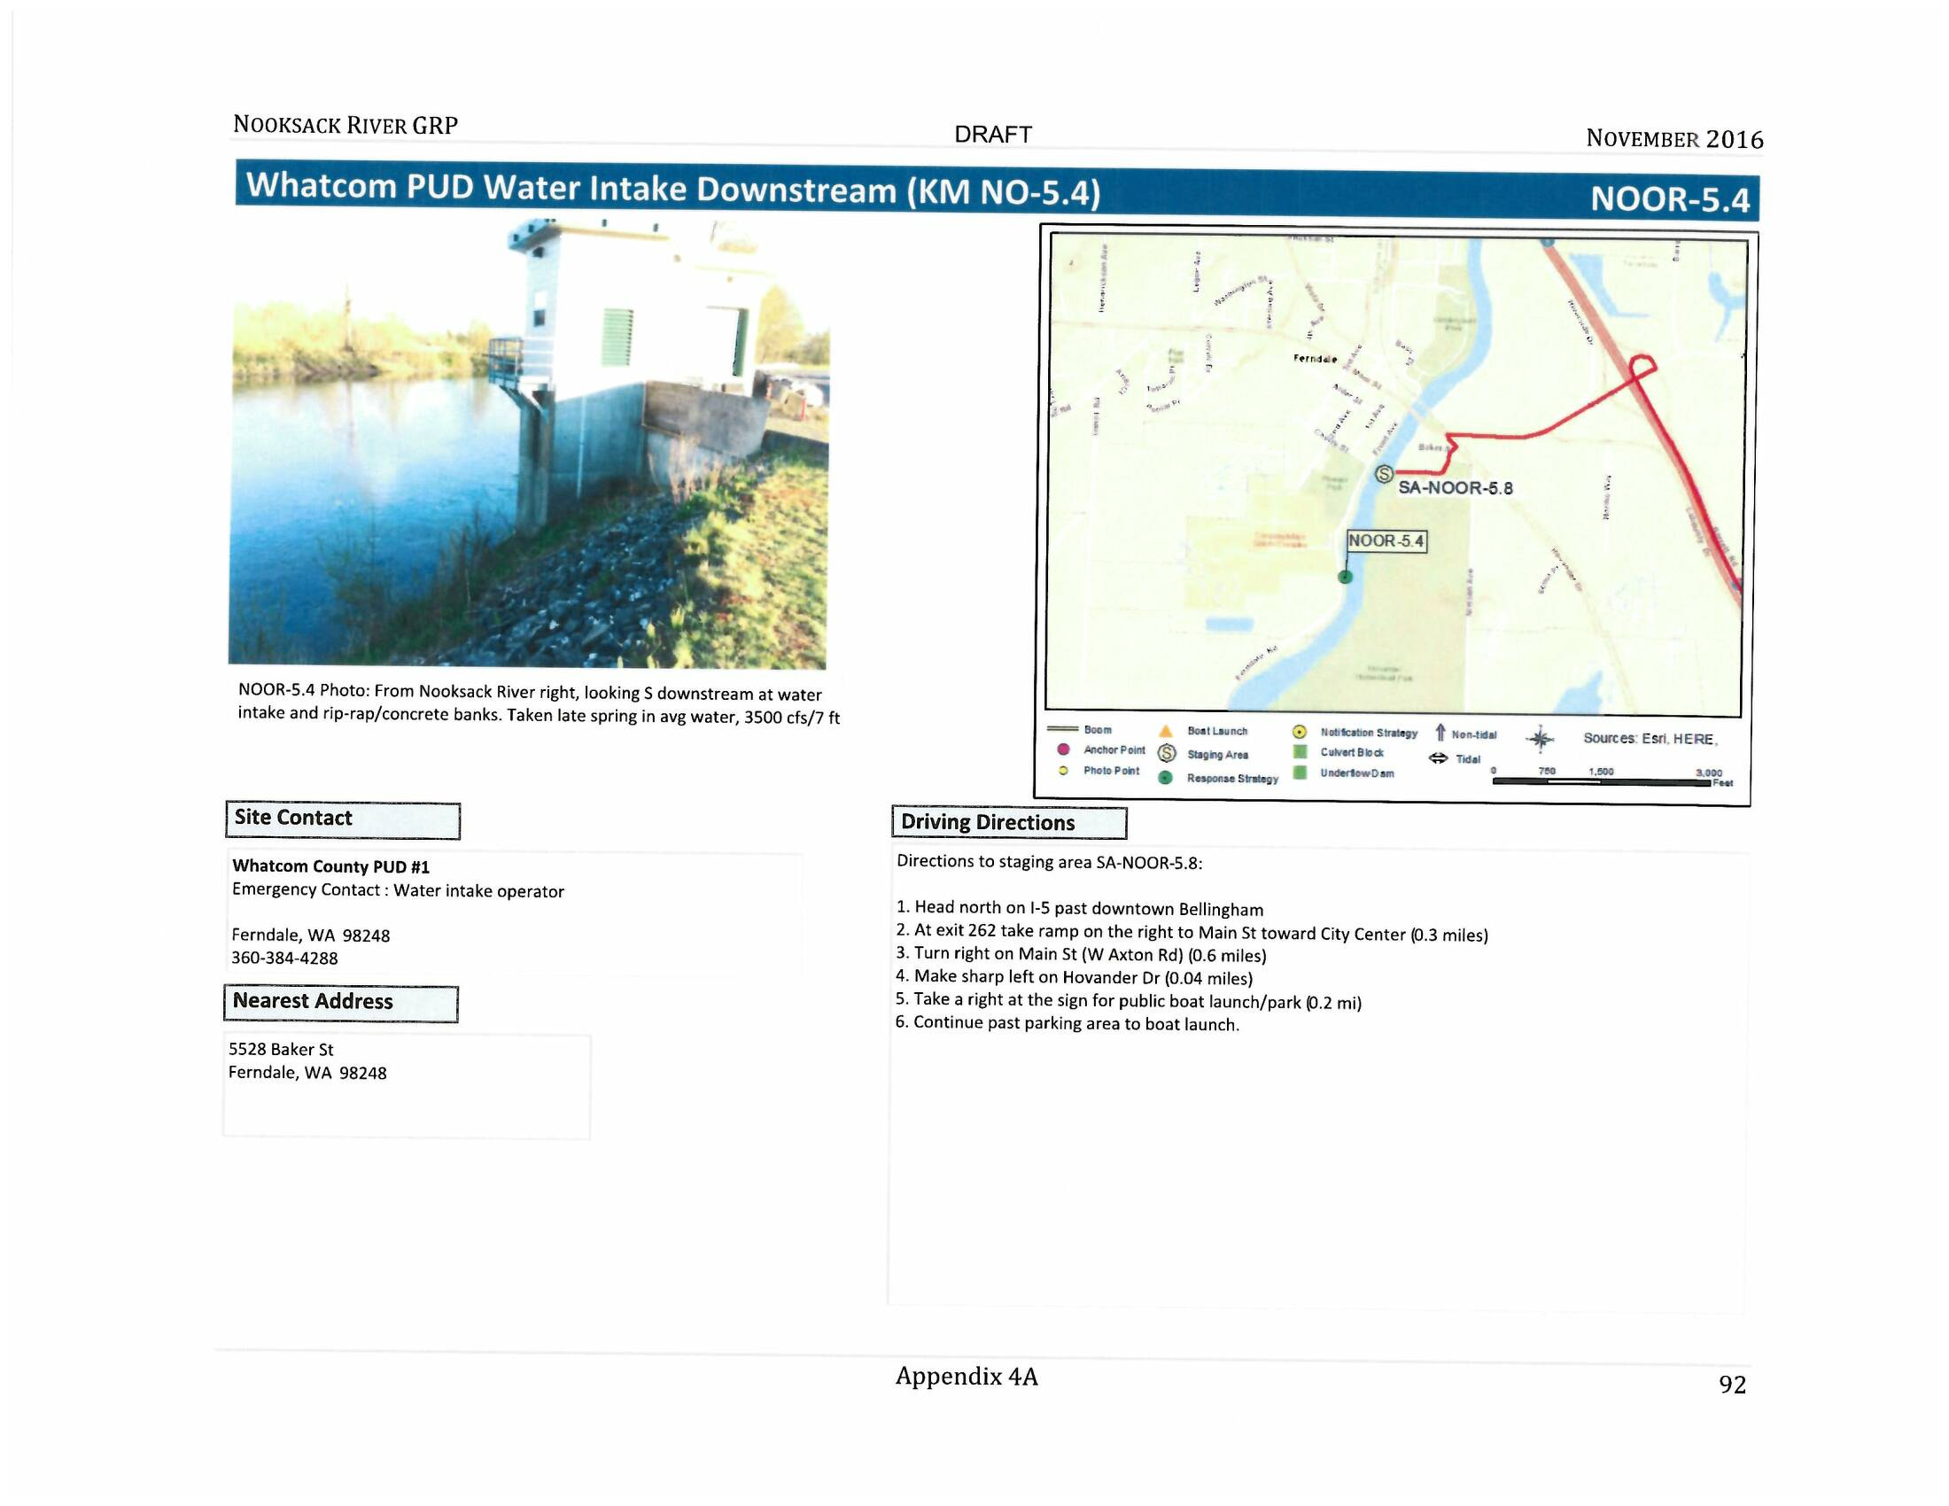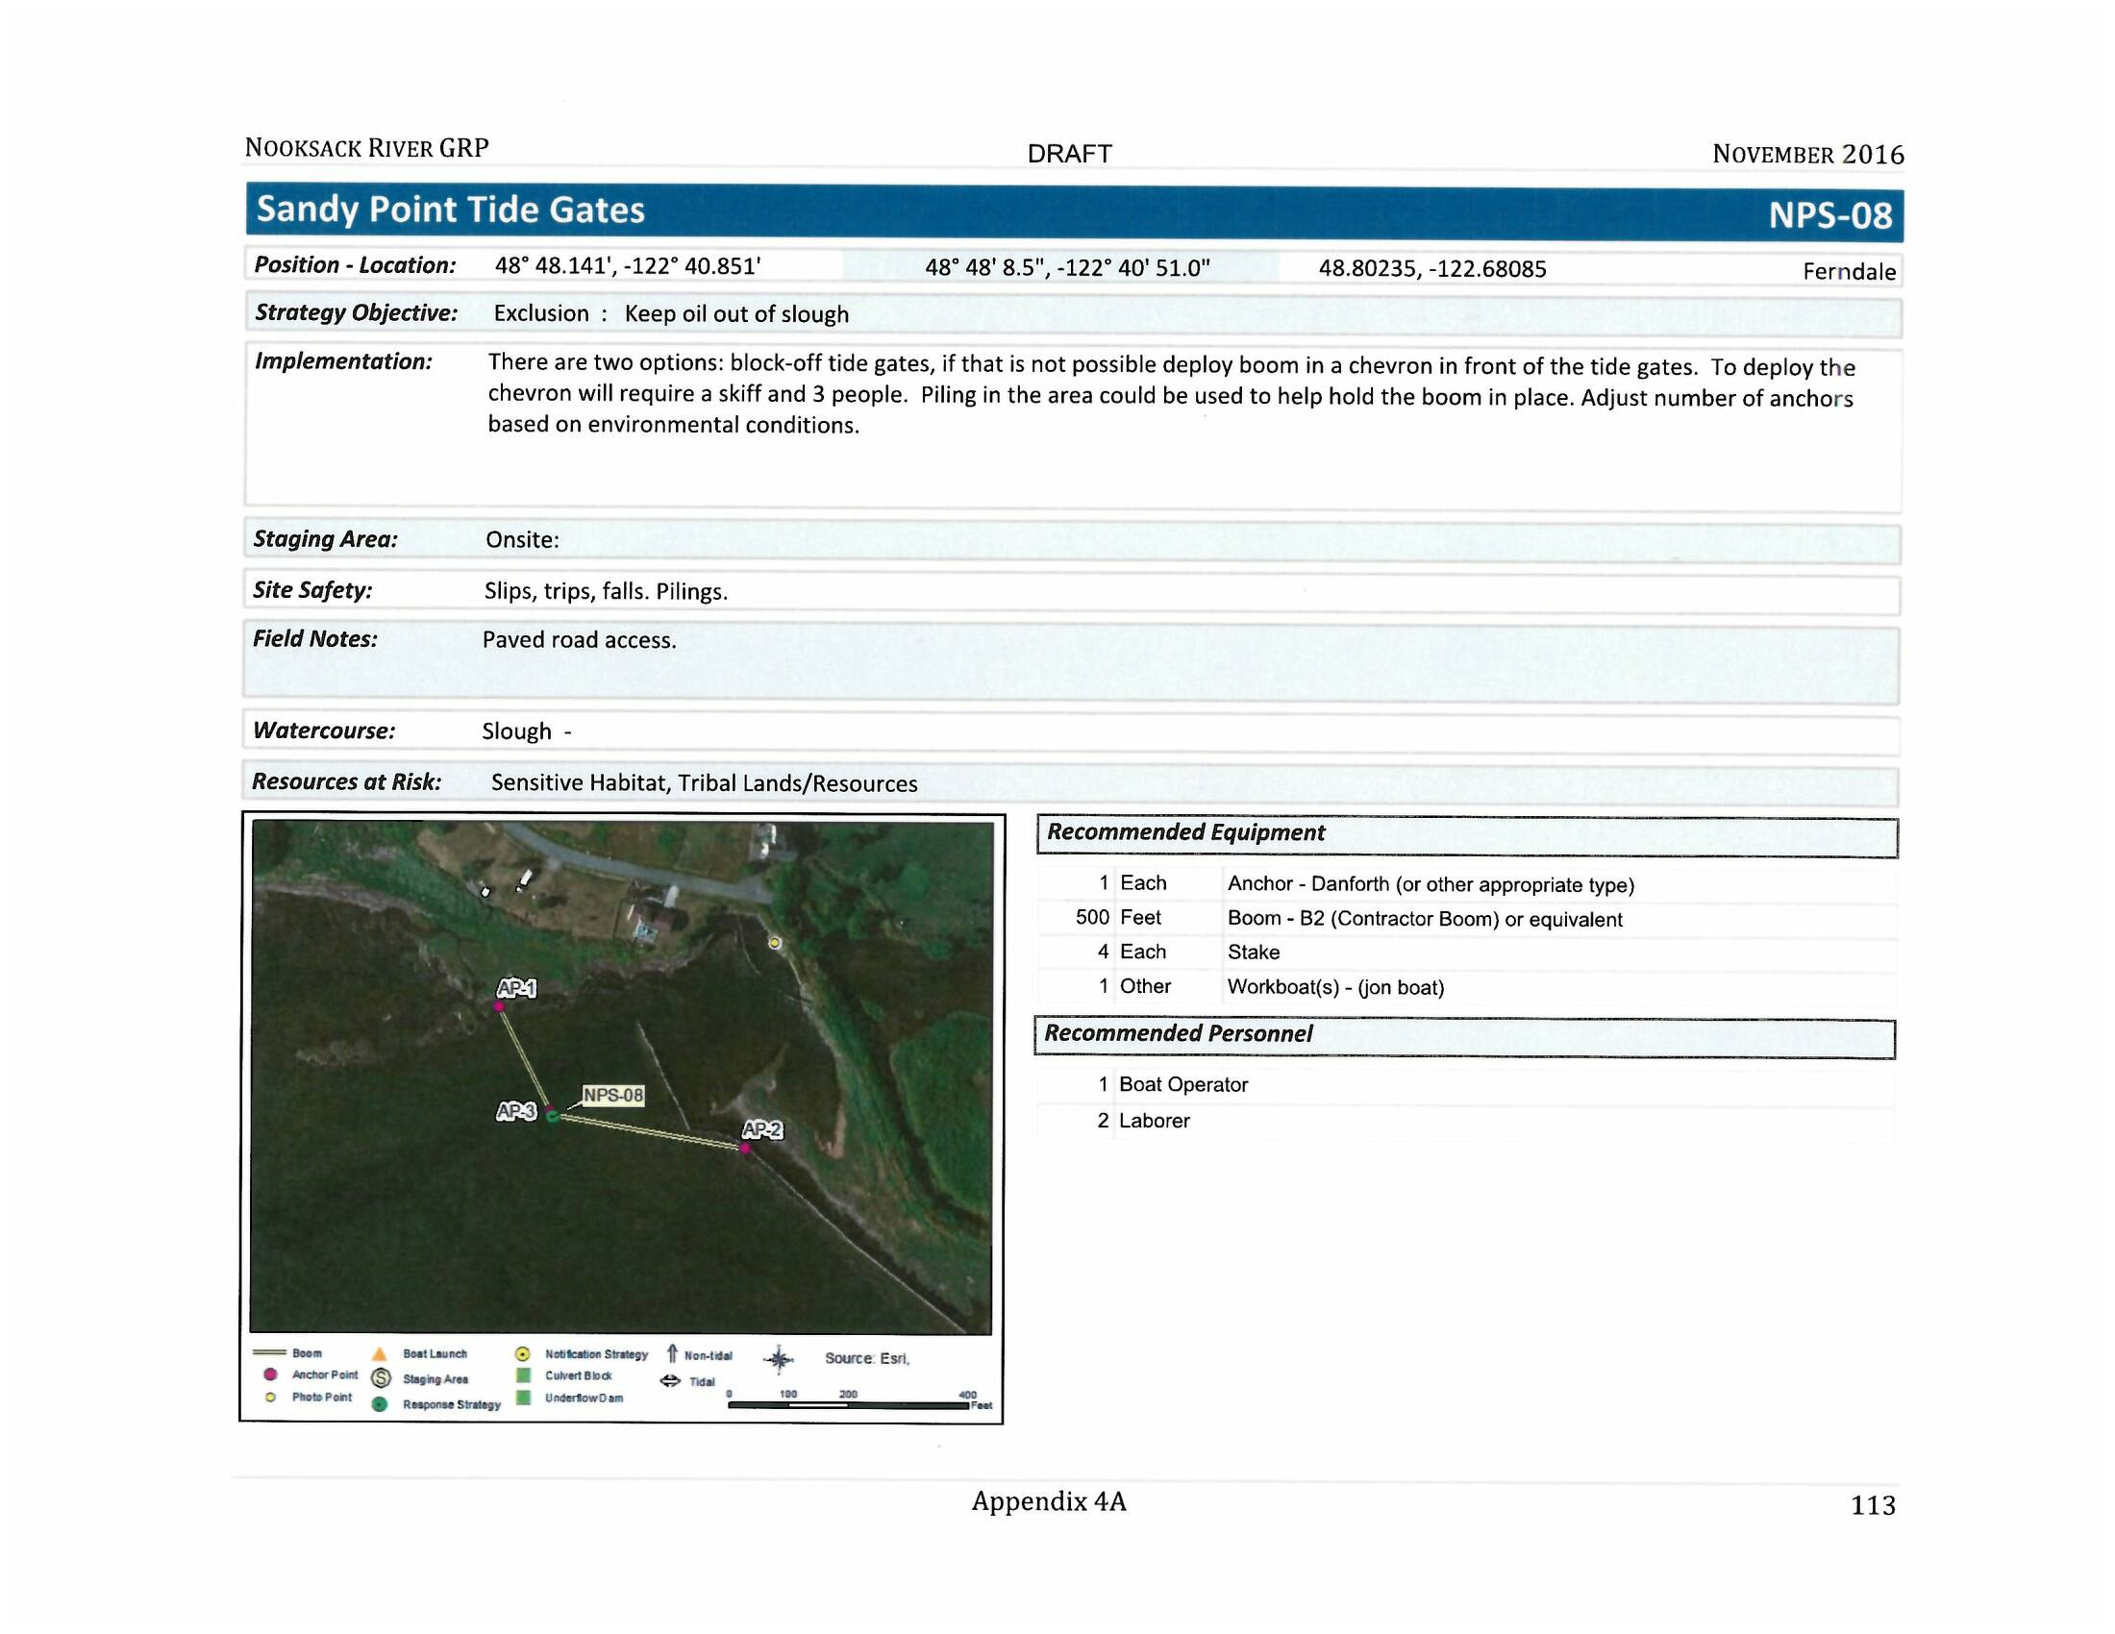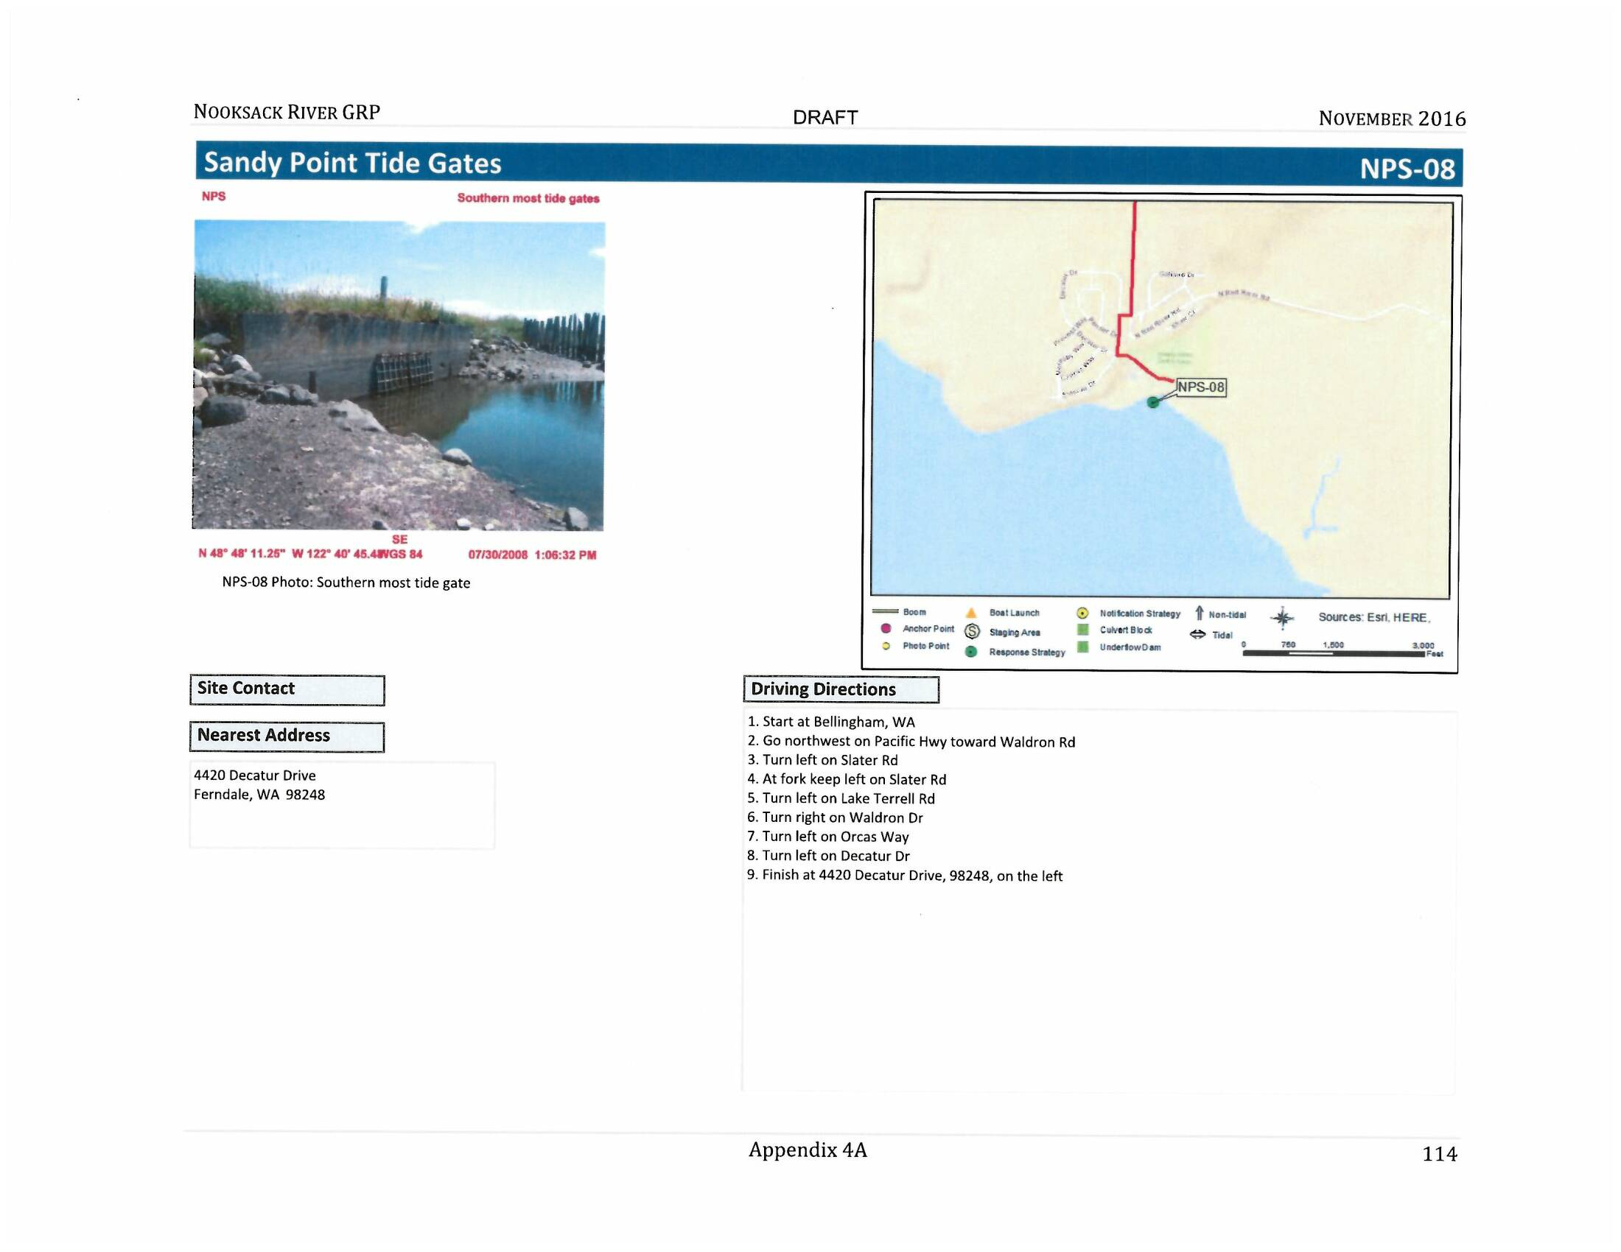

Staging Areas 2-Pagers
