**Appendix G**

**Response Methods/Protection Strategies**

Table A-6: Fast Water Booming Techniques

Current Chip Log and Maximum Boom Deflection Angle

The table uses the time for floating debris to drift 100 feet. This is accurately determined by anchoring a line with two floating buoy markers attached at a spacing 100 feet apart. Floating debris is then thrown into the water approximately 20 feet upstream of the first buoy marker. Determine the time it takes the debris to transit the distance between the two marker buoys in seconds. This assumes that the minimum escape velocity under a boom perpendicular to the current (90 degrees) is 1.2 feet per second. The table provides an estimate of the length of boom required for deflecting oil at a specified angle for a 110-foot profile (perpendicular length) to the current. It also provides an estimate of the number of anchors or shoreline tiebacks required for that length of boom assuming anchor points are required every 50 feet.

|  |  |  |  |  |
| --- | --- | --- | --- | --- |
| Time to Drift 100 Feet (seconds) | Velocity  (ft/sec) | Max. Boom Deflection Angle (degrees) | Boom for 100 Foot Profile to Current (feet) | Anchors if Placed Every  50 Feet (number) |
| 6 | 16.7 | 4.0 | 1,429 | 30 |
| 8 | 12.5 | 5.4 | 1,071 | 22 |
| 10 | 10.0 | 6.7 | 857 | 18 |
| 12 | 8.3 | 8.0 | 714 | 15 |
| 14 | 7.1 | 9.4 | 612 | 13 |
| 17 | 5.9 | 11.4 | 504 | 11 |
| 20 | 5.0 | 13.5 | 429 | 10 |
| 24 | 4.2 | 16.3 | 357 | 8 |
| 30 | 3.3 | 20.5 | 286 | 7 |
| 40 | 2.5 | 27.8 | 214 | 5 |
| 60 | 1.7 | 44.4 | 143 | 4 |
| >86 | <1.2 | 90.0 | 100 | 3 |

(1 Knot = 1.16 mile/hr, 6,080 ft/hr, or 1.7 ft/sec)

Table A-7: Current Drag Force on One-Foot Boom Profile to Current

The major force exerted on a boom is caused by the water drag on the skirt. Wave forces can increase the drag factor by two to three times depending upon the wave height, period, and loading dynamics. Wind force is less than current and waves, but is also a factor. In high current situations, drag is sometimes increased by water piling up on the boom, causing some submergence and increased drag forces, often resulting in mooring failure. In this situation, the 100-foot section of 4 X 6 diversion boom (4-inch floatation and 6-inch draft) should take the hydrodynamic load. A replacement section 50 feet long can withstand the reduced forces with submerging. The effects of current velocity and boom draft on boom drag force can be seen in

the table. Drag increases with draft in a linear fashion, while current increased drag more dramatically (to the square of the velocity).

|  |  |  |  |  |
| --- | --- | --- | --- | --- |
|  |  | | | |
| Velocity (ft/sec) | Boom Drag Force (pounds) | | | |
|  |  |  |  |
|  | Draft 0.5 Feet | Draft 1.0 Feet | Draft 1.5 Feet | Draft 2.0 Feet |
|  |  |  |  |  |
| 0.8 | 0.7 | 1.3 | 2.0 | 2.7 |
| 1.7 | 2.7 | 5.3 | 8.0 | 10.7 |
| 2.5 | 6.0 | 12.0 | 18.0 | 24.0 |
| 3.4 | 10.7 | 21.3 | 32.0 | 42.6 |
| 4.2 | 16.7 | 33.3 | 50.0 | 66.6 |
| 5.1 | 24.0 | 48.0 | 72.0 | 95.9 |
| 5.9 | 32.6 | 65.3 | 97.9 | 130.6 |
| 6.8 | 42.6 | 85.3 | 127.9 | 170.6 |
| 7.6 | 54.0 | 107.9 | 161.9 | 215.9 |
| 8.4 | 66.6 | 133.3 | 199.9 | 266.5 |
| 9.3 | 80.6 | 161.2 | 241.8 | 322.5 |
| 10.1 | 95.9 | 191.9 | 287.8 | 383.8 |
| 11.0 | 112.6 | 225.2 | 337.8 | 450.4 |
| 11.8 | 130.6 | 261.2 | 391.8 | 522.3 |
| 12.7 | 149.9 | 299.8 | 449.7 | 599.6 |
| 13.5 | 170.6 | 341.1 | 511.7 | 682.2 |

Table A-8: Approximate Safe Working Loads/Tensile Strength of New Rope

|  |  |  |  |
| --- | --- | --- | --- |
|  |  |  |  |
| Rope Diameter (inches) | Manila No. 1 (3 strand) (pounds) | Nylon (3-strand) (pounds) | Polyester (3-strand) (pounds) |
|  |  |  |  |
| 5/16 | 200 / 1,000 | 500 / 2,500 | 500 / 2,500 |
| 3/8 | 270 / 1,350 | 700 / 3,500 | 700 / 3,500 |
| 7/16 |  | 1,140 / 5,700 |  |
| 1/2 | 530 / 2,650 | 1,250 / 6,250 | 1,200 / 6,000 |
| 5/8 | 880 / 4,400 | 2,100 / 10,500 | 1,950 / 9,750 |
| 3/4 | 1,080 / 5,400 | 2,750 / 5,400 | 2,300 / 11,500 |

Towing load can be significant when a boom is anchored on one end and pulled against the current. Boats must have sufficient horsepower and be properly rigged to tow. Lines must be capable of withstanding the forces and the boom must have a tension member capable of high loads. If the boom is extended behind the tow boat and pulled free in the current, there is only the frictional drag along the boom. Because this drag is a function of the boat speed, proper motor size becomes a function of boom size and length, boat size, and water velocity. Although free towing drag is low, when one end of the boom is anchored to the shore, a small boat may be incapable of positioning the boom because of the high current drag exerted on the boom. The boom must be able to withstand the forces. The tension member must not become detached from the boom due to differential expansion.

Attempting to moor a boom in a straight line across a current (90 degrees) is not recommended. The result is a sag in the boom that will trap free floating oil at a point inaccessible to the shore.

In swift currents, the resulting forces on moorings can cause large lines of break and present possible safety hazards. The current can be so swift that the boom may dip and become completely or partially submerged. If this happens, the boom's position should be adjusted. The total force on the mooring points will be a combination of the forces caused by current, wind, and waves.

Boom positioning is an important point. The first step is to decide where the boom should be located. It is likely that the boom will be placed on an angle to the current; therefore, the prime concern becomes the location of the upstream end. If the selected upstream location is inaccessible, a spot further upstream can be used for access and the boat and boom allowed to drift to the selected mooring site. The boom can be secured to trees, stakes, anchors, or other solid objects. Do not attach boom to vehicles of any type or size.

**Lake or Reservoir Booming Strategy:**

**Floating Oil Strategy:**

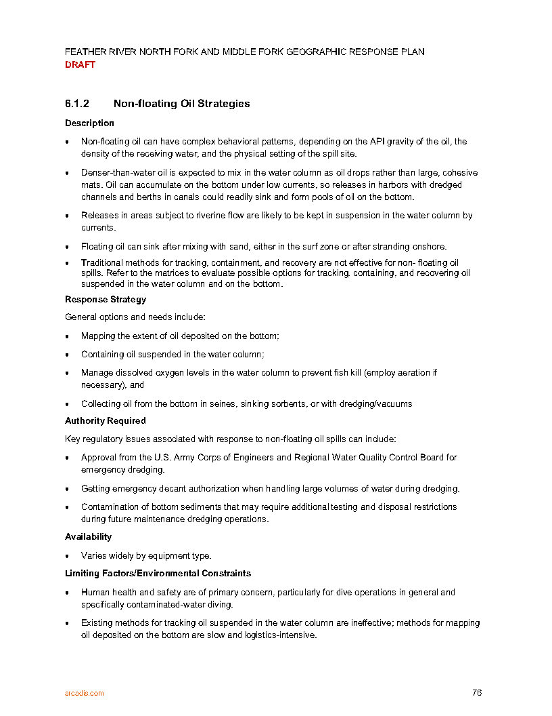

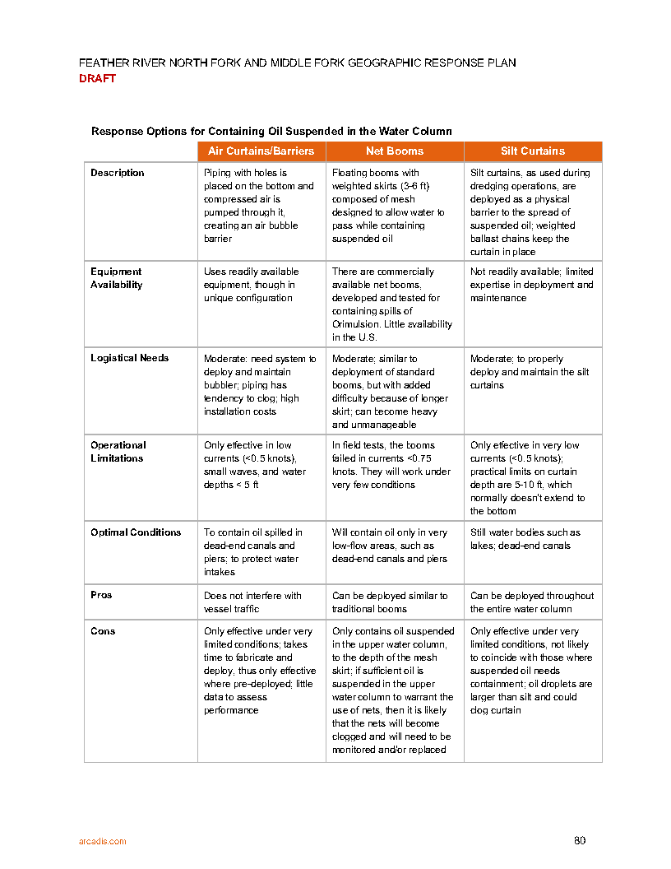

Figure A-1: Underflow Dams

Dams can be built in shallow rivers, culverts, and inlets using hand tools or heavy machinery, as available. Pipes are used to form an underflow dam to allow water passage out while oil stays behind, as seen in first figure below. The inlet of the pipe is cut at an angle to permit a larger entrance area for the water in order to reduce the inlet velocities and the possibility of oil drawdown due to formation of vortices. Caution should be taken to prevent whirlpools from forming and pulling the oil down. Face the cut pipe opening down (or insert a 90 degree angle) to help eliminate this. This technique is effective for water bodies less than two feet deep where flow volume can be accommodated by pipe flow. This method can also be used in deep, narrow culverts.

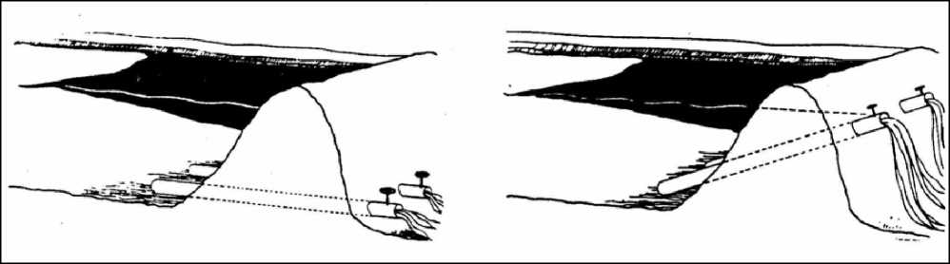

Earth underflow dam (DOWCAR 1997).

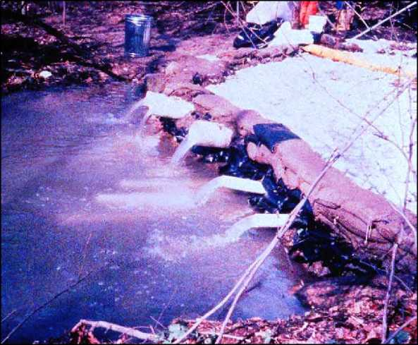

Sandbag underflow dam

Figure A-2: Culvert block

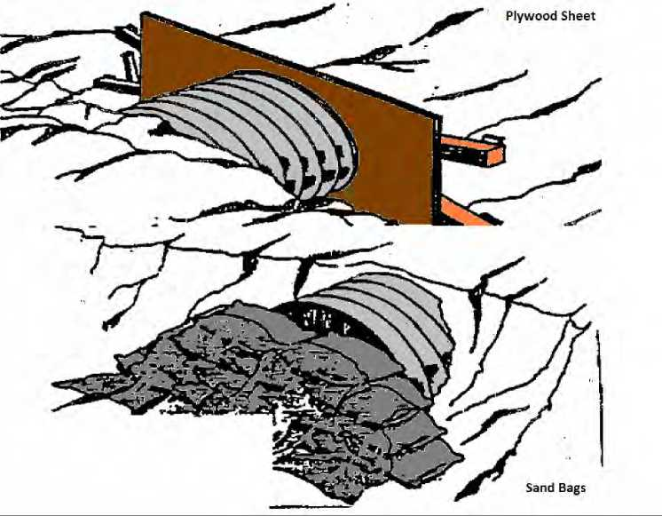

Figure A-3: Culvert weir

