XXX River

Geographic Response Plan

Chapter 5 - On-Water Recovery, Shoreline Countermeasures, Shoreline Assessment, Cleanup and Waste Management

5.1 Chapter Overview

Shoreline countermeasure processes continue to evolve, reflecting increasingly efficient treatment techniques. Response organizations and agencies must identify shorelines requiring treatment, establishing treatment priorities, monitoring the effectiveness and impacts of treatment, and resolve problems as the treatment progresses.

This chapter serves as a tool for countermeasure contingency planning and implementation for shorelines within the Grays Harbor GRP area. It contains shoreline-type maps, and oil countermeasure matrices for very light oils, light oils, medium oils, and heavy oils. The shoreline type for a specific area can be compared to the matrix for the particular oil spilled to determine (in general) what response cleanup actions are appropriate. The [Northwest Area](http://www.rrt10nwac.com/NWACP/Default.aspx) [Shoreline Countermeasures Manual (NWACP Section 9420)](http://www.rrt10nwac.com/NWACP/Default.aspx) provides detailed information on shoreline countermeasures and should be consulted during any oil spill response.

**5.2 On-Water Recovery of Product**

**5.3 Shoreline Countermeasures** Appendix XX contains oil countermeasure matrices for very light oils, light oils, medium oils, and heavy oils. Each matrix provides general guidance on the removal of oil from shoreline substrates. They must be used in conjunction with the [Northwest Area Shoreline](http://www.rrt10nwac.com/NWACP/Default.aspx) [Countermeasures Manual (NWACP Section 9420)](http://www.rrt10nwac.com/NWACP/Default.aspx) plus field observations and scientific advice. The countermeasures listed in the matrices are not necessarily the best under all circumstances, and any listed technique may need to be used in conjunction with other techniques. The Federal On-Scene Coordinator (FOSC), or the state OSC operating with the FOSC's authorization, has the responsibility and authority to determine which counter- measure^) are appropriate for various situations encountered. Selection of countermeasures is based on the degree of oil contamination, shoreline type, and the presence of sensitive resources.

**5.4 Shoreline Clean-up and Assessment Technique (SCAT)**Shoreline Cleanup and Assessment Technique (SCAT) is a systematic method for surveying an affected shoreline after an oil spill. The SCAT approach uses standardized terminology to document shoreline oiling conditions. SCAT is designed to support decision-making for shoreline cleanup. It is flexible in its scale of surveys and in the detail of datasets collected. SCAT is a regular part of the oil spill response. SCAT surveys begin early in the response to assess initial shoreline conditions, and ideally continue to work in advance of operational cleanup. Surveys continue during the response to verify shoreline oiling, cleanup effectiveness, and eventually, to conduct final evaluations of shorelines to ensure they meet cleanup endpoints.

During a spill response, SCAT is a function that is typically conducted under the  
Environmental Unit within the Planning Section. Depending on the complexity of the spill  
response, the SCAT Technical Specialist role may actually exist as a team. The teams are  
often made up of representatives from state and federal resource agencies, the  
responsible party and the USCG or USEPA and should be trained and knowledgeable in  
their roles.

http://response.restoration.noaa.gov/oil-and-chemical-spills/oil-spills/resources/shoreline-cleanup-and-assessment-technique-scat.html

* 1. **Shoreline Types and Clean-Up Measures**

**Table 5-1 ESI Shoreline Types**

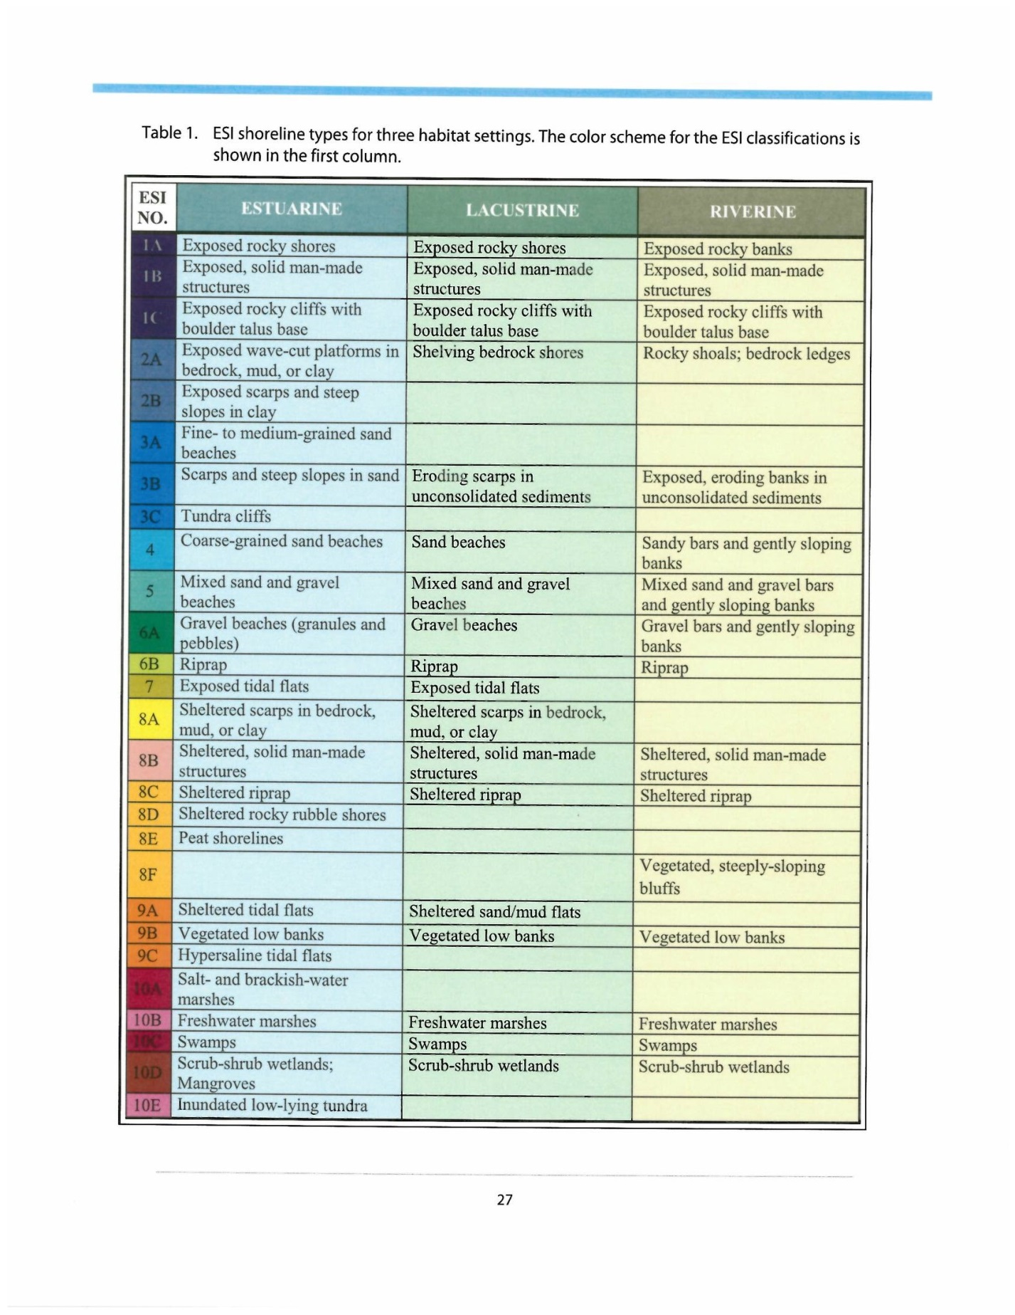

* 1. **Alternative Response Technologies (ART) (Dispersant,** **ISB, Bioremediation, Mechanical)**  
     The Alternative Response Technologies (ART) Technical Specialist is responsible  
     for evaluating the opportunities to use ART, including dispersant or other chemical  
     countermeasures, in-situ burning, and bioremediation. The specialist will conduct  
     the consultation and planning required to deploy a specific ART, and articulate the  
     environmental tradeoffs of using or not using a specific ART.

**5.7 Waste Management and Disposal**

Refer to APPENDIX XXVI of the Region IX Contingency Plan for a  
Waste Management Plan example. See Section 3240 for more detail  
regarding disposal. Info on carcass disposal.