Chapter 4

Response Strategies/Protection Techniques

4.1 Response Methods Overview

The appropriate response technique for a given release will be dictated by the type and volume of  
material released, the location of the release and of the response actions, river and weather conditions, and the time required to implement the response strategy. General response strategy descriptions for various inland shoreline types are provided in Appendix D in the NOAA publication Options for Minimizing Environmental Impacts of Freshwater Spill Response which is also available online:  
http://response.restoration.noaa.gov/sites/default/files/shoreline_countermeasures_freshwater.pdf

Table A-4: Summary of Protection Techniques for Rivers & Canals (Non-Tidal)

Where water depth is greater than typical boom skirt depth and there may be tidal influence, but current always flows in the same direction.

|  |  |
| --- | --- |
| Description | Tactics |
| Current speed dependent  Vessel traffic dependant | Single diversion boom  Current < 2 knots: Use boom skirt of 12 inches  Current > 2 knots: Use boom skirt of 6 inches or less |
| Currents over 2 knots | Cascading diversion boom  Use short skirts, short boom lengths and sufficient overlap |
| Collection areas available on both sides | Chevron booms  Open for vessel traffic  Closed if no traffic |
| Currents less than 2 knots and river is wide | Single diversion boom  Exclusion boom for sensitive areas  Encircle and divert to collection area |
| Sufficient room to maneuver | Skimmers for collection |
| No vessels available | Boom vane, Flow diverters |
| Special conditions | Air and water jets |
| Isolated areas | Sorbents and pom-poms |

Source: "Oil Spill Response in Fast Currents: A Field Guide." US Coast Guard, October 2001.

Table A-5: Summary of Protection Techniques for small Streams, Creeks, & Culverts

Where water depth is less than boom skirt depth.

|  |  |
| --- | --- |
| Description | Tactics |
| Dependent upon flow rate | Single diversion for volume greater than about 10 cubic ft/sec |
| Block for low volume flow | Sealing (Fill, Dams, Weirs) |
| Design for volume | Overflow / underflow dams |
| Low flow | Sorbents and pom-poms |

Source: "Oil Spill Response in Fast Currents: A Field Guide." US Coast Guard, October 2001

4.2 Water Velocity

4.2.1 Real Time Data Links:

4.2.2 Water Speed and Boom Deflection Angle

Measure the speed that water is moving by anchoring a line with two floating markers/buoys attached that are spaced 100 feet apart. Time the movement of floating debris between the two buoys, and then use Table 4.1 to estimate the water speed based on the travel time of the debris between the two buoys. You can also measure 100 feet along a straight portion of river bank or shoreline, and time the movement of debris between those points, but this method is generally less accurate than using the buoys. The maximum boom deflection angle is also provided in the table, based on the water speed measurements.

Table 4-2: Water Speed Drift Measurement and Boom Deployment

|  |  |  |  |  |  |  |
| --- | --- | --- | --- | --- | --- | --- |
| Time to Drift 100 Feet (seconds) | Velocity (ft/sec) | Velocity (m/sec) | Velocity (knots) | Max Boom Deflection Angle (degrees) | Boom required for 100-foot Profile to Current (feet) | Anchors needed if Placed Every 50 feet (number) |
| 6 | 16.7 | 5.1 | 10.00 | 4.0 | 1,429 | 30 |
| 8 | 12.5 | 3.8 | 7.50 | 5.4 | 1,071 | 22 |
| 10 | 10.0 | 3.1 | 6.00 | 6.7 | 857 | 18 |
| 12 | 8.3 | 2.5 | 5.00 | 8.0 | 714 | 15 |
| 14 | 7.1 | 2.2 | 4.29 | 9.4 | 612 | 13 |
| 17 | 5.9 | 1.8 | 3.53 | 11.4 | 504 | 11 |
| 20 | 5.0 | 1.5 | 3.00 | 13.5 | 429 | 10 |
| 24 | 4.2 | 1.3 | 2.50 | 16.3 | 357 | 8 |
| 30 | 3.3 | 1.0 | 2.00 | 20.5 | 286 | 7 |
| 40 | 2.5 | 0.8 | 1.50 | 27.8 | 214 | 5 |
| 60 | 1.7 | 0.5 | 1.00 | 44.4 | 143 | 4 |
| >86 | ≤1.2 | ≤0.35 | ≤0.70 | 90.0 | 100 | 3 |

*Source: Oil Spill Response in Fast Currents. A Field Guide. U.S. Coast Guard Research and Development Center. October, 2001*

Table 4-3: Boom Deployment Angles Based on Current Velocity

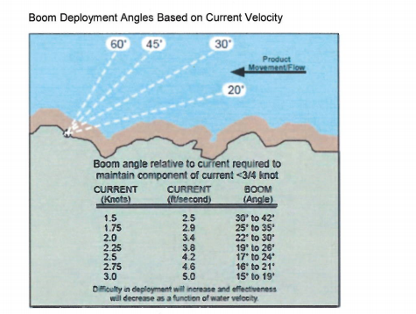

Table 4-4: Distance Covered Based on Flow Conditions

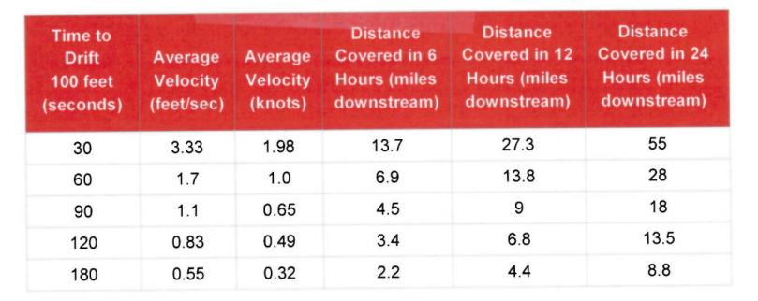

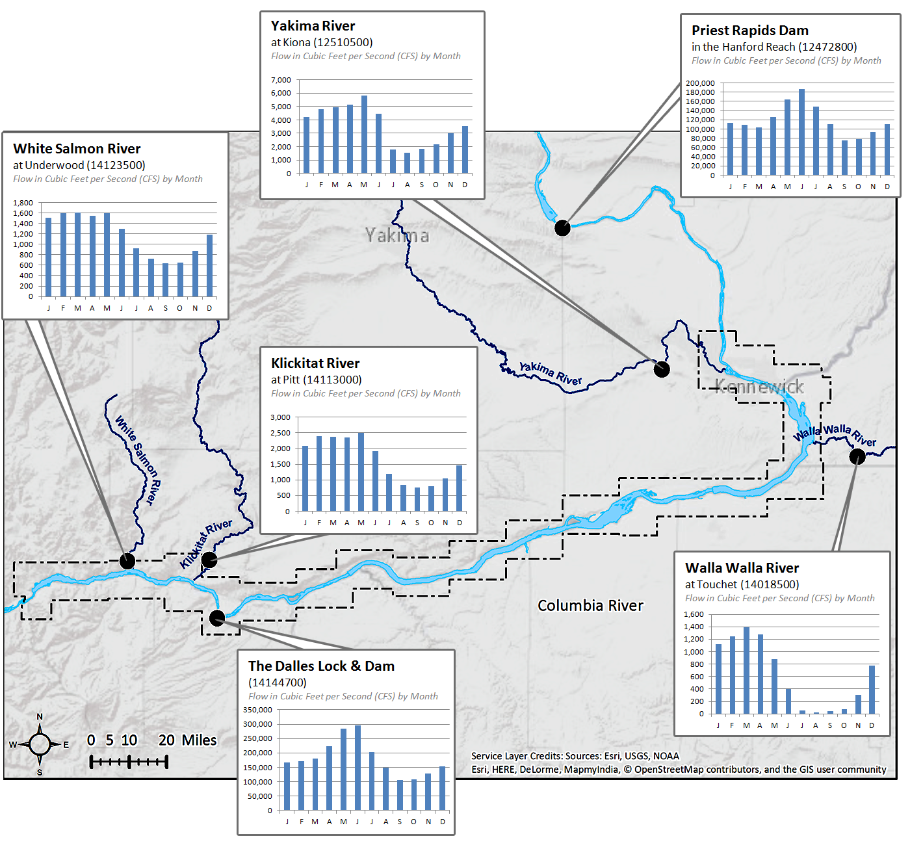

Figure 4-1: USGS Mean Monthly Discharge Measurements for the Columbia River and Tributaries