This spreadsheet is meant to mimic the data collection schematics of the Survey123 Geographic Response Plan Data Collection app for the iPad for those who do not choose to gather data electronically.

Here are the available attributes

***Access Point Name –*** Text field: the name of the access point.

***Location*** – Text field: Address if available, otherwise location description is fine.

***Thomas Guide Reference (page / grid, not available everywhere)*** – Text field: The Thomas Guide page / grid. This is not a required field.

***Directions access site:***  Text field

***Highway Milepost for Location:*** Text field: if mileposts are available. For more information about mile markers, please see appendix A.

***Railroad Milepost for Location*** – Text field: If railroad mileposts are available

***Nearby Rail / Pipeline / Fault crossing*** - Text field: Faults are available in ERMA, as are faults which intersect railroad lines. [https://erma.noaa.gov/southwest/erma.html#/x=-121.23920&y=38.56177&z=7&layers=1+13931](https://erma.noaa.gov/southwest/erma.html%23/x=-121.23920&y=38.56177&z=7&layers=1+13931)

***Hazards and Restrictions:*** Text Field

***River Width (meters; bank to bank based on geomorphology) -*** Numeric field: Probably easiest to do in Google Earth, but GIS can also fill this in.

***Gradient –*** Pulldown menu: 3 types of gradient and an explanation of each type.

***ESI Classification –***  Pulldown menu: every type of ESI classification. Shoreline ESI types starting on page 25 of this job aid. <http://response.restoration.noaa.gov/sites/default/files/jobaid_shore_assess_aug2007.pdf>

***Site_Information –*** Text field: any information that doesn’t fit the other fields.

***Response Strategies (feet of boom) –*** Numeric field

***Response Strategy Type –*** Pulldown menu: all strategy types. Please let me know if I have missed any strategy types.

***Response Strategy Comment –*** Text field

***Directions to Observation / Spot check site –*** Text field – A place where you can see the access point, if available.

***Resources at Risk (separate with comma)*** – Text field

EditDate – Date field

Editor- Text field

X (longitude) – numeric field: this can be filled in by GIS

Y (latitude) numeric field: this can be filled out by GIS

All questions can be sent to lori.gustafson@wildlife.ca.gov

Appendix A.

A few things about California mile markers

1. For people who have GRPs on interstates with exits, the exit numbers, which often coincide with mile markers on in google earth. If you zoom in far enough, they appear in green, like this.

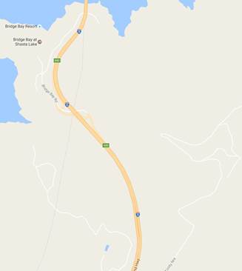

1. The above is not very helpful for those on highways without exits, but you can look postmiles up here -  <https://postmile.dot.ca.gov/PMQT/PostmileQueryTool.html>

It’s pretty clumsy and I will admit the results are not what I, personally, consider mile markers. It turns out that California doesn’t really use mile markers in the sense that the rest of the country does.  Here is a write up with pictures of where you would find postmile markers in the wild.  <http://www.cahighways.org/num-postmiles.html>