California Department of Fish and Game

Annual Report to the National Marine Fisheries Service for
Fisheries Restoration Grant Program Projects
Conducted under the Department of the Army Regional General Permit NO. 12
(Corps File No. 27922N) within the
U.S. Army Corps of Engineers, San Francisco District
January 1, 2007 through December 31, 2007

prepared by

Fisheries Restoration Grant Program
DFG Northern Region, Fortuna Office

March 1, 2008

The San Francisco District of the U.S. Army Corps of Engineers’ (COE) issued Regional General Permit (RGP) No. 12 (RGP-12) to the California Department of Fish and Game (DFG), pursuant to section 404 of the Clean Water Act, on September 8, 2004. RGP-12 authorizes an array of instream, riparian, and upslope habitat improvement activities within the geographic purview of the U.S. Army Corps of Engineers, San Francisco District (Figure 1). Authorization ends on December 1, 2009. This area encompasses the DFG’s Northern California Region, and a portion of the Bay Delta and Central regions. The authorization applies to salmonid habitat restoration projects that are specifically funded and/or authorized under California Department of Fish and Game’s Fisheries Restoration Grant Program (FRGP).

Special Condition #1 of Permit No. 27922N requires DFG to comply with mandatory terms and conditions associated with incidental take authorized by Biological Opinions (BOs) issued under Section 7 of the Environmental Species Act (ESA) by the National Marine Fisheries Service (NOAA Fisheries), dated May 21, 2004 and revised July 27, 2006, and the U.S. Fish and Wildlife Service (FWS), dated August 13 and 17, 2004. The NOAA Fisheries BO (IX.D.5.) stipulates that DFG will submit an annual report on the previous year’s restoration activities to NOAA Fisheries by March 1. This report is submitted in compliance of those terms and conditions. The annual report required under the FWS BOs was submitted separately by DFG’s FRGP.

This report summarizes the project implementation information provided by DFG grant managers and project effectiveness assessments conducted by DFG’s Coastal Restoration Monitoring and Evaluation Project during 2007. Projects are grouped by USGS Fourth Field Hydrologic Units (HUC) within the geographical areas specified in the NOAA Fisheries BO (Table 1, Figure 2).

Questions regarding this report should be directed to Mr. Barry Collins at (707) 725-1068, bcollins@dfg.ca.gov or Ms. Holly Sheradin at (916) 327-8658, hsheradin@dfg.ca.gov.

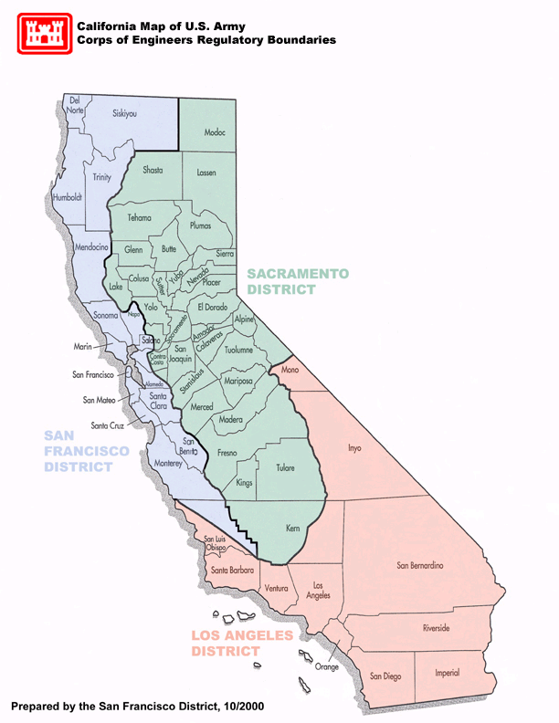

Figure 1. U.S. Army Corps of Engineers, San Francisco District.
Table 1. Geographical area separation and USGS Fourth Field Hydrologic Units specified in NOAA Fisheries Biological Opinion for COE Regional General Permit No. 12.

Geographical Area | Area Code | Fourth Field  Hydrologic Unit
North Coast Area | NC | Chetco
North Coast Area | NC | Illinois
North Coast Area | NC | Applegate
North Coast Area | NC | Smith
North Coast Area | NC | Lower Klamath
North Coast Area | NC | Upper Klamath
North Coast Area | NC | Salmon
North Coast Area | NC | Scott
North Coast Area | NC | Shasta
North Coast Area | NC | Trinity
North Coast Area | NC | South Fork Trinity
North Coast Area | NC | Mad-Redwood
North Coast Area | NC | Lower Eel
North Coast Area | NC | South Fork Eel
North Coast Area | NC | Middle Fork Eel
North Coast Area | NC | Upper Eel
North Coast Area | NC | Mattole
North Central Coast Area | NCC | Big-Navarro-Garcia
North Central Coast Area | NCC | Gualala-Salmon
North Central Coast Area | NCC | Russian
North Central Coast Area | NCC | Bodega Bay
North Central Coast Area | NCC | Tomales-Drake Bays
San Francisco Bay Area | SFB | San Pablo Bay
San Francisco Bay Area | SFB | Suisun Bay
San Francisco Bay Area | SFB | San Francisco Bay
San Francisco Bay Area | SFB | Coyote
Central Coast Area | CC | San Francisco Coastal South
Central Coast Area | CC | San Lorenzo-Soquel
Central Coast Area | CC | Pajaro
Central Coast Area | CC | Salinas
Central Coast Area | CC | Estrella
Central Coast Area | CC | Alisal-Elkhorn Sloughs
Central Coast Area | CC | Carmel
Central Coast Area | CC | Central Coastal

Figure 2. Geographical Areas and Fourth Field Hydrologic Units included in U.S. Army Corps of Engineers’ Regional General Permit No. 12.

2007 FRPG Implementation Monitoring

NOAA Fisheries BO (IX.D.5a.) specifies that DFG notify NOAA Fisheries of projects to be conducted each year that are authorized under RGP-12 (Notification List or List). Projects on the List are identified by the ProjectID and Grant number, as assigned in the FRGP’s grant tracking database, the California Habitat Restoration Project Database (CHRPD). The status of all the 2007 authorized FRGP Projects at the end of the year was determined from the Status field as recorded in the CHRPD. The relationship of the project status reported here and the Status field entry in the CHRPD is provided in Table 2.

Table 2. Project status as used for this report, compared to FRGP CHRP Status field.

Status | Status in CHRPD | Description
NA * | Proposed | Proposal submitted for funding consideration
NA * | Not funded | Proposal not selected for funding
Cancelled | Withdrawn | Proposal withdrawn from funding consideration
Cancelled | Terminated / Cancelled | Contract was terminated or cancelled
Not started | Funded, contract pending | Proposal selected for funding, but contract not written yet
Not started | Executed, field work not started | Contract written, but on-the-ground work has not started yet
Ongoing | Field work in progress | From the start of on-the-ground work to the end of work
Completed | Work complete but contract not closed | From the end of on-the-ground work until the contract is closed out
Completed | Closed | Contract has been closed out
* NA = Not applicable for this report

Some of these projects were not started during 2007 (i.e. no on-the–ground work was preformed); therefore, no implementation monitoring was conducted on them. The status of such projects was recorded as “Not started”. Other projects were started in either 2007 or prior years, but were not completed during 2007. It is anticipated that work on these projects will continue in 2008. The status of these projects was recorded as “Ongoing”. Restoration activities for any given project could consist of one or more distinct treatments (i.e. a physical feature which is intended to interact with the environment to improve anadromous salmonid habitat). For ongoing projects, implementation monitoring was conducted only on features which were completed during 2007. For example, the objective of an instream improvement project might be to construct seven instream structures, but work on only four structures were completed during 2007; therefore, implementation monitoring in 2007 would only have been done and reported on those four completed projects features. Implementation monitoring on the remaining features would then be conducted the following year or the year when they are completed. The status of projects included on the FRGP 2007 Notification List, where all project work was completed was recorded as “Completed”. In some cases projects on the List may have been withdrawn or contracts may have been cancelled, in such cases their status was recorded as “Cancelled”.

The FRGP employs ongoing Quality Assurance/Quality Control (QA/QC) procedures to identify errors and omissions and correct project data maintained and tracked in the CHRPD. QA/QC measures taken for 2007 Implementation Monitoring include:

- Evaluate project checklists for:
  - Completeness in content
  - Correct checklists used for monitoring of project treatment types
  - Metrics in checklists match metrics in CHRPD
- Evaluate each project individually in the CHRPD for:
  - Statement of Work
  - As-built Description
  - Expected Benefits
  - Construction Dates
  - Limiting Factors Addressed by Project
  - Work Status
  - Performance Measures entered and in correct units
  - Watershed Plan
  - Channel Dewatering and Species Relocation Data
  - Implementation Monitoring features in checklists match CHRPD
  - Field Inspections

A total of 205 projects were included on the 2007 RPG-12 Project Notification lists for the FRGP (183 projects) and the Klamath River Restoration Grant Program (KRGP) (22 projects). Seventy-six projects on were completed during 2007, and another 71 projects were ongoing (i.e. implementation work started but not completed) at the end of the year (Table 3). Fifty-one projects on the 2007 List were not started during 2007 and seven projects on the list were cancelled. A summary of the project status by RGP Project Activity at the end of 2007 is presented in Table 4. Individual project detail stratified by Fourth Field Hydrologic Unit and by Evolutionarily Significant Units (ESU) of Pacific salmon and steelhead in coastal California is provided in an attached Excel file (Appendix1_ProjSummary.2007.xls). Overall assessment ratings of how well these projects were implemented are also provided in Appendix 1.

Table 3. Status summary of projects on the 2007 Fisheries Restoration Grants Program List in each
geographic area.
Cancelled Not started Ongoing Completed Total
North Coast 5 42 44 56 147
North Central Coast 5 17 18 40
San Francisco Bay 1 4 1 6
Central Coast 2 3 6 1 12
Grand Total = 7 51 71 76 205
% of Total = 3.4% 24.9% 34.6% 37.1% 100.0%

Monday, February 25, 2008

Table 4. Status of restoration projects included on RGP-12 2007 Notification List in each geographic area
summarized by project type activity.
Cancelled Not started Ongoing Completed Total
North Coast
Instream Habitat Improvements 1 8 5 8 22
Instream Barrier Modification for Fish Passage Improvement 5 5 2 12
Stream Bank Stabilization 1 6 4 11
Fish Passage Improvement at Stream Crossings 1 4 3 7 15
Riparian Habitat Restoration 1 10 8 6 25
Upslope Watershed Restoration 2 8 14 23 47
Fish Screens 6 1 5 12
Streamflow Augmentation 2 1 3
Sum 5 42 44 56 147
% of Area Total 3.40% 28.57% 29.93% 38.10% 100.00
North Central Coast
Instream Habitat Improvements 1 4 6 11
Stream Bank Stabilization 1 3 1 5
Fish Passage Improvement at Stream Crossings 2 1 3
Riparian Habitat Restoration 2 2
Upslope Watershed Restoration 1 10 8 19
Sum 5 17 18 40
% of Area Total 12.50% 42.50% 45.00% 100.00
San Francisco Bay
Instream Habitat Improvements 1 1
Stream Bank Stabilization 2 2
Riparian Habitat Restoration 2 2
Upslope Watershed Restoration 1 1
Sum 1 4 1 6
% of Area Total 16.67% 66.67% 16.67% 100.00
Central Coast
Instream Barrier Modification for Fish Passage Improvement 1 1 2
Stream Bank Stabilization 1 1 2
Fish Passage Improvement at Stream Crossings 3 1 1 5
Riparian Habitat Restoration 1 1
Upslope Watershed Restoration 2 2
Sum 2 3 6 1 12
% of Area Total 16.67% 25.00% 50.00% 8.33% 100.00
Grand Grand Grand Grand Grand 7 51 71 76 205
Monday, February 25, 2008
Implementation monitoring consists of assessing how well the restoration treatments constructing individual restoration features were preformed. Each completed feature is rated as Excellent, Good, Fair, Poor, or Failed based on the criteria presented in Table 5. An overall implementation rating is then assigned to the project as a whole, based on the criteria presented in Table 6; for example the effectiveness of a project would be rated as Good if 80% or more of its features sampled were rated as either Good or Excellent, with no more than 10% of the project features rated as Poor, and no project features rated as Failed. Unsatisfactory project activity ratings lead to an investigation to identify possible contributing factors and the possible development of additional project monitoring and studies to obtain information which will aid in improving that activities employed.

Table 5. Implementation Feature Rating Definitions.

RATING | IMPLEMENTATION | ACTION
Excellent | Meets all specifications and exceeds expectations. | No action required.
Good | Meets all specifications and expectations. | No remedial action required.
Fair | Does not meet some specifications and expectations, but implemented adequately. | Probably not serious enough to require remedial action.
Poor | Does not meet most specifications and expectations, implemented inadequately. | Serious enough to require remedial action.
Fail | Fails to meet specifications, implemented incorrectly. Or, not implemented. | Serious enough to require remedial action.

Table 6. Overall project rating criteria based on cumulative percentage of feature ratings.

 | Overall Project Rating*
Feature Ratings | Excellent ¹ | Good ² | Fair ³ | Poor ⁴ | Failed ⁵
Excellent | ≥ 80% | ≥ 80% | ≥ 80% | ≥ 50% | < 50%
Good
Fair |  |  | ≥ 80% | ≥ 50% | < 50%
Poor | 0 | ≤ 10%
Failed | 0 | 0 | ≤10% | ≤ 25%
* These formulas should be read as:
¹ 80% or more of the project features were rated as Excellent, and no project features were rated as either Poor or Failed.
² 80% or more of the project features were rated as either Good or Excellent, no more than 10% of the project features were rated as Poor, and no project features were rated as Failed.
³ 80% or more of the project features were rated as either Fair, Good or Excellent, no more than 10% of the project features were rated as Failed.
⁴ 50% or more of the project features were rated as either Fair, Good or Excellent, and no more than 25% of project features were rated as Failed.
⁵ Less than 50% of the project features were rated as either Fair, Good or Excellent; alternatively 50% or more of the project features were rated as either Poor or Failed,.
The location of projects on the 2007 Fisheries Restoration Grants Program List is presented in Figure 3. Out of 91 projects with implementation features completed in during 2007, 82 projects (90.1%) were rated as either Good or Excellent, eight projects (8.8%) received a Fair rating and one project (1.1%) was rated as Poor. No project was rated as Failed (Table 7). Project-specific implementation monitoring information of restoration features constructed during 2007 is provided in an attached Excel file (Appendix2_Implementation.2007.xls). Summaries of project type activity ratings within each geographical area are presented in Table 8.

Table 7. Overall implementation ratings for projects completed or ongoing at the end of 2007.
RGP Activity Poor Fair Good Excellent Total
Instream Habitat Improvements 2 8 4 14
Instream Barrier Modification for Fish Passage Improvement 2 2 4
Stream Bank Stabilization 6 3 9
Fish Passage Improvement at Stream Crossings 7 2 9
Riparian Habitat Restoration 1 8 1 10
Upslope Watershed Restoration 1 5 27 11 44
Fish Screens 1 1
Grand Total = 1 8 59 23 91
% of Total = 1.1% 8.8% 64.8% 25.3% 100.0%

Monday, February 25, 2008

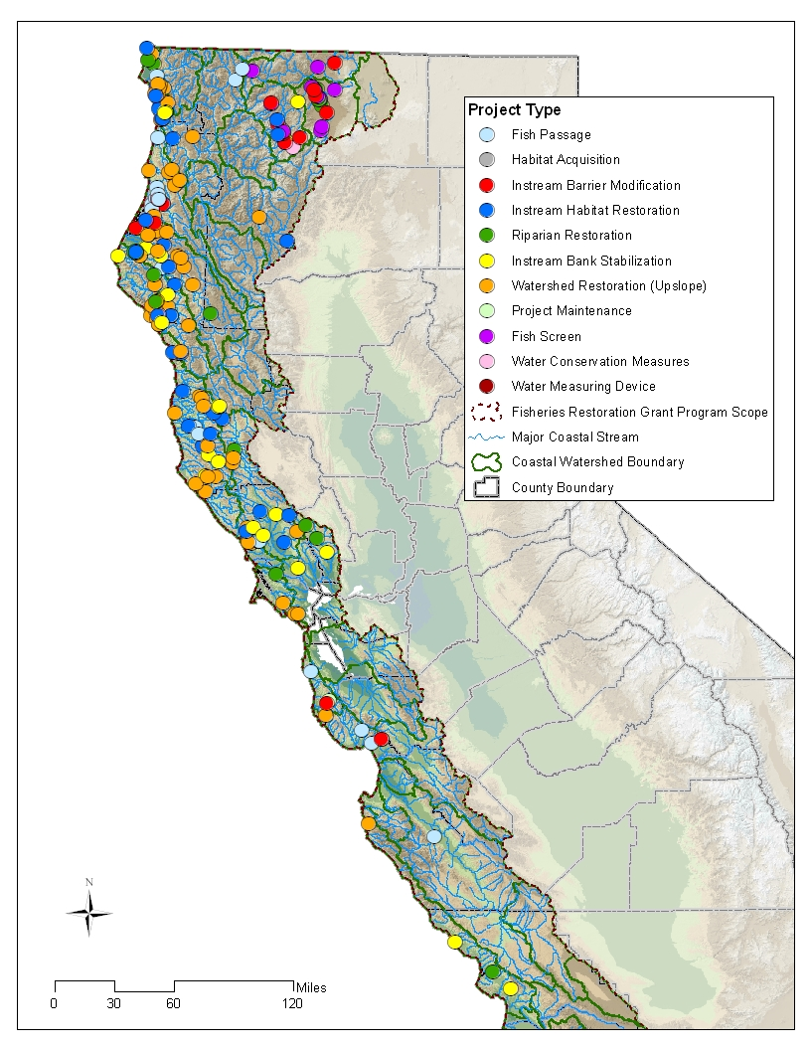
Figure 3. Location of projects on the 2007 RGP-12 Notification Lists for the Fisheries Restoration Grants Program and Klamath Restoration Grants Program.
Table 8. Implementation feature rating summary for project type activities by geographical area.

Geographical Area: North Coast
Number of Features % Number Number Number Number Number
Features Monitored Monitored Failed Poor Fair Good Excellent
Instream Habitat Improvements
131 131 100.0% 0 0 17 43 71
Percent of monitored features = 0.0% 0.00% 12.98% 32.82% 54.20%
Instream Barrier Modification for Fish Passage Improvement
28 28 100.0% 0 0 3 18 7
Percent of monitored features = 0.0% 0.00% 10.71% 64.29% 25.00%
Fish Passage Improvement at Stream Crossings
19 19 100.0% 0 0 0 12 7
Percent of monitored features = 0.0% 0.00% 0.00% 63.16% 36.84%
Riparian Habitat Restoration
27 27 100.0% 0 0 0 13 14
Percent of monitored features = 0.0% 0.00% 0.00% 48.15% 51.85%
Upslope Watershed Restoration
679 512 89.1% 0 3 37 249 223
Percent of monitored features = 0.0% 0.59% 7.23% 48.63% 43.55%
Fish Screens
11 9 90.0% 0 0 0 1 8
Percent of monitored features = 0.0% 0.00% 0.00% 11.11% 88.89%

Summary for 'Geographical Area' = North Coast (125 detail records)
895 726 93.6% 0 3 57 336 330
Percent of monitored features = 0.00% 0.41% 7.85% 46.28% 45.45%
Geographical Area: North Central Coast
Number of Features % Number Number Number Number Number
Features Monitored Monitored Failed Poor Fair Good Excellent
Instream Habitat Improvements
198 183 97.9% 0 1 25 139 18
Percent of monitored features = 0.0% 0.55% 13.66% 75.96% 9.84%
Riparian Habitat Restoration
6 6 100.0% 0 0 0 6 0
Percent of monitored features = 0.0% 0.00% 0.00% 100.00% 0.00%
Upslope Watershed Restoration
194 143 83.4% 1 6 26 82 28
Percent of monitored features = 0.7% 4.20% 18.18% 57.34% 19.58%

Summary for 'Geographical Area' = North Central Coast (45 detail records)
398 332 86.9% 1 7 51 227 46
Percent of monitored features = 0.30% 2.11% 15.36% 68.37% 13.86%

Geographical Area: San Francisco Bay
Number of Features % Number Number Number Number Number
Features Monitored Monitored Failed Poor Fair Good Excellent
Instream Habitat Improvements
93 11 53.9% 0 0 0 10 1
Percent of monitored features = 0.0% 0.00% 0.00% 90.91% 9.09%
Riparian Habitat Restoration
199 123 55.3% 0 0 0 123 0
Percent of monitored features = 0.0% 0.00% 0.00% 100.00% 0.00%

Summary for 'Geographical Area' = San Francisco Bay (6 detail records)
292 134 54.9% 0 0 0 133 1
Percent of monitored features = 0.00% 0.00% 0.00% 99.25% 0.75%
Geographical Area: Central Coast
Number of Features % Number Number Number Number Number
Features Monitored Monitored Failed Poor Fair Good Excellent
Riparian Habitat Restoration
6 1 100.0% 0 0 0 1 0
Percent of monitored features = 0.0% 0.00% 0.00% 100.00% 0.00%
Upslope Watershed Restoration
117 50 117.0% 0 0 5 41 4
Percent of monitored features = 0.0% 0.00% 10.00% 82.00% 8.00%
Summary for 'Geographical Area' = Central Coast (14 detail records)
123 51 115.4% 0 0 5 42 4
Percent of monitored features = 0.00% 0.00% 9.80% 82.35% 7.84%

Grand Grand Total
1708 1243 1 10 113 738 381
Percent of monitored features = 0.08% 0.80% 9.09% 59.37% 30.65%

Monday, February 25, 2008

Partial funding for the FRGP is provided by the Pacific Coastal Salmon Recovery Fund (PCSRF), which was established by Congress in FY 2000 to provide grants to assist with salmon conservation and recovery efforts. In order to document and track the progress of these efforts the PCSRF has developed a set of consistent performance reporting metrics. The FRGP utilizes these performance measures to provide a means to consistently report project results by the various entities that receive FRGP grants. This information will assist DFG and NOAA Fisheries to aggregate project data to develop an accurate picture of salmon recovery, conservation, and enhancement efforts. Project-specific performance measures of restoration features constructed during 2007 is provided in an attached Excel file (Appendix2_Implementation.2007.xls). The reporting metric data included in this annual report reflect information provided by DFG grant managers as entered into the FRGP’s California Habitat Restoration Project Database (CHRPD) as of February 22, 2008. Summaries of performance measures for projects implementation during 2007 within each geographical area are presented in Table 9.

Table 9. Performance measure summary for projects implementation during 2007 by geographical area.
North
North Central Central
Coast Coast Coast Total
Amount of estuarine area treated for invasive species (acres)
0 0
Amount of riparian area treated (acres, including fencing, excluding invasive species treatments)
2.5766 0.98 1.872 6.5601
Amount of riparian area treated for invasive species (acres)
0 5.642
Amount of upland area treated (acres)
6.7898 0 9.9276 16.7174
Area (footprint) of instream features installed within bankfull channel (square feet)
182716 18381 22744 232274
Barriers other than stream crossings removed/modified (number)
11 11
Fence length installed/repaired (miles, actual length of fence)
7.4541 7.4541
Fish screens installed (number)
0 0
Fish screens replaced/maintained (number)
0 0
Flow rate at screened diversion from the water right (cfs)
20.01 20.01
Gravel volume added to stream (cubic yards)
250 0 250
Instream features installed/modified (number)
223 188 14 442
Length of aquatic habitat disturbed (feet)
10740.14 4327.2077 2866.92 39654.2718
41
Length of instream habitat treated - except for bank stabilization (miles)
1.5944 0.7774 0.3633 2.774
Length of riparian stream bank treated (miles, count both sides of stream if applicable)
0.653 0.23 0.778 1.72
Length of streambank stabilized (miles, count both sides of stream where applicable)
2.4122 0.1156 0.0931 2.7494
Quantity of water protected by screens as stated in the water right (acre-feet/year)
14483.08 14483.08
Road length treated (miles)
62.1407 39.0088 9.0077 110.1572
Sediment volume prevented from entering stream (cubic yards)
391013 82997 4056 478066
Stream crossings treated to improve fish passage (number)
15 5 20
Stream length opened for fish passage - barriers other than stream crossings (miles)
47.58 47.58
Stream length opened for fish passage by improving stream crossings (miles)
17.4137 17.4137
Trees planted (number)
8840 251 9091
Upslope stream crossings treated (not for fish passage) (number)
545 138 25 708
Water flow gauges installed (number)
1 1
Monday, February 25, 2008

2007 FRPG Effectiveness Monitoring

DFG conducts effectiveness monitoring on at least 10% of the FRGP projects funded each year. In 2005 DFG initiated its sampling strategy for project selection and sequential monitoring phases to be conducted. Projects for effective monitoring are randomly selected and stratified by project activity and region as specified in NOAA Fisheries BO and March 14, 2005 modification letter. Effectiveness monitoring is broken down into two phase: pre-treatment monitoring and post-treatment monitoring. Pre-treatment monitoring seeks to determine and document existing habitat conditions and selected salmonid population attributes before on-the-ground restoration treatments are begun. This type of monitoring is also known as baseline monitoring and serves as a benchmark against which the effectiveness of the restoration treatment is assessed. Pre-treatment monitoring is generally conducted the year the project was awarded. Post-treatment monitoring is then conducted within three years after project completion to ensure that projects have experienced at least one, but not more than three winter high-flow periods. Post-treatment monitoring is primarily conducted the first year following project completion, although monitoring may be deferred to the second or third year if deemed appropriate. Subsequent monitoring in additional years may also be conducted if appropriate. This sampling strategy was established to be compatible with DFG’s capacity to perform annual restoration project effectiveness monitoring in compliance with the NOAA Fisheries Biological Opinion for RGP-12.

Pre-project monitoring was conducted on 36 restoration projects (Table 10). Results will be reported on next year when effectiveness monitoring results are provided.

Table 10. Number of pre-treatment projects monitored during 2007.
North North Central Central
Coast Coast Coast Total
Instream Habitat Improvements 2 2 4
Stream Bank Stabilization 2 1 2 7
Fish Passage Improvement at Stream 7 7
Riparian Habitat Restoration 1 7 8
Upslope Watershed Restoration 2 6 8
Fish Screens 2 2
Grand Total 16 3 15 36

Monday, February 25, 2008

Table 11. Post-treatment Effectiveness Feature Rating Definitions.

RATING | GOALS | TARGETS | UNINTENDED EFFECTS | STRUCTURAL CONDITION
Excellent | Achieved all stated goals. | Met or exceeded targeted values. | No negative unintended effects. Unintended positive effects may outweigh failure to achieve a targeted value. | Excellent to Good.
Good | Achieved most stated goals. | Did not quite meet targeted values. If no targets were specified, maximum rating is GOOD. | No negative unintended effects. | Excellent to Fair.
Fair | Partially achieved most goals, or goals not achieved were outside the control of the feature. | Did not meet targeted values, but the feature still has some functional value. | May have minor unintended negative effects that partially offset goals. | Excellent to Fair.
Poor | Achieved at least one goal; goals not achieved were the fault of the feature. | Did not meet targeted values, feature has little functional value. | May have minor or major unintended negative effects that offsets or negates a targeted gain. | Excellent to Poor.
Fail | Achieved no goals; feature has no functional value. | Did not meet targeted values. | May have unintended negative effects that are degrading the habitat and outweigh achieved goals. | Excellent to Fail (may be completely gone).

Effectiveness monitoring consists of assessing the structural integrity and function of completed restoration features. Each feature is rated as Excellent, Good, Fair, Poor, or Failed, based on the criteria presented in Table 11. Then an overall effectiveness rating (Table 6) is then assigned to the project as a whole. Effectiveness monitoring during 2007 was conducted on eight completed projects. The overall effectiveness rating for five of these projects (62.5%) was rated as either Excellent or Good, one project (12.5%) were rated as Fair, and two projects was rated as Poor (25.0%) (Table 12).

Project-specific effectiveness monitoring information of individual completed restoration features monitored during 2007 is provided in an attached Excel file (Appendix3.Effectiveness Rating.2007.xls). Summaries of post-treatment feature effectiveness ratings for different project type activities within each geographical area are presented in Table 13.
Table 12. Overall effectiveness ratings for completed projects monitored during 2007.

RGP Activity Poor Fair Good Excellent Total
Instream Habitat Improvements 1 1 2
Instream Barrier Modification for Fish Passage 1 1 2
Improvement
Fish Passage Improvement at Stream Crossings 1 1 2
Fish Screens 2 2
Grand Total = 2 1 4 1 8
% of Total = 25.0% 12.5% 50.0% 12.5% 100.0%
Monday, February 25, 2008

Table 13. Post-treatment effectiveness feature rating summary for project type activities by
geographical area.
Geographical Area: North Coast
Number of Features % Monitored Number Number Number Number Number
Features Monitored Failed Poor Fair Good Excellent
Instream Habitat Improvements
17 17 100.0% 0 3 1 11 2
Percent of monitored features = 0.0% 17.65% 5.88% 64.71% 11.76%
Instream Barrier Modification for Fish Passage Improvement
3 3 100.0% 0 0 0 3 0
Percent of monitored features = 0.0% 0.00% 0.00% 100.00% 0.00%
Fish Screens
2 2 100.0% 0 0 0 2 0
Percent of monitored features = 0.0% 0.00% 0.00% 100.00% 0.00%

Geographical Area: North Central Coast
Number of Features % Monitored Number Number Number Number Number
Features Monitored Failed Poor Fair Good Excellent
Instream Barrier Modification for Fish Passage Improvement
3 3 100.0% 0 2 1 0 0
Percent of monitored features = 0.0% 66.67% 33.33% 0.00% 0.00%
Fish Passage Improvement at Stream Crossings
2 2 100.0% 0 0 0 0 2
Percent of monitored features = 0.0% 0.00% 0.00% 0.00% 100.00%

Grand Total
27 27 0 5 2 16 4
Percent of monitored features = 0.00% 18.52% 7.41% 59.26% 14.81%

Monday, February 25, 2008

Fish Relocation Activities
Some restoration project activities require fish to the excluded from the project site to minimize harm and mortality to listed salmonids and other aquatic species during project construction activity. During 2007 fish relocation activities were reported for 19 restoration projects; 15 on the North Coast, three on the North Central Coast, and one in the San Francisco Bay area.. A summary of the anadromous salmonid relocation activities, including the number and species of fish relocated (caught) and the number and species injured or killed is presented Table 14; details for each individual project action area is presented in an attached Excel file (Appendix4.Relocation.2007.xls). The NOAA BO (IX.A.) states that mortality from fish relocation activities is anticipated to be no more than three percent of juvenile salmonids inhabiting each individual project action area. Most projects experienced no mortalities associated with fish relocation activities. One relocation action area in the Mad-Redwood HUC experienced a 5.6% mortality of coho salmon (11 out of 195 fish captured), and one other action area in the Mad-Redwood HUC experienced a 8.3% mortality of cutthroat (1 out of 12 fish captured).

Table 14. Summary of fish relocation activities during 2007.
Average Average
North Coast Total Catch Number Injured Number Killed % Injury % Mortality
Coho 253 0 11 0.0% 0.7%
Cutthroat 94 1 1 0.5% 1.7%
Steelhead 3732 10 21 0.7% 0.4%
Unknown trout 77 0 0 0.0% 0.0%

Average Average
North Central Coast Total Catch Number Injured Number Killed % Injury % Mortality
Coho 69 0 0 0.0% 0.0%
Steelhead 230 0 5 0.0% 0.9%

Average Average
San Francisco Bay Total Catch Number Injured Number Killed % Injury % Mortality
Steelhead 22 0 0 0.0% 0.0%

Monday, February 25, 2008

