The California Department of Fish and Game
Fisheries Restoration Grant Program

Provides technical assistance and grants to public agencies, private individuals, and non-profit organizations to restore salmon and steelhead trout habitat in the coastal areas of California.

MISSION:

To protect and restore coastal salmon and steelhead trout habitat, while collaborating with many stakeholders to provide the greatest environmental, cultural, and economic benefit to the state of California.

GOALS

 To protect and increase the naturally spawning salmon and steelhead trout resources of the coastal areas of California primarily through the improvement of stream habitat.

 To recover threatened and endangered species of salmon and steelhead trout.

 To reestablish sustainable and productive sport and commercial fisheries in the coastal areas of California.

ECONOMIC BENEFITS OF RESTORATION

The Fisheries Restoration Grant Program (FRGP) has a positive economic impact for local agencies and organizations, as well as the communities where the contracted work is accomplished. The potential benefits of providing grants for restoration projects not only include enhanced habitat for fish and wildlife, but also includes business stimulus, jobs, and increased income to communities in mostly rural counties.

HISTORY

Since 1981, the FRGP has awarded funding through a competitive annual Project Solicitation Notice (PSN) process to over 2,000 projects statewide, totaling more than $100 million in grant funds. Over the past 24 years, these funds have been appropriated from a variety of sources.

The majority of funds have been awarded for habitat restoration projects. These projects provided improved overhead cover, spawning gravels, and pool habitat; reduced or eliminated erosion and sedimentation impacts; screened diversions, and removed barriers to fish passage. Funds have also been awarded for indirect habitat restoration activities such as: cooperative fish rearing; acquisitions of riparian easements; research; project monitoring; watershed assessment and planning; support for watershed organizations; and public outreach and education.

WE FUND PROJECTS THAT:

 Protect, conserve, restore, and enhance the water quality, water quantity, structure, and function of instream habitat.
 Prevent, reduce, or eliminate erosion and sediment impacts to upslope and instream habitat.
 Modify or remove barriers to migration or emigration.
 Assess and improve the effectiveness of restoration efforts by conducting watershed evaluation and planning.
 Protect, conserve, restore, and enhance habitat through land and water right acquisitions.
Maintain and improve species population and abundance through support for public fish rearing.
Protect, conserve, restore, and enhance riparian habitat.
 Encourage local government and community-based collaborations, partnerships, project involvement, ownership, and commitment to habitat restoration through support for watershed organizations.
Provide funding and technical support for public school watershed and fishery conservation education; workshops and conferences that teach restoration techniques; and technical training that encourages land and water management practices.
 Assure the long-term efficacy and effectiveness of restoration efforts by conducting project monitoring and maintenance.

HOW ARE GRANTS AWARDED?

Grants are awarded by the FRGP through a competitive PSN process. The next PSN will be advertised in March 2005 in the State Contracts Register: (www.cscr.dgs.ca.gov/cscr/) Proposals are due in May 2005. Proposals are then forwarded to DFG regional staff for field review. Regional staff will evaluate proposals for technical merit, provide comments and scores, and forward them to a statewide Technical Review Team (TRT) in September 2005. The TRT will review the regional scores and comments, and forward the proposals to the California Coastal Salmonid Restoration Grants Peer Review Committee in November 2005. This advisory committee will evaluate each proposal, make final recommendations for funding, and provide the DFG Director with a prioritized list of recommended proposals. The DFG Director then makes final grant award decisions based on available funding. Grants for this cycle are expected to be awarded by December 2005.

HOW TO APPLY FOR A GRANT?

Information about the FRGP and the annual PSN application package can be viewed or downloaded in Microsoft Word or Adobe PDF format from the Internet at: www.dfg.ca.gov/nafwb/fishgrant.html

TECHNICAL ASSISTANCE

Regional DFG fishery biologists and fish habitat specialists are available to provide technical assistance in the planning and development of project proposals. Please contact the FRGP at the number provided for staff located in your area.
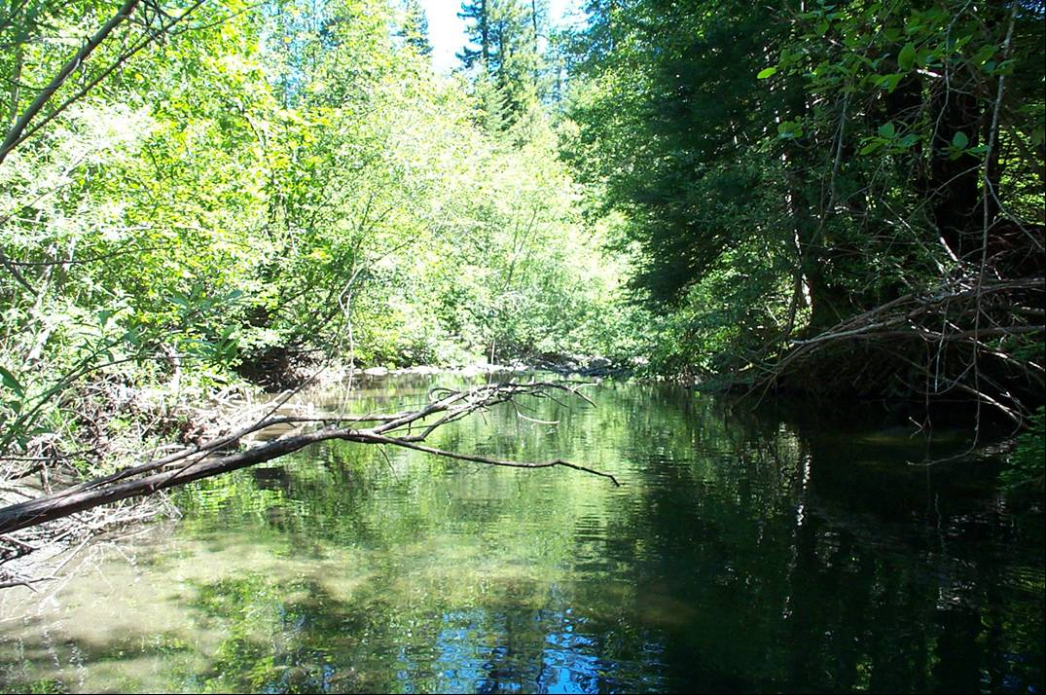

North Coast Region
Gary Flosi, Senior Fish Habitat Supervisor
1455 Sandy Prairie Court, Suite J
Fortuna, CA 95540
Phone: (707) 725-1072
Fax: (707) 725-1086
Email: gflosi@dfg.ca.gov

Central Coast Region
Bob Coey, Senior Fishery Biologist Supervisor
P.O. Box 47
Yountville, CA 94599
Phone: (707) 944-5582
Fax: (707) 944-5563
Email: bcoey@dfg.ca.gov

South Coast Region
Mary Larson, Senior Fishery Biologist Specialist
4665 Lampson, Avenue, Suite C
Los Alamitos, CA 90720
Phone: (562) 342-7186
Fax: (562) 342-7139
Email: mlarson@dfg.ca.gov

Additional information can be obtained by contacting the FRGP at the following address:

California Department of Fish and Game
Native Anadromous Fish and Watershed Branch
Fisheries Restoration Grant Program
830 “S” Street
Sacramento, CA 95814
Phone: (916) 327-8849
State of California
Resources Agency
Department of Fish and Game
Native Anadromous Fish and Watershed Branch
2005
Fax: (916) 327-8854
Email: dduvall@dfg.ca.gov

Fisheries Restoration
Grant Program

