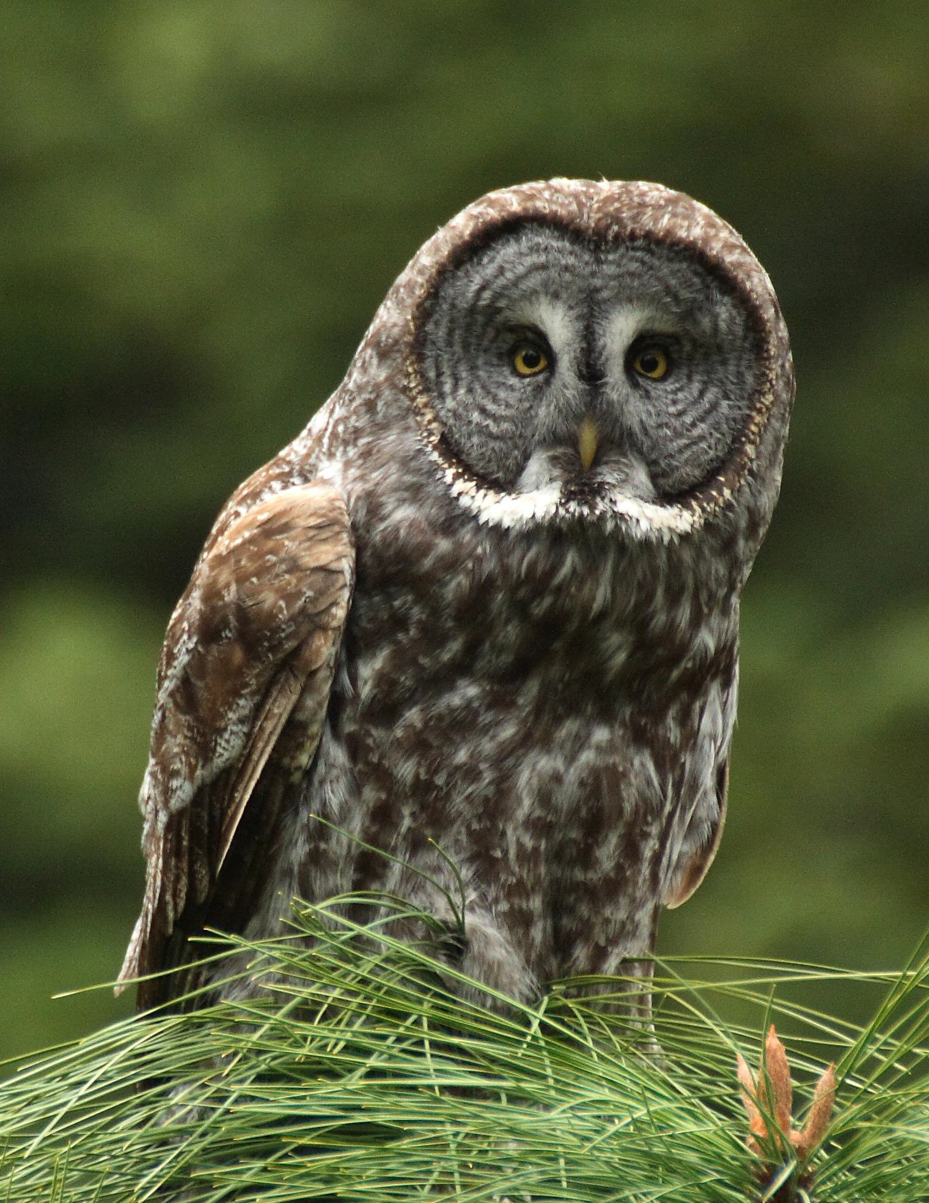




A Conservation Strategy for Great Gray Owls (Strix nebulosa) in California

Joanna X. Wu Helen L. Loffland Rodney B. Siegel Chris J. Stermer

THE INSTITUTE FOR
BIRD POPULATIONS

A Conservation Strategy for Great Gray Owls (Strix nebulosa) in California

Joanna X. Wu
The Institute for Bird Populations

Helen L. Loffland*
The Institute for Bird Populations

Rodney B. Siegel
The Institute for Bird Populations

Chris J. Stermer
California Department of Fish and Wildlife

*Corresponding author: hloffland@birdpop.org

The Institute for Bird Populations, P.O. Box 1346, Point Reyes Station, CA 94956.

Recommended citation:

Wu, J. X., H. L. Loffland, R. B. Siegel, C.J. Stermer. 2016. A Conservation Strategy for Great Gray Owls (Strix nebulosa) in California. Interim version 1.0. The Institute for Bird Populations and California Partners in Flight. Point Reyes Station, California.

Photographs (front and back cover) by: Cameron Rognan, Stanislaus National Forest.

Dedication

This Strategy is dedicated to the memory of Jon Winter, for his many years of work on and devotion to the study and conservation of Great Gray Owls.

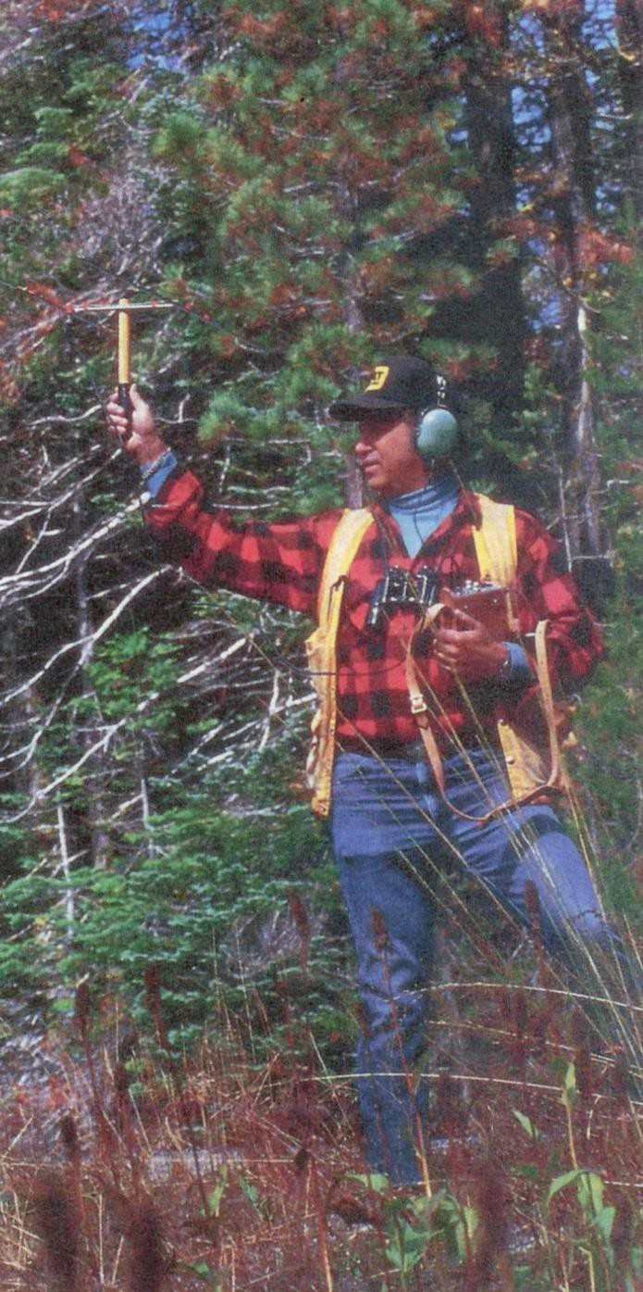

Photo: Chevron Corporation. October 2, 1986, Yosemite National Park.

TABLE OF CONTENTS

List of Figures iv
List of Tables vii
Executive Summary 1
Summary of Conservation Actions 2
Definitions 3
Recommended Conservation Actions 4
Delineation of Great Gray Owl Core Management Areas (CMAs) 4
Managing Meadows and Other Foraging Habitat 5
Managing Forest Habitats 6
Surveys Protocols and Incidental Sightings 8
Reducing Vehicle Strikes 9
Residential and Agricultural Development and Land Acquisition 9
Monitoring and Research Needs 10
Acknowledgments 13
Introduction to this Strategy 13
Information Sources 15
Species Description and Ecology 17
Physical Description and Taxonomy 17
Distribution and Population Status 18
Habitat Requirements 21
Breeding Season 21
Winter 22
Habitat Photo Gallery 24
Examples of Great Gray Owl Habitat Near Known Nest Sites 24
Diversity of Nest Trees Used 26
Food Habits 26
Life History and Population Ecology 28
Reproduction and Phenology 28
Mortality Factors 29
Home Range 30
Migration 31
Species Conservation, Habitat Management, and Recommendations for Land Managers 32
History of Great Gray Owl Protection in California 32
Current Management Status 32
Management on National Park Service Lands 32
Management on USDA Forest Service Lands 33
Management on Privately-Owned Lands 34
Great Gray Owls Outside the Greater Yosemite Area 35
El Dorado, Amador, and Calaveras Counties 36
Sierra, Yuba, and Plumas Counties 36
Modoc County 37
Delineating Great Gray Owl Core Management Areas 40
Examples of Core Management Area Configurations 43
Potential Threats and Recommendations to Minimize Them 47
Livestock Grazing 47
Outreach and Land Acquisition 51
Timber Harvest 52
Artificial Nests 56
Human Activity 57
Vehicle Strikes 57
Land Development 60
Rodent-Control 62
Off-Highway Vehicles 63
Birdwatchers and Photographers 64
Forest Wildfire 65
Climate Change 67
Drought and Conifer Mortality 69
Disease 69
Predation 70
Risks of a Small Population Size 71
Survey Protocol 73
Number of Visits and Survey Effort 73
Nest Searching Recommendations 74
Other Survey and Monitoring Methods 75
Incidental Sightings 76
Literature Cited 78

LIST OF FIGURES

Figure 1. Nested tiers of management corresponding to the recommended conservation actions. Recommendations made for the outer tier should also apply to the tier nested within it 2

Figure 2. Great Gray Owl female and nestling, Yosemite National Park (T. Ely). 13
Figure 3. Despite its size, Great Gray Owl’s cryptic plumage allows it to camouflage well against conifer trunks, Sierra Nevada, California (J. Medley) 16

Figure 4. Facial disc and “bowtie” of a Great Gray Owl (M. Woelfle) 17

Figure 5. A Great Gray Owl fledgling (left; T. Munson) compared to a Great Horned Owl fledgling (middle; T. Llovet) and a Spotted Owl fledgling (right; A. Maizlish). 17
Figure 6. Distribution of Great Gray Owls in North America (Bull and Duncan 1993) 18

Figure 7. Distribution of all known Great Gray Owl reproductive territories across California. This map includes natural nest locations (we excluded artificial nests to convey habitat selection) and fledgling-only locations (where a fledgling was detected at least once but the nest was not found). Data were collated from the Natural Resource Information System, California Natural Diversity Database, and various biologists from California Department of Fish and Wildlife, Yosemite National Park, Stanislaus National Forest, the Pacific Southwest Research Station, Sierra Pacific Industries, and Southern California Edison. Map current as of fall 2015. 19

Figure 8. Juvenile Great Gray Owl, Sierra National Forest (C. Stermer) 21
Figure 9. Great Gray Owl in a winter storm, Yosemite National Park (R. Byrnes). 23

Figure 10. Yosemite National Park, 2,220 m (H. Loffland). 24
Figure 11. Yosemite National Park, 2,070 m (K. Strohm). 24

Figure 12. Southern California Edison, Fresno County, 1,670 m (K. Strohm). 24

Figure 13. Stanislaus National Forest, 1,370 m (H. Loffland). 24
Figure 14. Eldorado National Forest, 1,250 m (K. Strohm). 25

Figure 15. Sierra Pacific Industries, El Dorado County, 670 m. (H. Loffland) 25

Figure 16. Examples of Great Gray Owl nests used in the Sierra Nevada, California. In the top panel, from left to right, are nests in the broken top of a red fir snag, broken top of a ponderosa pine snag, broken top of a lodgepole pine snag, and a fork in the branches of a live ponderosa pine. In the bottom panel, from left to right, are nests in the broken top of a live black oak bole, an upright cavity left by a sloughed-off secondary trunk in a live gray pine, and a fork in two large branches of a live black oak. The last panel shows a platform nest on a broad, flat section of a branch in a live black oak (indicated by the arrow to the left) used in one year, then another nest in a cavity (arrow, right) used in a subsequent year (and K. Roberts, pers. comm.). Figure from Wu et al. (2015) 26
Figure 17. Top, vole (V. Khustochka) and bottom, gopher (D. Hofmann). 27

Figure 18. Female Great Gray Owl with nestling on broken-top nest, Yosemite National Park (J. Medley) 28

Figure 19. Great Gray Owl perched on a post, Montana (USDA) 29

Figure 20. Locations of 32 of 42 known Great Gray Owl vehicle strikes in California. Ten locations were not specific enough to be mapped (nine were in Yosemite National Park, one was in Sierra National Forest) 30
Figure 21. Great Gray Owl, Madera County (A. Williams). 31
Figure 22. Great Gray Owl meadow and forest habitat, Yosemite National Park (NPS). 32
Figure 23. The top of the head of a female Great Gray Owl is barely visible at this nest in a broken-top snag on Sierra Pacific Industries land, El Dorado County. Owls are difficult to see in the nest from the ground (B. Campbell). 34

Figure 24. Female Great Gray Owl with nestlings in a nest in Calaveras County, 2015 (M. Reno).
....................................................................................................................................................... 36
Figure 25. Juveniles in mistletoe broom nest, Modoc County (Collins Timber Company LLC). 37 Figure 26. Habitat surrounding the only confirmed Great Gray Owl nest in Modoc County,
indicated by the red arrow (Collins Timber Company LLC). 38
Figure 27. A Great Gray Owl at a hunting perch (unknown photographer). 42
Figure 28. Steps to creating a Core Management Area. In this case, the final CMA encompasses 161 ha (398 ac) of forest and 13 ha (31 ac) of meadow. 43
Figure 29. A Core Management Area configuration where a single meadow is within 500 m of the activity center. The meadow is included in the CMA, but the other meadow farther than 500 m from the activity center is not included in the CMA. The best available forested habitat within a 400-m buffer of the meadow is included in the CMA (per Table 1), plus another patch that includes the activity center. This CMA encompasses 108 ha (267 ac) of forest and 5 ha (11 ac) of meadow. 44
Figure 30. A Core Management Area configuration where two meadows are within 500 m of the activity center. The best available forested habitat within a 300-m buffer (per Table 1) of the meadow is included in the CMA except for small patches (e.g. chaparral or other unsuitable Great Gray Owl habitat). This CMA encompasses 109 ha (269 ac) of forest and 12 ha (30 ac) of meadow. 45
Figure 31. A Core Management Area configuration where no meadow is within 500 m of the activity center. In this case, a forest patch of 212 ha (524 ac) of best available habitat that also includes the activity center is designated as the CMA. 46
Figure 32. An example of a meadow that provides both vole (foreground) and gopher (left and right back) habitat, Stanislaus National Forest (R. Kalinowski). 47
Figure 33. Two juvenile Great Gray Owls use ponderosa pine saplings as perches in a meadow in Sierra National Forest (K. Strohm). 48
Figure 34. An example of a meadow in El Dorado County with encroaching conifers (H. Loffland). 50
Figure 35. Two fledglings at a nest on a broken-top oak snag on, Sierra Pacific Industries, El Dorado County (K. Roberts). 53
Figure 36. Great Gray Owl on private timber land, Calaveras County (M. Reno). 54
Figure 37. Great Gray Owl, Yosemite National Park (J. Helling) 57

Figure 38. An artificial nest in an incense-cedar with a female Great Gray Owl in the nest; Tuolumne County (R. Bridgman) 58
Figure 39. A Great Gray Owl perches on a downed limb while hunting at the edge of a meadow at Yosemite National Park, California. The species’ tendency to hunt from low perches and swoop across roads may make it particularly susceptible to vehicle collisions (T. Ely) 59
Figure 40. Female Great Gray Owl on broken-top nest; Tuolumne County (R. Bridgman) 61
Figure 41. The Great Gray Owl is a sought-after species by birders and photographers (F. Lospalluto) 64

Figure 42. Great Gray Owl habitat that burned at high severity (foreground) and moderate severity (background) in the Rim Fire, taken one year post-fire, Yosemite National Park (NPS).
....................................................................................................................................................... 65
Figure 43. A Great Gray Owl peers down from its perch, Stanislaus National Forest (C. Rognan).
....................................................................................................................................................... 66
Figure 44. Two fledglings perch on an exposed branch on a lodgepole pine, Yosemite National Park (J. Medley). 68
Figure 45. A juvenile Great Gray Owl peers out from among an incense-cedar. Yosemite- Stanislaus region (T. Ely). 71
Figure 46. Great Gray Owl, Stanislaus-Yosemite region (R. Byrnes). 72
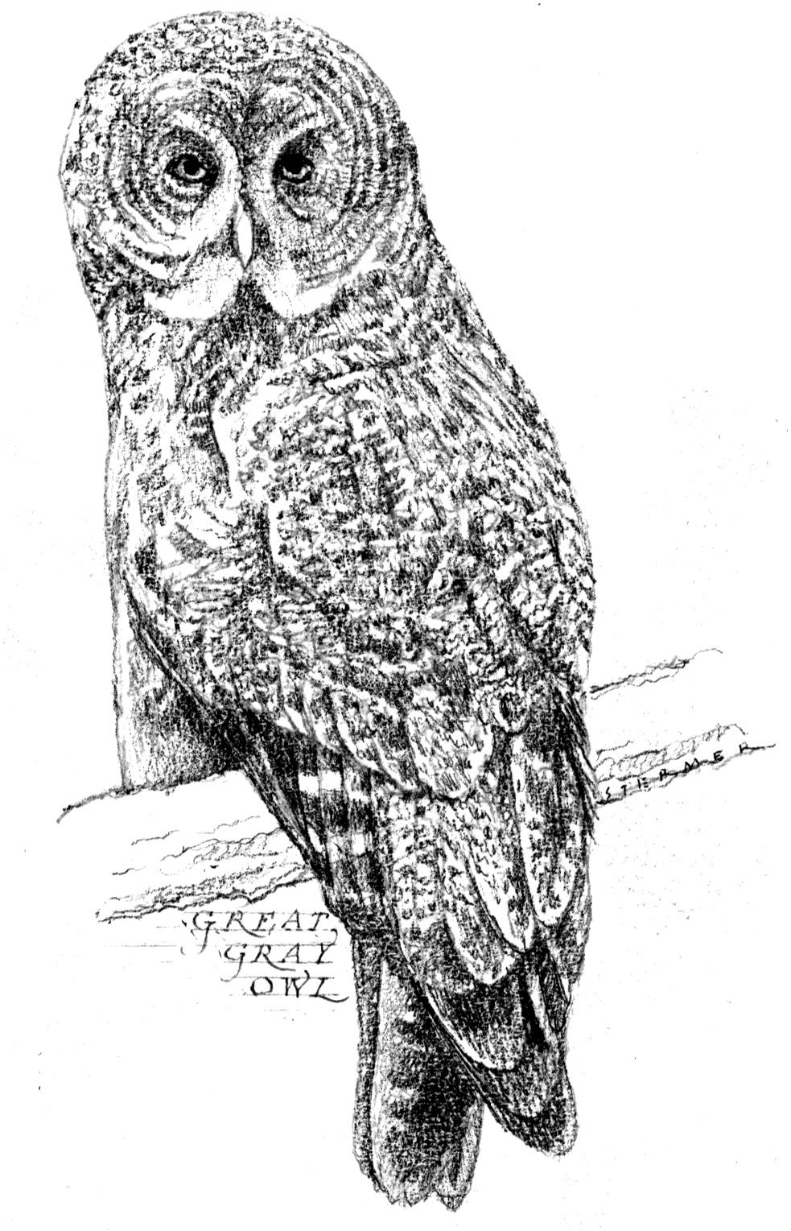
Figure 47. Nesting Great Gray Owl, Oregon (N. Barrett). 75

Artwork by: Dugald Stermer

LIST OF TABLES

Table 1. Meadow buffer size by region and elevation. Elevation zones are adapted from Beck and Winter (2000) 3

Table 2. List of experts interviewed to consult on the Conservation Strategy 15

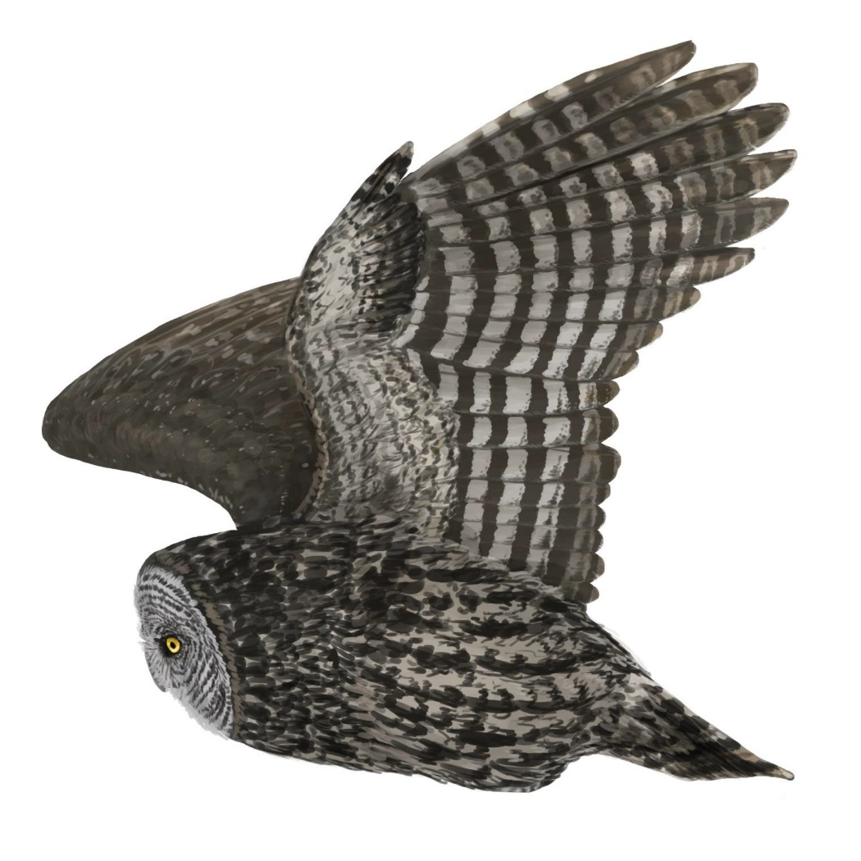

Artwork by: Lauren Helton
EXECUTIVE SUMMARY

The Great Gray Owl (Strix nebulosa) is one of the largest owls in the world and has a Holarctic distribution. Great Gray Owls nesting in California’s Sierra Nevada Mountains constitute a putative subspecies (S. n. yosemitensis) that is isolated from the rest of the North American population and likely comprises fewer than 100 breeding pairs. They breed most commonly near montane meadows in mid-elevation conifer forests with dense canopy cover. In recent years, multiple nests have also been found at lower elevations in mixed hardwood-conifer forests, sometimes miles from the nearest montane meadow. Including such nests, the Great Gray Owl’s overall elevation range for nesting in the Sierra Nevada is approximately 700-2,400 m above sea level.

The Great Gray Owl was listed as Endangered under the California Endangered Species Act (CESA) in 1980 and is designated as a sensitive species in Region 5 of the USDA Forest Service. The extremely small size of California’s Great Gray Owl population is reason for concern for its conservation status. This Conservation Strategy collates scientific knowledge about the Great Gray Owl and provides conservation recommendations that we believe offer the best chance of preventing extirpation of the species in California and increasing the size of the population, ultimately toward the goal of a sustainable population size. Information used to develop this Strategy was compiled from published literature pertaining to studies both in and outside California, and one- on-one interviews with 23 experts and land managers in California who have studied Great Gray Owls, surveyed extensively for them, or manage Great Gray Owl habitat on their lands. This is a strategic document intended for use by state and federal land managers, private land owners, non-governmental organizations, and the scientific community. It is not a regulatory document, but rather provides management suggestions, and the rationale for these suggestions, to land managers to protect the Great Gray Owl.

We recommend 59 specific actions that will help protect California’s Great Gray Owls. We have placed these recommendations near the front of this document to highlight their importance, with supporting rationale further developed in the text. The actions address the following topics:

- Designating and managing Great Gray Owl Core Management Areas
- Managing and restoring meadows and other foraging habitat
- Managing and recruiting nesting habitat
- Protecting Great Gray Owls during habitat-altering activities
- Conducting surveys and reporting incidental sightings
- Preventing vehicle strikes
- Reducing the impact of residential and agricultural development
- Monitoring and research needs

We believe the recommendations detailed in this Strategy, implemented in conjunction with other appropriate forest and meadow management practices, will conserve, and possibly increase, California’s endangered Great Gray Owl population, in pursuit of the larger goal of species recovery. Readers with additional conservation suggestions or ideas for refining and improving the recommendations in this Strategy are invited to contact the authors and CDFW.

SUMMARY OF CONSERVATION ACTIONS



Here we provide definitions and summarize recommended actions for conserving California’s Great Gray Owl population. Recommended habitat management actions are grouped into two nested tiers, as indicated in Figure 1, with recommendations for the outer tier also intended to apply to the tier nested within it. The page numbers of the section of this Conservation Strategy addressing each recommendation in greater detail are provided in parentheses.

CORE MANAGEMENT AREA

SUITABLE GREAT GRAY OWL BREEDING HABITAT

Figure 1. Nested tiers of management corresponding to the recommended conservation actions. Recommendations made for the outer tier should also apply to the tier nested within it.

Definitions

Core Management Area: areas on any public or private lands where nesting is indicated and associated areas that are important during the breeding season for foraging and roosting. On Forest Service lands, Core Management Areas (CMAs) are synonymous with Protected Activity Centers (PACs), where species of concern receive protection from habitat-altering activities during specified periods that include the breeding season. We suggest the proposed guidelines for CMAs for consideration as revisions to existing Forest Service management direction for PAC delineation and management, and for adoption by other public and private land managers.

Suitable Great Gray Owl breeding habitat: Suitable Great Gray Owl breeding habitat in California includes meadows and forest stands in buffer distances around occupied and unoccupied meadows, or occupied non-meadow sites, within the elevational and latitudinal zones indicated in Table 1.

Table 1. Meadow buffer size by region and elevation. Elevation zones are adapted from Beck and Winter (2000), taking into account lower-elevation nesting records compiled since 2000.

Region | Low Elevation | Middle Elevation | High Elevation
Northern Sierra:  Placer County and northward | 610-914 m  (2,000-3,000 ft) | 915-1,524 m  (3,001-5,000 ft) | >1,524m  (>5,000 ft)
Central Sierra:  Mariposa County to El Dorado County | 670-1,219 m  (2,200-4,000 ft) | 1,220-1,829 m  (4,001-6,000 ft) | >1,829 m  (>6,000 ft)
Southern Sierra:  Madera County and southward | 975-1,524 m  (3,200-5,000 ft) | 1,524-2,133 m  (5,001-7,000 ft) | >2,133 m  (>7,000 ft)
Recommended meadow  buffer for each elevation zone | 500 m  (1,640 ft) | 400 m  (1,312 ft) | 300 m  (984 ft)

Recommended Conservation Actions

Delineation of Great Gray Owl Core Management Areas (CMAs)

- Due to the difficulty of locating nests, Great Gray Owl CMAs should be delineated not only where nests are detected, but also for other ‘activity centers,’ i.e., locations where observations indicate the site is important during the breeding season even if no nest was found. In addition to nest detection, Great Gray Owl Core Management Areas should be designated upon (p. 40-42):
  - Fledgling detection
  - Detection of any Great Gray Owl during the core nesting season (Apr-Jul; Beck and Winter 2000)
  - Detection of an adult male and female in close proximity to one another
during the pre-breeding (Feb-Mar) or post-fledging (Aug-Sep) season

- Delineate a CMA that comprises at least 80 hectares (200 acres, an increase from the current prescription of 50 acres on Forest Service lands) of forest, in addition to all meadows within 500 m (1,640 ft) of the nest tree or activity center (as defined in Recommendation #1), to better align with home-range size based on observational studies (e.g., van Riper and van Wagtendonk 2006, Winter 1986). CMAs do not necessarily have to be configured as a circle around an activity center, but rather can be any shape that includes the best available forested area and adjacent meadows where applicable. Best available forest stands have (1) >65% canopy cover and (2) some very large, >100 cm (40 in) dbh snags. Within the CMA, strive to include habitat that meets the above conditions, or if not available, habitat that most closely resembles the best available forest stands. (p. 40-42)

To delineate a CMA (see pages 43-46 for example schematics):
  - Draw a 500-m (1,640-ft) radius circle around the activity center
  - Include in the CMA all meadows and grassy openings where Great Gray Owls can forage that intersect the circle, including portions of those meadows or openings that are >500 m from the activity center; be sure to also include the activity center itself.
  - Then draw 300-, 400-, or 500-m (900-, 1,300-, or 1,640-ft) buffers (depending on region; Table 1) around all of the meadows that intersect the 500-m circle around the activity center
  - Select at least 80 ha (200 ac) of the best available forested habitat within the meadow buffers to include in the CMA (the area of the meadows is in addition to the 80 ha/200 ac of forest)

- If a CMA or a portion thereof has been rendered unsuitable for Great Gray Owl nesting following natural disturbance, CMA boundaries can be modified to exclude the unsuitable portion, which should then be replaced with other nearby habitat this is more suitable (as defined in Recommendation #2; p. 41).

- Consider retiring a CMA if (p. 40-43):
  - A natural disturbance alters the habitat so significantly that continued owl nesting in the CMA is unlikely, one year of three-visit surveys after the disturbance yields no detection, and nearby suitable habitat that could be used for redrawing the CMA is not available.
  - No owls are detected in the CMA following one year of six-visit surveys at sites where a single detection of a single owl triggered CMA designation.

Managing Meadows and Other Foraging Habitat

Meadows in Great Gray Owl Core Management Areas:

- Where CMAs overlap a grazing allotment, periodically assess meadow ecological condition and implement appropriate measures to remedy negative conditions or trends including: active hydrologic restoration, reducing grazing pressure, fencing, allotment boundary revisions, resting, or retiring the allotment. Allotments with multiple CMAs should receive priority for assessment and adjusted grazing management (p. 47-50).

- Maintain meadow vegetation at a ‘sward height’ of at least 20 cm (8 in; Kalinowski et al. 2014) at mid- and high-elevations. If it is not possible to use the sward plate methodology, maintain herbaceous vegetation at a stubble height of 30 cm (12 in; Beck 1985, Greene 1995). Where meadows in CMAs are grazed, refrain from grazing between February 15th and August 15th (Beck 1985, Beck and Winter 2000) unless a
meadow assessment indicates that sward height standards and range conditions and trend standards are being met. Data suggest the above guidelines would enhance meadow habitat for voles at mid- and high-elevations, but at lower elevations, where Great Gray Owls may depend more on gophers (Kevin Roberts, unpublished data), alternative herbaceous vegetation management options may be warranted if supported by research (p.47-50).

- Consider the issue of conifer encroachment into meadows on a case-by-case basis.
When removing encroaching conifers, strive for creating a mix of ‘hard edges’ (i.e., total removal of encroaching conifers, yielding an abrupt transition between forest and meadow) and ‘soft edges’ (i.e., removing only dense patches of encroaching conifers that threaten persistence of meadow herbaceous cover; p. 47-51).

- Strive to create or maintain at least one potential hunting perch approximately 1-6 m (3-20 ft) in height (Winter 1986) per 30 m (100 ft) of meadow edge. Where existing natural structures seem insufficient, perches can be created by dragging downed logs with branches and large root wads intact from the forest interior to the meadow edge, by retaining some perches when removing encroaching conifers, or by installing posts (p. 47-51).

- Eliminate the use of rodenticides, and avoid rodent-trapping from February 15th through August 5th (approximately the end of the nesting season as defined in Beck and Winter 2000; p. 62-63).

- Prohibit the use of off-highway vehicles (OHV) from February 15th through August 5th (approximately the end of the nesting season as defined in Beck and Winter 2000; p. 63-64).

Meadows in Suitable Great Gray Owl Habitat:

- Strive to increase health and productivity of vegetation at large (>10 ha/25 ac; Beck and Winter 2000) meadows, such as via hydrological restoration, replanting native species, evaluating and adjusting grazing strategies. Where natural hydrology has been severely altered, strive to restore the water table to a less disturbed state, for higher graminoid productivity and increased ecological resilience to climate change and other stressors (p. 51).

- Enlist land trusts and others to aid in the development of site-specific meadow management plans, conservation easements and/or purchase of meadows and the forest stands that surround them. These efforts should be prioritized at sites with historical Great Gray Owl detections that are at risk of future development or land conversion (p. 51-52).

Managing Forest Habitats

Forests in Great Gray Owl Core Management Areas:

- Refrain from vegetation treatments (e.g., timber harvest, thinning, prescribed fire) and road construction from February 15th through August 5th (approximately the end of the nesting season as defined in Beck and Winter 2000), even after wildfire, unless surveys indicate non-nesting status during the same year (p. 52-55).

- Manage to retain or recruit a minimum of four conifer snags or oaks with diameter at breast height (dbh) >100 cm (40 in) per hectare in mature forest stands and encourage recruitment of additional trees and snags to replace them as they fall or senesce. If trees and snags this large are unavailable, strive to retain a minimum of four that are
>60 cm (24 in) per hectare (1.6 large snags/acre; Wu et al. 2015). If this is impossible

across the CMA, strive for the suggested snag density in pockets of dense canopy cover (see Recommendation #15; p. 52-55).

- Retain or recruit dense canopy cover (>65%, one standard deviation below the average canopy cover of 80% over nests; Wu et al. 2015) in multiple pockets around the activity center, especially where suggested density of large snags is met (see Recommendation #14; p. 52-55).

- When compatible with management activities related to human safety and forest health, retain low-hanging limbs within 200 m/650 ft (Bull and Henjum 1990) of nest trees and fledgling detection locations, to provide climbing opportunities and cover for fledgling Great Gray Owls not yet capable of flight (Nero 1980, Bull and Henjum 1990, Whitfield and Gaffney 1997; p. 52-55).

- Retain oaks >60 cm/24 in dbh in timber harvests. Retain smaller oaks for recruitment (p. 52-56).

- In reforestation units, avoid planting conifer seedlings within 6 m (20 feet) of the drip line of mature living oaks, including the dominant stem of stump sprouting oaks, and oak sapling stems greater than or equal to 2.5 cm (1 in) in diameter (Ferrell 2005; p. 52-56).

Forests in Suitable Great Gray Owl Habitat:

- In areas where Great Gray Owls have been detected, but reproduction has not been confirmed, and in areas lacking in snags or in even-aged stands, consider topping suitable trees (especially incense-cedars) to create nest structures (Winter 1982; p. 56-57).

- Great Gray Owls do not always nest near meadows, particularly at lower-montane conifer forests. Strive to maintain four large (>100 cm/40 in dbh, or >60 cm/24 in dbh if that is not feasible) conifer snags or oaks per hectare in stands where Great Gray Owls have been detected during the breeding or nesting season regardless of the distance from the nearest meadow (p. 54-56).

- Manage patches of forest surrounding large (>10 ha/25 ac; Beck and Winter 2000) meadows to provide the habitat features discussed above (canopy cover, nest structures, and hunting perches) to the extent possible (p. 56).

- Consider enhancing recruitment of oaks at elevations between 700-1,200 m (2,300- 3,930 ft) to a target basal area of 10-15 m2/ha (44-65 ft2/ac; Wu et al. 2015) through planting, brush-thinning, pruning stump-sprouts, and fire management (p. 55-56).

Surveys Protocols and Incidental Sightings

- The six-visit, two-year survey protocol (Beck and Winter 2000) should be carried out in full prior to any CEQA/NEPA compliance projects that would result in habitat alteration within suitable Great Gray Owl habitat (p. 73-74).

- In surveys for research and monitoring purposes that do not result in the approval of habitat-altering activities, managers may consider optimizing survey effort allocation by abbreviating the protocol to three visits (Keane et al. 2011). The visits should include two broadcast surveys and one meadow search survey, or three broadcast surveys in cases where foraging habitat is dispersed throughout the owl use area such that there are not distinct meadow edges to search. We recommend that one of the broadcast surveys be conducted during the courtship or incubation period, if snow conditions permit access by surveyors. We recommend the other broadcast survey be conducted during the nestling or post-fledging period, and the meadow search be
conducted between August 1st and October 15th. If doing three broadcast surveys, the
last two should be conducted during the nestling or post-fledgling period (see Beck and Winter 2000 for elevation-specific dates; p.73-74).

- Locations of owls detected more than 15 km (9 mi) from a known breeding site could indicate range expansion and should be followed up with six-visit surveys as soon as possible, and also in subsequent years (p. 73-74).

- Researchers should minimize disturbance of individual owls by using the least intrusive methods needed to achieve project goals and by coordinating across jurisdictions (p. 73-74).

- Agencies and land managers should share survey plans and results with one another to reduce disturbance of owls and to achieve a better understanding of Great Gray Owl distribution over a continuous landscape (p. 73-74).

- Expand survey efforts in mixed oak-conifer forests throughout the Sierra Nevada to determine if recently discovered nests in the lower-montane zone near the transition between oak- and conifer-dominated forests indicate broader occupancy of such areas (Polasik et al. 2016; p. 35-38).

- Report all sightings and mortality events to 1) the appropriate land management jurisdiction (e.g. Forest Service, National Park Service), and 2) CNDDB (California Natural Diversity Database; https://www.dfg.ca.gov/biogeodata/cnddb/submitting_data_to_cnddb.asp; p. 76).

- Land management agencies should track and report negative survey results (in addition to positive survey results) to better understand the spatial and temporal distribution of Great Gray Owl detections and non-detections (p. 73-74).

Reducing Vehicle Strikes

- In Great Gray Owl vehicle strike hotspots (i.e., the interface of owl meadows and roadways where multiple vehicle strikes have occurred), consider a reduced (ideally 15 mph) speed limit (at least during the breeding and fledgling period when owls are most vulnerable) and implementing speed-feedback signs and speed bumps. In areas where visitor traffic is high, managers should be conservative about divulging Great Gray Owl presence to minimize potential disturbance, using methods such as non- specific ‘Wildlife crossing’ signs (p. 58-60).

- In areas where previous vehicle strikes have occurred and where year-round enforcement of a 15 mph speed limit may be too restrictive, consider implementing a seasonal speed limit when nestlings and fledglings are present and foraging activity is elevated (p. 58-60).

- Consider management actions to discourage foraging along roadways specific to the given habitat conditions, where examples of management could include (p. 58-60):
  - Removing low perches, such as fence and snow posts, along roadways that are adjacent to meadows or other potential foraging areas, or making them unsuitable by installing spikes.
  - Consider increasing the height of fences and posts along roadways to at least 5 m (16 ft), higher if possible.

- Avoid creation of new roads adjacent to or through meadows (p. 58-60).

- Consider removing or re-routing roads away from meadows, particularly those with a history of Great Gray Owl vehicle strikes (p. 58-60).

Residential and Agricultural Development and Land Acquisition

- Particularly in Tuolumne, Mariposa, Madera, Fresno, El Dorado, Yuba, Calaveras, and Amador counties, where residential and agricultural development at the lower bounds of Great Gray Owl elevation range could pose the greatest risks to the species, encourage retention of habitat characteristics on private lands that are conducive to Great Gray Owl nesting and foraging. Within approximately 500 m (1,640 ft) of meadows or other grassy openings, recruit large snags and other trees with potential nesting structures in dense patches of forest (p. 60-62).

- Encourage local land use agencies (counties and cities) to avoid residential, commercial, and agricultural development in and adjacent to large meadows in suitable Great Gray Owl habitat through zoning, general plans, and other land use planning instruments (p. 60-62).

- To prevent important breeding and wintering habitat from being developed, enlist public agencies and local land trusts to prioritize acquisition of more land at the montane-foothill transition zone (roughly from 1000-1500 m/3280-4920 ft), especially in areas with records of Great Gray Owl detections. Encourage conservation easements for small private land parcel in the lower-montane zone of the Sierra Nevada (roughly from 700-1000 m/2300-3280 ft) with large valley and black oaks and meadow or savanna grasslands nearby (p. 60-62).

- Utilize the ‘safe harbor’ process (California Fish and Game Code sections 2089.2- 2089.26) to help protect private landowners from legal ramifications when landowners implement management plans developed for the purpose of improving or maintaining meadow and forest conditions for Great Gray Owls (p. 60-62).

- Develop outreach materials for grazing lands that emphasize how resting a meadow from grazing periodically can result in both ecological benefits for wildlife including Great Gray Owls, and improved forage yield, productivity, and water quality (p. 60-62).

- Manage for forest resistance and resilience to the extent possible to anticipate climate change (p. 67-69).

Monitoring and Research Needs

- Survey for Great Gray Owls across the Sierra Nevada. Increase survey effort at, but not limited to, the regions below. Where possible, conduct surveys over multiple years to determine occupancy rates, and collect breeding status data in order to assess habitat needs and reproductive success (p. 35-38).
  - At lower elevations, around the transition of oak woodland habitats to the montane conifer zone the Sierra Nevada, especially in Yuba, Placer, El Dorado, Amador, and Calaveras counties.
  - In the Central and Northern Sierra Nevada (between Highway 50 and Lassen Volcanic National Park), particularly near prior sporadic Great Gray Owl detections in Sierra and Plumas counties.
  - In the Southern Cascades, between Lassen Volcanic National Park and Oregon.

- Assess the size and extent of the Great Gray Owl populations in El Dorado, Amador, Calaveras, Yuba, and Modoc counties, where Great Gray Owls were only recently found to breed (p. 35-38).

- Study the ecology of the Great Gray Owl populations at low elevations in the Sierra Nevada (below approximately 1219 m/4000 ft) in El Dorado, Amador, Calaveras, and Yuba counties, and in far northern California in Modoc County, including, but not limited to (p. 35-39):
  - Hunting habits
  - Perch requirements
  - Characteristics of forest stands used for breeding
  - Characteristics and requirements of meadows/grassy openings
  - Prey base and prey selection
  - Breeding phenology
  - Brood size
  - Predator interactions
  - The availability of prey, hunting perches, and Great Gray Owl hunting success in stringer meadows and swales

- Study Great Gray Owl dietary requirements, particularly during the nesting season, including (p. 26-27):
  - Elevational and latitudinal variation in diet composition
  - Microtus population status, population cycling dynamics, and habitat requirements

- Assess the feasibility of using stable isotope analysis from collected feathers to study Great Gray Owl diet variations (p. 26-27).

- Assess whether Great Gray Owls nesting far from meadows forage in non-meadow habitats such as:
  - Various sizes and shapes of timber harvest units, ie. those with irregular borders, circular, and small strip clear cuts (p. 56)
  - Forests treated with prescribed fire (p.66-67)

- Examine Great Gray Owl occupancy and reproductive success as related to:
  - Grazing regimes (p. 47-51)
  - Forest management regimes on lands managed for timber production (p. 52-56)
  - Weather and climate (p. 67-69)

- Conduct research on the effects of fire on Great Gray Owls, including but not limited to the following questions (p. 63-67):
  - Examine patterns of Great Gray Owl distribution and occupancy in relation to fire regime and post-fire vegetation characteristics, and burn severity data.
  - Examine how individual Great Gray Owls use burned areas within their home ranges.
  - Determine fire vulnerability (e.g. fire return interval, burn severity patterns, etc.) of Sierra Nevada meadows and adjacent forest stands in comparison to upland areas.

- Analyze existing telemetry and habitat data or collect new data to better understand Great Gray Owl roost site selection (p. 22).

- Continue to monitor the prevalence of various diseases in Great Gray Owls, including, but not limited to West Nile Virus and avian trichomoniasis (p. 70):
  - Check for incidence of West Nile Virus in any blood samples collected during Great Gray Owl research.
  - Take oral swabs of any Great Gray Owls captured for banding or other research purposes, to test for avian trichomoniasis.

- Broaden research on Great Gray Owl population genetics (p. 35-39):
  - Continue to use DNA to determine population size and degree of inbreeding.
  - Collect DNA samples from owls located between Amador County and the Oregon border to determine the northern limits of the proposed Sierra Nevada subspecies.
  - Assess the degree of genetic differentiation and genetic exchange between upper- and lower-montane owls.

- Monitor Great Gray Owl populations over time by conducting broadcast and meadow search surveys in previously occupied areas (p. 73-74).

- Consider other methods of surveying and monitoring, such as, but not limited to (p.
75-76):
  - Acoustic monitoring
  - Surveys during winter/non-breeding season
  - Nest detection and monitoring using drones, especially as technology improves
  - Assess detection probability to improve the current survey protocol
  - Assess the feasibility of training dogs to detect pellets

- Initiate long-term demographic studies of the Great Gray Owl similar to those conducted for the Spotted Owl (Lande 1988, Seamans et al. 2001, Dugger et al. 2005) and perform a Population Viability Assessment for the Great Gray Owl in California (p. 71-72).

- Develop a formalized nest-search protocol for the Great Gray Owl (p. 75).

- Study the prevalence and effects of rodenticide exposure on Great Gray Owls using blood samples from birds captured during other research efforts, tissue samples from mortalities, or by testing pellets for rodenticide residue (p. 62-63).

- Assess the feasibility of using DNA extracted from pellets to distinguish Great Gray Owl pellets from Great Horned Owl pellets. If successful, this method may provide an additional non-invasive tool to help determine Great Gray Owl distribution within the state, define home range boundaries, reduce uncertainty in dietary studies using pellets, and understand interspecific competition and predation (p. 27).

- Continue to develop and refine predictive models that identify potential Great Gray Owl habitat in California, as new occurrence data and information about vegetation and landscapes become available (p. 39).

ACKNOWLEDGMENTS

We thank all of the interviewees whose collaboration and data sharing made this project possible. Special thanks to Gordon Gould for developing and maintaining the early database of Great Gray Owl occurrences for California, to Patti Krueger for helping us obtain access to NRIS data, and to Daniel Applebee for substantial contributions to the “Drought and Conifer Mortality” section. We thank Carie Battistone, Jeff Cordes, Daniel Gammons, Mike Magnuson, Morgan Tingley, and Christine Winter for additional consultation and collaboration, and CalPIF and all the reviewers of this Strategy. This project was funded by the California Department of Fish and Wildlife and conducted by The Institute for Bird Populations’ Sierra Nevada Bird Observatory. This is Contribution No. 509 of The Institute for Bird Populations.

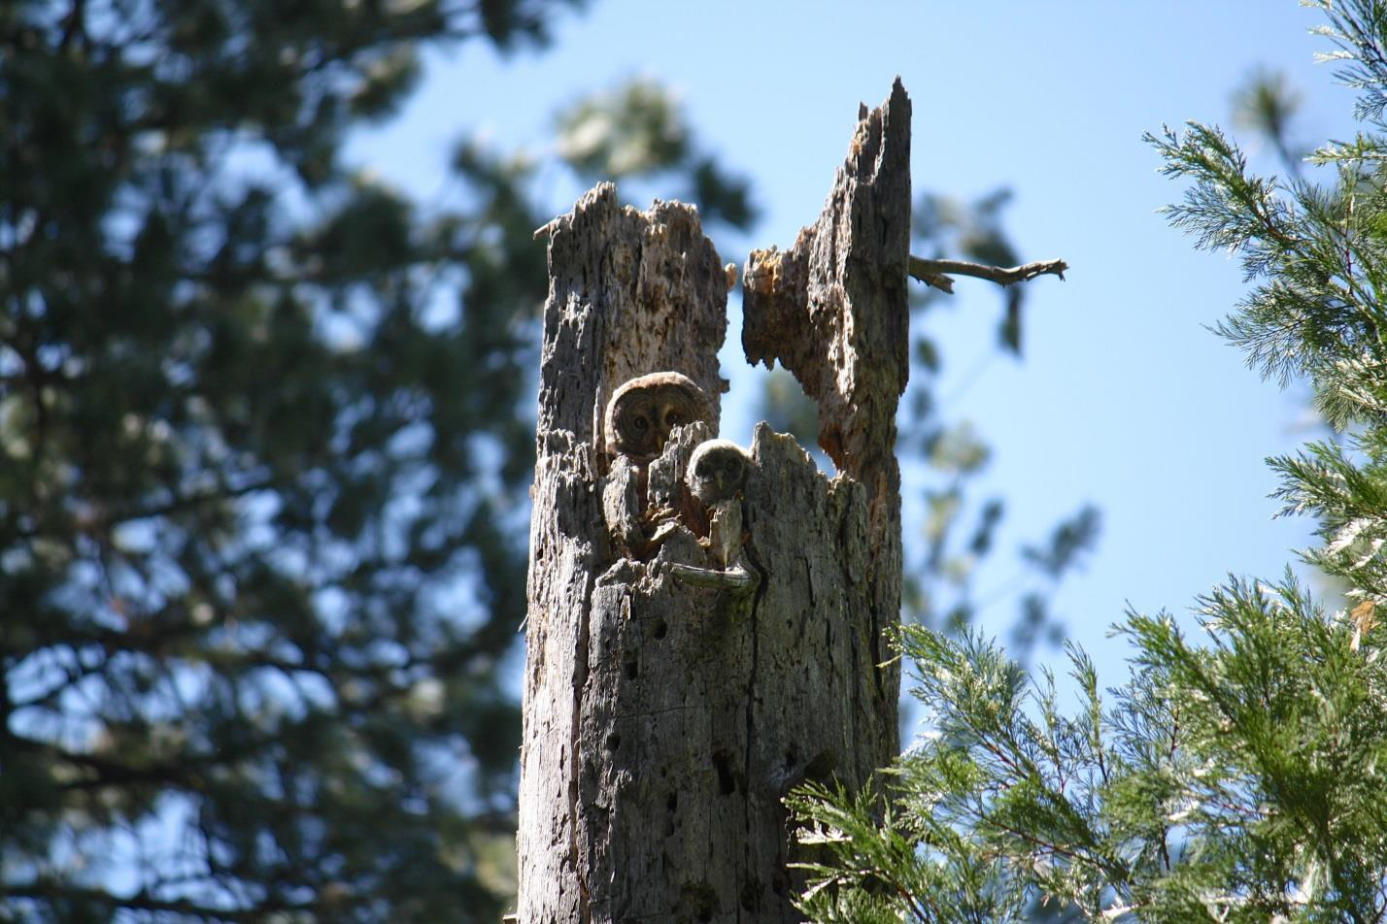
Figure 2. Great Gray Owl female and nestling, Yosemite National Park (T. Ely).

INTRODUCTION TO THIS STRATEGY

The Great Gray Owl was listed as endangered under the California Endangered Species Act in 1980 (Winter 1980). Few specific conservation and species recovery guidelines have subsequently been developed, although progress has been made in understanding habitat use and distribution in California. Habitat conditions and management approaches vary tremendously across lands administered by different government agencies and private landowners. The goal of this Conservation Strategy is to stimulate conservation actions that will prevent population declines and foster population increases. This report collates scientific knowledge of the species to inform

conservation recommendations to preventing extirpation of Great Gray Owls in California and increase the size of the population.

This Conservation Strategy is intended to be used by state and federal land managers, private landowners, and the scientific community. It provides more specific recommendations for management for Great Gray Owls than the Sierra Nevada Forest Plan Amendment guidelines on National Forests (US Forest Service 2004) and California Forest Practice Rules on private lands (California Department of Forestry and Fire Protection 2013), and supplements information in the widely used Great Gray Owl survey protocol (Beck and Winter 2000) that continues to guide survey efforts for the species in California. The geographic scope of this assessment is all of California, treating known owls on the Modoc Plateau as part of the North American subspecies (S. n. nebulosa) and owls from the Tahoe region to the southern tip of the Sierra Nevada as the putative Yosemite subspecies (S. n. yosemitensis), although substantial uncertainty about the geographic division between the two subspecies remains.

The objectives of this Conservation Strategy are to:
- Collate current knowledge of the owl’s biology,
- Outline current management policies across the species’ range in California,
- Identify threats to the species, and factors that may limit its population size,
- Recommend conservation actions (monitoring, habitat management and restoration, protection, outreach) to prevent declines and promote increases in the size of the California population, and
- Identify important gaps in knowledge and make recommendations for future research and monitoring efforts.

INFORMATION SOURCES

We compiled information used to develop this Great Gray Owl Conservation Strategy from a variety of sources. First, we gave precedence to peer-reviewed, published literature. Studies in California were weighted most heavily, but due to the paucity of such literature, we also consulted peer-reviewed studies from outside of California. The second source of information was an assessment of nesting habitat throughout the state (Wu et al. 2015) that we conducted after determining through literature review and interviews with subject experts (see below) that not enough was known about nesting habitat used by Great Gray Owls in California. A third source was theses and agency reports, several of which were crucial in the compilation of this document.

We also conducted one-on-one interviews with 23 experts and land managers in California who have studied Great Gray Owls, surveyed extensively for them, or manage for Great Gray Owl habitat on their lands (Table 2). We spoke to interviewees about Great Gray Owl biology, survey efforts, current management practices, threats to the species, conservation needs, and important gaps in knowledge.

Table 2. List of experts interviewed to consult on the Conservation Strategy. †Indicates reviewer of the Conservation Strategy.
Biologist | Affiliation | Date interviewed
Daniel Applebee† | California Department of Fish and Wildlife | 2/6/2014
Tom Beck | Former District Biologist, Stanislaus National Forest | 12/6/2014
Roy Bridgman† | Stanislaus National Forest – Groveland Ranger District, Tahoe National Forest – American River Ranger District | 4/17/2013
Stephen Byrd | Southern California Edison | 1/16/2014
Joe Croteau† | California Department of Fish and Wildlife | 4/16/2013
Mary Flores | Modoc National Forest – Devil’s Garden and Warner Mountain Ranger Districts | 4/16/2013
Eric Jepsen | UC Davis | 1/30/2014
Ryan Kalinowski† | Humboldt State University, Stanislaus National Forest | 3/26/2013
John Keane | USFS Pacific Southwest Research Station | 4/23/2013
Tim Kroeker | California Department of Fish and Wildlife | 2/18/2014
Patricia Krueger† | USFS Pacific Southwest Region Headquarters | 6/7/2013,  4/12/2016
Theresa Lowe | Sierra National Forest – Bass Lake Ranger District | 10/31/2013
Joe Medley | UC Davis, USFS Pacific Southwest Research Station | 7/19/2013
Russell Nickerson | Plumas National Forest – Beckwourth Ranger District | 11/6/2014
Anae Otto† | Sierra National Forest – Bass Lake Ranger District | 10/31/2013
Adam Rich† | Stanislaus National Forest – Summit Ranger District | 4/7/2013
Matt Reno | Sierra Pacific Industries | 9/5/2013
Kevin Roberts† | Sierra Pacific Industries | 4/18/2013
Cameron Rognan | Humboldt State University | 2/11/2014
Amanda Shufelberger | Sierra Pacific Industries | 4/18/2013
Kim Sorini† | Sierra National Forest – High Sierra Ranger District | 10/31/2013
Sarah Stock† | Yosemite National Park | 4/15/2013
Jon Winter | Winter and Associates | 12/6/2013, 12/17/2013

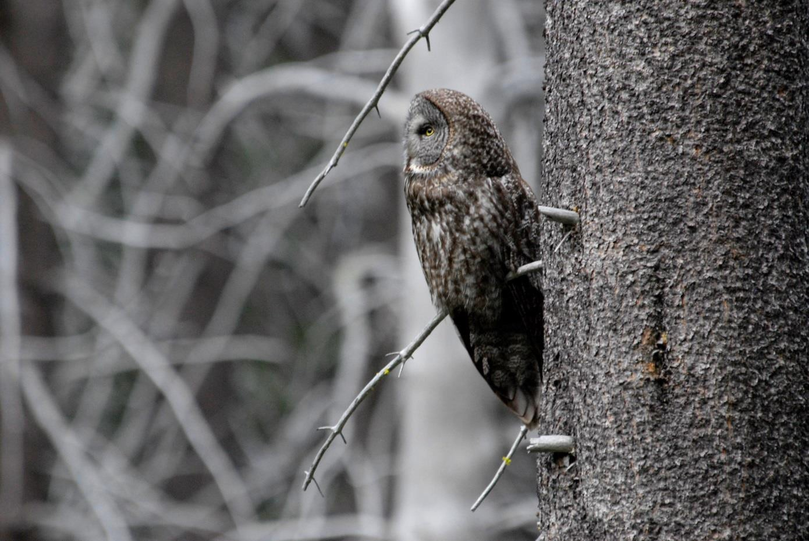
Despite the substantial research that has informed this Strategy, there are significant areas of uncertainty associated with many aspects of Great Gray Owl ecology and population biology in California. Throughout the text we have tried to identify areas of uncertainty, while still making working hypotheses or drawing preliminary inferences whenever possible. Information on Great Gray Owl ecology and conservation in California is being generated rapidly, with multiple important research efforts in progress. We request that new information be shared with the authors and CDFW so that we may make amendments to this Strategy as needed.

Figure 3. Despite its size, Great Gray Owl’s cryptic plumage allows it to camouflage well against conifer trunks, Sierra Nevada, California (J. Medley).

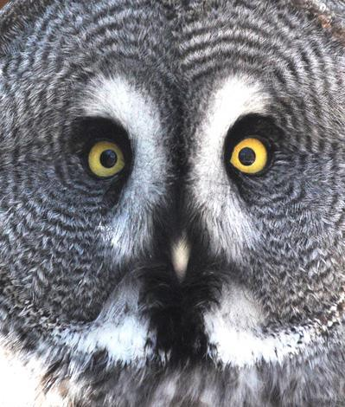
SPECIES DESCRIPTION AND ECOLOGY

Physical Description and Taxonomy

The Great Gray Owl (Strix nebulosa) is the largest owl in North America and one of the largest owls in the world, with a body length of 60-83 cm (Beck and Winter 2000) and an average body mass of about 1,080 grams. As with many raptors, females are slightly larger than males. Much of the species’ size is attributable to long feathers and thick plumage, as it weighs considerably less than the smaller Great Horned Owl (Bubo virginianus) and Snowy Owl (Bubo scandiacus). As its name suggests, the Great Gray Owl has overall gray plumage with smudgy markings (Sibley 2003) and some brown coloration on the back, underside of wings, and front. It has a large, round facial disk with dark concentric circles. Two white crescents, extending to three-quarters the length of the owl’s face, line the


Figure 4. Facial disc and “bowtie” of a Great Gray Owl (M. Woelfle).

inside edges of the owl’s small, yellow eyes. The Great Gray Owl has a yellow bill, heavily feathered tarsi and feet, and lacks ear tufts. On the middle of its chin is a diagnostic black spot flanked on either side by a white streak, forming a “bowtie” (Figure 4).

In its range in California, the Great Gray Owl can generally be readily distinguished from other owls by size and coloration. Spotted Owls (Strix occidentalis) are brown and cream and have larger black eyes. They are about two-thirds the size of a Great Gray Owl, have a stouter appearance, and have spot-like markings on its plumage. Barred Owls (Strix varia), which are currently rare in the Sierra Nevada but are experiencing range expansions (Gutiérrez et al. 2004), are similar in appearance and size as Spotted Owls but have a streaked front.

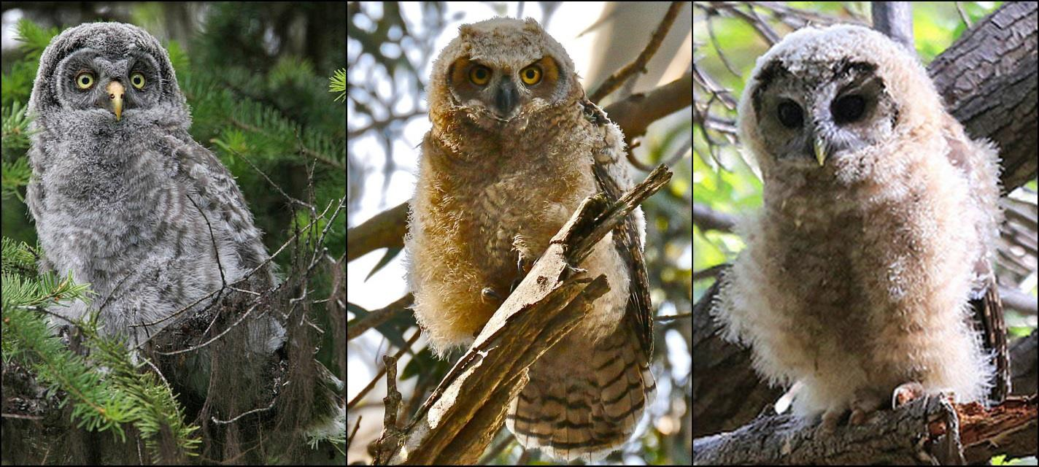
Figure 5. A Great Gray Owl fledgling (left; T. Munson) compared to a Great Horned Owl fledgling (middle; T. Llovet) and a Spotted Owl fledgling (right; A. Maizlish).

Compared to adults, Great Gray Owl fledglings (Figure 5) have lighter coloration on their body, but the same dark gray facial disk. Great Horned Owl fledglings (Figure 5) can look like Great Gray Owl fledglings, but the former always have brown facial disks. Spotted Owl fledglings have black eyes and brown coloration (Figure 5). Great Gray Owl fledglings molt into adult plumage in approximately September of the hatching year, although first-year birds retain white terminal tips on their tail feathers until their first winter (Beck and Winter 2000).

The Great Gray Owl is the only species in its genus (Strix) that breeds in both the new and old worlds (Hayward and Verner 1994). Other Strix owls in North America also include the Spotted Owl and the Barred Owl (S. varia). The Great Gray Owl is less nocturnal than other Strix species, as evidenced by its small eyes (Nero 1980). Two subspecies of Great Gray Owl are recognized: Strix nebulosa nebulosa in North America and S. n. lapponica in Eurasia (Gill and Donsker 2015). A third subspecies, S, n. yosemitensis, has recently been proposed for the Sierra Nevada of California. S. n. yosemitensis likely became isolated from the rest of the North American population during Pleistocene glaciation approximately 27,000 years ago, and retained genetic distinctness following glacial retreat (Hull et al. 2010a, 2014).

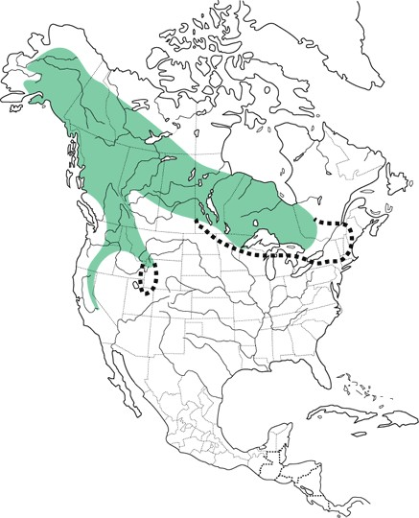
Distribution and Population Status

Great Gray Owls have a Holarctic distribution, inhabiting boreal forests from Scandinavia across Russia to northern Mongolia and China, and across Alaska and Canada down to the Rocky Mountains, Pacific Northwest, and the Sierra Nevada, which is the southernmost extension of their range (Figure 6; Bull and Duncan 1993). The core of the California population is considered to be the western slopes of the Sierra Nevada in Yosemite National Park, Stanislaus National Forest, and Sierra National Forest (Beck and Winter 2000, van Riper and van Wagtendonk 2006, Hull et al. 2014). However, breeding records to date extend north and south from El Dorado County to the boundary of Fresno and Tulare counties (Figure 7). North of Yosemite, there have been scattered records in El Dorado, Nevada, Sierra, Yuba, Butte, Plumas, and Modoc counties with a few historic records in the Klamath Mountains in northwestern California (Winter 1980, Hull et al. 2014). The species has been documented to breed as far south as Tulare County in Sequoia National Forest (Wu et al. 2015). Though there have been a few scattered detection records on the eastern slope of the Sierra Nevada, pairs or evidence of breeding have never been confirmed.
Figure 6. Distribution of Great Gray Owls in North America (Bull and Duncan 1993).

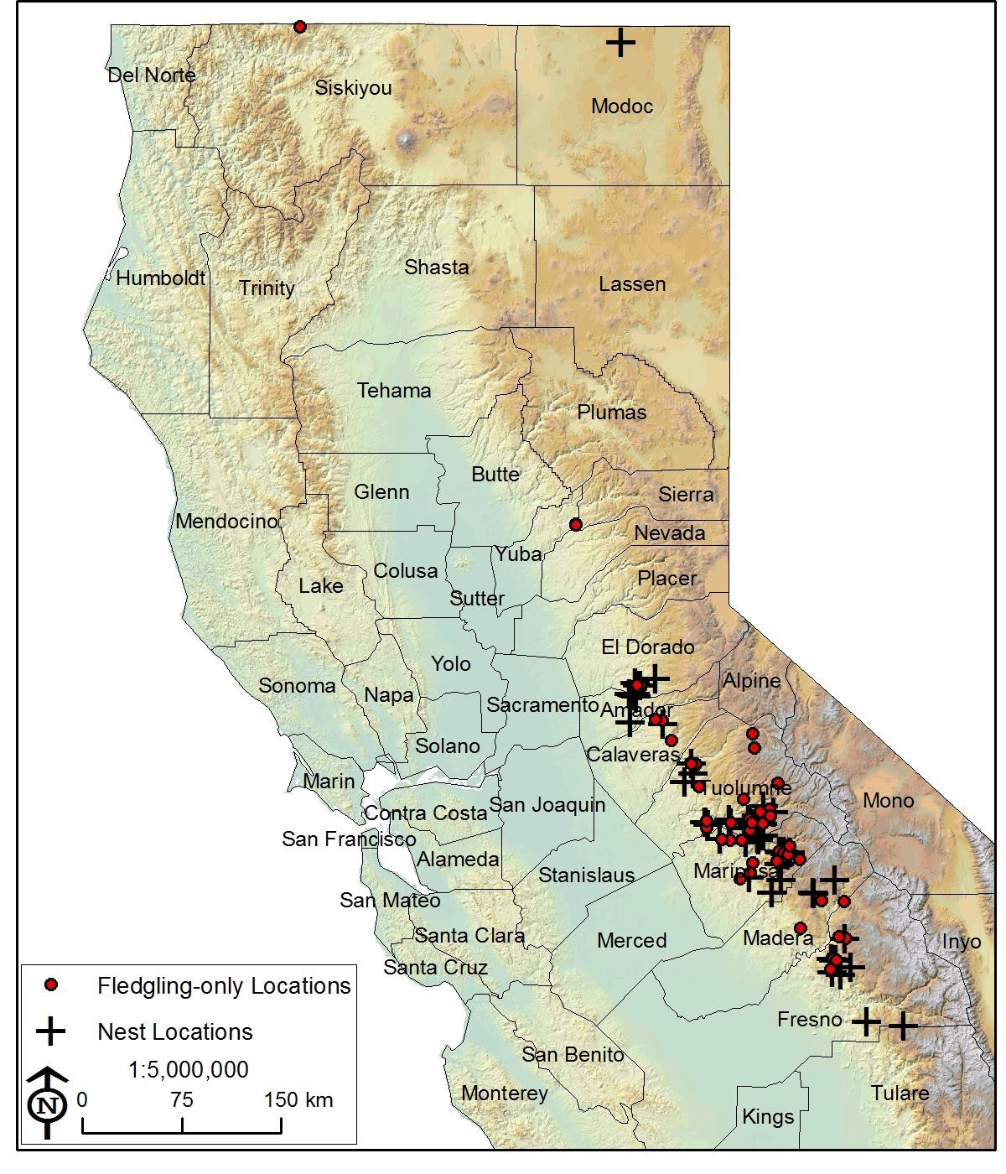

Figure 7. Distribution of all known Great Gray Owl reproductive territories across California.
This map includes natural nest locations (we excluded artificial nests to convey habitat selection) and fledgling-only locations (where a fledgling was detected at least once but the nest was not found). Data were collated from the Natural Resource Information System, California Natural Diversity Database, and various biologists from Yosemite National Park, Stanislaus National Forest, the California Department of Fish and Wildlife, the Pacific Southwest Research Station, Sierra Pacific Industries, and Southern California Edison. Map current as of fall 2015.

Great Gray Owls are secretive, less vocal than many other owls, and rare throughout their range, making precise assessment of population sizes difficult (Beck and Winter 2000). Nero (1969 in Hayward and Verner 1994) estimated 5,000-50,000 owls in North America and then later placed the estimate at the high end of that range, 50,000 owls in North America (Nero 1980). Partners in Flight estimates that 31,000 Great Gray Owls persist in North America, half of the global population of 60,000. Of the 31,000 owls in North America, 29,000 are thought to be in Canada and Alaska, and the rest in the lower United States (Partners in Flight Science Committee 2013). Initial surveys in 1979 that led to the placement of the species on the California Endangered Species List estimated there to be 30-40 individuals in the state of California (Winter 1980), later revised to 60-70 with 20-24 in Yosemite National Park (Winter 1984), then revised to 73 individuals based on density extrapolation to appropriate habitat (Winter 1986). Other researchers have estimated more than 100 individuals (Greene 1995), 80 individuals (Maurer 2006), no more than 200-300 individuals (California Department of Fish and Game 2007), and 100-200 pairs (Keane et al. 2011) as a result of more extensive surveys and the discovery of additional pairs since the initial 1979 survey.

We compiled Great Gray Owl reproductive records to obtain a population estimate for California. Using data from the Natural Resource Information System (US Forest Service 2013), the California Natural Diversity Database (California Department of Fish and Wildlife 2013a), the Gould Database (California Department of Fish and Wildlife 2013b), and unpublished data collected by various biologists affiliated with Yosemite National Park, Stanislaus National Forest, the Pacific Southwest Research Station, Sierra Pacific Industries, and Southern California Edison, we collated Great Gray Owl reproductive records between 1973 and 2015. If a nest or fledgling was confirmed at least once, then the sighting was classified as a breeding record. We tallied all reproductive territories, with each territory considered unique when spatially separated from another by 900 m, and each meadow assumed to support only one territory unless multiple pairs were confirmed to use it in the same year. Using all reproductive locations, we identified 79 reproductive pairs at 77 territories or meadow systems (Figure 7), suggesting a population of approximately 158 breeding adults. However this estimate has substantial potential to vacillate up or down. On the one hand, some reproductive sites were most likely never discovered and this method does not account for non-breeders. On the other hand, although evidence of the same nest being used several years in a row suggests some degree of site fidelity (Keane et al. 2011), no multi-year demography studies have been conducted to investigate the degree to which individual Great Gray Owls may shift territories or breeding sites between years; a count of all occupied sites over time could include the same individuals breeding at multiple sites in different years. To address the overestimation concern, we obtained a minimum population estimate by tallying all reproductive territories detected in the year with the highest number of such detections. There were 24 documented reproductive sites in 2007, leading to a minimum of 48 adult Great Gray Owls in California. However, there are almost certainly more Great Gray Owls in California than 24 pairs, given limited survey effort and relatively low probabilities of detecting nests or fledglings. We believe 79 pairs, or approximately 160 adults, is a more realistic estimate.

Historical data on Great Gray Owl abundance in California is scant, so population trends are unclear. The species was rarely detected during surveys across the Sierra Nevada in the early 1900s by Joseph Grinnell (Winter 1980), and is believed to have always been rare in the post-

settlement era. However, on top of being small, the population has likely experienced at least two major anthropogenic events that resulted in loss of habitat quality and quantity. The first such event occurred between 1850 and the early 1900s with a population influx due to the gold rush, and the associated stream and meadow degradation and deforestation from widespread mining, grazing, and old growth logging. After about 1950, another increase in logging activity occurred as mechanization allowed access to more forest previously too steep or remote to access, and as rural communities grew within upper foothill areas and around mountain resorts. Anthropogenic activities, such as removal of large trees and snags that were needed for nesting, and livestock grazing and stream channel incisions related to road construction and mining, impacted meadows, and in turn prey abundance (Gould 1987).

Habitat Requirements
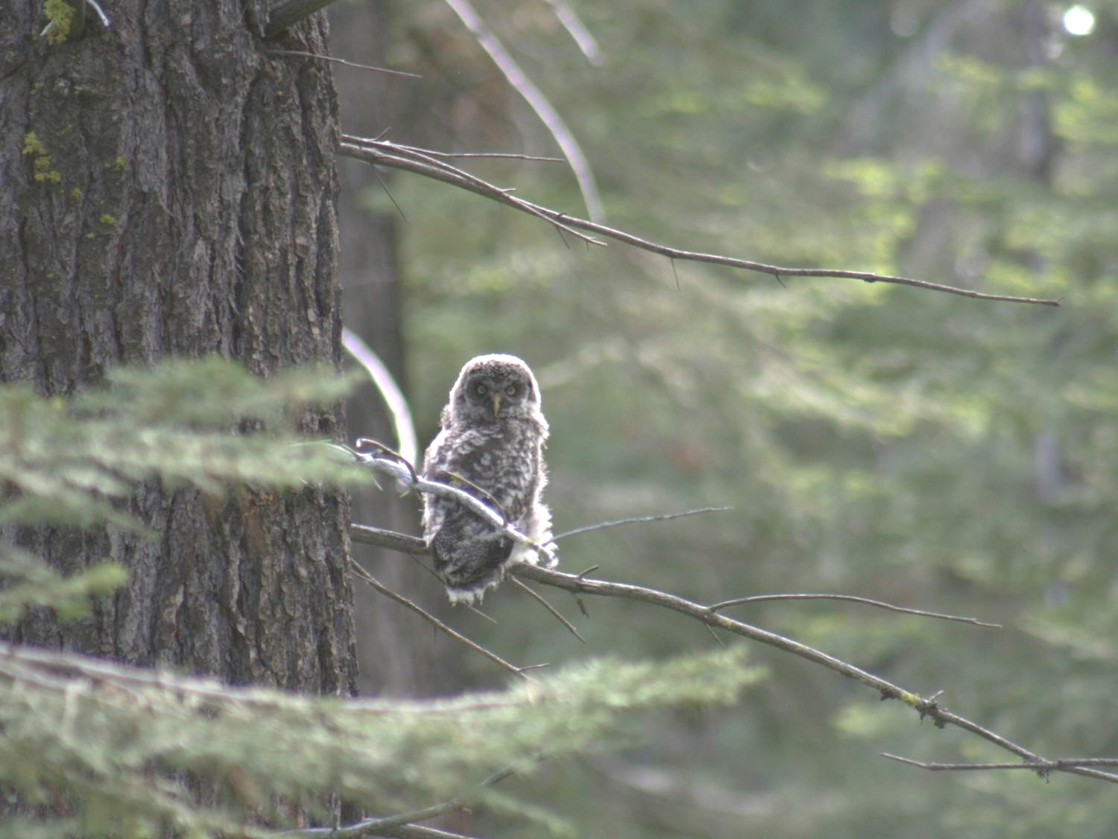
Breeding Season

Great Gray Owls nest in a variety of conifer-dominated habitats in California, from montane hardwood- conifer forests at lower elevations to Sierran mixed conifer, white fir (Abies concolor), red fir (Abies magnifica), and to some degree, lodgepole pine (Pinus contorta) forests (See nest habitat photo gallery, Figures 10-15, for examples). Once thought to be a montane conifer specialist occurring primarily within an elevation range of 1,980-2,380 m in the Sierra Nevada (Keane et al. 2011), recent information suggests that the breeding elevation of Great Gray Owls ranges more broadly, from 691-2,420 m (Wu et al. 2015, Polasik et al. 2016). Twelve of 56 (22%) nests documented in the Sierra Nevada were below 1,000 m in elevation, which approximately represents the lower conifer-zone limit in the central Sierra Nevada (Wu et al. 2015).
Figure 8. Juvenile Great Gray Owl, Sierra National Forest (C. Stermer).

Great Gray Owls generally breed in close proximity to meadows (Winter 1986, Greene 1995, Sears 2006, van Riper and van Wagtendonk 2006, Keane et al. 2011); however, 21% of nests documented in the Sierra Nevada were more than 750 m (2,460 ft) from the nearest meadow (Wu et al. 2015). In an analysis that rounded distances down to 750 m when nests were >750 m from the nearest meadow, nests averaged 240 ± 283 m (787 ± 928 ft) from the nearest meadow. Nests that did appear to be associated with meadows (<750 m from meadow perimeter) averaged 102 ± 104 m (335 ± 341 ft) from the nearest meadow (Wu et al. 2015). Great Gray Owls are less associated with meadows at the lower limits of their elevation range in the Sierra Nevada than in the middle and at the higher limits (Wu et al. 2015), perhaps because montane meadows are more common at higher elevations (Fites-Kaufman et al. 2007). At lower elevations, there are more annual and perennial grassland habitat types and riparian stringers that Great Gray Owls use for hunting, but even if those habitats are utilized as if they were meadows, nest sites are not

as closely associated with meadow-like habitats as they are at higher elevations (Wu et al. 2015). For nesting, Great Gray Owls prefer a dense overstory (Whitfield and Gaffney 1997) of >80% canopy cover (Greene 1995, Wu et al. 2015). Other nesting habitat characteristics may include a cool, north-facing slope (Greene 1995), relatively flat to a moderate slope (Greene 1995, Keane et al. 2011), and relatively high densities of large snags (Sears 2006, Wu et al. 2015). Although nests in conifers are most common, recently compiled data indicate that Great Gray Owls will also nest in oaks (see Figure 16 for examples of nest trees); 15 of 50 nests across various jurisdictions in California with identified substrates were in black oaks (Quercus kelloggii) or valley oaks (Quercus lobata; Wu et al. 2015). Nest trees of all species had an average dbh of
100.7 ± 30.6 cm (39.6 ± 12.0 in) and an average height of 18.3 ± 8.7 m (60.0 ± 28.5 ft; mean and SD; Wu et al. 2015). The one nest that has been described in Modoc County, likely belonging to owls of the nebulosa subspecies, was in a mistletoe broom in a 40 cm dbh ponderosa pine (Pinus ponderosa).

Characteristics of Great Gray Owl roost sites tended to be different from nest sites and hunting perches. Based on telemetry data from three males, Winter (1986) found that roosting perches were 10.9 ± SD 5.6 m (35.8 ± 18.4 ft) tall, which is significantly higher than hunting perches (3.3


± 2.3 m/10.8 ± 7.4 ft). Roost trees were also overwhelmingly live trees (92%), presumably because they offer more cover than snags, and were in a diversity of tree species (Winter 1986). Intermediate and large trees (>23 cm/9 in dbh) were used more than expected, while trees smaller than that were avoided (Winter 1986). Roost sites were 90.0 ± 91.0 m (295 ± 299 ft) from the nearest meadow, ranging from 23-362 m/75-1188 ft (Winter 1986). Besides this study in the core Yosemite-Stanislaus region, we know little about Great Gray Owl roost sites, and more research is needed to understand roost site selection.

Monitoring and Research Needs
Analyze existing telemetry and habitat data or collect new data to better understand Great Gray Owl roost site selection.

Winter

In the central Sierra Nevada, Great Gray Owl wintering habitat is generally lower in elevation than breeding habitat and may be more diverse (van Riper and van Wagtendonk 2006, Jepsen et al. 2011). Nine birds that bred in Yosemite wintered at lower elevations ranging from 600 to 1,450 m (Skiff 1995). Six birds that bred on the Sierra and Stanislaus National Forests spent the winter around 750 to 1,500 m (Chris Stermer, unpublished data). Wintering Great Gray Owls in California use a variety of habitat types, including montane hardwood-conifer, ponderosa pine, Sierran mixed conifer (Skiff 1995, Chris Stermer, unpublished data), lodgepole pine, red fir (van Riper and van Wagtendonk 2006), ponderosa pine (Jepsen et al. 2011), grassland, meadow, and riparian areas (van Riper and van Wagtendonk 2006, Jepsen et al. 2011). Skiff (1995) reported that observed winter grounds were generally snow-free for most of the winter, with the maximum snow depth measuring 31 cm (12 in) following a storm, compared to snow depths of 36-55 cm (14-22 in) on breeding grounds during the same time period.

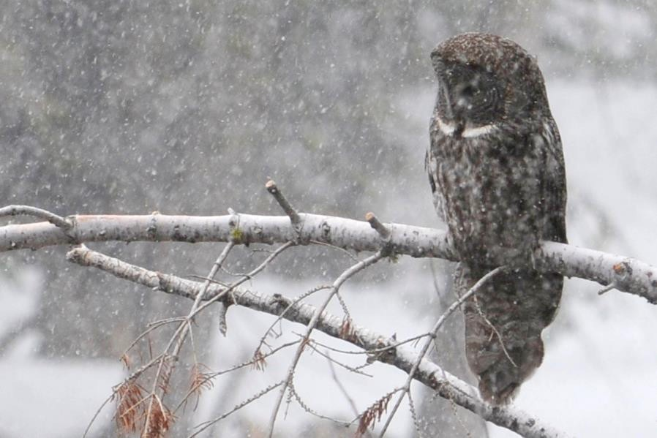
Figure 9. Great Gray Owl in a winter storm, Yosemite National Park (R. Byrnes).

Habitat Photo Gallery

Examples of Great Gray Owl Habitat Near Known Nest Sites

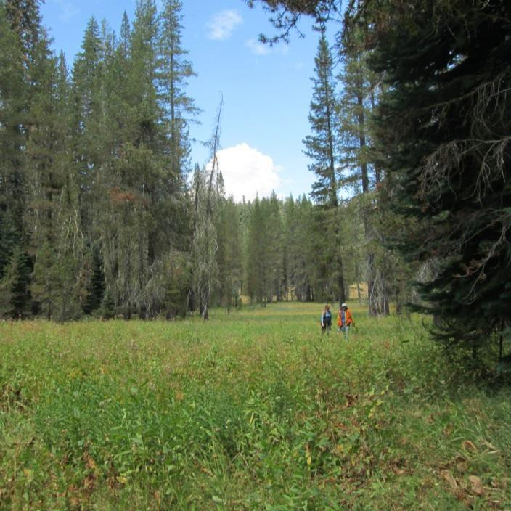
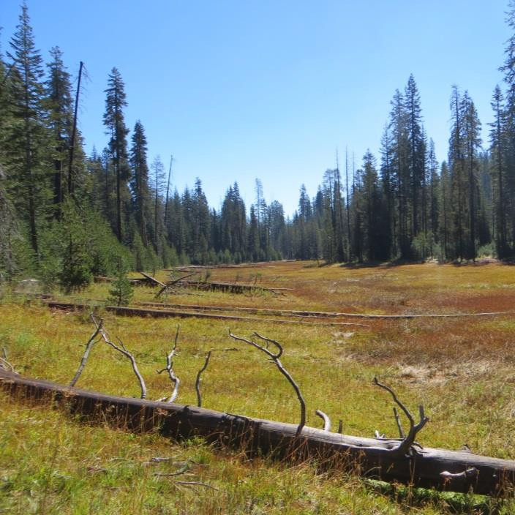
Figure 10. Yosemite National Park, 2,220 m (H. Loffland).
Figure 11. Yosemite National Park, 2,070 m (K. Strohm).

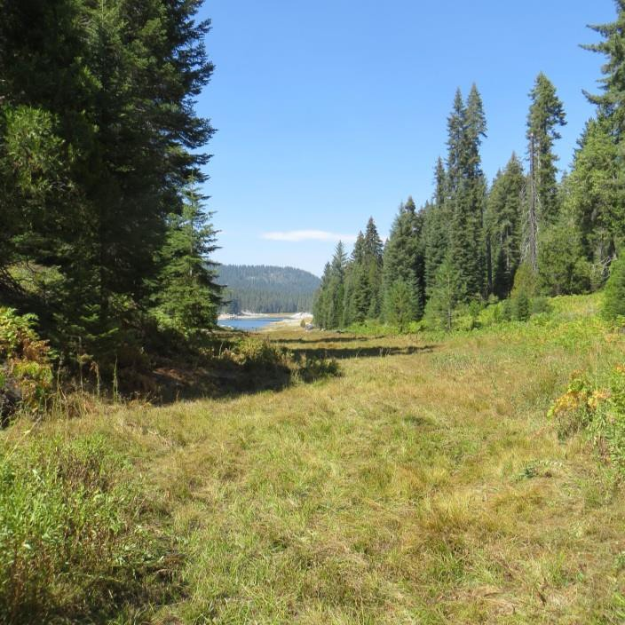
Figure 12. Southern California Edison, Fresno County, 1,670 m (K. Strohm).

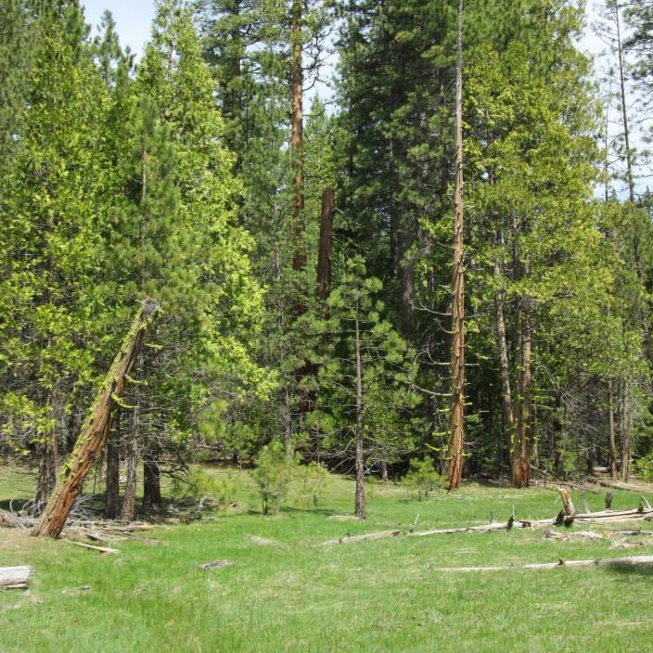
Figure 13. Stanislaus National Forest, 1,370 m (H. Loffland).

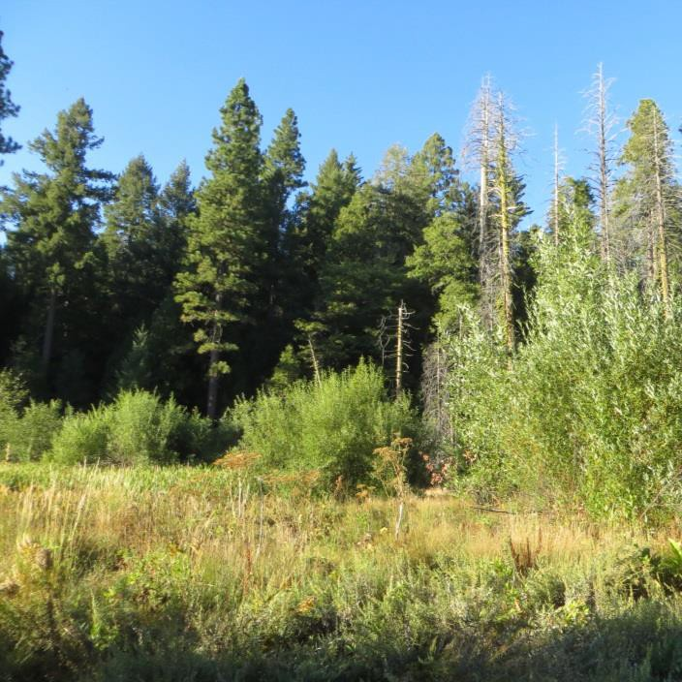
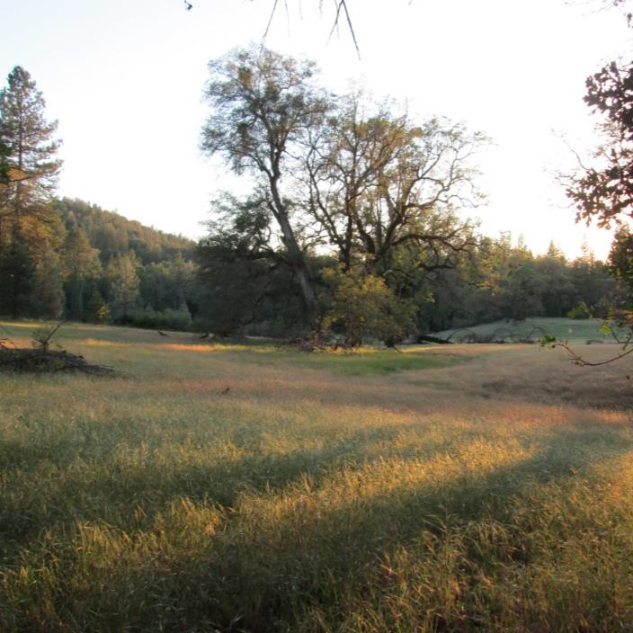
Figure 14. Eldorado National Forest, 1,250 m (K. Strohm).
Figure 15. Sierra Pacific Industries, El Dorado County, 670 m. (H. Loffland).

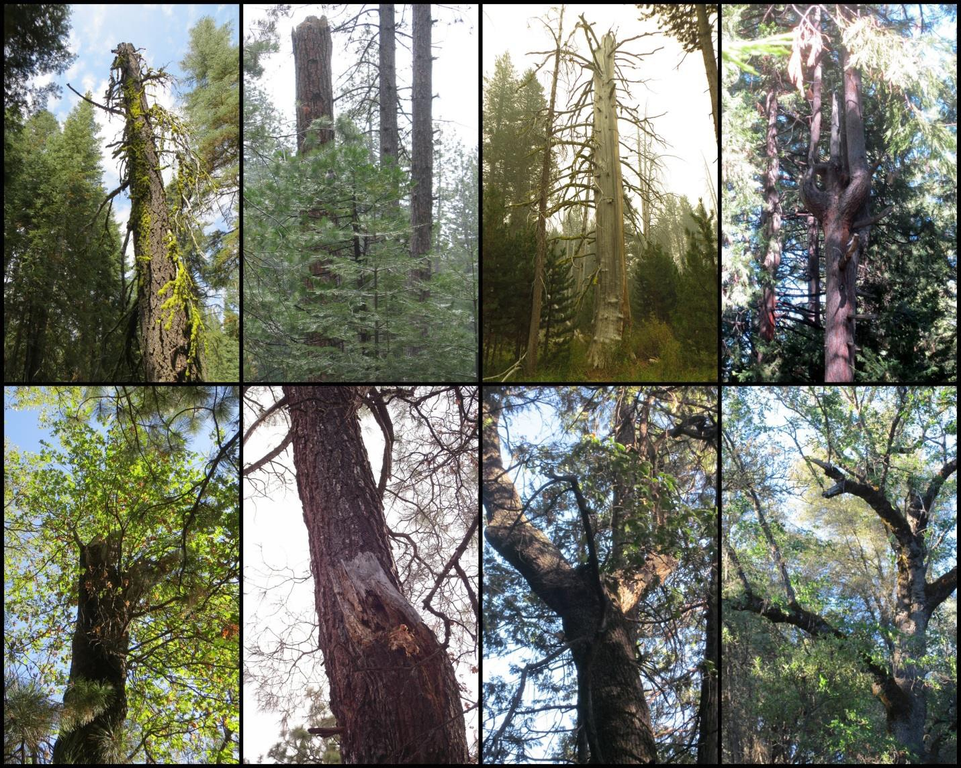

Diversity of Nest Trees Used

Figure 16. Examples of Great Gray Owl nests used in the Sierra Nevada, California. In the top panel, from left to right, are nests in the broken top of a red fir snag, broken top of a ponderosa pine snag, broken top of a lodgepole pine snag, and a fork in the branches of a live ponderosa pine. In the bottom panel, from left to right, are nests in the broken top of a live black oak bole, an upright cavity left by a sloughed-off secondary trunk in a live gray pine, and a fork in two large branches of a live black oak. The last panel shows a platform nest on a broad, flat section of a branch in a live black oak (indicated by the arrow to the left) used in one year, then another nest in a cavity (arrow, right) used in a subsequent year (and K. Roberts, pers. comm.). Figure from Wu et al. (2015).

Food Habits

In California, voles (particularly Microtus montanus and M. longicaudus) and pocket gophers (Thomomys sp.) comprise around 90% of Great Gray Owl diet in terms of biomass (Figure 17; Winter 1986, Reid 1989). Besides voles and gophers, Great Gray Owls have been documented to eat other food items in small quantities, such as deer mice, moles, shrews, beetles, small passerines, squirrels, a juvenile rabbit, chipmunks, and alligator lizards (Winter 1986, Reid 1989; Kevin Roberts, pers. comm.). In northeastern Oregon, Great Gray Owls were observed to consume 65% voles and 30% pocket gophers, with the rest of the diet comprised of a similar

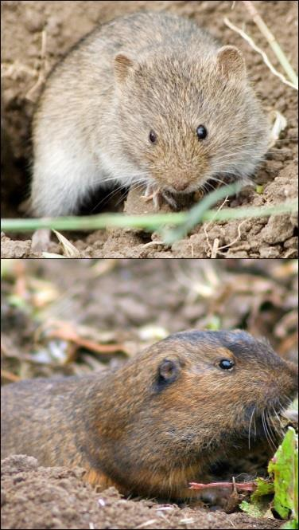
assemblage of food items as listed above (Bull et al. 1989). In northern Scandinavia, owls consumed more than 90% various voles and lemmings during the breeding season, with the rest of the diet consisting of shrews, snails, beetles, frogs, birds, mice, squirrels, weasels, and a muskrat (Mikkola and Sulkava 1970, Mikkola 1972).

There may be some elevational and latitudinal variation in diet composition in the Sierra Nevada. Gophers and voles are consumed in similar proportions at mid- to high-elevations (Winter 1986, Reid 1989). However, preliminary pellet analysis at lower-elevation (700- 1000 m) sites in the Sierra Nevada, where reproductive output is high (Polasik et al. 2016), suggests that pocket gophers might be the most abundant food resource (Kevin Roberts, unpublished data). Likewise,
- n. nebulosa on the Modoc Plateau may consume primarily gophers, although this information is also from preliminary pellet analysis from a very limited sample size, and more research is needed (Joe Croteau, pers. comm.).
Figure 17. Top, vole (V. Khustochka) and bottom, gopher (D. Hofmann)

Preying on locally abundant voles and gophers may allow Great Gray Owls to stay in their general range year round in California (Bull and Duncan 1993). It has been suggested that access to a consistent food supply may be more important for nesting Great Gray Owls than any specific structural component of nesting habitat because owls seem flexible in their use of nest structures. However, whether nesting success or fecundity varies with nest type is unknown.




Monitoring and Research Needs
  - Study Great Gray Owl dietary requirements, particularly during the nesting season, including:
    - Elevational and latitudinal variation in diet composition
    - Microtus population status, population cycling dynamics, and habitat
requirements

  - Assess the feasibility of using stable isotope analysis from collected feathers to study Great Gray Owl diet variations.

  - Assess the feasibility of using DNA extracted from pellets to distinguish Great Gray Owl pellets from Great Horned Owl pellets. If successful, this method may provide an additional non-invasive tool to help determine Great Gray Owl distribution within the state, define home range boundaries, reduce uncertainty in dietary studies using pellets, and understand interspecific competition and predation.

Life History and Population Ecology

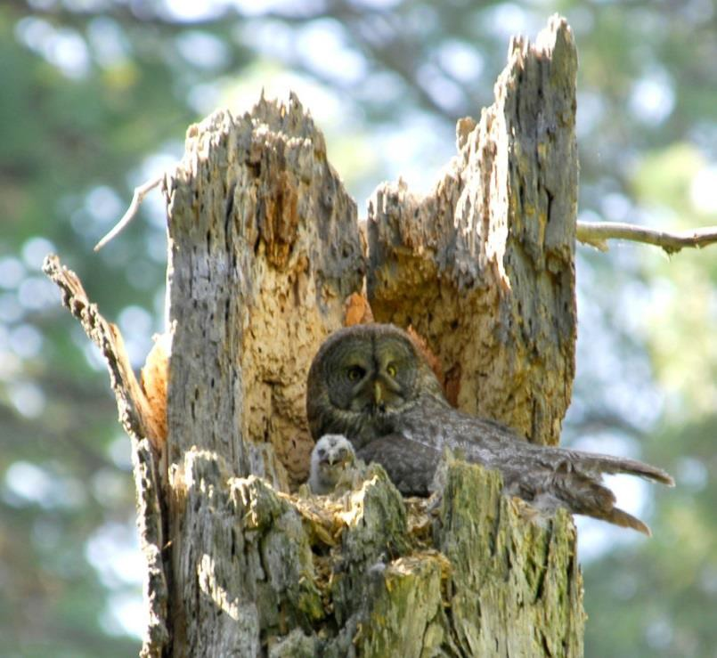
Like most large raptors, Great Gray Owls are long-lived, and are thought to have a life span of 10-20 years in the wild (Williams 2012). There are records of banded individuals recaptured after nine and 13 years (Bull and Duncan 1993). One Great Gray Owl, hit and killed by a car in 2003, was believed to have been banded in the late 1980s, indicating an age of more than 15 years; however, the record is not confirmed (Maurer 2004). Bull and Henjum (1990) estimated first year survival at only 0.53 in Northeastern Oregon, but adult mortality is believed to be >0.7 (Bull and Henjum 1990, Williams 2012). Great Gray Owls start breeding at three years of age, occasionally breed at two years of age and rarely breed at one year of age (Bull and Duncan 1993, Williams 2012).

Reproduction and Phenology
Figure 18. Female Great Gray Owl with nestling on broken- top nest, Yosemite National Park (J. Medley)

Pair bond formation in Great Gray Owls breeding in Manitoba, Canada occurs during January to April (Nero 1980), though phenology may be several weeks earlier in California (Winter 1982). In courtship, the male takes a rodent to the female. After the female accepts, the pair bond is established (Nero 1980). It was generally thought that nests in California do not produce more than two chicks (Winter 1986), while those in the rest of North America and Europe often produce a brood of three to five (Mikkola 1976, Nero 1980, Bull and Duncan 1993, Williams 2012). However, there have been eight documented cases since 1999 in which a brood of three young was produced: six on Sierra Pacific Industries property (Kevin Roberts, unpublished data) and two on Sierra National Forest (US Forest Service 2013). During incubation and early brooding, approximately April through May, the male generally feeds the female exclusively while the female stays on the nest (Beck and Smith 1987). During early to mid-June, the female leaves the nest more often, while the young became mobile and were frequently outside the nest. Young fledge from the nest typically around mid-June (Beck and Smith 1987), though the range was mid-May to mid-June in Northeastern Oregon (Bull and Henjum 1990). After fledgling, females left care of young to males in 11 of 12 observed cases in Northeastern Oregon; in the one other case, the male had ceased to feed the young prior to fledging, and one owlet died, presumably of starvation, while the female fed the other owlet that fledged (Bull and Henjum 1990). Young started hunting on their own at around three months (Bull and Duncan 1993), around mid- to late September.

Reproductive patterns in California’s Great Gray Owls may correspond to prey abundance and population cycling. Winter (1984) suggested that Great Gray Owl reproduction might be prey-

limited since low-vole years were also years of low owl reproduction. In the Great Gray Owl geographic range in the Sierra Nevada, three species of voles occur, Microtus montanus, M. longicaudus, and M. californicus (Kalinowski et al. 2014). M. montanus and M. californicus exhibit multi-annual cycles (Hoffmann 1958, Batzli and Pitelka 1971, Fitzgerald 1977), and M. longicaudus fluctuates seasonally instead of multi-annually (Taitt and Krebs 1985). Though Winter (1986) postulates that voles may be more important than gophers for Great Gray Owls to successfully reproduce, Reid (1989) documented successful reproduction in a year with high gopher prey biomass, and suggests that cumulative prey biomass may be more important than either gophers or voles. Gophers are not known to exhibit multi-annual population cycles. Given the fluctuating nature of microtine prey species, a male’s ability to provide for his nest may vary greatly within a season or between years.

Mortality Factors

As in other raptors, Great Gray Owl mortality rates are highest in the juvenile stage due to factors such as predation, malnutrition at the nest, and inexperience at hunting (Bull and Henjum 1990, Bull and Duncan 1993). In Oregon, young birds had a 0.53 and 0.31 probability of surviving one and two years, respectively (Bull and Henjum 1990). Once the owls reach adulthood, annual survival rates are apparently much higher, and were estimated at 0.91 and 0.84 for males and females respectively in Northeastern Oregon (Bull and Henjum 1990). Other isolated causes of death include shooting, infection from insect bites, and being electrocuted and impaled on wires (Bull and Duncan 1993). No demographic study has been conducted to determine survival rates in California, and relatively little is known about causes of death. Mortality factors include disease, depredation, and human-related causes.


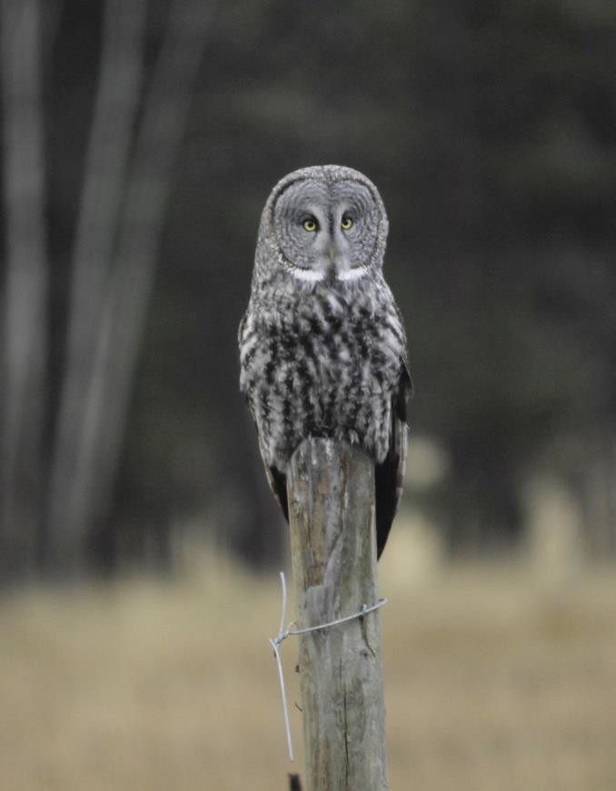
One mortality factor that emerges repeatedly across the owl’s range is collisions with vehicles. In Alberta, Canada, one of 36 banded owls was killed by a car (Collister 1997), and as many as 800 individuals during a winter irruption of more than 5,000 birds were killed by vehicles while hunting along the roadside (Svingen and Lind 2005). In California, 30 road kills were documented prior to 2005 (Maurer 2006), and between 2006 and 2014 an additional 12 road kills were documented (Figure 20; Chris Stermer, unpublished report; Roy Bridgman, Kevin Roberts, Sarah Stock, pers. comm.). These numbers represent a substantial portion of the state’s population, and likely several times more Great Gray Owls incur road casualties than are reported (Maurer 2006). Maurer (2006) suggested that car strikes may be the single biggest cause of mortality for Great Gray Owls in California (see Potential Threats and Recommendations to
Minimize Them: Human Activity). Figure 19. Great Gray Owl perched on a post,
Montana (USDA).

Figure 20. Locations of 32 of 42 known Great Gray Owl vehicle strikes in California. Ten locations were not specific enough to be mapped (nine were in Yosemite National Park, one was in Sierra National Forest).

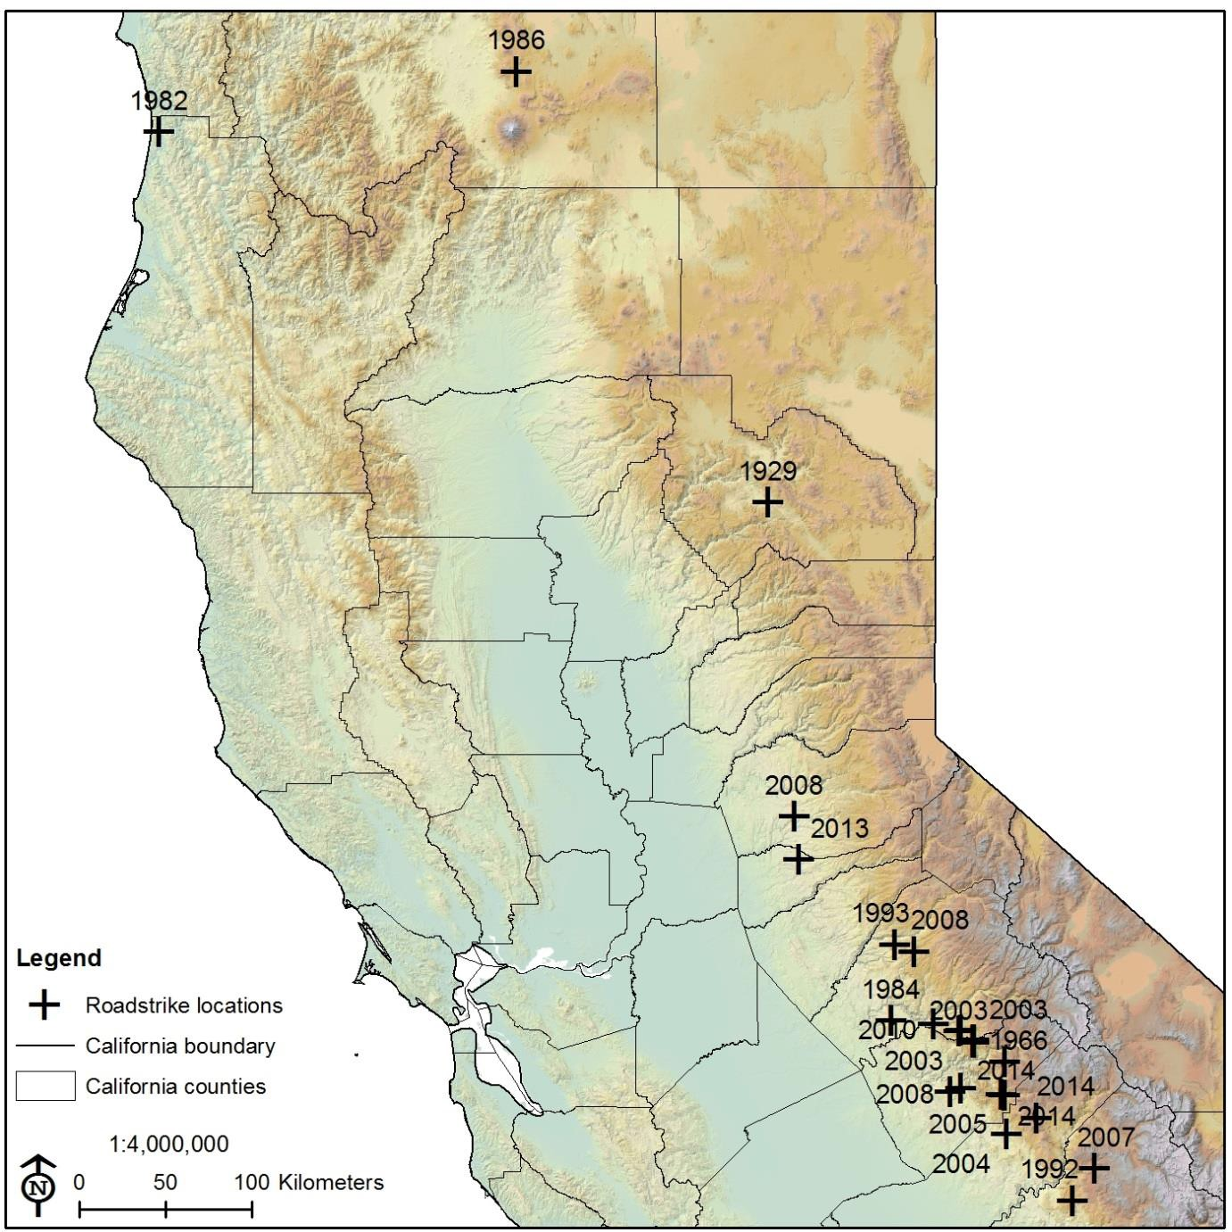
Home Range

The movements of California’s Great Gray Owls tend to be much smaller than those of their boreal counterparts, since they rely on two non-migratory prey items (van Riper and van Wagtendonk 2006). The few telemetry studies in California found that breeding birds had a home range of 61.5 ± 12.9 hectares (152.0 ± 31.9 acres; 95% adaptive kernel; van Riper and van Wagtendonk 2006) and 258 ± 118 hectares per breeding pair (638 ± 292 acres; minimum convex polygon; Winter 1986). Movements made during winter are an order of magnitude larger than those during the breeding season (van Riper and van Wagtendonk 2006), though this may in part

reflect that owls make large flights to the wintering range, and then use a much smaller area once there (Jon Winter, pers. comm.).

Migration

Great Gray Owls exhibit facultative downslope migration in California (Winter 1986, van Riper and van Wagtendonk 2006, Jepsen et al. 2011; Chris Stermer, unpublished data), but are otherwise non-migratory. In a study of nine Great Gray Owls that bred in Yosemite National Park between 1986-1990, all birds made downslope migrations during winter associated with a high snow depth on their breeding range (Skiff 1995). Most movements were within 5 km, but birds moved up to 30 km from their last known location (Skiff 1995). In a separate study in an area south of Yosemite National Park, none of four radio-tracked owls made downslope migrations during fall (between approximately August and December; Chris Stermer, unpublished data). In the same study, three owls spent at least a portion of winter months (approximately December to March) at a lower elevation site, whereas two other owls did not appear to make downslope movements during winter (Chris Stermer, unpublished data). Compared to the birds that bred within Yosemite National Park, the birds from the second study bred at lower elevations and perhaps did not need to move to avoid snow.

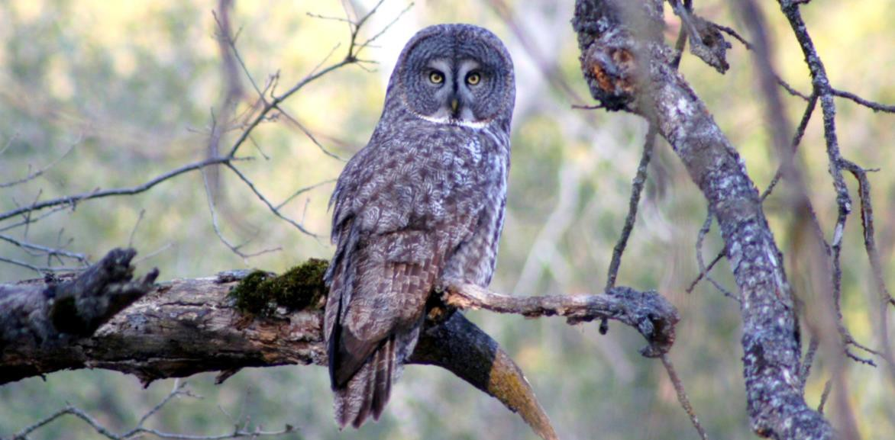
A diversity of habitats across the elevational gradient of the Sierra Nevada may reduce the need for long-distance migration, as was suggested for southwestern Alberta by Collister (1997). Though Great Gray Owls have been well documented to hunt in deep snow in the boreal forest and elsewhere in their range (Collins 1980, Nero 1980, Bull and Duncan 1993), they may have difficulty breaking the crust of ice that forms on top of snow in the Sierra Nevada as a result of repeated melting and freezing events (Jepsen et al. 2011). Furthermore, compared to the boreal forest, it is a relatively short flight for Sierra Nevada owls to travel downslope to snow-free areas, where hunting success is presumably higher than in snowy areas (Jon Winter, pers. comm.). Winter irruptions documented elsewhere in the Great Gray Owl’s range (Bull and Duncan 1993, Nero and Copland 1997) are not known to occur in California (Winter 1986). The population size may be too small for an irruption to manifest.

Figure 21. Great Gray Owl, Madera County (A. Williams).

SPECIES CONSERVATION, HABITAT MANAGEMENT, AND RECOMMENDATIONS FOR LAND MANAGERS

History of Great Gray Owl Protection in California

In 1980, the Great Gray Owl was listed as endangered under the California Endangered Species Act (CESA; Winter 1980). In receiving this designation, a review of the species status was performed, and based on that evaluation it was determined to warrant listing it as an endangered species. In a five-year evaluation by the California Department of Fish and Game, Gould (1987) recommended that the Great Gray Owl remain listed. The Stanislaus National Forest implemented interim management guidelines (Beck 1985), but besides that, there have been few guidelines issued until the US Forest Service implemented the 2001 Sierra Nevada Forest Plan Amendment (US Forest Service 2001).

Current Management Status

Management on National Park Service Lands

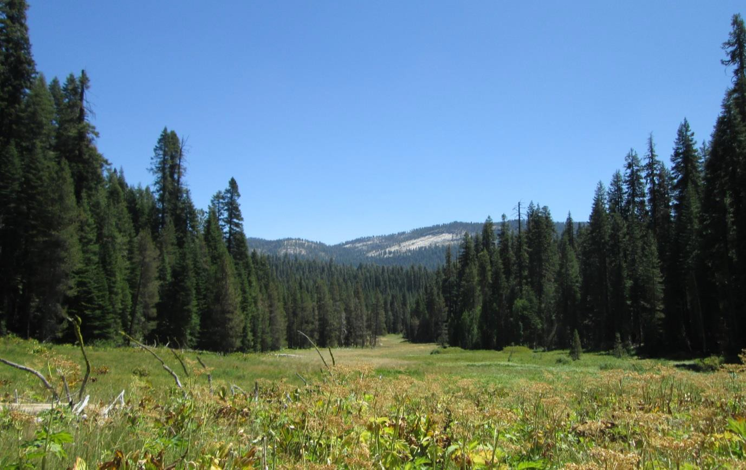
At Yosemite National Park, the Great Gray Owl is inventoried, monitored, and managed in a manner similar to federally endangered species (National Park Service 2006). Biologists and managers first became aware of Great Gray Owls nesting in the park around 1915, and various survey and monitoring efforts by researchers took place intermittently in the 1970s, more continuously throughout the 1980s, and then by independent researchers in 1992 and 1994 (NPS, unpublished reports). Since 2004, annual surveys are conducted for the owl, nest trees are marked discretely and protected from removal, nesting areas are protected from heavy visitor

Figure 22. Great Gray Owl meadow and forest habitat, Yosemite National Park (NPS).

traffic and prescribed fires, campground loops are closed when owls are breeding nearby, and speed limit signs are erected where Great Gray Owl territories occur near heavily traveled roads (Sarah Stock, pers. comm.). Timber harvest and livestock grazing, two activities that potentially reduce the quality of Great Gray Owl habitat, do not occur on National Park Service lands.

Although the great majority of Great Gray Owl records on NPS lands in California are from Yosemite National Park, six observations of Great Gray Owls were recorded from Sequoia and Kings Canyon National Parks between 1965 and 2002, some of which may have been misidentifications (Daniel Gammons, pers. comm.). There is one Great Gray Owl detection from Lassen Volcanic National Park in 1956 (Gould database), but no reliable record since then (Michael Magnuson, pers. comm.). Nests have never been found in Sequoia, Kings Canyon, or Lassen Volcanic National Parks (Daniel Gammons, Michael Magnuson, pers. comm.). There are no known Great Gray Owl records from the other National Parks, or from National Monuments in California.

Current management practices on National Park Service lands appear to provide adequate habitat conditions for Great Gray Owls (heavily vegetated meadows and dense stands of large trees). One area where additional action may be needed by park managers is to take further action to reduce vehicle collisions (see Potential Threats and Recommendations to Minimize Them: Human Activity).

Management on USDA Forest Service Lands

The Great Gray Owl is a designated Sensitive Species in Region 5 (which comprises most National Forest lands within California) of the US Forest Service, requiring that the owls “must receive special management emphasis to ensure their viability and to preclude trends toward endangerment that would result in the need for Federal listing” (Forest Service Manual 2672.1). The first document outlining guidelines for preserving Great Gray Owl habitat was an interim direction for Stanislaus National Forest, which suggested a 180-m (600-ft) buffer around known breeding meadows (Beck 1985). Within the buffer area, it prescribed 7.5-10 snags per hectare (3- 4 per acre) of at least 60 cm (24 in) dbh and 9 m height (30 ft; Beck 1985). It directed that livestock should only be permitted to graze after August 15, and even so, a minimum of 12.5 cm (5 in), with 25 cm (10 in) being preferable, of herbaceous vegetation in meadows should be left at the end of the season (Beck 1985). It also suggested installing hunting perches where meadows are wider than 120 m (400 ft) across (Beck 1985).

In 2001, the US Forest Service began implementing the Sierra Nevada Forest Plan Amendment (US Forest Service 2001) that superseded previous guidelines. The document focused heavily on conserving wildlife species associated with late-seral forest conditions, particularly the California Spotted Owl, by recommending the retention of large (>76 cm dbh [30 in]) conifers and management for 5M, 5D, and 6 class forest stands (Mayer and Laudenslayer 1988, US Forest Service 2001). The plan also called for establishment of Great Gray Owl Protected Activity Centers (PACs) in areas of known breeding activity, which are subject to special management guidelines. In PACs, the management direction calls for maintaining a meadow vegetation height of at least 30 cm (12 in) to ensure the probability that the vegetation is adequate to support a sufficiently large meadow vole population during the reproductive period (US Forest Service 2001).

Current US Forest Service monitoring and management guidelines are derived from the 2004 Sierra Nevada Forest Plan Amendment (US Forest Service 2004). The forest plan direction called for Great Gray Owl PACs to be designated around all known nest stands (US Forest Service 2004). A PAC entails at least 20 hectares (50 acres) of the “highest quality nesting habitat (CWHR types 6, 5D, and 5M)” that includes forest and meadow complexes. A limited operating period (LOP) that prohibits “vegetation treatment and road construction” is applied in a quarter mile buffer around an active nest stand from March 1 to August 15, though project- specific removal of trees may be allowed if doing so does not disturb nesting (US Forest Service
2004). It also calls for maintaining meadow vegetation that is “commensurate with site capability and habitat needs of prey species” (US Forest Service 2004).

This Strategy recommends guidelines for creating a Core Management Area/Protected Activity Center and increasing the size of PACs on Forest Service lands (see Delineating Great Gray Owl Core Management Areas).

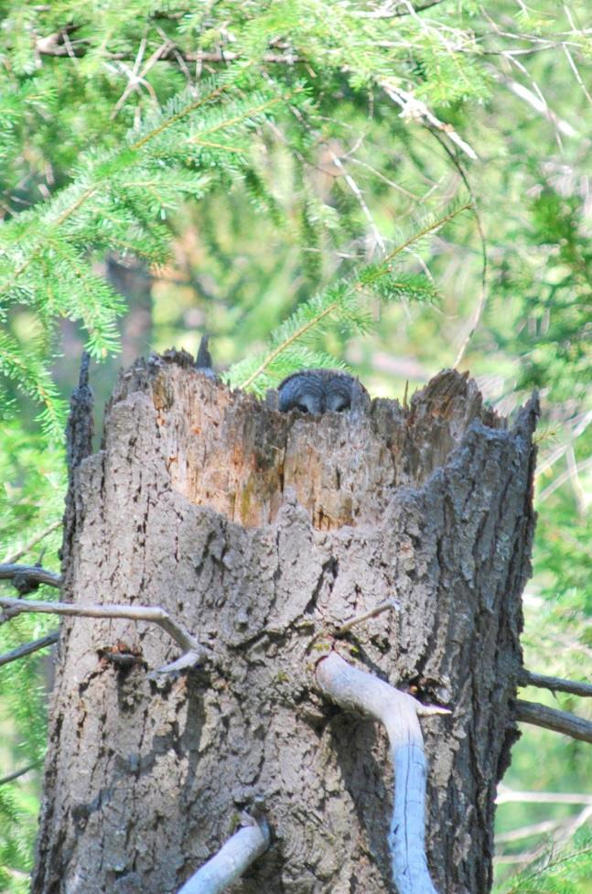
Management on Privately-Owned Lands

Because Great Gray Owl is listed as endangered in California, most land-development projects must avoid the “take” of the species (California Fish and Game Code [CFGC] sections 2050-2069), or obtain an incidental take permit from the California Department of Fish and Wildlife (CDFW). Take is defined as to “hunt, pursue, catch, capture, or kill, or attempt to hunt, pursue, catch, capture, or kill” (CFGC section 86). Incidental take permits require the applicant to minimize and fully mitigate impacts to listed species (CFGC sections 2080-2085). Additionally, CDFW cannot issue an incidental take permit if it would jeopardize the continued existence of a listed species or result in the destruction of habitat essential to the continued existence the species if alternatives exist (CFGC section 2053). Take of endangered species can also be permitted through Natural Community Conservation Plans, which are comprehensive regional plans that balance development with conservation of native environments (CFGC sections 2800-2835). Since 2009, private landowners in California have the option of entering into Safe Harbor Agreements or Voluntary Local Programs which allow willing participants to enhance threatened and endangered species habitat without the threat of future regulatory restrictions (CFGC sections 2086, 2089.2-2089.26).

Figure 23. The top of the head of a female Great Gray Owl is barely visible at this nest in a broken-top snag on Sierra Pacific Industries land, El Dorado County. Owls are difficult to see in the nest from the ground (B. Campbell)

The CDFW participates as a Review Team Member (Forest Practice Act) with Cal Fire, the Lead Agency for the California Environmental Quality Act (CEQA), to review Timber Harvest Plans

(THPs) on privately-owned lands. The Great Gray Owl is a designated Sensitive Species per the California Forest Practice Rules (Title 14, California Code of Regulations chapters 4, 4.5, and 10), which govern the regulation of timber harvesting on state and private lands in California, although no specific nest protection buffers are recommended for the species. If it is determined that a proposed THP has the potential to harm the owls directly or significantly disturb occupied nesting habitat, CDFW works with Cal Fire and the plan submitter to find alternatives and mitigation measures to prevent significant impacts to the species. If no alternatives exist, the plan submitter can apply for incidental take authorization (Fish and Game Code section 2080; Daniel Applebee, pers. comm.). CDFW’s ability to influence timber management decisions in currently unoccupied Great Gray Owl habitat is constrained by the California Forest Practice Rules’ emphasis on protecting only the wildlife community known to be present in the planning watershed of interest (California Forest Practice Rules section 897(b)(1)(B)). Reviewers generally recommend THPs maintain a high dominant canopy within approximately 200 m of a potentially occupied meadow, understory structure to allow juvenile owls to climb, and retention of large snags to provide present and future nesting structure (Daniel Applebee, pers. comm.). CDFW is also the Trustee Agency that reviews other projects subject to the California Environmental Quality Act (CEQA), such as commercial and residential development plans, subdivisions, and transportation projects in an effort to ensure that no take occurs to endangered species (Daniel Applebee, pers. comm.) and significant impacts to the owl’s habitat have been lessened to “less than significant.”




Recommended Conservation Actions

Use the same use area designation criteria (see Delineating Great Gray Owl Core Management Areas) on privately-owned lands as on Forest Service lands. Timber harvest can reduce nest tree availability as many privately-owned lands in Great Gray Owl habitat are managed for timber production, so we recommend land managers adhere to the recommendations in Potential Threats and Recommendations to Minimize Them: Timber Harvest. Likewise, managers should pay particular attention to guidelines in Potential Threats and Recommendations to Minimize Them: Livestock Grazing.

Great Gray Owls Outside the Greater Yosemite Area

Within California, the Great Gray Owl has traditionally been considered a mid- to high-elevation montane meadow specialist that breeds in the central and southern Sierra Nevada (Yosemite National Park, Stanislaus National Forest, Sierra National Forest; Winter 1986, Hull et al. 2010a, van Riper et al. 2013). Here we discuss Great Gray Owl detection records, biology, and breeding habitat conditions outside of this “core” breeding range.

El Dorado, Amador, and Calaveras Counties

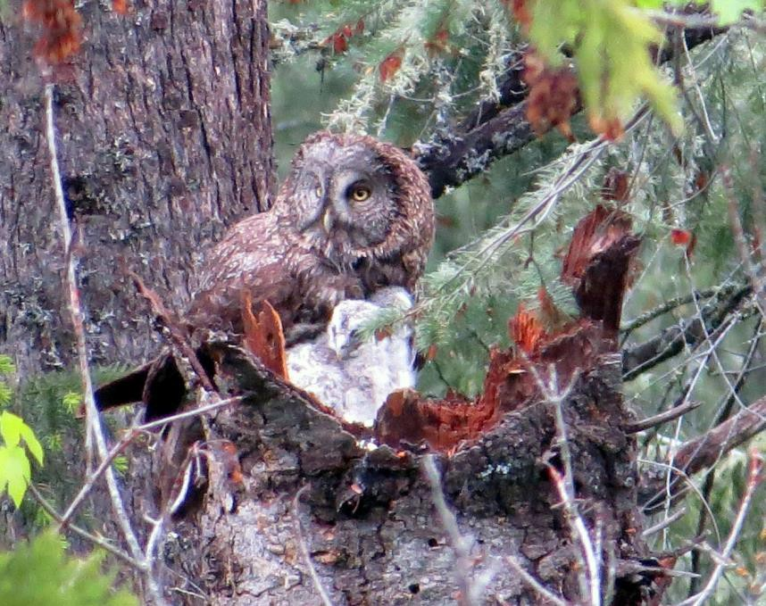
Though the Great Gray Owl’s breeding range is now widely considered to include habitat down to 700 m (Beck and Winter 2000, van Riper and van Wagtendonk 2006, Hull et al. 2014), the importance of the lower extent of the Great Gray Owl’s range has not been well understood. Recent data suggest that the lower-montane zone of the Sierra Nevada might be more important than previously thought. Since the inadvertent discovery of a nesting Great Gray Owl territory at an elevation of 860 m in 2006, biologists on Sierra Pacific Industries land in El Dorado County have been surveying for and monitoring territories each year. Recent summaries show relatively high rates of productivity (1.9 ± 0.9 young produced at 21 observed breeding attempts) at the eight monitored territories, suggesting that the area at the lower extent of the Great Gray Owl’s known elevation range is likely
not a population sink (Polasik et al. 2016). In addition, many of these lower-montane territories have been occupied nearly continuously since their discovery (Polasik et al. 2016). Including the 2015 breeding season, there are at least 12 known reproductive territories between 700 m and 1,000 m in El Dorado, Amador, and Calaveras counties (Polasik et al. 2016; Kevin Roberts and Matt Reno, pers. comm.), comprising 15% of the 79 reproductive territories documented in California between 1973 and 2015 (See

Distribution and Population Status).
Figure 24. Female Great Gray Owl with nestlings in a nest in
Calaveras County, 2015 (M. Reno).

The question of whether Great Gray Owls recently colonized this lower-montane area from their “core” range or have long occupied this region remains unresolved. Polasik et al. (2016) modeled potential Great Gray Owl habitat between 585–1,129 m in the Sierra Nevada to identify regions with similar habitat characteristics as the eight known nest sites. These areas should be prioritized for Great Gray Owl surveys. When possible, researchers should collect data on nest trees and habitat, monitor reproductive output, study Great Gray Owl diet, and identify potential threats to the owls in these areas, especially because many of these areas are managed for commercial timber production or are at risk for residential development.

Sierra, Yuba, and Plumas Counties

North of the central Sierra Nevada, Great Gray Owl detections have been sparse, consisting of mostly one-time and non-breeding detections. A pair of Great Gray Owls was detected calling in May, 2004 near Independence Lake, Sierra County, which could potentially indicate a breeding

territory. In such cases, we suggest delineating a CMA as this could indicate a range extension beyond what was previously known. Great Gray Owls were also detected there on two occasions in winter, 2010. Fledglings have been observed in Yuba County, near the boundary of Sierra County, from 2009 to 2011 (California Department of Fish and Wildlife 2013a; Kevin Roberts, unpublished data).

Great Gray Owl surveys have been conducted from 2004-2011 near Lake Davis, Plumas County with at least one confirmed pair reported during that time and also unconfirmed reports of young in 2004-2005 (California Department of Fish and Wildlife 2013a). Searches since 2010 following reports of Great Gray Owls found no Great Gray Owls.

Modoc County

Great Gray Owls have been known to occur in Modoc County since the 1970s, and more extensive surveys since 2008 revealed several owls using at least three meadows in the region. They have been found at elevations of 1500-1700 m, though they may occupy a wider elevation band. The habitat utilized is primarily eastside pine (Mayer and Laudenslayer 1988) in proximity to meadows. Trees in Eastside Pine forests generally do not grow as big as conifers in the central Sierra core range of Great Gray Owl, so management for tree size and density should be adjusted accordingly (for example, a 60 cm dbh pine would be considered very large in the Modoc region). Great Gray Owls in Modoc County are most likely a part of the S. n. nebulosa subspecies, rather than the S. n. yosemitensis subspecies. The one nest discovered to date was in a mistletoe broom in ponderosa pine, on private timber land (Figure 25). Conifers may not grow large enough to support broken top nests, though that does not seem to preclude breeding as the birds have either imprinted on a different nest type from those in the central Sierra, or they are flexible in nest choices. There may be more owls and nests discovered in the region as biologists continue to investigate their presence in northeastern California (all information about the Modoc Great Gray Owls: Joe Croteau and Mary Flores, pers. comm.).
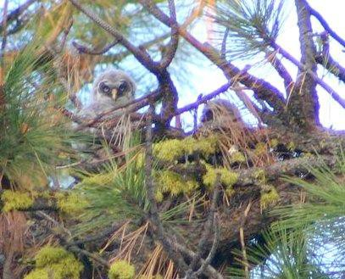

Figure 25. Juveniles in mistletoe broom nest, Modoc County (Collins Timber Company LLC).

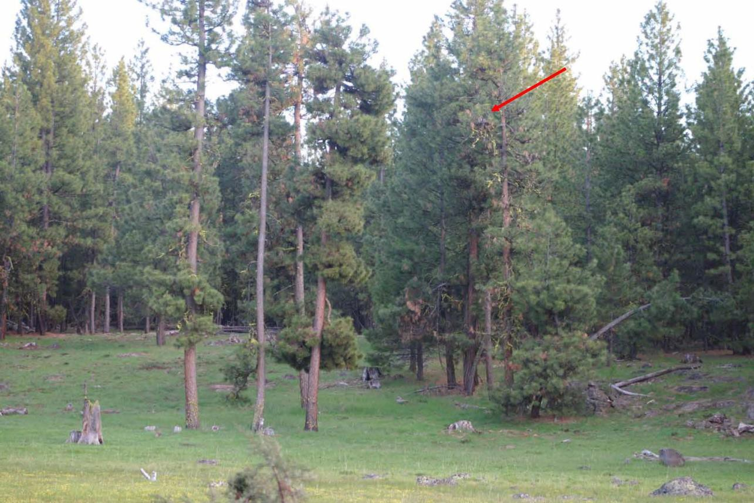

Figure 26. Habitat surrounding the only confirmed Great Gray Owl nest in Modoc County, indicated
by the red arrow (Collins Timber Company LLC).

Recommended Conservation Actions

- Survey for Great Gray Owls across the Sierra Nevada. Increase survey effort at, but not limited to, the regions below. Where possible, conduct surveys over multiple years to determine occupancy rates, and collect breeding status data in order to assess habitat needs and reproductive success.
- At lower elevations, around the transition of oak woodland habitats to the montane conifer zone the Sierra Nevada, especially in Yuba, Placer, El Dorado, Amador, and Calaveras counties.
- In the Central and Northern Sierra Nevada (between Highway 50 and Lassen Volcanic National Park), particularly near prior sporadic Great Gray Owl detections in Sierra and Plumas counties.
- In the Southern Cascades, between Lassen Volcanic National Park and Oregon.
- Expand survey efforts in mixed oak-conifer forests throughout the Sierra Nevada to determine if recently discovered nests in the lower-montane zone near the transition between oak- and conifer-dominated forests indicate broader occupancy of such areas (Polasik et al. 2016).



Monitoring and Research Needs

- Assess the size and extent of the Great Gray Owl populations in El Dorado, Amador, Calaveras, Yuba, and Modoc counties, where Great Gray Owls were only recently found to breed.

- Study the ecology of the Great Gray Owl populations at low elevations in the Sierra Nevada (below approximately 1,219 m/4,000 ft) in El Dorado, Amador, Calaveras, and Yuba counties, and in far Northern California in Modoc County, including, but not limited to:
  - Hunting habits
  - Perch requirements
  - Characteristics of forest stands used for breeding
  - Characteristics and requirements of meadows/grassy openings
  - Prey base and prey selection
  - Breeding phenology
  - Brood size
  - Predator interactions
  - The availability of prey, hunting perches, and Great Gray Owl
hunting success in stringer meadows and swales

- Broaden research on Great Gray Owl population genetics:
  - Continue to use DNA to determine population size and degree of
inbreeding.
  - Collect DNA samples from owls located between Amador County and the Oregon border to determine the northern limits of the proposed Sierra Nevada subspecies.
  - Assess the degree of genetic differentiation and genetic exchange between upper- and lower-montane owls.

- Continue to develop and refine predictive models that identify potential Great Gray Owl habitat in California, as new occurrence data and information about vegetation and landscapes become available.

Delineating Great Gray Owl Core Management Areas

In this Conservation Strategy, we recommend broadening the definition of a Core Management Area (CMA) to include sites likely important for breeding where nests have not been found. Fledgling detection, delivery of food, and the detection of a male and female in proximity to one another indicates the habitat is likely to certainly important for breeding. Detection of an adult during the core breeding season (Apr-Jul) indicates potential selection of the habitat for breeding in a current or subsequent year.

Core Management Areas (Protected Activity Centers on Forest Service lands) should be 80 hectares of the best available forested habitat, plus adjacent meadows where applicable. On Forest Service lands, we strongly recommend increasing the size of PACs from 50 to 200 acres (80 hectares). This size is based on studies which found that breeding birds had a home range of
  - ± 12.9 hectares (152.0 ± 31.9 acres; 95% adaptive kernel; van Riper and van Wagtendonk
2006) and 258 ± 118 hectares per breeding pair (638 ± 292 acres; minimum convex polygon; Winter 1986). van Riper and van Wagtendonk (2006) was weighed more heavily than Winter (1986) because it is the latest analysis on home range sizes, its adaptive kernel method tends to be a more realistic estimate of landscape use than minimum convex polygon, and it is more achievable than setting a target an order of magnitude larger than the current mandate.

Core Management Areas should be monitored and modified as needed. If a CMA or a portion thereof has been rendered unsuitable for Great Gray Owl nesting following natural disturbance, CMA boundaries can be modified to exclude the unsuitable portion and augmented with another portion of best available forest stands (as defined in Recommendation #2). In addition, some conditions may warrant retirement of a CMA. If a natural disturbance alters the habitat so significantly that continued owl nesting in the CMA is unlikely, conduct one year of three-visit surveys after the disturbance since owls have been documented to use habitats post-disturbance (Maurer 2006; NPS, unpublished data). If no owls are detected, then consider retiring the CMA. Also, if a CMA was designated upon a single detection of a single owl, and a six-visit survey conducted in the following year finds no owls, then that CMA may be retired. If pair or breeding status led to the designation of the CMA, the CMA should not be retired as long as habitat conditions are still appropriate for breeding. While recommendations made for the California Spotted Owl suggest that the protected area can be retired after three years of non-detection (Sawyer et al., unpublished report), Great Gray Owls can return to breed at a site more than five years later (data from Wu et al. 2015). Given their inconsistent rate of response in surveys (Beck and Winter 2000), tendency to breed intermittently (Keane et al. 2011), and more extreme rarity, we suggest maintaining CMAs for all pair and reproductive detections.



Delineation of Great Gray Owl Core Management Areas (CMAs)

    - Due to the difficulty of locating nests, Great Gray Owl CMAs should be delineated not only where nests are detected, but also for other ‘activity centers,’ i.e., locations where observations indicate the site is important during the breeding season even if no nest was found. In addition to nest detection, Great Gray Owl CMAs should be designated upon:
      - Fledgling detection
      - Detection of any Great Gray Owl during the core nesting season (Apr-Jul; Beck and Winter 2000)
      - Detection of an adult male and female in close proximity to one another during the pre-breeding (Feb-Mar) or post-fledgling (Aug-Sep) season
    - Delineate a CMA that comprises at least 80 hectares (200 acres, an increase from the current prescription of 50 acres on Forest Service lands) of forest, in addition to all meadows within 500 m (1,640 ft) of the nest tree or activity center (as defined in Recommendation #1), to better align with home-range size based on observational studies (e.g., van Riper and van Wagtendonk 2006, Winter 1986). CMAs do not necessarily have to be configured as a circle around an activity center but rather can be any shape that includes the best available forested area and adjacent meadows where applicable. Best available forest stands have (1) >65% canopy cover and (2) some very large, >100 cm (40 in) dbh snags. Within the CMA, strive to include habitat that meets the above conditions, or if not available, habitat that most closely resembles the best available forest stands.

To delineate a CMA (see pages 43-46 for example schematics):

      - Draw a 500-m (1,640-ft) radius circle around the activity center
      - Include in the CMA all meadows and grassy openings where Great Gray
Owls can forage that intersect the circle, including portions of those
meadows or openings that are >500 m from the activity center; be sure to also include the activity center itself
o Then draw 300-, 400-, or 500-m (900-, 1,300-, or 1,640-ft) buffers (depending on region; Table 2) around all of the meadows that intersect the 500-m circle around the activity center
      - Select at least 80 ha (200 ac) of the best available forested habitat within the meadow buffers to include in the CMA (the area of the meadows is in addition to the 80 ha/200 ac of forest)




Delineation of Great Gray Owl Core Management Areas (Cont.)

    - If a CMA or a portion thereof has been rendered unsuitable for Great Gray Owl nesting following natural disturbance, CMA boundaries can be modified to exclude the unsuitable portion, which should then be replaced with other nearby habitat that is more suitable (as defined in Recommendation #2; p. 41when).

    - Consider retiring a CMA if:
      - No owls are detected in the CMA following one year of six-visit surveys at sites where a single detection of a single owl triggered CMA designation.
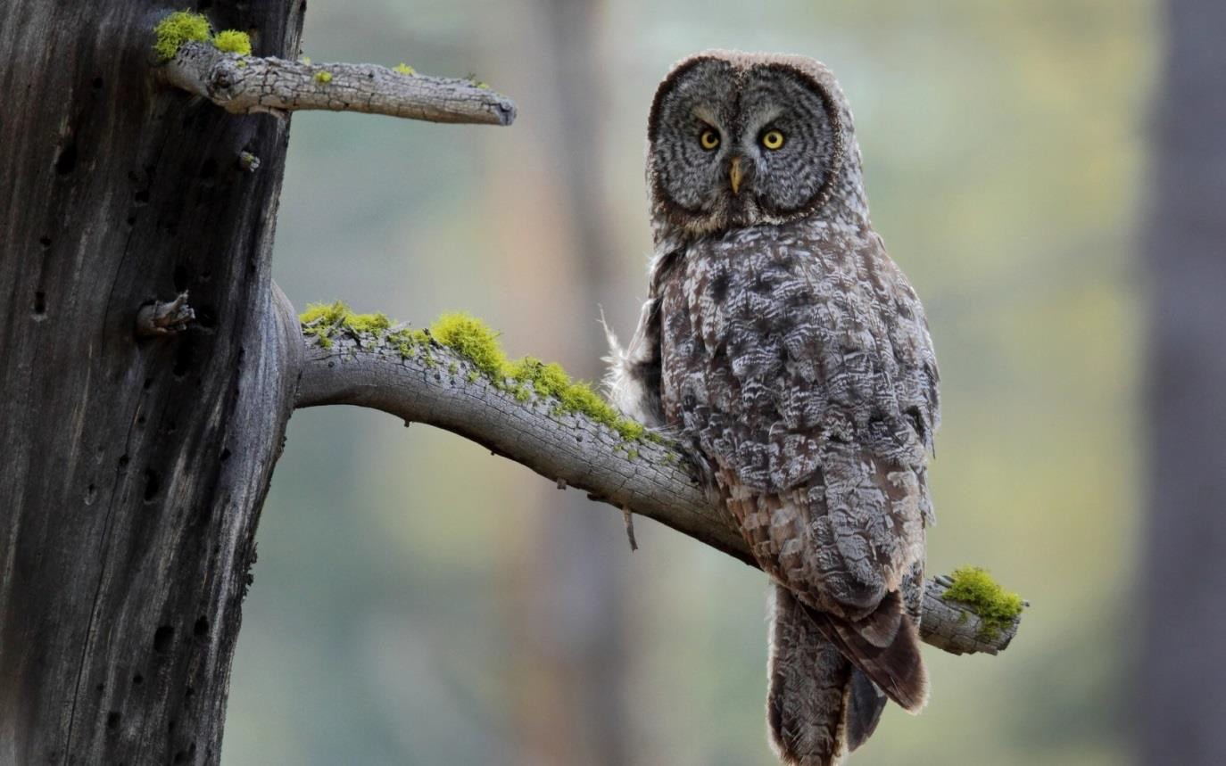
      - A natural disturbance alters the habitat so significantly that continued owl nesting in the CMA is unlikely, and one year of three-visit-surveys after the disturbance yields no detection.

Figure 27. A Great Gray Owl at a hunting perch (unknown photographer).

Examples of Core Management Area Configurations

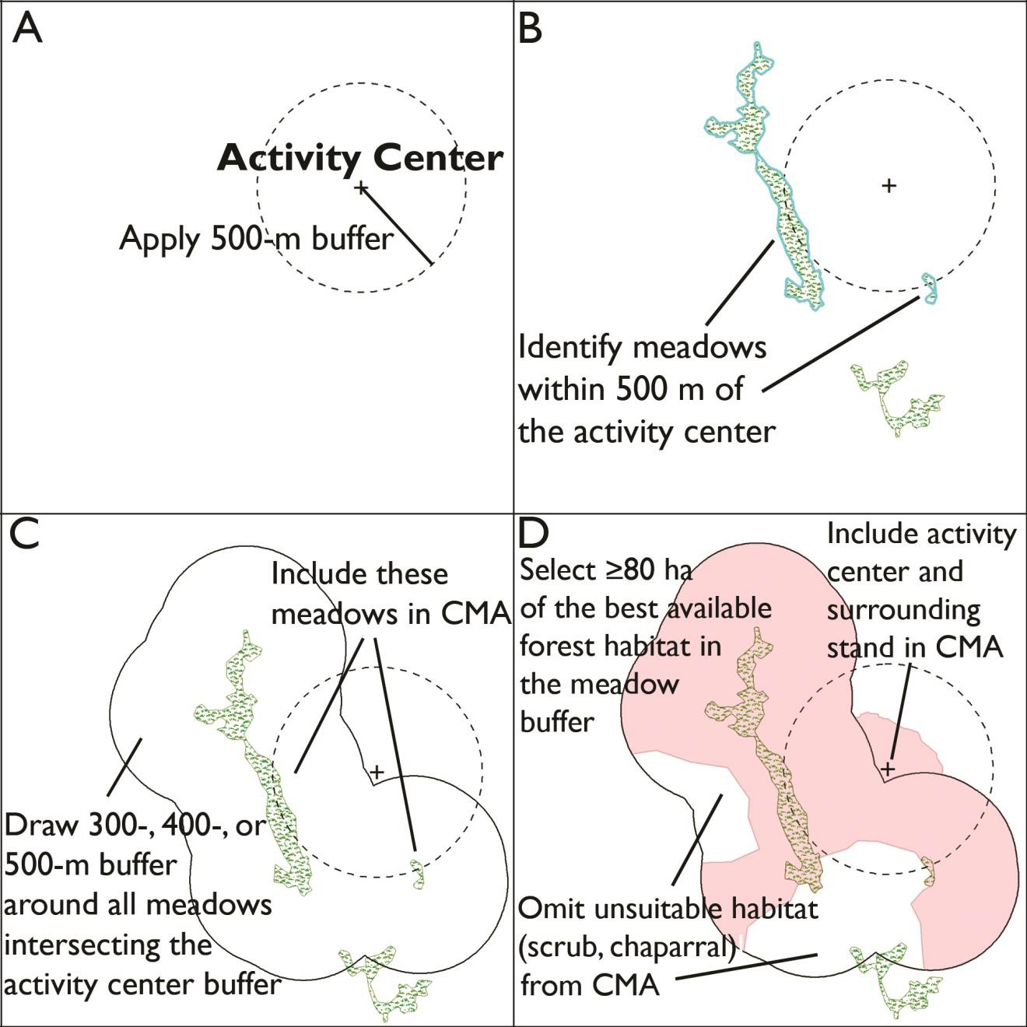
Figure 28. Steps to creating a Core Management Area. In this case, the final CMA encompasses 161 ha (398 ac) of forest and 13 ha (31 ac) of meadow.

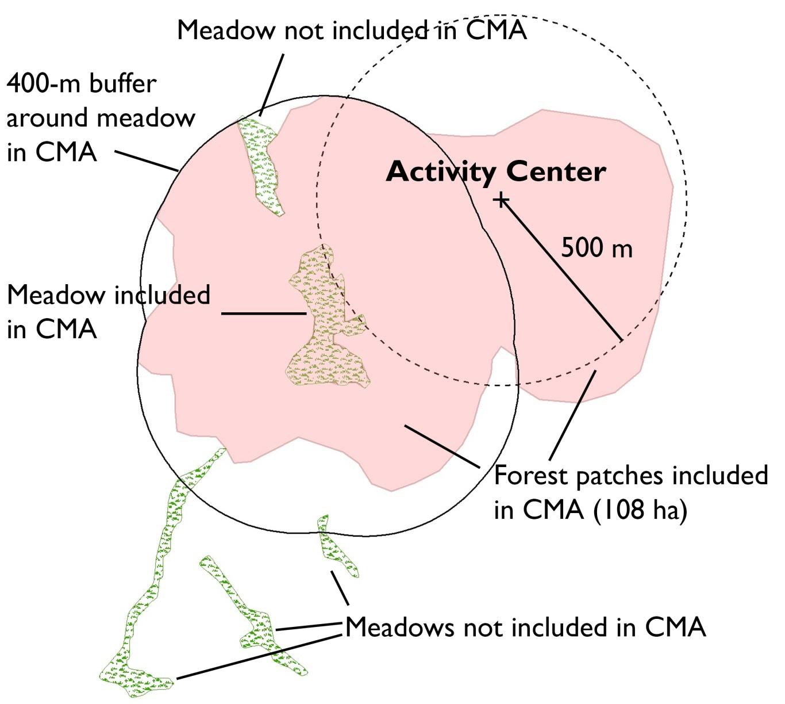

Figure 29. A Core Management Area configuration where a single meadow is within 500 m of the activity center. The meadow is included in the CMA, but the other meadow farther than 500 m from the activity center is not included in the CMA. The best available forested habitat within a 400-m buffer of the meadow is included in the CMA (per Table 1), plus another patch that includes the activity center. This CMA encompasses 108 ha (267 ac) of forest and 5 ha (11 ac) of meadow.

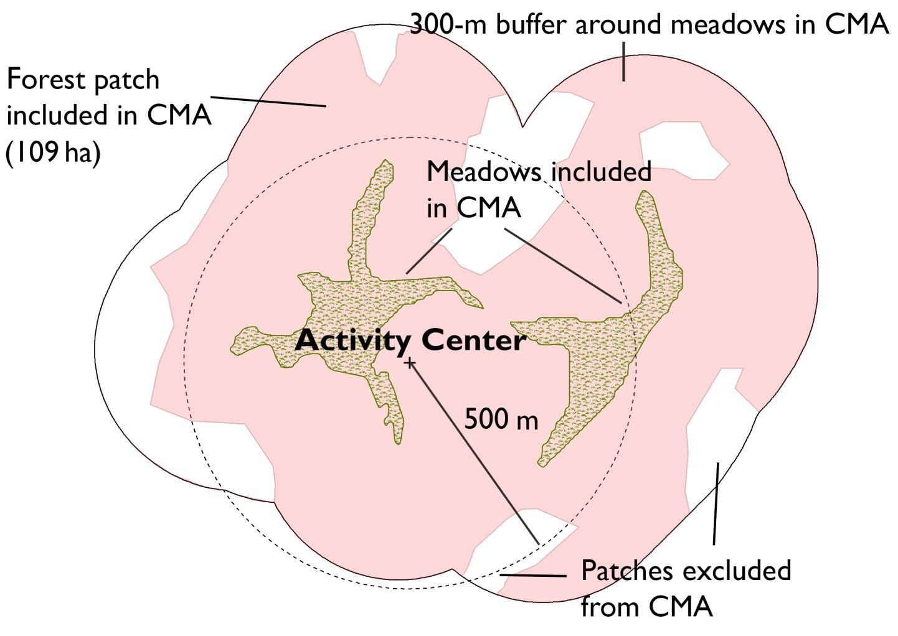
Figure 30. A Core Management Area configuration where two meadows are within 500 m of the activity center. The best available forested habitat within a 300-m buffer (per Table 1) of the meadow is included in the CMA except for small patches (e.g. chaparral or other unsuitable Great Gray Owl habitat). This CMA encompasses 109 ha (269 ac) of forest and 12 ha (30 ac) of meadow.

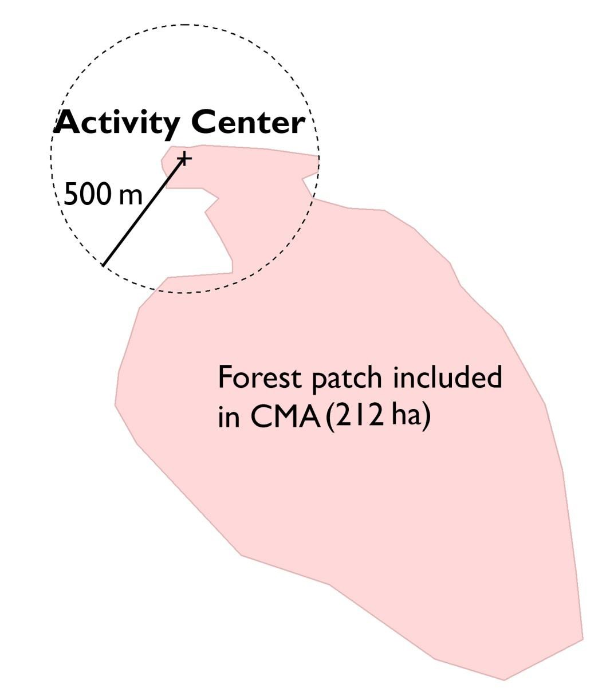
Figure 31. A Core Management Area configuration where no meadow is within 500 m of the activity center. In this case, a forest patch of 212 ha (524 ac) of best available habitat that also includes the activity center is designated as the CMA.

POTENTIAL THREATS AND RECOMMENDATIONS TO MINIMIZE THEM

Livestock Grazing

Livestock grazing that substantially alters meadow hydrology and vegetation is likely one of the greater indirect threats to the Great Gray Owl. If not judiciously managed, livestock grazing can remove cover for prey species, particularly voles (Beck and Winter 2000), and lead to effects such as a lowered water table, reduction of meadow vegetation diversity and abundance, and increased soil compaction and erosion (Fleishner 1994, Belsky et al. 1999), each of which could have consequences for prey populations (Torre et al. 2007, Long et al. 2013, Rickart et al. 2013). However, the effects of grazing are not straightforward and vary by prey species. Vole densities are negatively correlated with grazing intensity (Winter 1986, Reid 1989, Johnson and Horn 2008, Kalinowski 2012, Rickart et al. 2013), whereas gopher densities may increase or decrease in association with grazing (Dull 1999, LaManna 2009, Powers et al. 2010), perhaps as a function of vegetation condition (Hunter 1991). In CMAs in wet meadows (typically mid- and high-elevation Sierra meadows) that naturally support voles, we suggest using ‘sward height’ instead of vegetation height to manage for vole habitat. Sward height accounts for grass density in addition to height, both of which are important for voles (Kalinowski 2012). Sward height should be measured by dropping a 170-g 30-cm x 30 cm sward plate with a meter stick through the middle from a height of 80 cm, and recording the height at which the plate rests (Kalinowski et al. 2014). At grazed meadows, maintain a sward height of at least 20 cm (8 in; Kalinowski et al. 2014). If it is not possible to use a sward plate, herbaceous vegetation should be maintained at a height of 300 mm (12 in; Beck 1985, Greene 1995). Data suggest the above guidelines would enhance meadow habitat for voles at mid- and high-elevations, but at lower elevations, where Great Gray Owls may depend more on gophers (Kevin Roberts, unpublished data), alternative herbaceous vegetation management options may be warranted if supported by research.
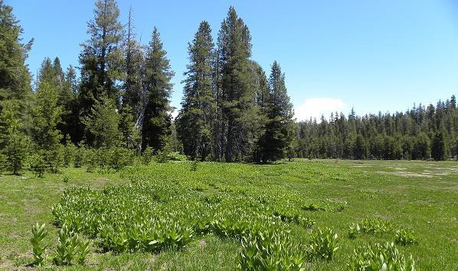

Figure 32. An example of a meadow that provides both vole (foreground) and gopher (left and right back) habitat, Stanislaus National Forest (R. Kalinowski).

The Sierra Nevada has a long history of grazing throughout public and private lands. Livestock management recommendations to benefit Great Gray Owl will have to, in many cases, also meet the needs of ranchers and National Forest grazing permittees. Relaxed or altered annual grazing pressures, such as reducing the number of cattle or sheep and/or reducing the duration of grazing in meadows, may present benefits to both Great Gray Owls and ranchers, enhancing conditions for small mammal populations (Fleishner 1994) and increasing forage productivity (Crider 1955, Briske et al. 2011). Similarly, resting a meadow periodically from grazing may actually yield greater cattle weight gains (Ratliff et al. 1972); actively restoring hydrologic conditions and thereby meadow health may increase livestock forage (and prey species cover and population density) without significantly impacting livestock production (Briske et al. 2011, Freitas et al. 2014). Kalinowski et al. (2014) suggest the juxtaposition of nearby grazed and ungrazed meadows on National Forest land so that individual Great Gray Owls may have access to both gophers and voles within their hunting ranges (LaManna 2009, Powers et al. 2010). Beck (1985) suggested restricting grazing until after the fledgling period concludes, approximately August
15th, and foraging activity declines. Briske et al. (2008) suggested resting a meadow during the growing season, and allowing grazing only during flowering and seed-ripening periods (July to August; Hormay 1970).

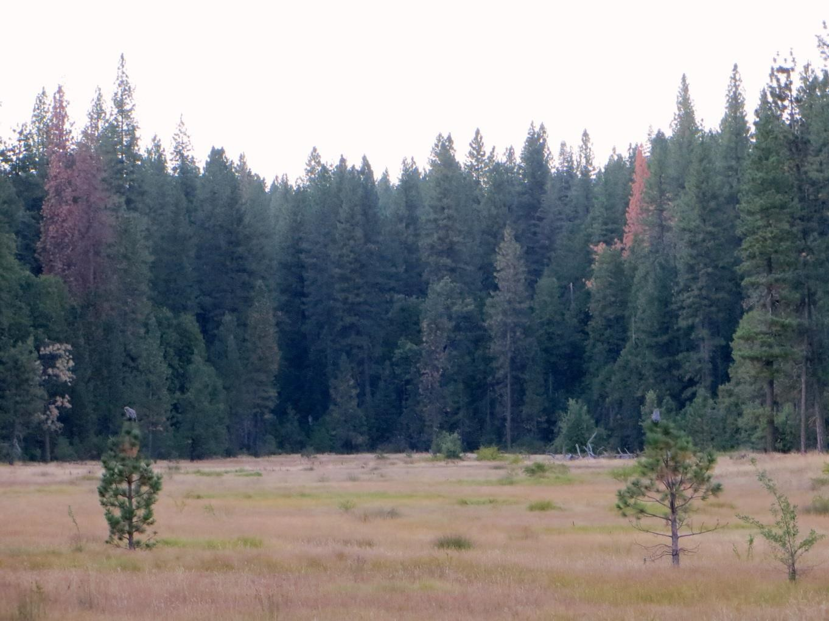
Figure 33. Two juvenile Great Gray Owls use ponderosa pine saplings as perches in a meadow in Sierra National Forest (K. Strohm).

When CMAs overlap a grazing allotment, managers should review existing range monitoring data and/or collect new meadow condition data. If meadow ecological condition is declining or not meeting proper functioning condition (Weixelman and Zamudio 2001, Weixelman and Cooper 2009, Weixelman et al. 2011), managers should implement one or more of the following measures: actively restoring the meadow, developing new allotment management plans to reduce livestock pressure, fencing, altering allotment boundaries, and/or seasonally, temporarily (year- round multi-year) or permanently resting the allotment. When multiple CMAs overlap a grazing allotment, that allotment should receive priority for assessment and formal management planning. If meadows within a CMA remain grazed (either temporarily while assessment occurs, or after assessment) we strongly suggest that post-grazing season sward or grass height be maintained to the standards outlined above. When reviewing livestock grazing allotment management plans, Uresk (2010) suggested that managers also consider the larger size of cattle compared to 30 years ago, which is likely to affect the amount of meadow vegetation consumed and degree of soil compacting even when livestock numbers and season of use go unchanged.

Proactive management of foraging habitat needs to be considered on a site-specific basis. Meadows that have been desiccated or compacted should be managed to increase health and productivity of vegetation, including hydrological restoration, replanting native species, restoring water table back to a less disturbed state for higher graminoid productivity and increased ecological resilience to climate change and other stressors (Loffland et al. 2011, Stillwater Sciences 2012). At meadows with uniformly tall trees at the edges that may lack hunting perches, habitat may be improved by creating perches for hunting. Appropriate perches can be made by dragging downed logs with branches and large root wads intact from the forest interior to the meadow edge or installing posts approximately 1-6 m (3-10 ft) in height (Winter 1986). Recruit or maintain at least one potential hunting perch per 30 m (100 ft) of meadow edge, given that the average stoop distance is around 9 m (Winter 1986).

Conversely, a problem at other meadows might be conifer encroachment, particularly by pole- sized conifers (Figure 34), which can shade out herbaceous understory plants, dry out the meadow, and reduce plant species diversity (Shepperd et al. 2006, Huago and Halpern 2010). At such sites, a useful action might be removing small encroaching conifers and/or using prescribed fire along meadow edges to decrease litter and increase herbaceous cover into the forest understory. However, careful consideration needs to be given to assess the overall condition of the meadow, and retain hunting perches as well as large trees that could potentially serve as nest trees. Additionally, possible causes of conifer encroachment, which may reflect desiccation – perhaps resulting from hydrologic disturbance – should be assessed and addressed, if appropriate.

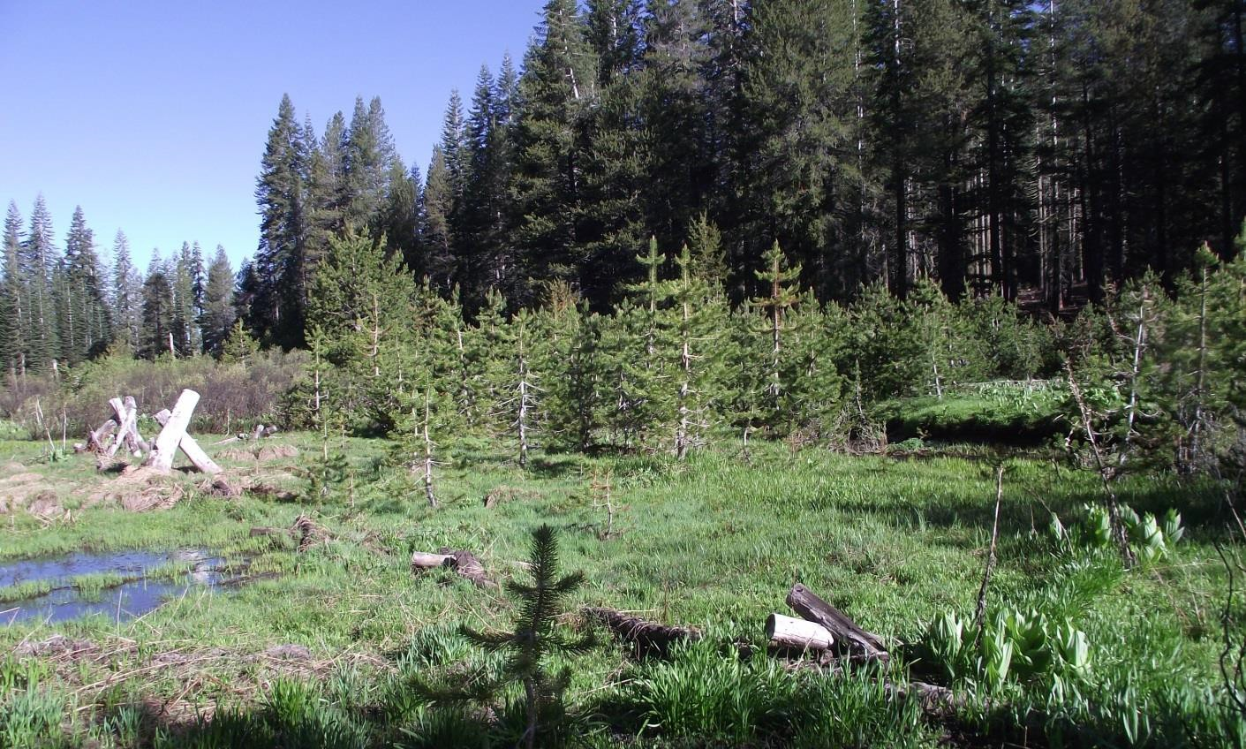
Figure 34. An example of a meadow in El Dorado County with encroaching conifers (H. Loffland).




Recommended Conservation Actions

Meadows in Great Gray Owl Conservation Management Areas:

- When CMAs overlap a grazing allotment, assess meadow ecological condition and implement appropriate measures to remedy negative conditions or trends including: active hydrologic restoration, reducing grazing pressure, fencing, allotment boundary revisions, resting, or retiring the allotment. Allotments with multiple CMA should receive priority for assessment and adjusted grazing management.

- Maintain meadow vegetation at a ‘sward height’ of at least 20 cm (8 in; Kalinowski et al. 2014) at mid- and high-elevations. If it is not possible to use the sward plate methodology, maintain herbaceous vegetation at a stubble height of 30 cm (12 in; Beck 1985, Greene 1995). Where meadows are being grazed, refrain from grazing within meadows between February 15th and August 15th (Beck 1985, Beck and
Winter 2000) until the meadow assessment and new allotment management plan, if conditions warrant, are completed. Data suggest the above guidelines would enhance meadow habitat for voles at mid- and high-elevations, but at lower elevations, where Great Gray Owls may depend more on gophers (Kevin Roberts, unpublished data), alternative herbaceous vegetation management options may be warranted if supported by research.




Recommended Conservation Actions (Cont.)

Meadows in Great Gray Owl Conservation Management Areas:

- Consider the issue of conifer encroachment into meadows on a case-by-case basis.
When removing encroaching conifers, strive for creating a mix of ‘hard edges’ (i.e., total removal of encroaching conifers, yielding an abrupt transition between forest and meadow) and ‘soft edges’ (i.e., removing only dense patches of encroaching conifers that threaten persistence of meadow herbaceous cover).
- Strive to create or maintain at least one potential hunting perch approximately 1-6 m (3-20 ft) in height (Winter 1986) per 30 m (100 ft) of meadow edge. Where existing natural structures seem insufficient, perches can be created by dragging downed logs with branches and large root wads intact from the forest interior to the meadow edge, by retaining some perches when removing encroaching conifers, or by installing posts.

Meadows in Suitable Great Gray Owl Habitat:

- Strive to increase health and productivity of vegetation at large (>10 ha/25 ac; Beck and Winter 2000) meadows, such as via hydrological restoration, replanting native species, evaluating and adjusting grazing strategies. Where natural hydrology has been severely altered, strive to restore the water table to a less disturbed state, for higher graminoid productivity and increased ecological resilience to climate change and other stressors.
Monitoring and Research Needs:

- Examine Great Gray Owl occupancy and reproductive success as related to grazing
regimes.

Outreach and Land Acquisition

We suggest an interagency collaborative effort to determine impacts of grazing on Great Gray Owls. Land managers can work with groups such as Natural Resources Conservation Science (NRCS) and the California Cattlemen’s Association to study impacts on Great Gray Owl prey species and develop “best management practices” for grazing lands used by Great Gray Owl. Conduct outreach to private inholdings, including education on the value of resting a meadow from grazing periodically for restoration purposes. Efforts that improve ecological condition of meadows also increase or improve yield, productivity, and water quality which are important components of sustainable grazing practices (Briske et al. 2011).

Involving land trusts in the purchase of privately owned meadows or other lands containing suitable habitat as they become available (thereby reducing risk or development and timber harvest and also reducing or eliminating grazing pressure) is another potential action to benefit the Great Gray Owl, particularly in and adjacent to the Sierra and Stanislaus National Forests, the National Forests with the majority of historic Great Gray Owl detections.




Recommended Conservation Action

Meadows in Suitable Great Gray Owl Habitat:

  - Enlist land trusts and others to aid in the development of site-specific meadow management plans, conservation easements and/or purchase of meadows and the forest stands that surround them. These efforts should be prioritized at sites with historical Great Gray Owl detections that are at risk of future development or land conversion.

Timber Harvest

Timber harvest can present another threat to Great Gray Owls by reducing canopy cover in potential or actual nesting areas or removing potential or actual nest structures, particularly as harvest tends to target the large trees that are most often essential for Great Gray Owl nesting (Greene 1995, Beck and Winter 2000, Wu et al. 2015). There are at least two documented cases on the Tahoe and Plumas National Forests where breeding owls were known to have left an area following logging activities (Winter 1984, Winter 1986). When suitable nesting stands or trees are removed via clearcutting (even-age selection), habitat in that area is rendered unsuitable for Great Gray Owl nesting. However, other harvest prescriptions (e.g., selective or uneven-age harvest) may not prove as detrimental to the owl. Wu et al. (2015) found eight of 55 Great Gray Owl nests located on private lands managed primarily for timber production, and in some cases nests were adjacent to clearcut harvest units and within selective harvest units. The study also found 27 of 55 owls were on US Forest Service lands where varying degrees of timber harvest occurs (Wu et al. 2015). This suggests that carefully-managed timber harvest and the presence of Great Gray Owls are not mutually exclusive, particularly when the specific prescriptions noted within this strategy are considered.

On lands managed by Sierra Pacific Industries, large oaks are most often used by Great Gray Owls as nest trees, and oaks are generally retained in harvests (Kevin Roberts, pers. comm.). Trees used by owls for nesting are marked and the quarter-mile radius around them protected from vegetation disturbance (Sierra Pacific Industries 2008). Southern California Edison, which also manages land that Great Gray Owls nest on, practices uneven age, single tree selection timber harvest, protects occupied nest trees, and has set up several artificial nests in stands where Great Gray Owls have been detected (Stephen Byrd, pers. comm.). The logging practices currently in place on at least some of these private timber lands apparently meet Great Gray Owl nesting needs, although more rigorous study is needed to determine effects of timber management practices on reproductive success and output.

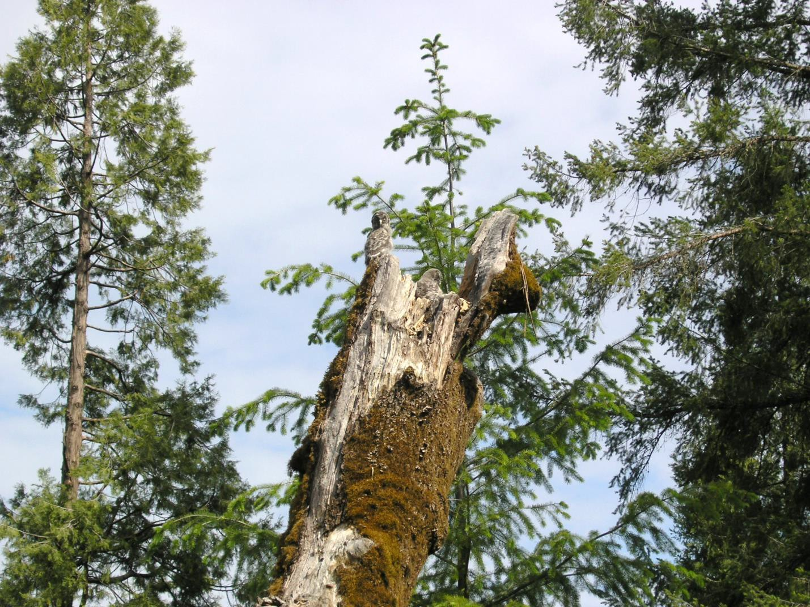
On US Forest Service lands, large conifers and oaks are generally retained in harvest, and management is directed at recruiting young trees to replace older ones. Currently vegetation treatments are prohibited within 400 m (1/4 mile) of an active nest stand from March 1 to August 15 (US Forest Service 2004). Timber harvest plans vary among individual management units, but in general, conifers larger than 76 cm (30 in) and oaks larger than 30 cm (12 in) in diameter are retained, and management is directed at recruiting young oaks to replace older ones (US Forest Service 2004). California Forest Practice Rules state that nest trees, perch sites, and replacement trees should be protected in consultation with the California Department of Fish and Wildlife, such that the nest is best protected from the effects of timber operations (California Forest Practice Rules sections 919.3, 939.3, 959.3).

Figure 35. Two fledglings at a nest on a broken-top oak snag on, Sierra Pacific Industries, El Dorado County (K. Roberts).

The effects of timber harvesting on Great Gray Owl prey are unclear. Voles have been documented to react positively to timber harvest, when after several years, herbaceous vegetation becomes abundant (Fisher and Wilkinson 2005, Zwolak 2009). Similarly, pocket gophers prefer open habitats and can increase following forest thinning treatments (Kalies et al. 2012). However, small mammal abundance may decrease as shrubs and conifer regrowth occur. Furthermore, comparisons of prey availability between harvested units/types and meadows have not been completed, and that other factors related to nestling and fledgling survival in harvest areas versus meadows are unknown. Winter (1982) suggested harvest units were more likely to provide foraging habitat for Great Gray Owls if they were irregularly shaped and elongated so that the

maximum distance across the unit is less than 120 m (390 ft; owls did not stoop more than 60 m from edge when foraging).

Since Great Gray Owls require large snags and oaks to nest in, and large recently dead snags are often selected during salvage logging (or removed to increase safety during green tree harvest), maintain or recruit a minimum of four snags per ha with dbh >100 cm (40 in); if this snag retention level proves impossible, smaller snags of at least 60 cm (24 in) dbh may be retained and still meet Great Gray Owl nesting habitat requirements (Wu et al. 2015). Along with sufficient snag density, potential nest stands should have canopy cover >65%, one standard deviation below the average canopy cover of 80% (Wu et al. 2015), with pockets of denser canopy cover to provide shade and protection from aerial predators. Ideally, some large snags would be in those dense pockets. To prevent disturbance to nesting owls and to maintain canopy cover, refrain from vegetation treatments (e.g., timber harvest, thinning, prescribed fire) and road construction in CMAs from
February 15th through September 30th. As Great Gray Owls have been documented to nest even following stand-replacing fires (Wu et al. 2015), this

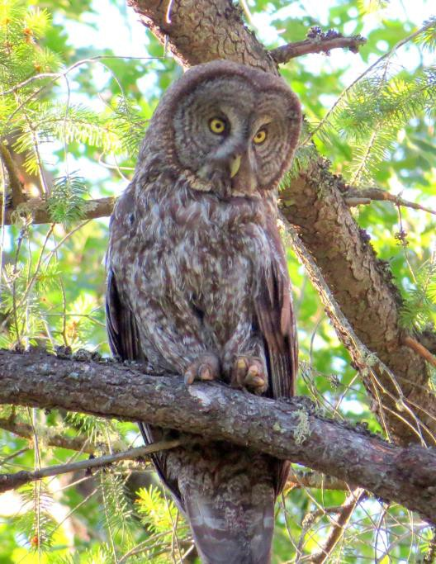


Figure 36. Great Gray Owl on private timber land, Calaveras County (M. Reno).

recommendation should be applied after wildfire as well. Limited hand treatments should be considered on a case-by-case basis. They may be appropriate if they improve breeding habitat conditions.

If there is a lack of natural snags, managers should consider creating artificial nests (see How to Create an Artificial Nest, below). Winter (2005) suggested maintaining at least 1 acre of adjacent forest with at least one nesting opportunity (see nest tree photo gallery for examples) per 5 acres of meadow. A forest structure dominated by large (>100 cm [40 in] dbh) trees is favorable to Great Gray Owls; 70% of 56 nests were in forests of size 5 class, and the rest were in size 4 class (Mayer and Laudenslayer 1988; data from Wu et al. 2015). In addition to large snags and a high canopy cover, understory, such as low-hanging limbs and other concentrations of woody material, provide hiding cover and climbing opportunities for juveniles that fledge to the ground and are not yet capable of full flight (Nero 1980, Bull and Henjum 1990). Such low-hanging limbs are sometimes removed to reduce the potential of fire climbing up into the canopy (Agee and Skinner 2005, Stephens and Moghaddas 2005). This needs to be considered on a site-specific basis in a CMA.

It is important to note that a suitable nest tree is an ephemeral resource because it should be deteriorated enough to provide a rotted bole, cavity or other sheltering structure for nesting, but not so deteriorated that it loses substantial diameter or falls. Even where Great Gray Owls are already nesting successfully, managers should consider the standing crop of appropriate nest trees, and whether recruitment in the coming decades is likely to counterbalance attrition. In the fir zone, suitable nest trees may only stand for a few years (Keen 1955, Morrison and Raphael 1993, Landram et al. 2002) once they reach the necessary level of decay to provide a

nesting site. Managing for clusters of large firs and a mosaic of many age classes may therefore be vital to retaining suitable nesting sites over time (Wu et al. 2015). At lower and middle elevations, managing for oak retention and recruitment may be just as important as for large conifers, as numbers of oaks have been substantially reduced due to historic timber management activities and rangeland practices (Standiford et al. 1996). Oaks are relatively more resilient to fire (Collins et al. 2011) and continue standing even after considerable deterioration occurs. Because oaks provide nesting structures while still alive, they may also provide better overhead cover to nests (in the form of live foliage) and abundant branching opportunities to fledglings. To recruit large oaks on the landscape, managers should consider pruning stump-sprouting oaks along edges of occupied meadows to a single dominant stem, which is believed to promote shorter time to maturity and increased ability to compete with conifers and browsing animals (Ferrell 2005). Managers should also avoid planting conifer seedlings within six meters (20 ft) of the drip line of mature living oaks, the dominant stem of stump sprouting oaks, and oak sapling stems greater than or equal to one inch in diameter (Ferrell 2005).

Recommended Conservation Actions

Forests in Great Gray Owl Coe Management Areas:

  - Refrain from vegetation treatments (e.g., timber harvest, thinning, prescribed fire) and road construction from February 15th through August 5th (approximately the end of the nesting season as defined in Beck and Winter 2000), even after wildfire, unless surveys indicate non-nesting status during the same year.

  - Manage to retain or recruit a minimum of four conifer snags or oaks with diameter at breast height (dbh) >100 cm (40 in) per hectare in mature forest stands and encourage recruitment of additional trees and snags to replace them as they fall or senesce. If trees and snags this large are unavailable, strive to retain a minimum of four that are >60 cm (24 in) per hectare (1.6 large snags/acre; Wu et al. 2015). If this is impossible across the CMA, strive for the suggested snag density in pockets of dense canopy cover (see Recommendation #16).

  - Retain or recruit dense canopy cover (>65%, one standard deviation below the average canopy cover of 80% over nests; Wu et al. 2015) in multiple pockets around the activity center, especially where suggested density of large snags is met (see Recommendation #14).

  - When compatible with management activities related to human safety and forest health, retain low-hanging limbs within 200 m/650 ft (Bull and Henjum 1990) of nest trees and fledgling detection locations, to provide climbing opportunities and cover for fledgling Great Gray Owls not yet capable of flight (Nero 1980, Bull and Henjum 1990, Whitfield and Gaffney 1997).




Recommended Conservation Actions (Cont.)
Forests in Great Gray Owl Core Management Areas:

  - Retain oaks >60 cm/24 in dbh in timber harvests. Retain smaller oaks for recruitment.

  - In reforestation units, avoid planting conifer seedlings within 6 m (20 feet) of the drip line of mature living oaks, including the dominant stem of stump sprouting oaks, and oak sapling stems greater than or equal to 2.5 cm (1 in) in diameter (Ferrell 2005).

Forests in Suitable Great Gray Owl Habitat:

- In areas where Great Gray Owls have been detected, but reproduction has not been confirmed, and in areas lacking in snags or in even-aged stands, consider topping suitable trees (especially incense-cedars) to create nest structures (Winter 1982). Instructions are provided below on page 57.

- Great Gray Owls do not always nest near meadows, particularly at lower-montane conifer forests. Strive to maintain four large (>100 cm/40 in dbh, or >60 cm/24 in dbh if that is not feasible) conifer snags or oaks per hectare in stands where Great Gray Owls have been detected during the breeding or nesting season regardless of the distance from the nearest meadow.

- Manage patches of forest surrounding large (>10 ha/25 ac; Beck and Winter 2000) meadows to provide the habitat features discussed above (canopy cover, nest structures, and hunting perches) to the extent possible.

- Consider enhancing recruitment of oaks at elevations between 700-1,200 m (2,300- 3,930 ft) to a target basal area of 10-15 m2/ha (44-65 ft2/ac; Wu et al. 2015) through planting, brush-thinning, pruning stump-sprouts, and fire management.

Monitoring and Research Needs

- Assess the extent to which Great Gray Owls forage in various sizes and shapes of timber harvest units, ie. those with irregular borders, circular, and small strip clear cuts.

- Examine Great Gray Owl occupancy and reproductive success as related to forest management regimes on lands managed for timber production.

Artificial Nests

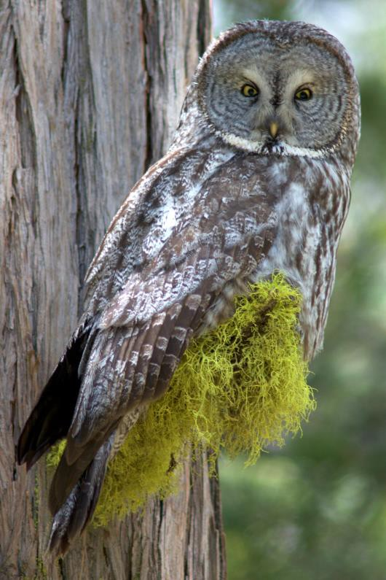

In mature forest stands within Great Gray Owl range that lack nest sites, top trees to provide artificial nest structures. These nest structures should be placed where historical logging practices or other factors have made natural nesting substrates unduly rare. Artificial nests should be placed within 250 m of meadows, particularly where the density of large (>60 cm dbh) snags is less than 4 per hectare (Wu et al. 2015). Incense-cedars (Calocedrus decurrens) are preferable to other species for the creation of nests because they decay slowly, resulting in a nest structure that will persist longer, and because topped incense-cedars will continue growing and even provide shade over the nest even after modification. It is important to create artificial nests under dense (e.g., >60%) canopy cover (Beck and Smith 1987, Winter 2005), particularly at lower elevations, where summer temperatures can be quite high. Microclimate factors such as proximity to streams and placing nests at the south end of a meadow, where trees to the south can provide shade (Roy Bridgman, pers. comm.), can also be taken into consideration. Furthermore, artificial nests should be placed nearby smaller trees leaning at approximately 40 degrees (Winter 2005), providing structures for young to climb on before they are capable of flight. While artificial nest creation may be an important conservation measure in the short-term, the longer-term need is to ensure an adequate supply of natural nesting opportunities, through recruitment and retention of meadow-adjacent forest stands with late seral characteristic – particularly large trees and large snags. To encourage this activity, particularly among private land owners, state regulators should consider offering a form of regulatory relief.
Figure 37. Great Gray Owl, Yosemite National Park (J. Helling).

How to Create an Artificial Nest
    - Select incense-cedars with dbh larger than 100 cm (40 in; or if this is not possible, topped trees should have a minimum dbh >60 cm/24 in).

    - Cut trees at a height of 8 m (26 ft) or greater (Beck and Smith 1987); natural Great Gray Owl nests ranged from 6 m to 39 m (20-128 ft; Wu et al. 2015).

    - Hollow out the top to create a bowl shape that is at least 46 cm (18 in) in diameter and 18-30 cm (7-12 in) deep (Beck and Smith 1987, Winter 2005). Create several drain holes at the bottom of the bowl for rainwater, and add 3 inches of sawdust to the bowl (Beck and Smith 1987, Winter 2005).

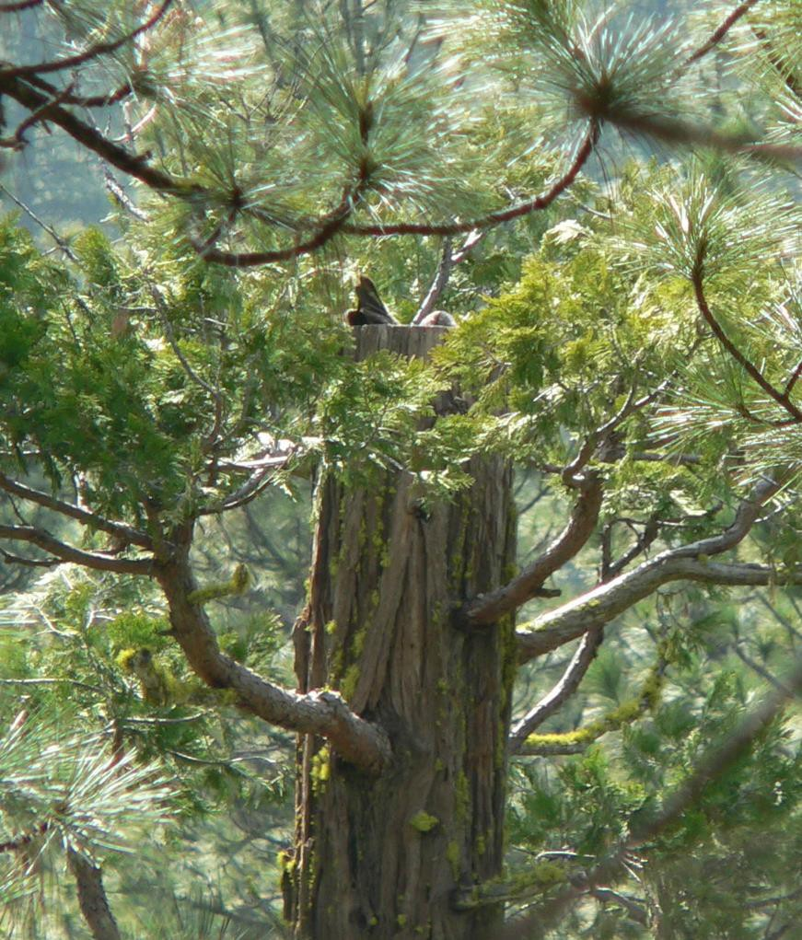
Figure 38. An artificial nest in an incense-cedar with a female Great Gray Owl in the nest; Tuolumne County (R. Bridgman).

Human Activity

Vehicle Strikes

Vehicle strikes are a significant source of mortality for Great Gray Owls (see Species Description and Ecology: Mortality Factors), and given the extremely small population size in California, this poses a serious threat to the species. Action is urgently needed across

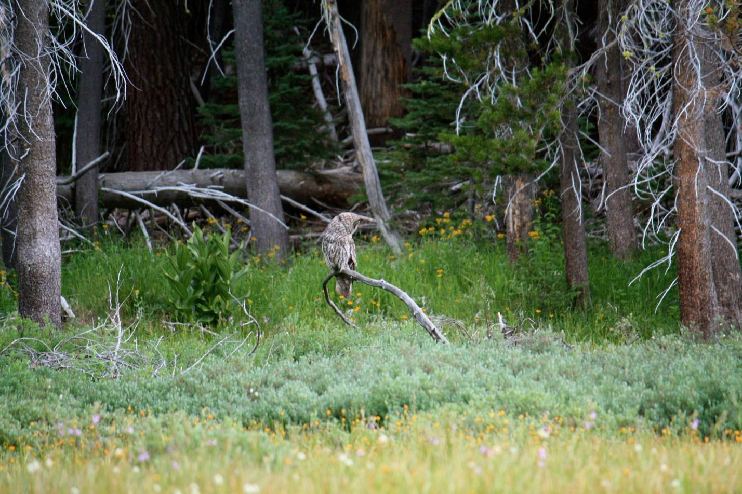
management jurisdictions to reduce vehicle collisions. In Yosemite National Park, speed limit reductions have been enacted and posted in areas with high use by Great Gray Owls and other wildlife. Enforcement of speed limits with the park is still a challenge despite increased efforts (Sarah Stock, pers. comm.). Vehicle strikes have not been limited to the heavily traveled roads of Yosemite National Park. Vehicle-killed Great Gray Owls have also been collected from highways and roadways in Amador, El Dorado, and Tuolumne counties. Anecdotal reports suggest the owls may be particularly vulnerable to vehicles strikes because of their tendency to use low perches while hunting. They may be so focused on prey that they swoop across the road despite oncoming vehicles, in one case a snowplow coming towards them (Nero 1980). We suggest that the speed limit be reduced to 15 mph on particular sections of roads frequented by Great Gray Owl both inside and outside of Yosemite National Park, perhaps in conjunction with speed bumps and enforcement via camera to reduce costs of patrol. In areas where visitor traffic is high, managers should be conservative about divulging Great Gray Owl presence to minimize potential harassment, using signs such as ‘Wildlife Crossing’ to explain the reduction in speed limit. In addition, speed feedback signs have been effective in Yosemite National Park (Sarah Stock, pers. comm.). During winter, owls may be susceptible to vehicle strikes at lower elevations as they disperse downslope to hunt (Skiff 1995, van Riper and van Wagtendonk 2006, Jepsen et al. 2011). At areas where year-round enforcement of a 15 mph speed limit may be too restrictive, consider implementing a seasonal speed limit outside the breeding season, as delineated in Beck and Winter (2000), when nestlings and fledglings are present and foraging activity is elevated.

Figure 39. A Great Gray Owl perches on a downed limb while hunting at the edge of a meadow at Yosemite National Park, California. The species’ tendency to hunt from low perches and swoop across roads may make it particularly susceptible to vehicle collisions (T. Ely).



Other suggestions include exploring vegetation management on a site-specific basis to discourage foraging along roadways. Avoid creation of new roads adjacent to or through meadows and grassy regions. As many vehicle strikes are clustered in sections of certain roads, consider removing or re-routing roads at those hotspots whenever possible. Other examples of management could include removing low perches, such as fence and snow posts, along roadways that are adjacent to meadows or other potential foraging areas, or making them unsuitable by installing spikes; and possibly increasing the height of fences and posts along roadways to at least 5 m. The use of posts along roadsides as hunting perches is one factor that likely increases risk of vehicle collisions; snow stakes, for example, can be removed in the early spring to ameliorate the problem (Maurer 2004).

Recommended Conservation Actions
- In Great Gray Owl vehicle strike hotspots (i.e., the interface of owl meadows and roadways where multiple vehicle strikes have occurred), consider a reduced (ideally 15 mph) speed limit and implementing speed-feedback signs and speed bumps. In areas where visitor traffic is high, managers should be conservative about divulging Great Gray Owl presence to minimize potential disturbance, using methods such as non-specific ‘Wildlife crossing’ signs.

- In areas where previous vehicle strikes have occurred and where year-round enforcement of a 15 mph speed limit may be too restrictive, consider implementing a seasonal speed limit when nestlings and fledglings are present and foraging activity is elevated.

- Consider management actions to discourage foraging along roadways specific to the given habitat conditions, where examples of management could include:
- Removing low perches, such as fence and snow posts, along roadways that are adjacent to meadows or other potential foraging areas, or making them unsuitable by installing spikes.
- Consider increasing the height of fences and posts along roadways to at least 5 m (16 ft), higher if possible.
- Avoid creation of new roads adjacent to or through meadows.
- Consider removing or re-routing roads away from meadows, particularly those with a history of Great Gray Owl vehicle strikes.

Land Development

Another threat to the Great Gray Owl is habitat loss due to land development. On the west slope of the Sierra Nevada, development has spread up in elevation with an ever-increasing human

population size (Davis and Gould 2008, Jepsen et al. 2011). Much of the lower montane zone below 1,500 m is privately owned, and although a large percentage of the montane foothills is currently wildland, approximately half of it is projected to be developed by 2040 (Jepsen et al. 2011). More than half of the 55 Great Gray Owl nests in the Sierra Nevada are below 1,500 m (data from Wu et al. 2015), particularly in Tuolumne, Mariposa, Madera, Fresno, El Dorado, Yuba, Calaveras, Amador counties, where residential and agricultural development (particularly conversion of wildlands to vineyards) at the lower bounds of Great Gray Owl range could pose the greatest risks to the species.

Great Gray Owl surveys should be completed to protocol (Beck and Winter 2000) before any CEQA/NEPA compliance projects that would result in permanent land conversion or land development in suitable habitat. In Tuolumne, Mariposa, Madera, Fresno, and Tulare counties, where there are the majority of historic records for breeding Great Gray Owls, compliance surveys should be completed within potentially suitable habitat (see Habitat Requirements). In parts of El Dorado and Calaveras counties, where there have been recent breeding records near meadows and within grassy openings, and even within timberlands, we suggest broadening the definition of suitable habitat to include grassy openings and oak-conifer woodlands. Finally, in places that have sporadic breeding-season detections (Modoc, Shasta, Lassen, Plumas, Tehama, Yuba, Sierra, Nevada, Placer, Amador, and Alpine counties), we suggest compliance surveys in proximity of historic detection sites. The ‘safe harbor’ process under CDFW should be used. Please contact CDFW to obtain exact locations in development planning.

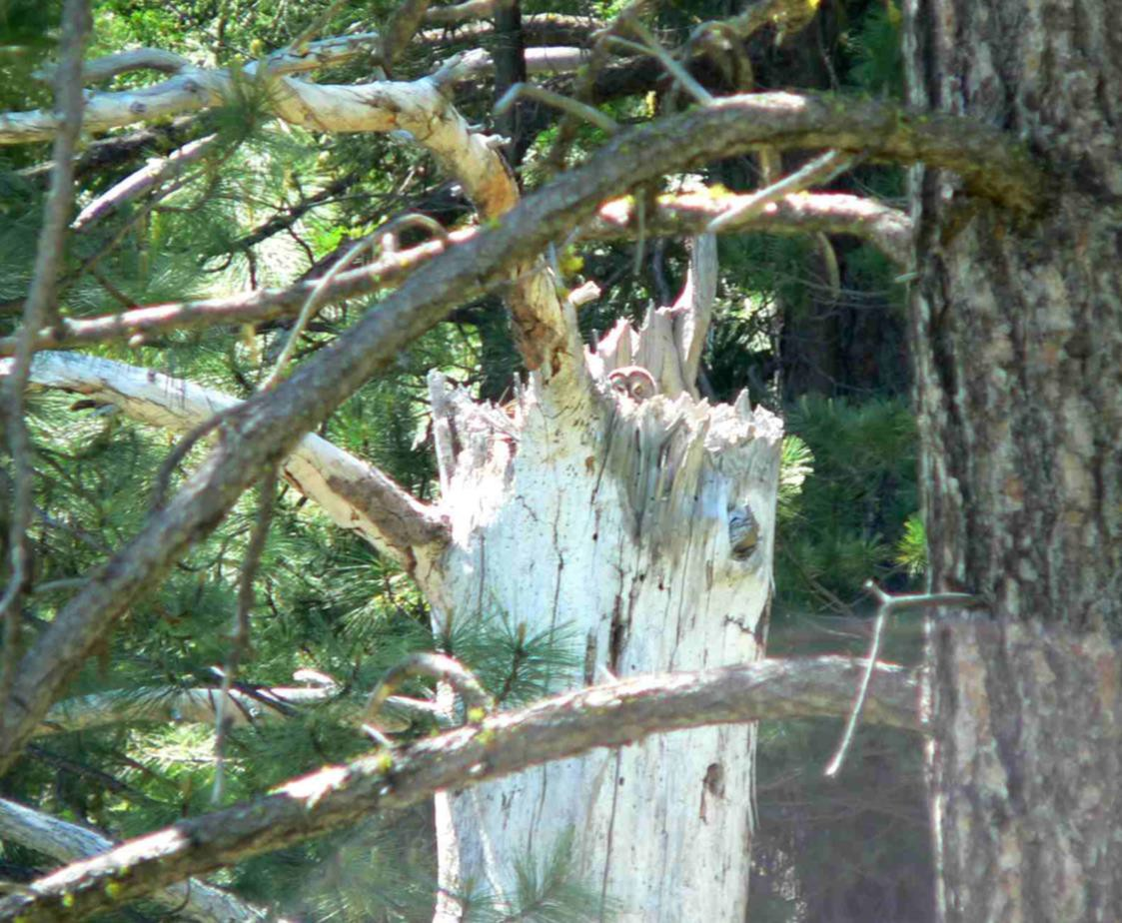

Figure 40. Female Great Gray Owl on broken-top nest; Tuolumne County (R. Bridgman).

Recommended Conservation Actions
- Particularly in Tuolumne, Mariposa, Madera, Fresno, El Dorado, Yuba, Calaveras, and Amador counties, where residential and agricultural development at the lower bounds of Great Gray Owl elevation range could pose the greatest risks to the species, encourage retention of habitat characteristics on private lands that are conducive to Great Gray Owl nesting and foraging. Within approximately 500 m (1,640 ft) of meadows or other grassy openings, retain large oaks and conifers and dense patches of forest.

- Encourage local land use agencies (counties and cities) to avoid residential, commercial, and agricultural development in and adjacent to large meadows in suitable Great Gray Owl habitat through zoning, general plans, and other land use planning instruments.

- To prevent important breeding and wintering habitat from being developed, enlist public agencies and local land trusts to prioritize acquisition of more land at the montane-foothill transition zone (roughly from 1,000-1,500 m/3,280-4,920 ft), especially in areas with records of Great Gray Owl detections. Encourage conservation easements for small private land parcel in the lower-montane zone of the Sierra Nevada (roughly from 700-1,000 m/2,300-3,280 ft) with large valley and black oaks and meadow or savanna grasslands nearby.

- Utilize the ‘safe harbor’ process (California Fish and Game Code sections 2089.2- 2089.26) to help protect private landowners from legal ramifications when land owners implement management plans developed for the purpose of improving or maintaining meadow and forest conditions for Great Gray Owls.

- Develop outreach materials for public and private grazing lands that emphasize how resting a meadow from grazing periodically can result in both ecological benefits for wildlife including Great Gray Owls, and improved forage yield, productivity, and water quality.


Rodent-Control

Small mammal poison in legal (e.g., at gopher control in forestry plantations, in vineyards, around cabins, in campgrounds) and illegal uses (e.g., at illicit marijuana grow sites) may travel up trophic levels to the Great Gray Owl. Researchers in Northwest California found marijuana- associated anticoagulant rodenticide (AR) poison in the livers of 62 percent and 41 percent of dead Barred Owls (Strix varia) on the Hoopa Valley Indian Reservation and on private timber lands, respectively (Learn 2015). Similar AR compounds that target important Great Gray Owl prey species are used on private and public lands in the Sierra Nevada where Great Gray Owls occur, often at illegal marijuana sites (Thompson et al. 2013, Gabriel et al. 2015). Over 600

illegal cultivation sites have been located in Sierra and Sequoia National Forests alone (Gabriel et al. 2013). Furthermore, many grow sites are near streams and meadows (Thompson et al. 2013), heightening the potential for conflict with Great Gray Owls. There are documented mortalities resulting from rodenticides in Barn Owls (Tyto alba; Newton et al. 1990, Albert et al. 2009), Tawny Owls (Strix aluco; Walker et al. 2008), Great Horned Owls (Mendenhall and Pank 1980, Stone et al. 1999, Albert et al. 2009), Northern Saw-Whet Owls (Aegolius acadicus; Mendenhall and Pank 1980), and Long-eared Owls (Asio otus; Stone et al. 2003), thus we can extrapolate that rodenticides would also affect the Great Gray Owl. No mortalities from AR compounds have been documented in the species to date, but such data are difficult to obtain as liver tissue from an intact carcass is required for testing (Thompson et al. 2013), and the isolation of many grow sites compounded by the rareness of the Great Gray Owl almost entirely precludes incidental discoveries. We recommend eliminating the use of all rodenticides in known Great Gray Owl CMAs. However, we acknowledge the complications of enforcement at illegal marijuana sites that inherently disregard such regulations.



Trapping for rodents in meadows used by Great Gray Owls may also deplete prey supply, though the extent of this impact on Great Gray Owls is likely smaller than the use of ARs since there is no issue of secondary poisoning. Regardless, prey can be limiting during the breeding season, so we recommend eliminating rodent-trapping within Great Gray Owl CMAs.

Recommended Conservation Actions
Meadows and Forests in Great Gray Owl Conservation Management Areas:

  - Eliminate the use of rodenticides, and avoid rodent-trapping from February 15th through August 5th (approximately the end of the nesting season as defined in Beck and Winter 2000).
Monitoring and Research Needs:

  - Study the prevalence and effects of rodenticide exposure on Great Gray Owls using blood samples from birds captured during any future research, tissue samples from mortalities, or by testing pellets for rodenticide residue.

Off-Highway Vehicles

The use of off-highway vehicles (OHV) is likely to negatively impact meadow function. OHV traffic was found to reduce vegetation by 40-100% and compacted, displaced, and loosened soils, the latter of which made soils more prone to erosion (Meadows et al. 2008). Compacted soils were less permeable to root growth (Ouren et al. 2007), and in one study the ability of the soil to absorb water was reduced by half (Meadows et al. 2008). Water quality can also be reduced via increased sedimentation, turbidity, and pollutants from mobilizing contaminants (Ouren et al. 2007). To maintain meadow function and resilience, as well as to avoid potential disturbance of nesting owls, we recommend prohibiting OHV use in meadows in Great Gray Owl CMAs during

the breeding season, February 15th through August 5th (approximately the end of the breeding season as defined in Beck and Winter 2000).



Recommended Conservation Actions
Meadows in Great Gray Owl Conservation Management Areas:

  - Restrict the use of off-highway vehicles (OHV) in meadows in CMAs from February 15th through August 5th (approximately the end of the breeding season as defined in Beck and Winter 2000).

Birdwatchers and Photographers

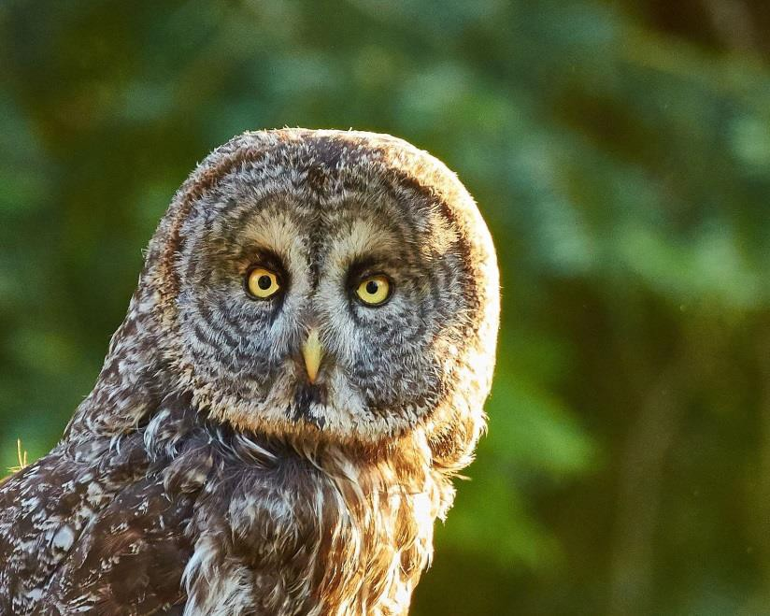
Several studies have investigated the impacts of birdwatchers on Great Gray Owls, which is not an issue across its range, but has been in certain hotspots that draw large crowds and increased traffic. When visitors flush an owl from its perch during the day it decreases the owl’s hunting efficiency by causing it to leave the area and expend additional energy (Reid 1989). In one study, when birdwatchers flushed hunting owls, the birds didn’t return to the meadow for 45 minutes; however, only 5-10% of the owl’s hunting time overlapped with birdwatcher presence (Wildman 1992).

Birders and photographers should refrain from active broadcasts of Great Gray Owl calls and from supplying mice to the owl, though passive birdwatching, particularly by single birders or small groups that do not pursue the birds, are likely to have a much smaller impact and can contribute positively to citizen science data. As birds respond to playbacks, their normal behavior is likely being interrupted, possibly resulting in increased energy expenditure, decreased hunting efficiency, or even increased risk to young in the nest if a female is agitated to the point of leaving the nest. For these reasons, vocalization broadcasts should not be used recreationally; excessive use could be construed as illegal take by the Department of Fish and Wildlife (Daniel Applebee, pers. comm.). On the other hand, Great Gray Owls may become accustomed to stealthy visitors, approaching to within a few meters of a researcher in one instance (Winter 1986). Despite this, researchers should continue to minimize impact to owls by using methods with the minimal level of disturbance needed to achieve project goals (See Survey Protocol: Number of Visits and Survey Effort for more discussion). In general, Great Gray Owl hotspot locations should continue to be redacted from publicly accessible documents, although respectful birdwatchers that refrain from using vocalization broadcasts should not be seen as a threat.
Figure 41. The Great Gray Owl is a sought-after species by birders and photographers (F. Lospalluto)

Forest Wildfire

The effects of fire on Great Gray Owls are complex and not fully understood. Medium- and high-severity wildfire leads to loss of canopy cover and may consume nest trees, but may also
aid in the recruitment of snags that are suitable for nesting. Low-severity fires may help maintain grassy hunting patches by clearing out understory. Great Gray Owls are vulnerable to the loss of historical nest sites and other large trees near meadow edges that are suitable for nesting. Where Great Gray Owl conservation is a priority, managers should consider using the full range of forest management options to reduce the chances of losing stands of large trees adjacent to meadows in areas where similarly large trees may not be recruited for decades or even centuries. If suitable nest trees are lost from otherwise appropriate habitat, managers working within the core Sierra Nevada range of Great Gray Owl should consider creating or installing artificial nest structures (as discussed elsewhere in this document). Such structures should not be viewed as a permanent solution to a lack of suitable nest trees, but rather as a temporary measure to try to maintain site occupancy until suitable natural nest sites become available again.

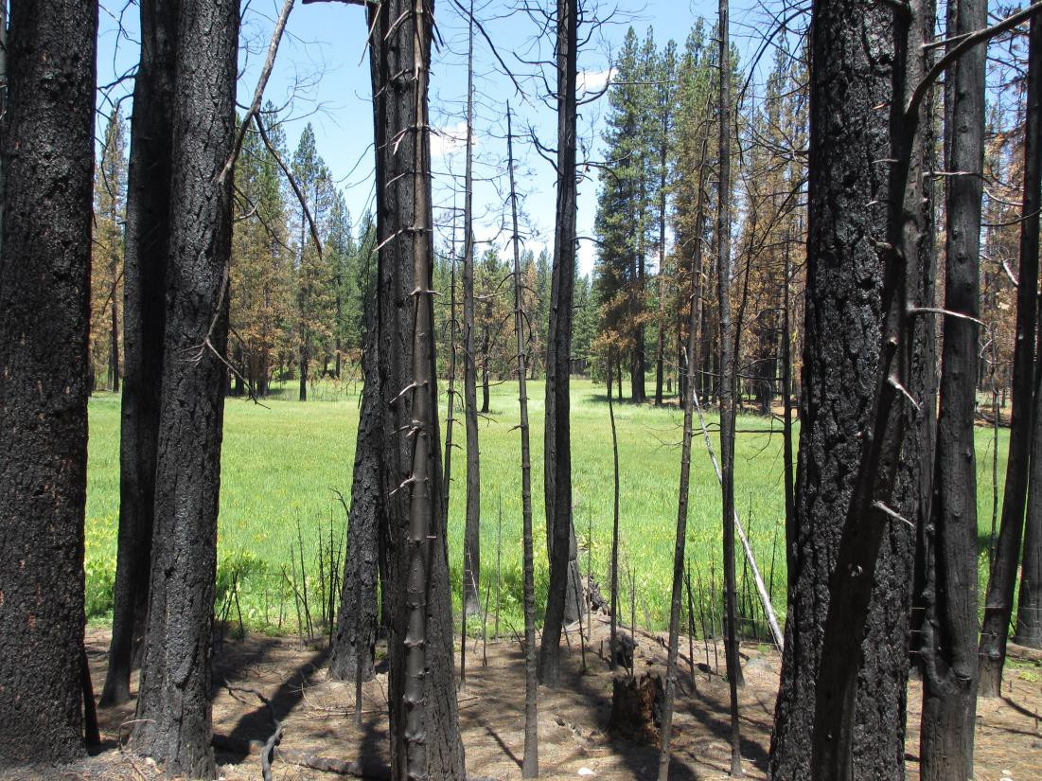
Figure 42. Great Gray Owl habitat that burned at high severity (foreground) and moderate severity (background) in the Rim Fire, taken one year post-fire, Yosemite National Park (NPS).

Within Yosemite National Park, the Rim Fire significantly reduced canopy cover in known and potential nest stands within the fire footprint; however, other characteristics (number of large dead trees, apparent gopher abundance, and Great Gray Owl detection frequency) generally did not differ between burned and unburned patches of known or potential Great Gray Owl habitat one year after fire (Wu et al., unpublished report). Despite the reduction in canopy cover, average canopy cover at burned sites was still within one standard deviation of the mean canopy

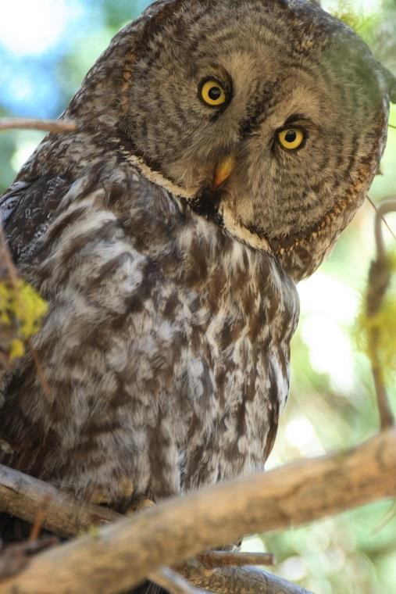
cover at all nest sites across California, and as high as at many unburned nest stands outside the park (Wu et al., unpublished report). One theory meriting further study is that wet meadows may act as a barrier or buffer to fire, making forest stands adjacent to meadows less susceptible to fire than upland forests. It is important to note that while the Rim Fire did not drastically alter Great Gray Owl habitat conditions in Yosemite National Park, it generally burned at higher severity in the adjacent Stanislaus National Forest. Thirteen PACs, approximately half of all Great Gray Owl PACs on the Stanislaus National Forest, were located in the Rim Fire perimeter, and around half of those 13 burned at high (>75% basal area mortality) severity (Baumbach and Rich 2014). Seventy percent of 35 natural and artificial nest structures were consumed in the 2013 Rim Fire, and current efforts are underway to mitigate with new artificial nest structures (Ryan Kalinowski, pers. comm.). Because of anecdotal observations indicating that Great Gray Owls may continue to use burned areas after fire, PACs were not retired; in fact, area was added when feasible to offset hazard tree removal (Baumbach and Rich 2014). Within the Rim Fire perimeter, six sites on Stanislaus National Forest in 2015 (Ryan Kalinowski, pers. comm.) had detections of Great Gray Owls, including a pair that was observed less than a month post-fire (Kristen Strohm, pers. comm.). Seven sites in 2014 and nine in 2015 in Yosemite National Park had Great Gray Owl detections (Stephanie Eyes, pers. comm.). Three pairs nested in the Rim Fire perimeter in 2014 and seven pairs nested in 2015 (Stephanie Eyes and Ryan Kalinowski, pers. comm.).
Figure 43. A Great Gray Owl peers down from its perch, Stanislaus National Forest (C. Rognan).

Other anecdotal reports of post-fire use include a non-breeding female that continued to occupy a burned meadow after a 1990 fire in Yosemite National Park (van Riper and van Wagtendonk 2006). Maurer (2006) observed that although some owls avoided burned areas in a prescribed fire in 2004, they did not seem to be permanently forced out. Two pairs in Yosemite nested six and seven years following a fire that removed virtually all canopy around the nest (data from Wu et al. 2015). In addition, several pairs of Great Gray Owls nested on the Stanislaus National Forest five years following a large fire in 1987, when large snags and tall grasses were abundant (Roy Bridgman, pers. comm.). The effects of fires on small mammals are also complex. Initially, fire can reduce small mammal numbers (depending on burn severity), but meadow voles reach pre-burn numbers several years later, when grasses dominate following a significant disturbance (Fisher and Wilkinson 2005).

Prescribed fire may be an effective management strategy to remove fuels, thereby reducing the risk of stand-replacing fire that would place nesting habitat in jeopardy. We recommend following the suggestion of Maurer (2006) that any prescribed burning within Great Gray Owl nesting areas be done outside the breeding period, and be conducted with care to retain large snags during the burn. Low severity wildfire and prescribed fire may also remove encroaching conifers along stringer meadows (Stillwater Sciences 2012), increasing the available meadow herbaceous habitat available to Great Gray Owls. Removal of encroaching conifers may increase

water availability for sedges and grasses, yielding increased height and density of herbaceous cover, thereby improving vole habitat. Even areas of high severity fire may be used by owls as ephemeral foraging habitat while herbaceous vegetation remains dominant. Fire is also a process by which large trees are either killed or damaged, thus becoming potential nesting substrate for owls. In some cases it may take many years for canopy cover to return to a burned site, or in cases of lower severity fire it may occur quickly.

In addition, fire regime in the Sierra Nevada has changed drastically since European settlement due to fire suppression and climate change (McKelvey et al. 1996, Mallek et al. 2013). Fires may have been more frequent, smaller, and lower severity in the past than they are today (Lydersen et al. 2014). A reversion back to a historic fire regime with a more frequent fire return interval could benefit Great Gray Owls, but climate change, as well as a legacy of fuel build-up from fire suppression, may make this difficult or impossible to achieve.



Monitoring and Research Needs
  - Conduct research on the effects of fire on Great Gray Owls, including but not limited to the following questions:
- Examine patterns of Great Gray Owl distribution and occupancy in relation to fire patterns at the landscape level, post-fire vegetation characteristics, and burn severity data.
- Examine how individual Great Gray Owls use burned areas within their home ranges.
- Determine fire vulnerability (e.g. fire return interval, burn severity patterns, etc.) of Sierra Nevada meadows and adjacent forest stands in comparison to upland areas.
  - Assess whether Great Gray Owls nesting far from meadows forage in non-meadow habitats such as forests treated with prescribed fire.

Climate Change

The Great Gray Owl was recently classified as one of the 17 bird species most vulnerable to anthropogenic climate change in the Sierra Nevada (Siegel et al. 2014). Climate change, particularly a snowpack that is projected to be reduced by ~40-90% (Hayhoe et al. 2004, Godsey et al. 2014), is likely to reduce moisture in Sierra Nevada meadows, especially during the middle and late summer (Thorne et al. 2012). Reduced moisture may lead to a host of ecological changes that could make meadows less suitable for Great Gray Owls and their main prey. Hydrological systems at many Sierra Nevada meadows have already been compromised by historic (and sometimes ongoing) landscape alterations and management activities, such as water diversion, soil compaction, livestock grazing, and impacts from roadways. Where feasible, addressing the legacy of past activities and restoring natural hydrologic processes that yield well-

watered meadows will help build resistance to the effects of climate change in meadow ecosystems and may allow Great Gray Owls to persist even as summer meadow conditions become drier.

Species with narrow dietary niches may be especially vulnerable to climate change (Young et al. 2011). Such is the case with the Great Gray Owl, and consequently, it may be important to manage for healthy vole populations in the face of climate change. A century of climate change in the Sierra Nevada is correlated with range contractions in the long-tailed vole (Microtus longicaudus) at the upper limits of its elevational distribution (Moritz et al. 2008). Warmer temperatures may push this boreal-adapted owl to higher elevations than it currently occupies, which may then lead to the potential of reducing range overlap with the long-tailed vole, and therefore, reduced foraging opportunities on one of the two vole species in the Sierra Nevada.

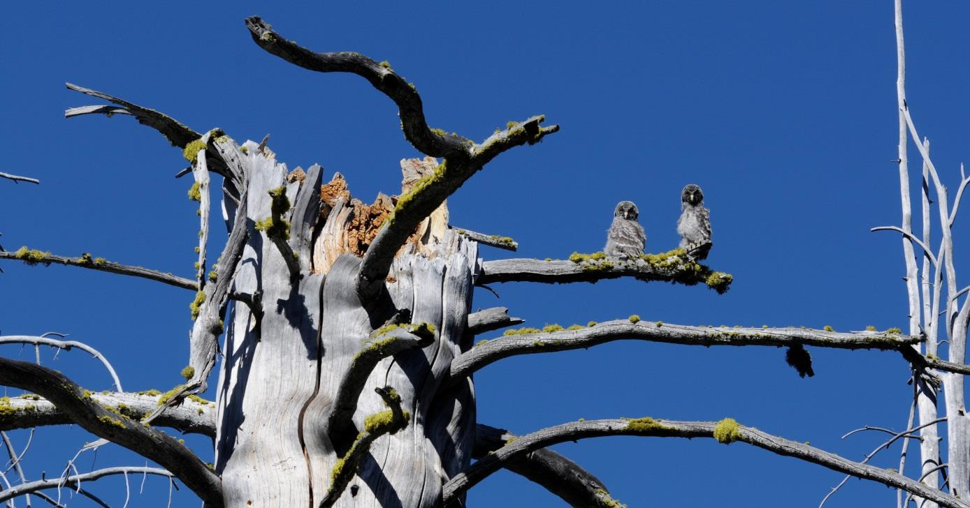
Increased temperatures may also directly threaten Great Gray Owls. Temperature of around 20° C can cause heat stress (Beck and Smith 1987), induce lethargic and panting reactions (Whitfield and Gaffney 1997), and cause young to leave the nest prematurely (Hoglund and Lansgren 1968 in Beck and Smith 1987). However, recent breeding records at low elevations where temperatures are regularly higher than 20° C during the breeding season (and where nesting success appears anecdotally to have been high) suggest more temperature flexibility than previously thought, and/or thermal adaptation by the segment of the population occupying lower-elevation areas.

Figure 44. Two fledglings perch on an exposed branch on a lodgepole pine, Yosemite National Park (J. Medley).



Additional risks to the Great Gray Owl may stem from the interaction of climate change and wildfire. Warming trends and reduced moisture availability within climate change projections is expected to result in increased prevalence of large fires along the western slope and foothills of the Sierra Nevada (Westerling and Bryant 2008). Due to the small Great Gray Owl population in the Sierra Nevada, losses even of a small number of occupied breeding sites could have population-level consequences (discussed below).

Recommended Conservation Actions

    - Manage for forest resistance and resilience to the extent possible to anticipate climate change.
Monitoring and Research Needs:

    - Examine Great Gray Owl occupancy and reproductive success as related to weather and climate.

Drought and Conifer Mortality

Related to climate change is the emerging issue of conifer mortality from the effects of prolonged drought and the interaction of drought-stressed trees with bark beetles and other agents of tree mortality. Forests with low soil moisture can respond nonlinearly to temperature increases (Goldstein et al. 2000), though studies tended to predict a general decrease in conifer growth and/or biomass (Miller and Urban 1999, Battles et al. 2008). California forests have experienced native bark beetle and wood boring beetle outbreaks nearly every decade since 1949, and increasingly from non-native diseases and insects (California Department of Forestry and Fire Protection 2010). Recent (spring of 2015) surveys of the Sierra Nevada largely south of Stanislaus National Forest have detected mortality of ~5-10 million trees, most of which was attributed to western pine beetle (Dendroctonus ponderosae; US Forest Service 2015).

It is not yet clear exactly how changes in California’s climate will affect forest insects that kill trees, but a warmer, drier climate would be expected to result in increased overwinter survival of insects and a decreased capacity of host trees to repel them (Trotter 2013). On small scales, the mortality of conifers could be expected to improve Great Gray Owl habitat by providing nesting structures; however conifer mortality on a large scale could degrade Great Gray Owl nest stands and increase the likelihood of habitat loss from large, severe fires. As annual snowpack in the Sierra Nevada decreases (Godsey et al. 2014), it appears likely that insect outbreaks may reach a level that substantially alters Great Gray Owl habitat.

Disease

Diseases, particularly avian trichomoniasis, pose a threat to Great Gray Owls. Two birds in Madera and Tuolumne Counties in 2006 and 2007, respectively, were diagnosed with avian trichomoniasis following their deaths (Chris Stermer, unpublished report). Pigeons and nocturnal and diurnal raptors are common carriers of avian trichomoniasis (Sansano-Maestre et al. 2009).

One possible mechanism of transmission could be through the consumption of Band-tailed Pigeons, which are thought to be a reservoir for the disease in Spotted Owls (Krysta Rogers, pers. comm.). There is some range overlap between the Great Gray Owl and Band-tailed Pigeons, though Great Gray Owls are not known to hunt Band-tailed Pigeons, or even birds, regularly (see Species Description and Ecology: Food Habits). Another mechanism of transmission is through contaminated water sources (Bunbury et al. 2008). To help determine the extent of trichomoniasis in the Great Gray Owl population, we suggest researchers take opportunistic oral swabs of any Great Gray Owls captured for any reason to test for avian trichomoniasis. Sample processing should be coordinated with CDFW’s Wildlife Investigation Lab.



West Nile virus (WNV) presents a threat to raptors as mortality rates tend to be high (Hull et al. 2010b). Following an outbreak in a captive population in Ontario, 91% of 23 Great Gray Owls died from WNV (Gancz et al. 2004). One Great Gray Owl in Northeastern Oregon in 2015 (Lynn Thompkins, pers. comm.) and six Great Gray Owls in Canada (Lopes et al. 2007) tested positive for WNV following their deaths. There are no other known cases in North America, and the prevalence of WNV in California is unclear. There is no incidence of infection in the wild, which could indicate absence of the virus from the population or, alternately, a high mortality rate associated with infection (Hull et al. 2010b). Yet another concern is the projected increase in the incidence of WNV due to more suitable climate conditions under climate change scenarios (Harrigan et al. 2014). To continue to monitor the occurrence or prevalence of WNV in the Great Gray Owl population, we suggest that blood samples from any Great Gray Owls captured be analyzed opportunistically for incidence of WNV. Sample processing should be coordinated with CDFW’s Wildlife Investigation Lab.

Recommended Conservation Actions

Continue to monitor the prevalence of various diseases in Great Gray Owls, including, but not limited to West Nile Virus and avian trichomoniasis:

- Check for incidence of West Nile Virus in all blood samples collected during present and future Great Gray Owl research.
- Take oral swabs of all Great Gray Owls captured to test for avian trichomoniasis.

Predation

Fisher, black bears, and particularly Great Horned Owls and Northern Goshawks have been documented to prey on young Great Gray Owls in North America; additionally, adults are occasionally killed by Great Horned Owls (Bull and Duncan 1993). There have been two reported cases of mortality by inter-specific predation in California. In 2004, an adult was found dead in a meadow with its young alive and begging. It was killed and plucked by a raptor, suspected to be a Bald Eagle or Northern Goshawk due to their presence in adjacent or overlapping territories (Roy Bridgman, pers. comm.). In 2007, another juvenile Great Gray Owl

found dead had sustained damage to its pectoral muscles in what was likely a raptor attack (Chris Stermer, unpublished report).

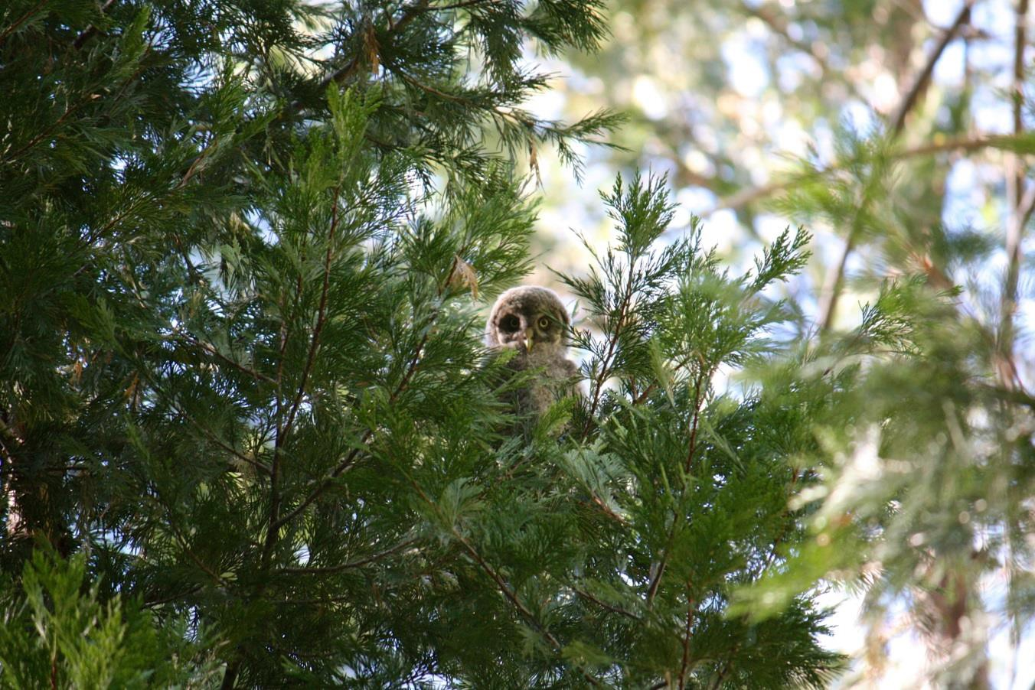
Further exploration of the role of Great Horned Owl predation on adults and young is warranted. Great Horned Owl populations have shown an average of 0.2% increase per year from 1966- 2013 across California, with >1.5% per year growth rates in the mid- to northern Sierra Nevada and -0.25% to 0.25% per year growth rates in the mid- to southern Sierra (Sauer et al. 2014). If human alterations of habitat have created increased predator populations, then understanding the mechanisms could lead to management that favors Great Gray Owl predation avoidance and balances unexpected increases in predator populations.

Figure 45. A juvenile Great Gray Owl peers out from among an incense-cedar. Yosemite- Stanislaus region (T. Ely).

Risks of a Small Population Size

Finally, California’s Great Gray Owl population is at risk simply because it is so small (Hull et al. 2010a). The Sierra Nevada population is subject to demographic, genetic, and environmental stochastic events (random changes over time). Demographic stochasticity can cause unbalanced age or sex ratios resulting in reduced capacity to breed (Lee et al. 2011). Deleterious effects, such as the loss of adaptive genes from the population or the proliferation of maladaptive genes, can be associated with reduced genetic diversity (Shaffer 1981, Lande 1993). Additionally, small populations are less able to weather and recover from random catastrophic events in the environment such as large wildfires. The putative Sierra Nevada subspecies may even, at worst, undergo stochastic extinction due to such a small population size. It is important to implement



management actions that result in an increase in the Great Gray Owl’s population size, although achieving ultimate population stability for this putative subspecies is a challenging task.

Monitoring and Research Needs

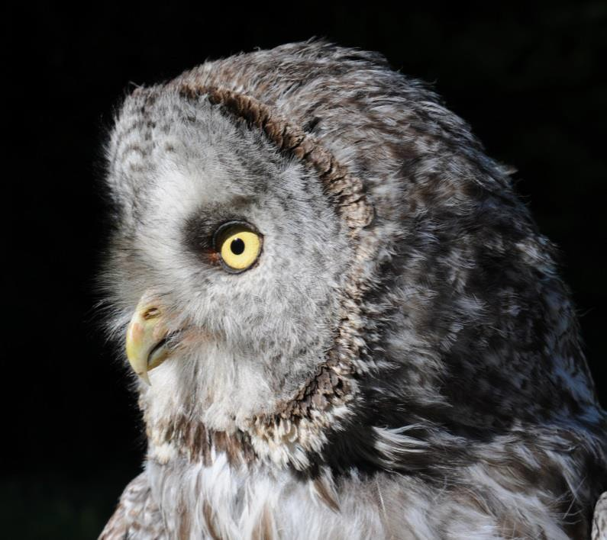
- Initiate long-term demographic studies of the Great Gray Owl similar to those conducted for the Spotted Owl (Lande 1988, Seamans et al. 2001, Dugger et al. 2005) and perform a Population Viability Assessment for the Great Gray Owl in California.

Figure 46. Great Gray Owl, Stanislaus-Yosemite region (R. Byrnes).

SURVEY PROTOCOL

Number of Visits and Survey Effort

The current widely accepted and comprehensive survey protocol for Great Gray Owl in the Sierra Nevada (Beck and Winter 2000) advises seasonal timing of surveys that distributes six survey visits across the different phases of the nesting cycle. The protocol is effective, but is also time- and labor-intensive to carry out in full, and federal and state personnel are frequently unable to achieve twelve visits over the two years that are currently required for a full survey to compliance standard, especially in years when heavy snowpack precludes access during the spring. For research and monitoring efforts that are not linked to proposed habitat-altering activities, and for which occupancy may be assessed in a probabilistic framework, the survey protocol may be abbreviated to three visits over a one-year period. However, in instances where lack of detection will make permissible habitat-altering activities, we strongly suggest retaining all six visits per year and two years of surveys, until any revisions to the protocol. The three- survey protocol should consist of two broadcast surveys and one meadow search per year. Keane et al. (2011) suggested that in historically occupied meadows in Yosemite National Park, this could achieve a detection probability of over 95%. However, other surveyors have reported much lower rates in other years and locations (Joe Medley, Kevin Roberts, Sarah Stock, pers. comm.). When conducting a three-visit survey, it would be most effective to conduct one broadcast survey during the initial courtship or incubation period and another during the nestling or post-fledging period (Beck and Winter 2000), as owls may be most vocal during those periods (Tom Beck, Joe Medley, and Sarah Stock, pers. comm.). However, snow and access conditions can make the initial visit difficult or impossible. In those cases, surveyors should visit sites as early as logistically feasible. Daytime meadow searches should be conducted as recommended (Beck and Winter 2000), after pellet and molted flight feather accumulation following the breeding season.

Researchers studying the Great Gray Owl should minimize impact to owls by using the minimal level of disturbance needed to achieve project goals. Land managers and land management agencies should share survey plans and results with one another to prevent redundant surveys and reduce disturbance of owls. In addition, effective communication and information sharing is important to achieve a better understanding of Great Gray Owl distribution over a continuous landscape. Locations of owls detected more than 15 km (9 mi) from a known breeding site could indicate range expansion and merit additional surveys.



Recommended Conservation Actions

  - The six-visit, two-year survey protocol (Beck and Winter 2000) should be carried out in full prior to any CEQA/NEPA compliance projects that would result in major habitat alteration within suitable Great Gray Owl habitat.

  - In surveys for research and monitoring purposes that do not result in the approval of habitat-altering activities, managers may consider optimizing survey effort allocation by abbreviating the protocol to three visits (Keane et al. 2011). The visits should include two broadcast surveys and one meadow search survey, or three broadcast surveys in cases where foraging habitat is dispersed throughout the owl use area such that there are not distinct meadow edges to search. We recommend that one of the broadcast surveys be conducted during the courtship or incubation period, if snow conditions permit access by surveyors. We recommend the other broadcast survey be conducted during the nestling or post-fledging period, and the meadow search be conducted between August 1st and October 15th. If doing three broadcast surveys, the last two should be conducted during the nestling or post- fledgling period (see Beck and Winter 2000 for elevation-specific dates).

  - Locations of owls detected more than 15 km (9 mi) from a known breeding site could indicate range expansion and should be followed up with six-visit surveys as soon as possible, and also in subsequent years.

  - Researchers should minimize disturbance of individual owls by using the least intrusive methods needed to achieve project goals and by coordinating across jurisdictions.

  - Agencies and land managers should share survey plans and results with one another to reduce disturbance of owls and to achieve a better understanding of Great Gray Owl distribution over a continuous landscape.

  - Managers should track and report negative survey results (in addition to positive survey results) to better understand the spatial and temporal distribution of Great Gray Owl detections and non-detections.

  - Monitor Great Gray Owl populations over time by conducting broadcast and meadow search surveys in previously occupied areas.

Nest Searching Recommendations

Finding a nest leads to the highest degree of protection from land-altering activities possible in any management regime (but see Recommendation #1, page 5). Monitoring of nests and reproductive success can also yield valuable information to land managers about breeding habitat quality and population constraints. Yet Great Gray Owl nests are very hard to find, and the

‘mousing’ technique typically used for finding Spotted Owl nests has generally not been successful for Great Gray Owls. Since Great Gray Owls nest primarily on top of broken- top snags, it is sometimes impossible to see a female sitting low in the nest from ground level. Previous suggestions have included searching for nests by walking through the forest scanning all broken-topped trees (Maurer 2006), listening for begging females and juveniles, and looking for whitewash, although the latter also indicates roost or hunting perches, and nests may or may not be within the proximity of whitewash (Beck and Winter 2000).

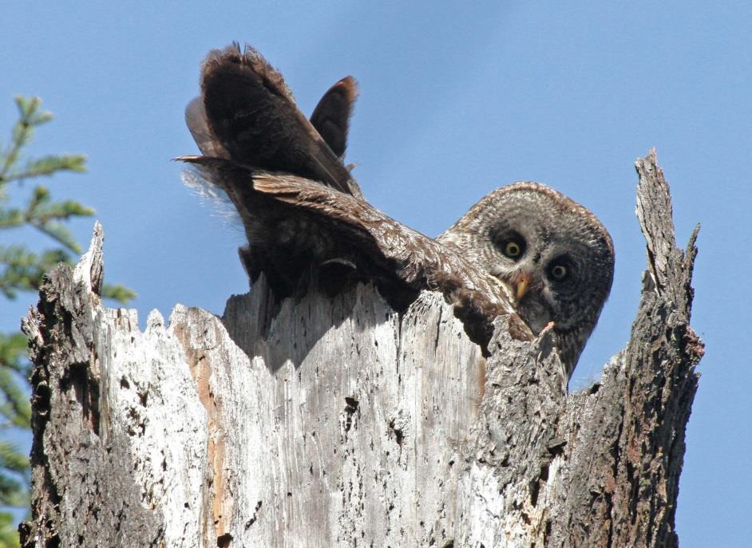
Figure 47. Nesting Great Gray Owl, Oregon (N. Barrett).

When researchers have a need to find nests, another strategy that may yield results is to observe the male owl hunting. If he carries food into the forest, follow him at a distance to try to locate the nest as the male provides for brooding females (Bull and Henjum 1990, Beck and Winter 2000). However, females have been seen flying 50 m off the nest to meet the male, so observers may need to follow the female back to the nest tree (Jon Winter, pers. comm.). We stress that Great Gray Owls are shy (Beck and Winter 2000) and more sensitive to disturbance than Spotted Owls (Gutiérrez et al. 1995, Verner et al 1992), and this level of intensive monitoring should only be done if there is a compelling need, in situations where knowing the nest location could improve conservation and protection.



Monitoring and Research Needs

- Develop a formalized nest-search protocol for the Great Gray Owl.

Other Survey and Monitoring Methods

In order to better understand summer and winter ranges, we suggest that additional surveys (not necessarily to six-visit protocol) also be conducted. Surveys during the winter are useful to determine the wintering range of the Great Gray Owl, though response rates in winter may be lower. We suggest using a system of road-based call points where surveyors drive along routes, stopping to broadcast for owls at systematic call stations. Priority should be given to areas near previous Great Gray Owl detections that have meadows and grassy openings (See Definitions: Suitable Great Gray Owl Habitat). Annual visits, bi-annual visits, or even a one-time effort, particularly in areas of the Sierra Nevada that have not been well covered by formal surveys in the past, would all provide useful information.



In addition, land managers could consider implementing novel monitoring techniques that are under development and may become more widely applied in the future. Autonomous recording units (ARUs) may be placed at survey sites to record many hours of data, which then can be filtered through audio algorithms for owl vocalizations (Joe Medley, pers. comm.). Using ARUs enables managers to survey sites for an extended period of time without requiring human observers on the ground, though there are costs associated with equipment and analyzing recordings. Techniques to analyze DNA from feathers collected during meadow searches are also being developed (John Keane, pers. comm.). Feather DNA analysis may be able to determine the number of individuals at a particular site, differentiate population groups, and even resolve population growth rate (lambda) with multi-year data (John Keane, pers. comm.). Researchers should also assess the feasibility of monitoring nests using camera-mounted drones, as nests, often high up in deteriorating snags, can be impossible to see into from the ground and too dangerous to climb. Again, potential disturbance to nesting owls should be carefully weighed, though impacts may be minimized as technology improves.

Monitoring and Research Needs

Consider other methods of surveying and monitoring, such as, but not limited to:
- Acoustic monitoring
- Surveys during winter/non-breeding season
- Nest detection and monitoring using drones, especially as technology
improves
- Assess detection probability to improve the current survey protocol
- Assess the feasibility of training dogs to detect pellets

Incidental Sightings

Incidental sightings, including vehicle strikes, should be reported to the applicable land managing jurisdiction (e.g. Forest Service, National Park Service). They should also be reported to the California Natural Diversity Database (CNDDB) according to methods listed on the CDFW website: https://www.dfg.ca.gov/biogeodata/cnddb/submitting_data_to_cnddb.asp

If the sighting is in an area where Great Gray Owls are not already known to occur, a trained observer should follow up with broadcast surveys and a meadow search survey (if there is a meadow nearby) as soon as possible (Beck and Winter 2000).

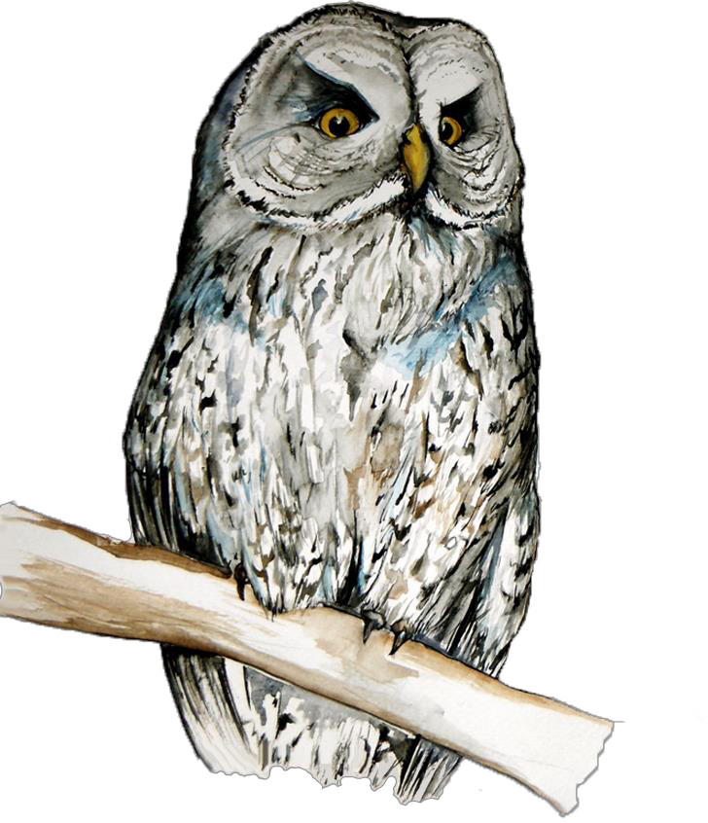
Artwork by: Lynn Schofield.

LITERATURE CITED

Agee, J. K. and C. N. Skinner. 2005. Basic principles of forest fuel reduction treatments. Forest Ecology and Management 211:83-96.
Albert, C. A., L. K. Wilson, P. Mineau, S. Trudeau, and J. E. Elliott. 2009. Anticoagulant Rodenticides in Three Owl Species from Western Canada, 1988–2003. Archives of Environmental Contamination and Toxicology 58:451-459.
Battles, J. J., T. Robards, A. Das, K. Waring, J. K. Gilless, G. Biging, and F. Schurr. 2008.
Climate change impacts on forest growth and tree mortality: a data-driven modeling study in the mixed conifer forest of the Sierra Nevada, California. Climatic Change 87:S193-S213.
Batzli, G. O. and F. A. Pitelka. 1971. Condition and Diet of Cycling Populations of the California Vole, Microtus californicus. Journal of Mammalogy 52:141-163.
Baumbach, M. and A. Rich. 2014. Final Terrestrial Biological Assessment, Evaluation, and Wildlife Report: Rim Fire Recovery. U.S. Department of Agriculture, Forest Service, Stanislaus National Forest, California.
Beck, T. W. 1985. Interim direction for management of great gray owl. Stanislaus National Forest, CA.
Beck, T. W. and R. A. Smith 1987. Nesting chronology of the great gray owl at an artificial nest site in the Sierra Nevada. Journal of Raptor Research 21:116-118.
Beck, T. W. and J. Winter. 2000. Survey protocol for the Great Gray Owl in the Sierra Nevada of California. U.S. Department of Agriculture, Forest Service, Vallejo, California.
Belsky, A. J., A. Matzke, S. Uselman. 1999. Survey of livestock influences on stream and riparian ecosystems in the western United States. Journal of Soil and Water Conservation 54:419-431.
Briske, D. D., J. D. Derner, J. R. Brown, S. D. Fuhlendorf, W. R. Teague, K. M. Havstad, R. L. Gillen, A. J. Ash, and W. D. Willms. 2008. Rotational Grazing on Rangelands: Reconciliation of Perception and Experimental Evidence. Rangeland Ecology and Management 61:3-17.
Briske, D. D., J. D. Derner, D. G. Milchunas, and K. W. Tate. 2011. An Evidence-Based Assessment of Prescribed Grazing Practices. Pages 21-74 in D. D. Briske, ed. Conservation benefits of rangeland practices: assessment, recommendations, and knowledge gaps. U.S. Department of Agriculture, Natural Resources Conservation Service, Washington, D.C., USA.
Bull, E. L. and J. R. Duncan. 1993. Great Gray Owl (Strix nebulosa). In A. Poole, ed. The Birds of North America Online. Cornell Lab of Ornithology, Ithaca, New York.
<http://bna.birds.cornell.edu/bna/species/041> Accessed 5 March 2013.
Bull, E. L. and M. G. Henjum. 1990. Ecology of the Great Gray Owl. Gen. Tech. Rep. PNW- GTR-265. U.S. Department of Agriculture, Forest Service, Pacific Northwest Research Station, Portland, Oregon.
Bull, E. L., M. G. Henjum, R. S. Rohweder. 1989. Diet and Optimal Foraging of Great Gray Owls. Journal of Wildlife Management 53:47-50.
Bunbury, N., C. G. Jones, A. G. Greenwood, and D. J. Bell. 2008. Epidemiology and conservation implications of Trichomonas gallinae infection in the endangered Mauritian pink pigeon. Biological Conservation 141:153-161.
California Department of Fish and Game. 2007. Great Gray Owl species information. Draft document, April 23, 2007. Northern Region, California Department of Fish and Game.

California Department of Fish and Wildlife. 2013a. California Natural Diversity Database.
<http://www.dfg.ca.gov/biogeodata/cnddb/> Accessed 8 March 2013.
California Department of Fish and Wildlife. 2013b. Gordon Gould’s database of Great Gray Owl detections. California Department of Fish and Wildlife, Sacramento.
California Department of Forestry and Fire Protection. 2010. California’s Forests and Rangelands: 2010 Assessment. California Department of Forestry and Fire Protection, Fire and Resource Assessment Program, Sacramento, California.
California Department of Forestry and Fire Protection. 2013. California Forest Practice Rules 2013. California Department of Forestry and Fire Protection, Forest Practice Program, Sacramento, California.
Collins, B. M., R. G. Everett, and S. L. Stephens. 2011. Impacts of fire exclusion and recent managed fire on forest structure in old growth Sierra Nevada mixed-conifer forests. Ecosphere 2:1-14.
Collins, K. M. 1980. Aspects of the biology of the Great Gray Owl, Strix nebulosa Forster. MS Thesis, University of Manitoba, Winnipeg.
Collister, D. M. 1997. Seasonal Distribution of the Great Gray Owl (Strix nebulosa) in Southwestern Alberta. Pages 119-122 in J. R. Duncan, D. H. Johnson, and T. H. Nicholls, eds. Biology and conservation of owls of the Northern Hemisphere: 2nd International symposium. Gen. Tech. Rep. NC-190. U.S. Department of Agriculture, Forest Service, North Central Forest Experiment Station, St. Paul, Minnesota.
Davis, J. N. and G. I. Gould, Jr. 2008. California Spotted Owl (Strix occidentalis occidentalis).
Studies of Western Birds 1:227-233.
Dugger, K. M., F. Wagner, R. G. Anthony, and G. S. Olson. 2005. The relationship between habitat characteristics and demographic performance of northern spotted owls in southern Oregon. Condor 107:863-878.
Dull, R. A. 1999. Palynological Evidence for 19th Century Grazing-Induced Vegetation Change in the Southern Sierra Nevada, California, U.S.A. Journal of Biogeography 26:899-912.
Ferrell, P. 2005. Power Fire Restoration Final EIS. U.S. Department of Agriculture, Forest Service, Eldorado National Forest, California.
Fisher, J. T. and L. Wilkinson. 2005. The response of mammals to forest fire and timber harvest in the North American boreal forest. Mammal Review 35:51-81.
Fites-Kaufman, J., P. Rundel, N. Stephenson, and D. A. Weixelman. 2007. Montane and Subalpine Vegetation of the Sierra Nevada and Cascade Ranges. Pages 460-501 in M.G. Barbour, T. Keeler-Wolf, and A. A. Schoenherr, eds. Terrestrial Vegetation of California. University of California Press, Berkeley, California.
Fitzgerald, B. M. 1977. Weasel Predation on a Cyclic Population of the Montane Vole (Microtus montanus) in California. Journal of Animal Ecology 46:367-397.
Fleishner, T. L. 1994. Ecological costs of livestock grazing in Western North America.
Conservation Biology 8:629-644.
Freitas, M. R., L. M. Roche, D. Weixelman, and K. W. Tate. 2014. Montane meadow plant community response to livestock grazing. Environmental management 54:301-308.
Gabriel, M. W., G. M. Wengert, J. M. Higley, S. Krogan, W. Sargent, and D. L. Clifford. 2013.
Silent Forests? Rodenticides on illegal marijuana crops harm wildlife. The Wildlife Professional, Spring 2013:46-50.
Gabriel, M. W., L. W. Woods, G. M. Wengert, N. Stephenson, J. M. Higley, C. Thompson, S. M. Matthews, R. A. Sweitzer, K. Purcell, R. H. Barrett, S. M. Keller, P. Gaffney, M. Jones,

R. Poppenga, J. E. Foley, R. N. Brown, D. L. Clifford, and B. N. Sacks. 2015. Patterns of Natural and Human-Caused Mortality Factors of a Rare Forest Carnivore, the Fisher (Pekania pennanti) in California. PLoS ONE 10(11): e0140640. doi:10.1371/journal.pone.0140640.
Gancz, A. Y., I. K. Barker, R. Lindsay, A. Dibernardo, K. McKeever, and B. Hunter. 2004. West Nile Virus Outbreak in North American Owls, Ontario, 2002. Emerging Infectious Disease Journal 10:2135-2142.
Gill, F. and D. Donsker. 2015. IOC World Bird List. Version 5.4. International Ornithological Congress. <http://www.worldbirdnames.org/bow/> Accessed 17 November 2015.
Goldstein, A. H., N. E. Hultman, J. M. Fracheboud, M. R. Bauer, J. A. Panek, M. Xu, Y. Qi, A.
B. Guenther, and W. Baugh. 2000. Effects of climate variability on the carbon dioxide, water, and sensible heat fluxes above a ponderosa pine plantation in the Sierra Nevada (CA). Agricultural and Forest Meteorology 101:113-129.
Godsey, S. E., J. W. Kirchner, and C. L. Tague. 2014. Effects of changes in winter snowpacks on summer low flows: case studies in the Sierra Nevada, California, USA. Hydrological Processes 28:5048-5064.
Gould, G. I. 1987. Five-year status report: Great Gray Owl. Wildlife Management Division, California Department of Fish and Wildlife, Sacramento, California.
Greene, C. 1995. Habitat Requirements of Great Gray Owls in the Central Sierra Nevada. MS Thesis, University of Michigan, Ann Arbor.
Gutiérrez R., M. Cody, S. Courtney, and D. Kennedy. 2004. Assessment of the potential threat of the northern barred owl. In S. P. Courtney, J. A. Blakesley, R. E. Bigley, M. L. Cody, J.
P. Dumbacher, R. C. Fleischer, A. B. Franklin, J. F. Franklin, R. J. Gutiérrez, J. M. Marzluff, and L. Sztukowski, eds. Scientific evaluation of the status of the northern spotted owl. Sustainable Ecosystems Institute, Portland, Oregon.
Gutiérrez, R. J., A. B. Franklin and W. S. Lahaye. 1995. Spotted Owl (Strix occidentalis). In A. Poole, ed. The Birds of North America Online. Ithaca: Cornell Lab of Ornithology.
<http://bna.birds.cornell.edu/bna/species/179> Accessed 6 July 2015.
Harrigan, R. J., H. A. Thomassen, W. Buermann, and T. B. Smith. 2014. A continental risk assessment of West Nile virus under climate change. Global Change Biology 20(8). doi: 10.1111/gcb.12534.
Hayhoe, K., D. Cayan, C. B. Field, P. C. Frumhoff, E. P. Maurer, N. L. Miller, S. C. Moser, S.
H. Schneider, K. N. Cahill, E. E. Cleland, L. Dale, R. Drapek, R. M. Hanemann, L. S. Kalkstein, J. Lenihan, C. K. Lunch, R. P. Neilson, S. C. Sheridan, and J. H. Verville. 2004. Emissions pathways, climate change, and impacts on California. PNAS 101:12422- 12427.
Hayward, G. D. and J. Verner, tech. editors. 1994. Flammulated, boreal, and great gray owls in the United States: A technical conservation assessment. Gen. Tech. Rep. RM-253, U.S. Department of Agriculture, Forest Service, Rocky Mountain Forest and Range Experiment Station, Fort Collins, Colorado.
Hoffmann, R. S. 1958. The Role of Reproduction and Mortality in Population Fluctuations of Voles (Microtus). Ecological Monographs 28:79-109.
Hormay, A. L. 1970. Principles of rest-restoration grazing and multiple land-use management.
U.S. Department of the Interior, Bureau of Land Management.
Huago, R. D. and C. B. Halpern. 2010. Tree age and tree species shape positive and negative interactions in a montane meadow. Botany 88:488-499.

Hull, J. M., A. Englis, Jr., J. R. Medley, E. P. Jepsen, J. R. Duncan, H. B. Ernest, and J. J. Keane.
2014. A New Subspecies of Great Gray Owl (Strix nebulosa) in the Sierra Nevada of California, U.S.A. 2014. Journal of Raptor Research 48:68-77.
Hull, J. M., J. J. Keane, W. K. Savage, S. A. Godwin, J. A. Shafer, E. P. Jepsen, R. Gerhardt, C. Stermer, H. B. Ernest. 2010a. Range-wide genetic differentiation among North American great gray owls (Strix nebulosa) reveals a distinct lineage restricted to the Sierra Nevada, California. Molecular Phylogenetics and Evolution 56: 212-221.
Hull, J. M., J. J. Keane, L. Tell, and H. B Ernest. 2010b. West Nile Virus antibody surveillance in three Sierra Nevada raptors of conservation concern. The Condor 112:168-172.
Hunter, J. E. 1991. Grazing and Pocket Gopher Abundance in a California Annual Grassland.
The Southwestern Naturalist 36:117-118.
Jepsen, E. P. B., J. J. Keane, H. B. Ernest. 2011. Winter Distribution and Conservation Status of the Sierra Nevada Great Gray Owl. The Journal of Wildlife Management 75:1678-1687.
Johnson, M. D. and C. M. Horn. 2008. Effects of rotational grazing on rodents and raptors in a coastal grassland. Western North American Naturalist 68:444-452.
Kalies, E. L., B. G. Dickson, C. L. Chambers, and W. W. Covington. 2012. Community occupancy responses of small mammals to restoration treatments in ponderosa pine forests, northern Arizona, USA. Ecological Applications 22:204-217.
Kalinowski, R. 2012. Habitat Relationships of Great Gray Owl Prey in Meadows of the Sierra Nevada Mountains. MS thesis, Humboldt State University.
Kalinowski, R. S., M. D. Johnson, and A. C. Rich. 2014. Habitat Relationships of Great Gray Owl Prey in Meadows of the Sierra Nevada Mountains. Wildlife Society Bulletin 38:547- 556.
Keane, J. J., H. B. Ernest, J. M. Hull. 2011. Conservation and Management of the Great Gray Owl 2007-2009: Assessment of Multiple Stressors and Ecological Limiting Factors. Report F8813-07-0611, National Park Service & U.S. Department of Agriculture, Forest Service.
Keen, F. P. 1955. The rate of natural falling of beetle-killed ponderosa pine snags. Journal of Forestry 53:720-723.
LaManna, J. 2009. Grazing Effects on Prey Populations of Great Gray Owl in the Central Sierra Nevada. Investigator’s report, USDI National Park Service, Yosemite National Park, California.
Lande, R. 1988. Demographic Models of the Northern Spotted Owl (Strix occidentalis caurina).
Oecologia 75:601-607.
Lande, R. 1993. Risks of Population Extinction from Demographic and Environmental Stochasticity and Random Catastrophes. The American Naturalist 142: 911-927.
Landram, M. F, W. F. Laudenslayer, and T. Atzet. 2002. Demography of snags in eastside pine forests of California. U.S. Forest Service, Gen. Tech. Rep. PSW507 GTR-181, Vallejo, California.
Learn, J. R. 2015. Illegal Weed Plantations May Affect Owl Recovery. The Wildlife Society.
<http://wildlife.org/illegal-weed-plantations-may-affect-owl-recovery/> Accessed 13 Feb 2015.
Lee, A. M., B.-K. Sæther, and S. Engen. 2011. Demographic Stochasticity, Allee Effects, and Extinction: The Influence of Mating System and Sex Ratio. The American Naturalist 177:301-313.

Loffland, H. L, R. B. Siegel, and R. L. Wilkerson. 2011. Avian Monitoring Protocol for Sierra Nevada Meadows: A tool for assessing the effects of meadow restoration on birds. Version 1.0. The Institute for Bird Populations, Point Reyes Station, California.
Long, J., K. Pope, and K. Matthews. 2013. Wet Meadows. In Science synthesis to promote resilience of social-ecological systems in the Sierra Nevada and Southern Cascades. U.S. Department of Agriculture, Forest Service Pacific Southwest Research Station, Vallejo, California.
Lydersen, J. M., M. P. North, and B. M Collins. 2014. Severity of an uncharacteristically large wildfire, the Rim Fire, in forests with relatively restored frequent fire regimes. Forest Ecology and Management 328:326-334.
Mallek, C., H. Safford, J. Viers, J. Miller. 2013. Modern departures in fire severity and area vary by forest type, Sierra Nevada and southern Cascades, California, USA. Ecosphere 4:1-28.
Maurer, J. 2004. Final Report: 2004 Great Gray Owl Survey, Yosemite National Park. U.S.
Department of the Interior, National Park Service, Yosemite National Park, California. Maurer, J. 2006. Final Report: 2005 Great Gray Owl Survey in Yosemite National Park. Contract
Number P8826-05-0058, U.S. Department of the Interior, National Park Service, Yosemite National Park. California.
Mayer, K. E. and W. F. Laudenslayer, Jr, eds. 1988. A guide to wildlife habitats of California.
Department of Fish and Game, State of California, Resource Agency, Sacramento, California.
McKelvey, K. S., C. N. Skinner, C. Chang, D. C. Et-man, S. J. Husari, D. J. Parsons, J. W. van Wagtendonk, and C. P. Weatherspoon. 1996. An Overview of Fire in the Sierra Nevada. Sierra Nevada Ecosystem Project: Final report to Congress, vol. II. Assessments and scientific basis for management options. Centers for Water and Wildland Resources, University of California, Davis.
Meadows, D., R. Foltz, and N. Geehan. 2008. Effects of all-terrain vehicles on forested lands and grasslands. U.S. Department of Agriculture, Forest Service & U.S. Department of Transportation, Federal Highway Administration.
Mendenhall, V. M. and L. F. Pank. 1980. Secondary poisoning of owls by anticoagulant rodenticides. Wildlife Society Bulletin 8:311–315.
Mikkola, H. 1972. Food of Great Grey Owls in the Lapland Reserve, U.S.S.R. British Birds 65:30-31.
Mikkola, H. 1976. Great Grey Owls of Konnevesi. Savon Luonto 8:13-22.
Mikkola, H. and S. Sulkava. 1970. Food of Great Grey Owls in Fenno-Scandia. British Birds 63:23-27.
Moritz, C., J. L. Patton, C. J. Conroy, J. L. Parra, G. C. White, S. R. Beissinger. 2008. Impact of a Century of Climate Change on Small-Mammal Communities in Yosemite National Park, USA. Science 332:261-264.
Miller, C. and D. L. Urban. 1999. Forest Pattern, Fire, and Climatic Change in the Sierra Nevada. Ecosystems 2:76-87.
Morrison, M. L., and M. G. Raphael. 1993. Modeling the Dynamics of Snags. Ecological Applications 3:322-330.
National Park Service. 2006. Management Policies. U.S. Department of the Interior, National Park Service, Washington, D.C.
Nero, R. W. 1980. The Great Gray Owl: Phantom of the Northern Forest. Smithsonian Institution Press: Washington, D.C.

Nero, R. W. and H. W. R. Copland. 1997. Sex and age composition of Great Gray Owls (Strix nebulosa), Winter 1995/1996. Pages 587-590 in Duncan, J. R., D. H. Johnson, T. H. Nicholls, eds. 1997. Biology and conservation of owls of the Northern Hemisphere: 2nd International symposium. Gen. Tech. Rep. NC-190. U.S. Department of Agriculture, Forest Service, North Central Forest Experiment Station, St. Paul, Minnesota.
Newton, I., I. Wyllie, and P. Freestone. 1990. Rodenticides in British Barn Owls. Environmental Pollution 68:101–117.
Ouren, D. S., C. Haas, C. P. Melcher, S. C. Stewart, P. D. Ponds, N. R. Sexton, L. Burris, T. Fancher, and Z. H. Bowen. 2007. Environmental effects of off-highway vehicles on Bureau of Land Management lands: A literature synthesis, annotated bibliographies, extensive bibliographies, and internet resources. Open-File Report 2007-1353, U.S. Geological Survey, Reston, Virginia.
Partners in Flight Science Committee. 2013. Population Estimates Database, version 2013.
<http://rmbo.org/pifpopestimates> Accessed 6 January 2015.
Polasik, J. S., J. X. Wu, K. N. Roberts, R. B. Siegel. 2016. Great Gray Owls nesting in atypical, low-elevation habitat in the Sierra Nevada, California. Journal of Raptor Research 50:194-206.
Powers, B., M. D. Johnson, J. A. LaManna, and A. Rich. 2011. The Influence of Cattle Grazing on Pocket Gophers in the Central Sierra Nevada Mountains, California: Potential Implications for Great Gray Owls. Northwestern Naturalist 92:13-18.
Randall, J. A. and R. E. Johnson. Population Densities and Habitat Occupancy by Microtus longicaudus and M. montanus. Journal of Mammalogy 60:217-219.
Ratliff, R. D., J. N. Reppert, and R. J. McConnen. Rest-Rotation Grazing at Harvey Valley...range, health, cattle gains, costs. 1972. U.S. Department of Agriculture, Forest Service, Research Paper, PSW-77, Berkeley, California.
Rickart, E. A., K. G. Bienek, and R. J. Rowe. 2013. Impact of livestock grazing on plant and small mammal communities in the Ruby Mountains, northeastern Nevada. Western North American Naturalist 73:505-515.
Reid, M. E. 1989. The predator-prey relationships of the great gray owl in Yosemite National Park. U.S. Department of the Interior, Cooperative National Park Resources Studies Unit Report 35, Davis, California.
Sansano-Maestre, J., M. M. Garijo-Toledo, and M. T. Gómez-Muñoz. 2009. Prevalence and genotyping of Trichomonas gallinae in pigeons and birds of prey. Avian Pathology 38: 201-207.
Sauer, J. R., J. E. Hines, J. E. Fallon, K. L. Pardieck, D. J. Ziolkowski, Jr., and W. A. Link. 2014.
The North American Breeding Bird Survey, Results and Analysis 1966-2013. Version 01.30.2015. USGS Patuxent Wildlife Research Center, Laurel, Maryland.
Sawyer, S., J. Keane, P. Manley, P. Stine, M. North, D. Lipton and D. Walsh. Unpublished report. California Spotted Owl Conservation Strategy. U.S. Department of Agriculture, Forest Service, Pacific Southwest Research Station, California.
Seamans, M.E., Gutiérrez, R.J., Moen, C.A. and Peery, M.Z., 2001. Spotted owl demography in the central Sierra Nevada. The Journal of Wildlife Management 65:425-431.
Sears, C. 2006. Assessing distribution, habitat suitability, and site occupancy of Great Gray Owls (Strix nebulosa) in California. Thesis, University of California, Davis.
Shaffer, M. L. 1981. Minimum Population Sizes for Species Conservation. Bioscience 31:131- 134.
Sibley, D. A. 2003. The Sibley Field Guide to Birds of Western North America. Alfred A. Knopf: New York.
Siegel, R. B., P. Pyle, J. H. Thorne, A. J. Holguin, C. A. Howell, S. Stock, and M. Tingley. 2014.Vulnerability of birds to climate change in California’s Sierra Nevada. Avian Conservation and Ecology 9:7 <http://www.ace-eco.org/vol9/iss1/art7/> Accessed 22 September 2014.
Sierra Pacific Industries. 2008. SPI Policy Regarding Raptors and Raptor Surveys. Sierra Pacific Industries, Redding, California.
Skiff, S. 1995. Winter ecology of great gray owls (Strix nebulosa) in Yosemite National Park, California. MS Thesis. University of California, Davis.
Standiford, R. B., J. Klein, B. Garrison. 1996. Sustainability of Sierra Nevada hardwood rangelands. Sierra Nevada Ecosystem Project: Final report to Congress, vol. III. University of California, Davis.
Stephens, S. L. and J. J. Moghaddas. 2005. Experimental fuel treatment impacts on forest structure, potential fire behavior, and predicted tree mortality in a California mixed conifer forest.
Stermer, C. Unpublished report. An assessment of Great Gray Owl mortalities in Central Sierra Nevada: a clinical examination. Resource Assessment Program, California Department of Fish and Wildlife, Sacramento, California.
Stillwater Sciences. 2012. A guide for restoring functionality to mountain meadows of the Sierra Nevada. Berkeley, California.
Stone, W. B., J. C. Okoniewski, and J. R. Stedelin. 1999. Poisoning of wildlife with anticoagulant rodenticides in New York. Journal of Wildlife Diseases 35:187–193.
Stone, W. B., J. C. Okoniewski, and J. R. Stedelin. 2003. Anticoagulant Rodenticides and Raptors: Recent Findings from New York, 1998-2001. Bulletin of Environmental Contamination and Toxicology 70:34-40.
Svingen, P. H. and J. W. Lind. 2005. The 2004-2005 Influx of Northern Owls. Part II: Great Gray Owl. The Loon 77:194-208.
Taitt, M. J. and C. J. Krebs. 1985. Population dynamics and cycles. In R.H. Tamarin, ed. Biology of New World Microtus, Special Publication of the American Society of Mammalogists 8:567-620.
Thompson, C., R. Sweitzer, M. Gabriel, K. Purcell, R. Barrett, and R. Poppenga. 2013. Impacts of rodenticide and insecticide toxicants from marijuana cultivation sites on fisher survival rates in the Sierra National Forest, California. Conservation Letters 7:91-102.
Thorne, J. H., R. Boynton, T. N. Le, A. Flint, and L. Flint. 2012. Development and application of downscaled hydroclimatic predictor variables for use in cross-sector climate vulnerability and assessment studies. California Energy Commission. CEC-500-2011-009.
Torre, I., M. Díaz, J. Martínez-Padillac, R. Bonalb, J. Viñuelae, J. A. Fargallof. 2007. Cattle grazing, raptor abundance and small mammal communities in Mediterranean grasslands. Basic and Applied Ecology 8:565-575.
Trotter, T. 2013. Relationships among climate, forests, and insects in North America: Examples of the importance of long-term and broad-scale perspectives. Pages 161-177 in Camp, A. E., L. C. Irland, and C. J. W. Carroll, eds. Long-term silvicultural and ecological studies. Results for science and management: volume 2. GISF Research Report #013, School of Forestry and Environmental Studies, Yale University, New Haven, Connecticut.
U.S. Forest Service. 2001. Sierra Nevada Forest Plan Amendment. Environmental Impact Statement. U.S. Department of Agriculture, Forest Service, Pacific Southwest Region, Vallejo, California.

U.S. Forest Service. 2004. Sierra Nevada Forest Plan Amendment – Final Supplemental Environmental Impact Statement. U.S. Department of Agriculture, Forest Service, Pacific Southwest Region, Vallejo, California.
U.S. Forest Service. 2013. Natural Resource Manager. < http://www.fs.fed.us/nrm/index.shtml> Accessed 23 April 2014.
U.S. Forest Service. 2015. Forest Health Protection Survey Report: Aerial Detection Survey – April 15th-17th, 2015. U.S. Department of Agriculture, Forest Service, Pacific Southwest Region, Vallejo, California.
U.S. Forest Service Manual. Office of the Chief of the Forest Service, Washington, D.C.
<http://www.fs.fed.us/im/directives/> Accessed 25 November 2014.
Uresk, D. W. 2010. Cattle Weights on U.S. Department of Agriculture, Forest Service Lands by State With Cow and Calf Forage Consumption. Rangelands 32:26-29.
van Riper, C. and J. van Wagtendonk. 2006. Home range characteristics of Great Gray Owls in Yosemite National Park, California. Journal of Raptor Research 40:130-141.
Verner, J., R. J. Gutiérrez, and G. I. Gould, Jr. 1992. The California Spotted Owl: general biology and ecological relations. Pages 55-78 in The California Spotted Owl: a technical assessment of its current status. J. Verner, K. S. McKelvey, B. R. Noon, R. J. Gutierrez,
G. I. Gould, Jr., and T. W. Beck, eds. Gen. Tech. Rep. PSW-GTR-133, U.S. Department of Agriculture, Forest Service, Albany, California.
Walker, L. A., A. Turk, S. M. Long, C. L. Wienburg, J. Best, and R. F. Shore. 2008. Second generation anticoagulant rodenticides in tawny owls (Strix aluco) from Great Britain. Science of the Total Environment 392:93-98.
Weixelman, D. A. and D. J. Cooper. 2009. Assessing proper functioning condition for fen areas in the Sierra Nevada and Southern Cascade Ranges in California, a user guide. Gen. Tech. Rep. R5-TP-028. U.S. Department of Agriculture, Forest Service, Pacific Southwest Region, Vallejo, California.
Weixelman, D. A., B. Hill, D. J. Cooper, E. L. Berlow, J. H. Viers, S. E. Purdy, A. G. Merrill, and S. E. Gross. 2011. A field key to meadow hydrogeomorphic types for the Sierra Nevada and southern Cascade Ranges in California. U.S. Department of Agriculture, Forest Service, Pacific Southwest Region, Vallejo, California.
Weixelman, D. A. and D. C. Zamudio. 2001. Determining ecological status of Sierra Nevada Mountain meadows using plant frequency and soil characteristics. Pages 436-471 in California riparian systems: processes and floodplains management, ecology, and restoration. 2001 Riparian Habitat and Floodplains Conference Proceedings, Riparian Habitat Joint Venture, Sacramento, California.
Westerling, A.L., B.P. Bryant. 2008. Climate change and wildfire in California. Climatic Change 87:S231-S249.
Whitfield, M. B., and M. Gaffney. 1997. Great Gray Owl (Strix nebulosa) breeding habitat use
within altered forest landscapes. Pages 498-505 in Duncan, J. R., D. H. Johnson, T. H. Nicholls, eds. Biology and conservation of owls of the Northern Hemisphere: 2nd International symposium. Gen. Tech. Rep. NC-190. U.S. Department of Agriculture, Forest Service, North Central Forest Experiment Station, St. Paul, Minnesota.
Wildman, A. 1992. The effect of human activity on Great Gray Owl hunting behavior in Yosemite National Park, California. MS Thesis, University of California, Davis.

Williams, E. J. 2012. Conservation Assessment for Great Gray Owl (Strix nebulosa). U.S. Department of Agriculture, Forest Service Region 6 and U.S. Department of the Interior, Bureau of Land Management, Portland, Oregon.
Winter, J. 1980. Status and Distribution of the Great Gray Owl in California. Project W-54-R-12, State of California Department of Fish and Game.
Winter, J. 1982. Further investigations on the ecology of the Great Gray Owl in the Central Sierra Nevada. Contract #43-2348, Final Report. Stanislaus National Forest, Region 5,
U.S. Department of Agriculture, Forest Service.
Winter, J. 1984. Great Gray Owl Survey. Project W-65-R-2, State of California Department of Fish and Game.
Winter, J. 1986. Status, distribution, and ecology of the great gray owl (Strix nebulosa) in California. M.A. Thesis, San Francisco State University, California.
Winter, J. 2005. Great Gray Owl mitigation. Recommendations to Southern California Edison Company. Letter from Jon Winter & Associates, Santa Rosa, California.
Wu, J. X., R. B. Siegel, S. A. Eyes, S. L. Stock. Unpublished report. Effects of the Rim Fire on Great Gray Owl (Strix nebulosa) Habitat in Yosemite National Park.
Wu, J. X., R. B. Siegel, H. L. Loffland, M. W. Tingley, S. L. Stock, K. N. Roberts, J. J. Keane, J.
R. Medley, R. Bridgman, C. Stermer. 2015. Diversity of Great Gray Owl Nest Sites and Nesting Habitats in California. Journal of Wildlife Management 79:937-947.
Young, B. E., E. Byers, K. Gravuer, K. Hall, G. Hammerson, and A. Redder. 2011. NatureServe guidelines for using the NatureServe Climate Change Vulnerability Index (Release 2.1, 7 April 2011). NatureServe, Arlington, Virginia.
Zwolak, R. 2009. A meta-analysis of the effects of wildfire, clearcutting, and partial harvest on the abundance of North American small mammals. Forest Ecology and Management 258:539-545.

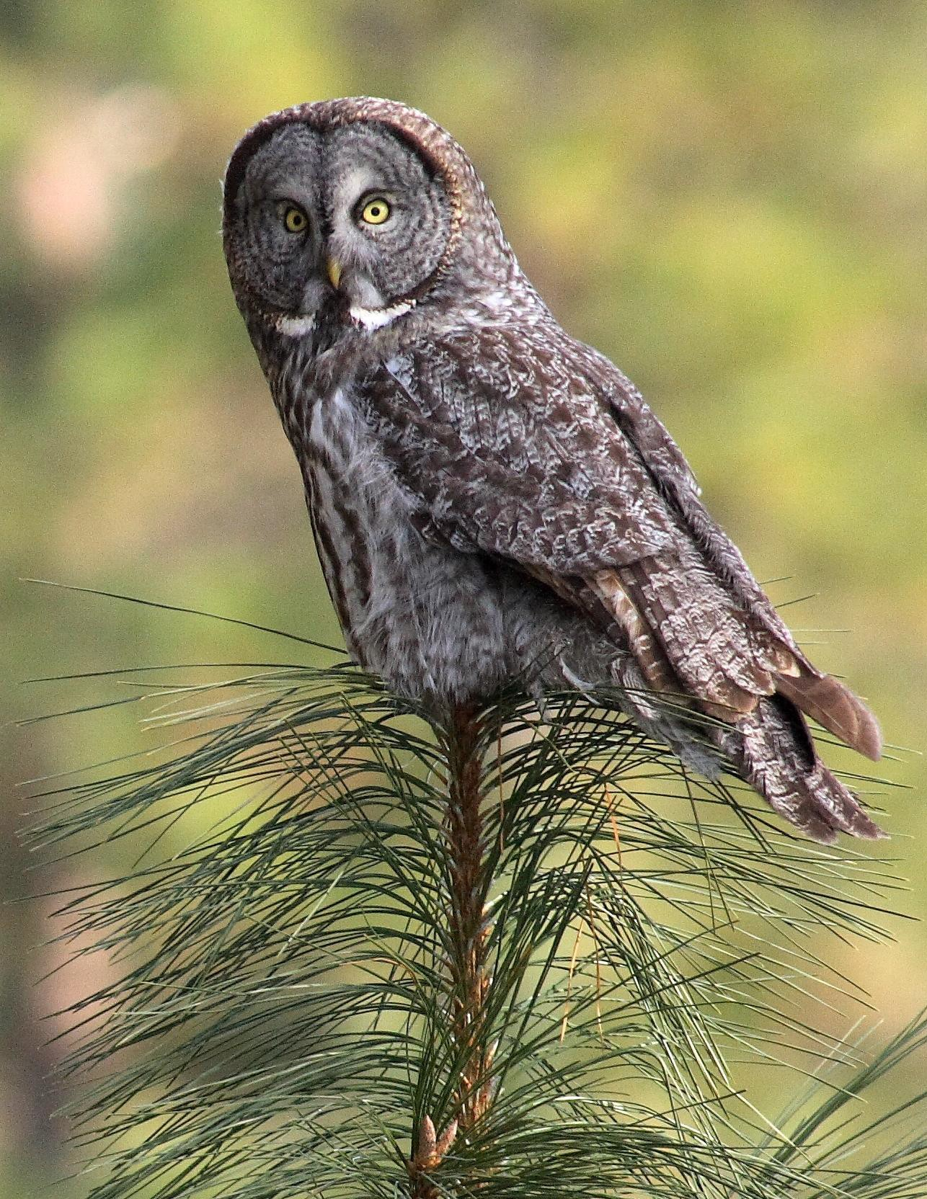

The Institute for Bird Populations A Conservation Strategy for Great Gray Owls in California

88

