CDFW SURVEY PROTOCOL FOR MESO-PREDATORS IN CALIFORNIA (DRAFT 6/8/2016)

(For information on this protocol contact: chris.stermer@wildlife.ca.gov)

Introduction

The methodology described here applies to the detection, monitoring, and assessment of Meso-Predator populations in California. The general framework of the camera trap survey protocol is derived from methods described by Zielinski and Kucera, in the 1995 GTR-157 report “American Marten, Fisher, Lynx, and Wolverine: Survey Methods for Their Detection”. CDFW has been using modified versions of this protocol, beginning with a multi-region project to conduct broad surveys of mesopredator populations in the southern Cascade and Sierra Nevada Ecoregions between 2005 and 2010, funded by a State Wildlife Grant (SWG-T11-1). The protocol was further refined, and its effectiveness evaluated, for its use in conducting over winter surveys for the Sierra Nevada red fox (Vulpes vulpes necator) in the Sonora Pass region. Beginning in August 2010, the CDFW along with its UC Davis and USFS partners, applied these methods in a systematic effort to initially determine the extent and distribution of the SNRF population in this region. While the results of the research are still being prepared for publication, our initial findings are that the camera trap survey protocol had a greater than 80% detection probability when surveying for the SNRF, which has been one of our most difficult species to detect. In addition, when combined with an intensive search for additional genetic (scat) samples, provided valuable data determining the distribution, range extent, size, habitat associations, and genetic health for this population.

Sampling frame
A systematic grid of 4 mi² (10.4 km²) hexagons is used as the sampling frame for this survey protocol. The sampling frame GIS layer is available by contacting Chris Stermer at CDFW (916-445-2626, or chris.stermer@wildlife.c.gov). A unique identifier (Unique_ID) included in the attributes of the template GIS shapefile, and is used to identify hexagons being sampled.

Survey Period and length between revisits
Survey period will vary based on the objectives of the research, and the target species being surveyed. Surveys conducted in the montane habitat during the non-winter season will likely attract bears to your camera station within a short period after setting them up. This will affect your surveys for all other species, since bears will likely remove the bait on their first visit, making the detection of other mesopredator’s less likely. While the lingering smell of the scent lure will continue as an attractant long after the bait has been removed, without the hanging bait you’re not likely to draw the animal onto the hair snare devices. For this reason I suggest conducting mesopredator surveys in montane environments during the winter/early spring season, when feasible. For example, results from two years of SNRF surveys in 2010 and 2011 indicate the period between late winter and early spring as the best time to detect SNRF (Stermer, unpublished data). These results indicate an 83% detection probability for SNRF, over a 60 day survey period beginning April 1 and ending May 30. The table below indicates our detection probability results for 60 day sampling periods beginning in December. While we conducted surveys for SNRF in October and November, no detections occurred during this period.

Table 1. Unpublished survey results for the Sierra Nevada red fox in the Sonora Pass Region.
Survey  Period | Detection  Probability
Dec - Jan | 68%
Jan - Feb | 75%
Feb - Mar | 77%
Mar - Apr | 78%
Apr - May | 83%

Sample Unit Selection
Selecting which 4 sq mile sample unit to survey should be determined by the objectives of your study, and/or the target species being surveyed. The objectives of your study may indicate the need to take a complete random approach to your selection, a stratified random approach, or some form of non-random approach to selection.

In the case of the SNRF survey effort, very little is known about the habitat preferences for the SNRF in the Sonora Pass region, and so sampling unit selection used an adaptive strategy, largely guided by assessing habitat characteristics where positive detections had been made previously during the study and using this information to predict additional habitat. We also considered the feasibility of surveying a remote site and crew safety, which were concerns that influenced our choice of sample unit selection. Another approach we used for sample site selection for our 2016 Meadow Monitoring Project was to select sample units that overlapped our meadows to be monitored.

Site selection
Two survey stations should be established within a sample unit (4 sq mile hexagon). Camera trap stations are spaced a minimum of 1 mile (1.6 km) apart, within a sample unit, and also 1 mile apart between camera stations in neighboring sample units. Again, the selection of where to place your camera stations should fit the objectives of your research, and may require a complete random approach, or a more flexible approach as is described below that was used in our SNRF survey effort. The only strict criteria is that the cameras are spaced a minimum of 1 mile apart within your sampling unit, and from camera stations in neighboring sample units.

Within a given sample unit, site specific stations can be evaluated using GIS layers, including: aerial photography, elevation, vegetation layers, and trail maps. Survey stations will be placed at sites to avoid potential human interference, and so placed away from human traveled trails, camp sites, and other recreation areas (e.g. birding, fishing, and hunting opportunities).

Specific criteria to consider for selecting potential survey sites include:
- Best available habitat within a sample unit.
- Micro-site features for camera and bait setup, as in appropriately spaced trees.
- Crew safety in accessing survey sites.
- Sites that are hidden from view and/or are difficult to access by the public. Sites should be >50 meters from a human foot trail, or road.
- Sites near or along commonly used animal trails.

Station Setup
Surveys will utilize non-invasive detection methods, using a trail camera and hair snare. Each station includes a remotely-triggered digital camera with a passive infrared sensor and a hair snaring device. Stations are baited with a combination of chicken and commercial scent lure (Gusto, Minnesota Trapline Products, Pennock, MN).

Two people are preferred for setting up a camera station, with one person handling only the bait and lure, while the second person handles the camera and hair snares. If only one person is available, they should be extremely careful to not leave any scent or food pieces on the camera or hair snare devices. Important - handling of the camera and hair snare devices should only be done with rubber gloves that do not have remnants of human related scent on them.

Setting the Camera. The attachment of camera stations and bait/hair snare devices typically require two trees spaced approximately 10 feet (range: 8 – 14 feet) apart. The camera is mounted to a tree with an approximate diameter of 15 inches (range 8 - 32 inches). Cameras attached to trees smaller than 8 inches will tend to blow in the wind and cause the camera to prematurely activate, and for trees larger than 32 inches the camera locking cable will not go around the tree. The tree with the bait and hair snare devices should have a minimum diameter of 10 inches, with no limit on maximum diameter size.

Cameras are attached to trees utilizing bungee cords and/or locking cables. Cameras are mounted approximately 3-6 ft above the ground, or snow cover. In the case of variable snow depths consider the weather forecast, if the forecast indicates new snow during the survey period consider setting the camera no less than 6 feet, and if the forecast is for snow melt consider placing the camera less than 6 feet from the current snow depth. Snow depth should also be considered when setting the bait and hair snare devices described below.

Face the camera toward an aspect to minimize direct sunlight on the camera (close to a northerly aspect). Direct sunlight will cause the camera to prematurely trigger. Remove any foliage in front of the camera that could blow in the wind, otherwise this will also cause premature camera trigger. Using shims, or an appropriately sized tree limb or rock, angle the camera so it faces directly at the bait station. Figure 1 below shows examples of camera station setups.

Figure 1. Examples of a camera station setup.
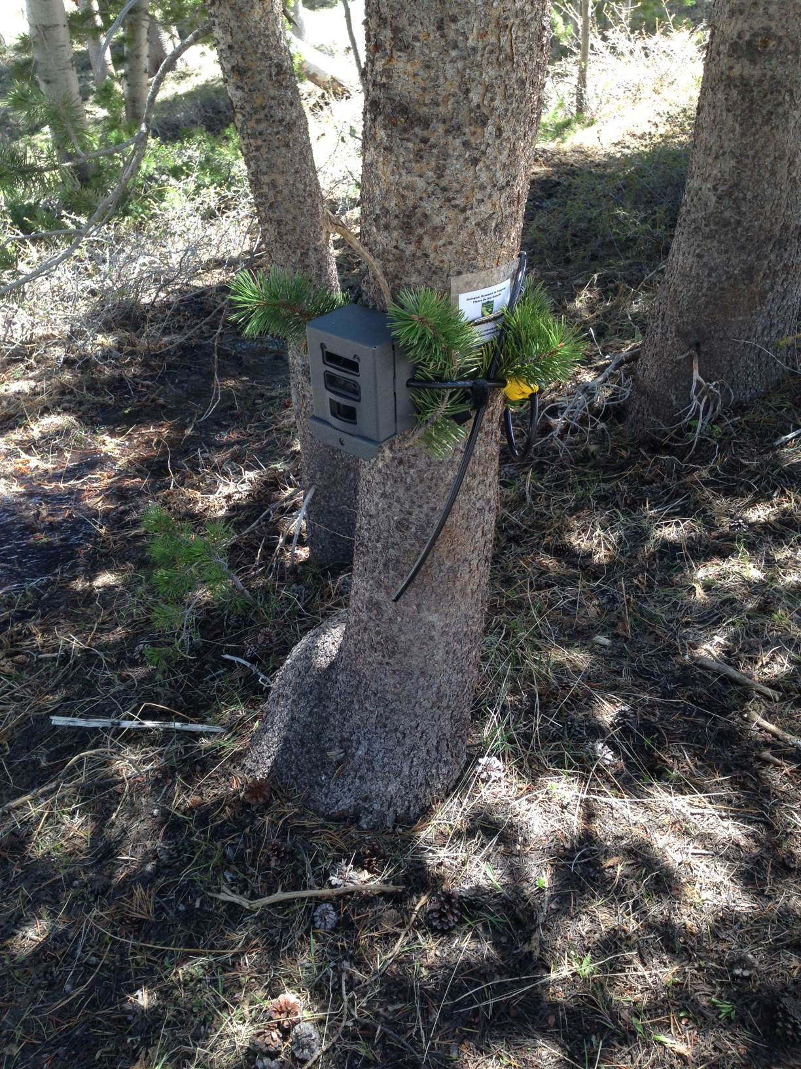
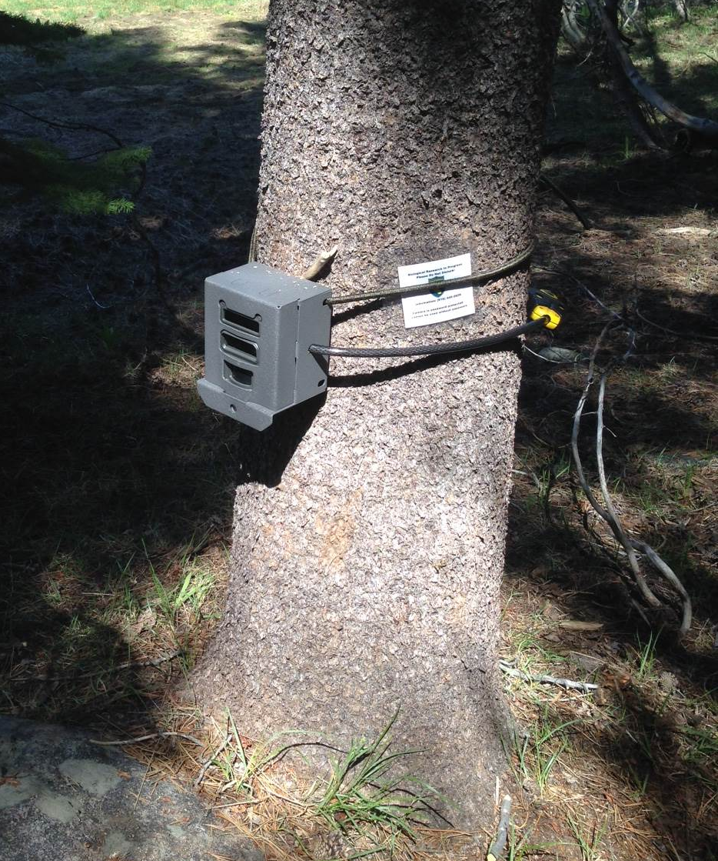

Bait and scent lure. A small amount of chicken is the preferred bait, with the approximate size of a single chicken leg (3-6 oz), or one full sized breast (5-10 oz). Important - Leaving greater amounts of bait may have the unintended consequence of habituating animals to the camera trap station. Place the chicken into a black cotton sock, and tie a secure knot to close the sock opening. Attach the sock to the tree using 1/8” cotton line tied either around the tree, or to an available branch, such that the bottom of the sock is approximately 3-4 feet above ground level resting against the tree trunk (figure 1). The scent lure (“Gusto”) is a viscous liquid. Approximately 1oz of Gusto should be used for each camera station. 0.5 oz is applied on both sides of the tree, and about 1 ft, above the bait sock. Apply the additional 0.5 oz to vegetation immediately surrounding the site where the wind can carry the scent of the lure, such as windblown conifer and shrub leaves. Also, place a small amount of scent lure on the ground at the base of the tree with the bait sock. Important - Do not let the scent lure come into contact with the bait sock or bore brushes.

Hair snare devices. There are a number of options for collecting hair samples at a camera station. Commonly we have used a hair snare device described by Figura and Knox (2010) that utilizes copper bore brushes (used to clean guns and rifles), and while this design has shown to be successful, they are also prone to being torn off the tree quickly by bears and destroyed.

In addition, we have been using a hair snare design also utilizing bore brushes, and are simple to construct, lightweight, and seem to be more resilient to vandalism by bears. Figure 2 below shows examples of this design. I haven’t had the chance to write this design up, though you are welcome to email me (chris.stermer@wildlife.ca.gov) for a description.

Figure 2. Hair snare design and placement.
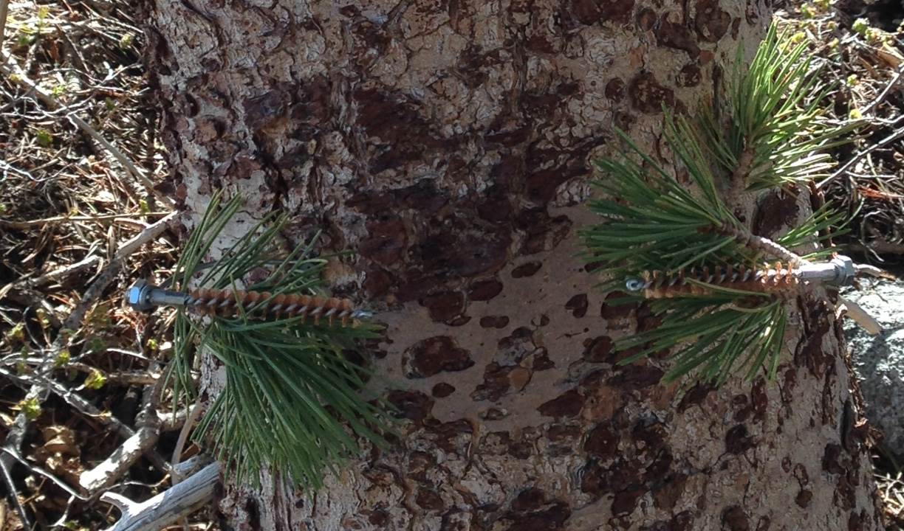
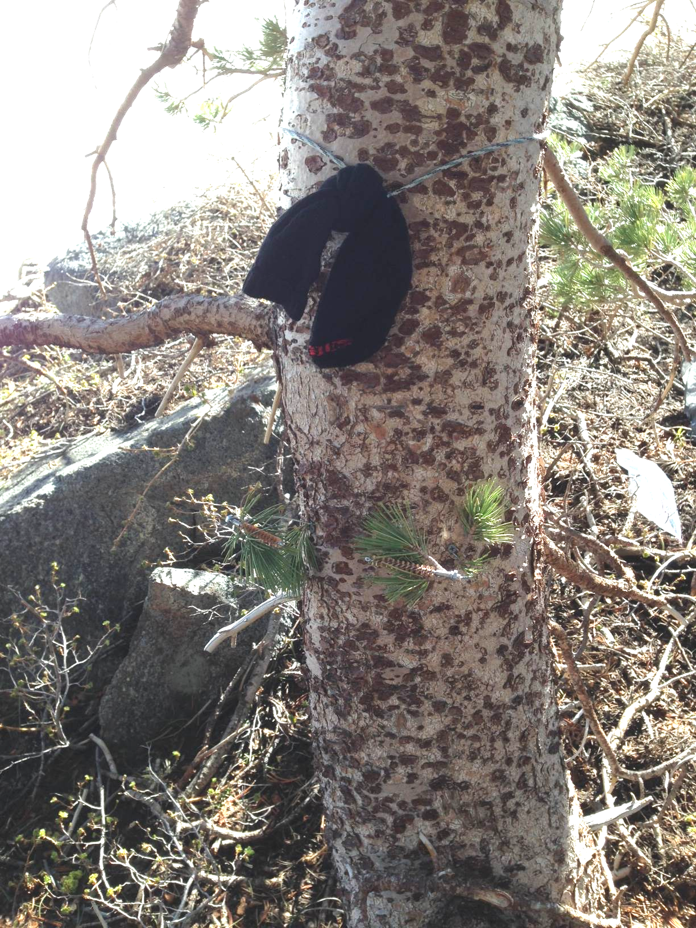

Hair snare devices should be placed about 6 inches below the bait sock (2.5 -3.5 ft. from the ground). Be very careful not to let the hair snare bore brushes touch the bait sock, or come into contact with the scent lure.

Final steps before leaving survey station
A small laminated sign (approximately 2 x 3 inches) explaining the camera is part of a wildlife research project and a phone number to call for questions regarding the project should be attached under the bungee cord holding the camera.

Important - Make sure the camera has been turned on and is being triggered to take pictures. Walk in front of the camera to document the date and time camera was placed. Completely fill out datasheet before leaving the site.

Survey Station Revisits
We recommend that each station run for a minimum of 60 days, and checked on approximately 20-30 day intervals.

During each station revisit, the primary tasks are to:
- inspect the camera and hair snare and adjust/maintain them as necessary,
- reposition camera and bait station to maintain protocol ground level distance due to changing snow conditions,
- collect the camera’s memory card and replace it with a blank card,
- collect hair samples and replace gun brushes as necessary, and
- add or replace bait and scent lure as necessary.

Following Sacks (2012) genetic sample protocol described below, hair samples will be collected during each revisit by unscrewing those brushes containing hair and placing them into a paper envelope. Clean replacement brushes will be threaded into place to replace those removed. The bait sock can also be a source of a genetic sample, and so if the sock has been torn open, collect the sock and store it in a plain brown paper bag. Written directly on the bag holding the genetic sample, provide the following information:
- Date and time collection was made.
- GPS coordinates of location.
- Name of collector.
- The species you believe the sample came from.

Chicken bait and sock are replaced at each revisit interval. Bait still remaining after a revisit interval can be left at the base of the tree, and the fresh bait attached to the tree. Fresh Gusto is applied at the base of the tree, on the tree trunk, and on surrounding branches.

To the extent feasible, camera images should be downloaded daily in the field from memory cards to a laptop computer or photo viewer. Photos should be reviewed as soon as possible. In cases where a hair sample was collected and photos indicate a target species visited the bait station during the previous sample period, those hair samples should be transferred to a 50 ml centrifuge tube. Tubes should be topped off with silica desiccant, labeled with a permanent marker, and taped with transparent tape to prevent the label from being abraded (Sacks 2012).

At the end of the survey period, the camera, bait container, and hair snare at each survey station will be removed. All screws used to attach these items to trees will be removed and carried out of the field. No temporary (e.g., flagging, tree marking paint) or permanent markers (e.g., tree tags, metal posts) are used and no permanent monuments will be created.

Literature Cited

Bull, E.L., R.S. Holthausen, and L.R. Bright. 1992. Comparison of 3 techniques to monitor marten. Wildlife Society Bulletin 20: 406-410.

Cleve, C. 2007. Models of habitat suitability for the Sierra Nevada red fox in the Lassen Peak region and throughout California. From thesis in progress: Modeling the Sierra Nevada Red Fox (Vulpes vulpes necator) distribution in California. San Francisco State University, Department of Geography and Human Environmental Studies.

Davis, F. W., C. Seo, and W. J. Zielinski. 2007. Regional variation in home-range scale habitat models for fisher (Martes pennanti) in California. Ecological Applications 17: 2195-2213.

Figura, P., and L. Knox. 2010. A lightweight, tree-mounted hair snare for mesocarnivores. Unpublished protocol. California Department of Fish and Game, Redding, CA.

Kirk, T.A. 2006. Building and Testing a Habitat Suitability Model for the American Marten (Martes americana) in Northeastern California. Unpublished report, available online: http://www.ucgis.org/summer2006/studentpapers/kirk_tom.pdf

Slauson, K.M., J. Baldwin2, W.J. Zielinski, and M. Schwartz. 2009. Estimating Detection Probabilities for Fishers Using Non-Invasive Methods and Implications for Survey Protocols. Draft final report, prepared U.S. Fish and Wildlife Service, Yreka Field Office and the Fisher Science Team. 29 January 2009.

Zielinski, W.J. and T.E. Kucera. 1995. American Marten, Fisher, Lynx, and Wolverine: Survey Methods for Their Detection. USDA Forest Service, Pacific Southwest Research Station, General Technical Report PSW GTR-157.

Zielinski, W.J., R. L. Truex, F.V. Schlexer, L. A. Campbell, and C. Carroll. 2005. Historical and contemporary distributions of carnivores in forests of the Sierra Nevada, California, USA. Journal of Biogeography 32:1385-14
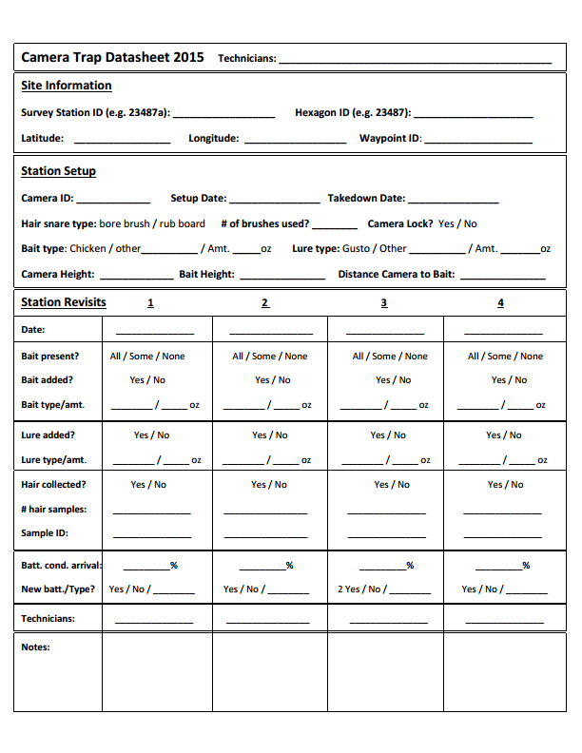

Noninvasive DNA sampling protocols– updated Aug 24, 2011 – (BNS)

- Fecal Samples
Pregnancy warning and safety: Animal feces ideally should not be handled by pregnant women to reduce risk of exposure to Toxoplasma gondii. Scats also can contain various parasites including Echinococcus multilocularis (or E. granulosis) which are rare but potentially very dangerous if ingested or inhaled, so please either wear gloves or use a plastic bag to handle scats. Wash hands with soap and water after collecting.

Supplies:
Latex (or similar) gloves or inverted plastic bag
95-100% EtOH in 15-mLor 50-mL centrifuge tubes
Fine-point permanent marker
Applicator sticks (or coffee stirrers)
Scotch tape (to cover label and avoid ink loss from leaked ethanol)

Sampling procedure:

- Wear gloves (new for every scat)
- In field, collect entire scat in paper bag labeled as follows:
  - Apparent species
  - General location description (e.g., McKay drainage)
  - GPS decimal degree coordinates to the 5th decimal place
  - Date in format: YYYYMMDD (e.g., 20110824)
  - Unique number (can restart at ‘1’ every day as date will be unique)
  - Your initials
  - “fresh” (if wet or known to be <2 days old), “not fresh” otherwise

- Before end of day, put ~2 mL of the scat in a 15mL tube (use new glove for every new scat), using applicator stick to submerge completely in EtOH; note the level before putting scats in and add scat until it rises 2-3 mL. (always put ethanol in tube first; NEVER pour ethanol after scat is in tube)
  - If scat is small (e.g., pup scat), put entire scat in tube.
  - If scat is large, take preferentially from outside edges likely to have scraped epithelial cells from colon on the way out (a sugar-cubed size piece).
- Label tube as in (2) above and additionally mark date, No., and initials on the top in case alcohol spills and clears labeling off side.
- Place Scotch tape over label on tube to protect ink
- Record all label information also in your field journal as well as any additional details referenced to field ID (i.e., date, unique daily number, and initials) on tube.
- Save the remainder of the scat for diet analysis in the original labeled paper bag

Storage: Keep ethanol and bagged samples in a cool, dry, dark place (protected from UV light and humidity) until transferring to the laboratory. DO NOT store in refrigerator or freezer.

- Hair Samples
Supplies:
Latex (or similar) gloves or inverted plastic bag
50-mL centrifuge tubes filled with ~20 mL silica desiccant
Manila coin envelopes
Fine-point permanent marker
Replacement brushes or boards
Forceps
Ethanol
kimwipes
lighter

Bore brushes from hair snare
Sampling procedure:
- Visually check brushes for presence of hairs and note in field notebook which ones had hairs and will be collected: number from left (e.g., “L 1,3, 7” indicates brushes first, third and 7th from the left)
- Wear gloves
- Unscrew the indicated brushes and replace with new ones
- Unless it appears different species types are on different brushes, combine in one 50mL tube with desiccant
- Label tube as follows:
  - Apparent species
  - Site location description (e.g., McKay1)
  - GPS decimal degree coordinates to the 5th decimal place
  - Date in format: YYYYMMDD (e.g., 20110824)
  - Unique number (can restart at ‘1’ every day as date will be unique)
  - Your initials
- Record all label information also in your field journal as well as any additional details referenced to field ID (i.e., date, unique daily number, and initials) on tube.

Rub boards
Sampling procedure:
- Visually check boards for presence of hairs
- Wear gloves
- Wipe forceps clean with ethanol-soaked kimwipe
- Remove all visible hairs with forceps and put in one 50mL tube with desiccant
- Label tube as follows:
  - Apparent species
  - Site location description (e.g., McKay1)
  - GPS decimal degree coordinates to the 5th decimal place
  - Date in format: YYYYMMDD (e.g., 20110824)
  - Unique number (can restart at ‘1’ every day as date will be unique)
  - Your initials
- Record all label information also in your field journal as well as any additional details referenced to field ID (i.e., date, unique daily number, and initials) on tube.
- Carefully use lighter to sanitize board and replace

Storage: Keep hair samples in a cool, dry, dark place (protected from UV light and humidity) until transferring to the laboratory. DO NOT store in refrigerator or freezer.

