August 29, 2013

IEP Lead Scientist Dr. Anke Mueller-Solger and MAST Report Authors

*Submitted electronically to* [*interagencyecologicalprogram@gmail.com*](mailto:interagencyecologicalprogram@gmail.com)

**Subject: Sacramento Regional County Sanitation District 2013 MAST Report Review**

Dear MAST Report Authors:

The Sacramento Regional County Sanitation District (SRCSD) provides wastewater conveyance and treatment services to over 1.3 million customers in the greater Sacramento area. Our mission is to protect human health and the environment. We take our mission seriously and work on a daily basis to meet our obligations to protect water quality and beneficial uses in the Delta. We greatly appreciate this opportunity to review and comment on the draft MAST report.

The report provides an important review of potential factors regulating delta smelt populations. In general, the report provides a well-balanced discussion of many factors potentially limiting delta smelt growth and survival. The conceptual model has a good structure, as specific environmental drivers and proximal stressors are likely to vary among delta smelt life-stages and corresponding seasons. Comparisons of key environmental drivers and delta smelt abundance, survival and growth among past wet and dry years also provide an excellent analysis of the potential factors regulating the species abundance. Specific comments are listed below:

Line 1334. Clam grazing should be added to the conceptual model during the winter and spring periods. Data from the IEP Environmental Monitoring Program indicates that the seasonal abundance of *P. amurensis* varies by location and water year. In 2011, *P. amurensis* abundance was relatively high in Suisun Bay during the wet winter and spring (Fuller 2012). *Corbicula fluminea* grazing pressure is also significant in low-salinity regions of the Delta (Lucas et al. 2002, Lopez et al. 2006), and these clams do not show seasonal declines (Fuller et al. 2012).

Line 1348. More discussion on the grazing effects of *Corbicula fluminea* in the Delta and other low-salinity regions of the system is needed. Populations of *C. fluminea* in the Sacramento–San Joaquin River Delta are reported to cause regional phytoplankton sinks, or areas with low phytoplankton production and biomass (Lucas et al. 2002, Lopez et al. 2006), which may contribute to overall low net productivity (Jassby et al. 2002). *C. fluminea* can remain abundant year-round in some locations and their range has been found to expand during wet years (Fuller 2012, Fuller et al. 2012).

IEP Lead Scientist Dr. Anke Mueller-Solger and MAST Report Authors

August 29, 2013

Page 2

Line 1357. The report should state that the hypotheses offered by Dugdale and Wilkerson have been examined by scientists involved in the San Francisco Bay Nutrient Numeric Endpoints effort in various documents (McKee et al, 2011, Senn, et al, 2012, and Senn and Novick, 2013). These reviews have concluded that there remains a lack of consensus among the regional scientific community about these hypotheses and the potential ecosystem-scale importance of ammonium inhibition relative to other factors that limit phytoplankton biomass.

Line 1359. The report should include a statement that many species of phytoplankton, including diatoms, have been found to grow at the same rate when supplied ammonium or nitrate as their nitrogen source in unialgal culture investigations (See Figure 2.8 below, from Senn et al. 2012). Therefore, the report’s wording should describe the “ammonium inhibition hypothesis” as a developing, not universally supported, theory. 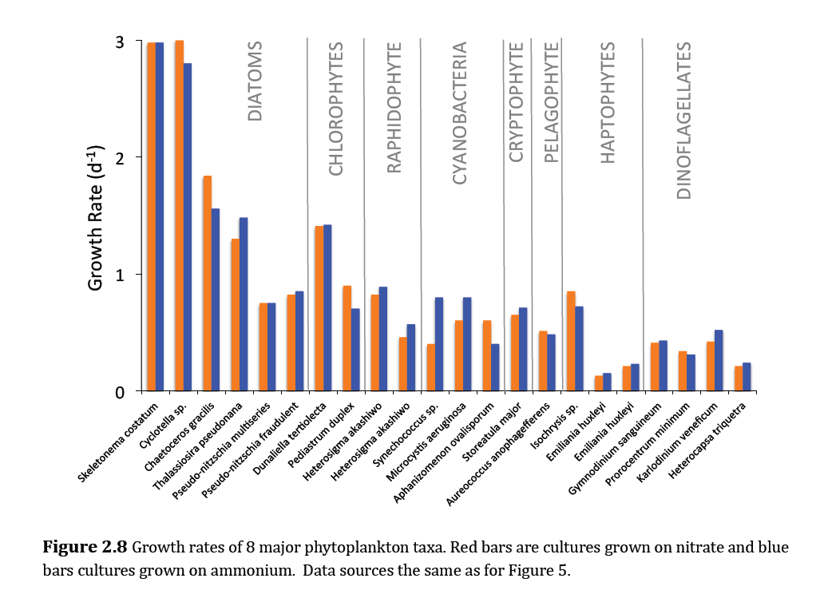

Figure 2.8 from Senn et al. 2012. Growth rates of 8 major phytoplankton taxa. Red bars are cultures grown on nitrate and blue bars are cultures grown on ammonium. Data compiled from Ferguson et al. 1976, Dortch and Conway 1984, Levasseur et al. 1993, Berman and Chava 1999, Herndon and Cochlan 2007, Berg et al. 2008, Solomon and Glibert 2008, Sinclair et al. 2009, Strom and Bright 2009, Thessen et al. 2009, Solomon et al. 2010.

Line 1361. The report should state that the hypotheses offered by Glibert (2012) have been examined by Senn and Novick (2013) as part of the development of a nutrient conceptual model for San Francisco Bay. This review has concluded that the mechanisms underlying these hypotheses need to be rigorously explored before concluding that elevated nutrients and altered nutrient ratios have played an important role in causing pronounced changes in phytoplankton community composition in Suisun Bay since the 1980s.

IEP Lead Scientist Dr. Anke Mueller-Solger and MAST Report Authors

August 29, 2013

Page 3

Line 1371. The sentence stating that SRWTP reduced its discharge rate is incorrect. Effluent discharge rates are dependent upon sewage inflow rates and were not reduced by changes in operation. However, in 2009, the ammonia concentration in effluent from SRWTP was reduced by approximately 10%, due to changes in operation. Please cite K. Ohlinger for your personal communication.

Line 1376. Dugdale et al. (2013) does not directly attribute the 2010 spring phytoplankton bloom in Suisun Bay to a reduction in ammonia from SRWTP and the paper does not report ammonium concentrations in the Sacramento River. Please remove this incorrect sentence.

Line 1385. Turbidity (water clarity) is a key environmental driver for phytoplankton production and should be indicated as such in the conceptual model. Light limitation of phytoplankton production should be evaluated further in the report. Phytoplankton growth is known to be limited by the photic zone depth (Jassby et al. 2002), which is dependent upon water clarity, depth, mixing and flow. Phytoplankton production can be increased in shallow water habitats with longer water residence times, but these conditions can also increase clam grazing pressure (Lucas and Thompson 2012).

Line 1385. Include in the discussion on phytoplankton abundance regulation that 30% of primary production in the Delta is estimated to be removed by water export and within-Delta diversion pumps (Cloern and Jassby 2012).

Line 2124. It is important to determine why delta smelt fecundity increases with decreased X2 position in future studies. The MAST report indicates that a large number of larval delta smelt were produced by a relatively small adult population in 2011, over a normal spawning duration (estimated from water temperatures), suggesting that egg production can substantially increase under favorable high-flow conditions.

Line 2534. The increased number of delta smelt collected when X2 was located in Suisun Bay (greatly increasing the area of the low salinity zone) stresses the importance of high outflow rates for delta smelt habitat (Feyrer et al. 2010) and food availability (Kimmerer 2002).

Line 2544. We would greatly appreciate the opportunity to comment on Chapter 6 of the MAST report when a draft is complete. It is very important to include stakeholders in developing the next steps for delta smelt research and management actions.

In conclusion, SRCSD believes that MAST report provides an important synthesis of IEP’s research regarding multiple potential factors influencing delta smelt population health. Increased water flow through the Delta appears to benefit delta smelt, but the proximal causes of differing survival among wet years remains uncertain and requires further study. If you would like further information on our comments please contact Tim Mussen at 916-875-4344 or [mussent@sacsewer.com](mailto:mussent@sacsewer.com).

Sincerely,

Kurt N. Ohlinger Ph.D., PE

Chief Scientist

Attachment: Literature Cited

cc: Prabhakar Somavarapu, District Engineer

Christoph Dobson, Director of Policy and Planning

Tim Mussen, Scientist

Terrie Mitchell, Legislative and Regulatory Affairs Manager

Literature Cited

Cloern, J., and A. Jassby, 2012. Drivers of Change in Estuarine-Coastal Ecosystems: Discoveries from Four Decades of Study in San Francisco Bay. Rev. Geophys., 50:1-33.

Feyrer, F., Newman, K., Nobriga, M., and Sommer, T., 2010, Modeling the effects of future freshwater flow on the abiotic habitat of an imperiled estuarine fish: Estuaries and Coasts 34:120–128.

Fuller, H. 2012. Status and trends, Benthis Monituring, 2011. IEP Newsletter V25 (2), Spring

<http://www.water.ca.gov/iep/newsletters/2012/IEPNewsletter_FinalSPRING2012.pdf>

Fuller, H., K. Gehrts, D. Riordan, and J. Thompson. The biomass of *Corbula* and *Corbicula* in the low salinity zone in August 2011. Poster presentation at the 2012 IEP Workshop.

<http://www.water.ca.gov/bdma/docs/hlfuller_IEPposter2012_FINAL.pdf>

Jassby, A., J. Cloern and B. Cole, 2002. Annual primary production: Patterns and mechanisms of change in a nutrient-rich tidal ecosystem. Limnol Oceanogr 47:698-712.

Kimmerer, W., 2002. Effects of freshwater flow on abundance of estuarine organisms: physical effects or trophic linkages: Marine Ecology Progress Series 243:39–55.

Lopez, C., J. Cloern, T., Schraga, A. Little, L. Lucas, J. Thompson and J. Burau (2006) Ecological Values of Shallow-Water Habitats: Implications for the Restoration of Disturbed Ecosystems. Ecosystems 9:422-440.

Lucas, L., J. Cloern, J. Thompson and N. Monsen, 2002. Functional variability of habitats within the Sacramento-San Joaquin Delta: restoration implications. Ecological Applications 12:1528-1547.

Lucas, L. and J. Thompson 2012. Changing restoration rules: Exotic bivalves interact with residence time and depth to control phytoplankton productivity. Ecosphere 3(12):117.

McKee, L.J., M. Sutula, A.N. Gilbreath, J. Beagle, D. Gluchowski, and J. Hunt. 2011. Numeric Nutrient Endpoint Development for San Francisco Bay Estuary: Literature Review and Data Gaps Analysis. Southern California Coastal Water Research Project. Technical Report No. 644. www.sccwrp.org.

Senn, D.B., E. Novick, T. Jabusch, M. Berg, and W.J. Kimmerer, 2012. Suisun Bay Ammonium Synthesis Report. A report prepared for the Bay Area Clean Water Agencies (BACWA), San Francisco Estuary Institute, Richmond, CA.

<http://www.waterboards.ca.gov/sanfranciscobay/water_issues/programs/planningtmdls/amendments/estuarineNNE/March%202013/SuisunSynthdraftNov2012.pdf>

Senn, D.B. and E,. Novick. 2013. San Francisco Bay Nutrient Conceptual Model, San Francisco Estuary Institute. Draft. <http://www.waterboards.ca.gov/sanfranciscobay/water_issues/programs/planningtmdls/amendments/estuarineNNE/SAG-June-2013/Nutrients_CM_DRAFT_May12013.pdf>