1. SUBREGION BACKGROUND 4
1.1 Other surveys / Sampling cooperation 4
1.1.1 Volunteering on Other Projects 5
1.2 Data Elements Specific to Subregion 5
1.3 Situations Specific to Subregion 5
2. GENERAL PROTOCOL 6
2.1 Training 6
2.2 Standard Procedure 7
2.3 Attire 8
2.3.1 Uniform Shirt 9
2.3.2 Cold Weather Attire 9
3. SITES 9
3.1 Register / pressures 9
4. ASSIGNMENTS 10
4.1 Site Problems / Tips 11
4.1.1 Parking in General 11
4.1.2 Pay Parking Lots 11
4.1.3 Parking Meters 11
4.1.4 Parking Tickets 12
4.1.5 Criminal Activity 12
4.1.6 CDFG Violations 12
4.2 Man Made 13
4.3 Beach / Bank 13
4.4 Private / Rental Boats 13
4.5 Party / Charter Boats 13
4.5.1 Refused Access 16
4.5.2 Fishing in Mexican Waters 16
4.6 Alternate Site Problems / Tips 16
4.7 Reassignment Procedures 17
4.8 Two Assignments in One Day 17
5. INTERVIEWING 18
5.1 Tips for filling out the form 18
5.2 Canvassing and Screening Problems / Tips 19
5.3 Item by Item Problems / Tips 20
6. FISH SPECIES 22
6.1 Common Southern California Species 23
6.1.1 Acceptable Abbreviations 23
6.2 Angler Reported Species Names 24
6.3 Identification of Difficult Species 24
6.4 Specimen Collection 25
6.5 Taking Photographs of Fish 26
6.6 Correct Procedures and Tips for Handling Fish 26
6.6.1 California Scorpionfish 26
6.6.2 Rockfish (Sebastes spp.) 27
6.6.3 White Seabass 27
6.6.4 Lingcod 27
6.6.5 Ratfish 27
6.6.6 Electric Ray 27
6.6.7 Skates 27
6.6.8 Stingrays 28
6.6.9 Barracuda 28
6.6.10 California Halibut 28
6.6.11 Pacific Angel Shark 28
6.7 Measuring Problems / Tips 28
6.8 Gender Determination of Selected Species 29
6.8.1 Sharks, Skates, and Rays 30
6.8.2 Sheephead 30
6.8.3 Rock Wrasse 30
6.8.4 Dolphinfish 31
6.8.5 Shiner Surfperch 31
6.8.6 Ratfish 31
7. ADMINISTRATIVE 32
7.1 Editing / Mailing Forms 32
7.2 Weekly Reports 34
7.3 Timesheets 35
7.4 Work Schedule / Work Week 36
7.5 Expense Claims 36
7.5.1 Reimbursable Expenses 36
7.5.1.1 Reimbursable Mileage 36
7.5.2 Non-reimbursable Expenses 36
7.6 Use of Privately Owned Vehicle 37
7.7 Scheduling Vacation 37
7.7.1 Leave Request Forms 37
7.8 Holidays 37
7.9 Equipment Care and Replacement 38
8. Personnel Matters 38
8.1 Work Evaluation 38
8.2 Resources 39
8.2.1 Sampler Registry 39
8.2.1.1 Check Data Entry Trapped Errors 39
8.2.1.2 Check Goal Fulfillment 39
8.2.2 Other Useful Websites 39
9. Attachments 42-58

1. SUBREGION BACKGROUND

The CRFS is a state-wide coastal program implemented to establish a reliable database for estimating the impact of recreational fishing on marine resources. PSMFC is involved in analyzing the data to assist others in management issues, but is not directly involved in fisheries management. The NMFS, California Department of Fish and Game, Interstate Fisheries Commissions, and regional Fishery Management Councils use the data from the CRFS in fisheries assessment and management decisions. For this reason, the collection of high quality data in a manner consistent with other regions is very important and cannot be understated.

The southern California subregion consists of five counties: Santa Barbara, Ventura, Los Angeles, Orange, and San Diego. The regional supervisor is centrally located in the California Department of Fish and Game (CDFG) office in Los Alamitos. Each sampler is generally assigned to one county, but may be expected to cover assignments in adjacent counties on occasion.

Of the four subregions involved in the California coast CRFS (northern California, San Francisco Bay area,, central California, and southern California), we typically have the best weather and the highest number of anglers. For these reasons we usually have the easiest time in reaching our quota.

The quotas are based on the results of the survey of fishing effort and the quality (lack of variation) in the sample data by key species. The quotas are guidelines and are subject to change periodically due to changes in management issues.

Other surveys / Sampling cooperation

Currently, there are no other field sampling programs being conducted by the CDFG or PSMFC that would conflict with CRFS field sampling; this is always subject to change. However, while sampling at launch ramps you may encounter members of the Coast Guard Auxiliary conducting complimentary boat inspections. Try to avoid competing for the angler’s attention. Talk with the boat inspector to see if you can come to some sort of agreement about which boats each of you will approach so that minimal problems will be encountered. If there is very little fishing activity, necessitating interviewing every angler, see if you can interview the anglers before they talk with the boat inspector. Anglers tend to get less cooperative after completing another survey.

You may also see CDFG Wildlife Protection Officers (wardens) while in the field. These situations are less straightforward than when encountering the Coast Guard. Use your good judgment. Law enforcement and research do not mix, and we do not want to give anglers the impression that we are related to law enforcement in any way. If a warden is checking anglers at your site, all attempts should be made to avoid approaching the anglers at the same time. However, you should not let the warden’s activities influence which anglers you do or do not interview. Cut the rest of this sentence since we don’t randomly sample boats any more, that is, you should still maintain the same randomness as on any other day.

Most of the wardens are familiar with our survey and will for the most part ignore you. Do not take this personally, since this is for your and the survey’s benefit. Occasionally, a new warden who is unfamiliar with our project may approach you and ask if you have seen any illegal activity. If this should happen, explain that you are conducting a biological survey, not looking for violations, and refer the warden to your supervisor. At all times you should minimize your contact with wardens. Even if you are not discussing violations, anyone who sees you talking to a warden may assume otherwise.

Occasionally, the CDFG and/or PSMFC have ongoing field projects where your assistance may be requested. While we may be able to help in data collection, there are administrative issues that need to be considered before you get involved. If another biologist contacts you requesting your assistance, contact your supervisor. Any request for your assistance must go through your supervisor first! See the 1999 memo from Pam Kahut at the end of this addendum for more information.

1.1.1 Volunteering on Other Projects

There are several ongoing projects within the CDFG that can utilize volunteers. Contact your supervisor if you wish to volunteer your time. If your supervisor is aware of your desire to volunteer, he or she will make an effort to inform you of projects needing assistance, but it is still your responsibility to take the initiative in any necessary follow-up.

If you wish to participate in a “ride-along” with a Wildlife Protection Officer (warden), you must have prior approval from your supervisor. This situation is potentially damaging to the CRFS project if details are not worked out between you and your supervisor.

Data Elements Specific to Subregion

Since we sample PC and PR boat trips into
Mexican waters, it is very important that we
distinguish these data from other trips.
When sampling in PR1 put an “X”in the box
marked “mex” if most of the fishing was
conducted in Mexican waters. And likewise
put an “M” in E1 on the angler form when
sampling in PC or PR2 modes. Also when sampling in
PC mode, the area box on the On-board Catch
Sampling Form is coded with an “M” when
the boat you are sampling spends most of its time
fishing in Mexican waters.

It is also important to distinguish data from within 3 miles of an island, from those within 3 miles of the mainland. For PC and PR2 trips occurring within 3 miles of an island, put the appropriate code in item B7, CA Island.

1=Coronado | 2=San Clemente | 3=Catalina | 4=Santa Barbara | 5=San Nicolas
6=Anacapa | 7=Santa Cruz | 8=Santa Rosa | 9=San Miguel

There is also a list of island codes on page 277 of your CRFS Sampler Manual.

Situations Specific to Subregion

We are currently sampling MM, PR, and BB(when there is an opportunity) modes on Catalina Island. Approximately three business days prior to your trip, you will make your reservation and receive a confirmation number. There are several shuttles to and from Catalina and they all can be accessed at http://www.catalina.com/main.html. Choose the one closest to your home if it’s available. The cost of the ticket is a reimbursable expense. If you’re not sure what time to depart and return from the island, check with your supervisor.

In addition to sampling at Avalon you will also call the Two Harbors Outboard Shop (310 510-4212) on the day you sample to get a count of rental skiffs out fishing.

If effort at all sites on the island is very low, you may try to get return passage on an earlier boat than you were originally scheduled for. If you are uncertain about leaving the site, contact your supervisor and he or she will advise you.

2. GENERAL PROTOCOL

The data you collect is confidential and any information that would permit identification of any individual anglers should not be discussed with anyone except your supervisor. Completed interviews should be put inside your clipboard, out of view of anyone who may approach you while in the field. Do not discuss party boat fishing locations or catch with anyone but your supervisor. Anglers and other interested bystanders at launch ramps will sometimes ask you what the anglers on a particular boat caught. While it’s true that these people could certainly ask the anglers themselves you should still not volunteer any information. Noncommittal, vague answers would be your best bet.

Remember that no data is better than bad data. In the interest of maintaining the integrity of the survey, honesty is not only the best policy; it is the only policy. There will be times when you forget to ask a question of someone you’re interviewing, or you are unable to identify a fish, or you make a poor decision or some other mistake. You will not be reprimanded for being honest.

2.1 Training

When you are first hired, you will spend one or two days in the office with your supervisor. The purpose of these training sessions is to give you an introduction to the purpose of the CRFS, what is expected of you as a sampler, and how to properly fill out the variety of forms, among other things. Your supervisor will conduct this initial training in tandem with your manual and this addendum, so you should have already spent some time reading these items, and perhaps even formulated some questions. The CRFS is a complicated project and requires an intense amount of effort from you the first two or three months, if not longer.

You will also spend one or two more days with your supervisor covering the basics of fish identification, using photographs and frozen specimens.

After training in the office and lab with your supervisor, you can expect to train in the field with one or more experienced samplers. Generally your supervisor will attempt to schedule training with another sampler at least twice in each mode (MM, BB, PC, and PR). Because sampling in PC mode is the most complicated, you can generally expect to have 2 or 3 additional PC training assignments.

During field training, you will observe primarily how the sampler conducts interviews, how he or she answers questions from anglers and the general public, how the sampler facilitates the process of getting fish lengths and weights, what items to consider when making decisions, and a variety of other things. You are strongly encouraged to incorporate this information with what you have already learned from your supervisor, the manual and this addendum. It is imperative you inform your supervisor of any conflicting information so that he or she can clarify the issue.

During each day’s field training, although you will be observing the other sampler at first, you will also be conducting interviews. Observing is passive learning, while actually performing the duties will help you to take an active role in learning.

2.2 Standard Procedure

There are certain procedures to follow during your employment as a CRFS field sampler:

• Read your Interviewer Manual (including this addendum) and Personnel Policy Handbook and refer to them as often as necessary. A general guideline is to review the Interviewer Manual at least every two to three months, even if you feel you don’t need to. When new to the job, you should read and/or refer to them more often (e.g., weekly or even daily) because there is much information that’s impossible to absorb through only one or two readings.

• Regardless of the number of times you read your manual and/or addendum, once your supervisor assigns them to you, you are responsible for knowing what’s contained in them.

• For those of you with Internet access, visit PSMFC’s web site at www.psmfc.org. This will help you in understanding survey objectives, as well as enable you to explain the survey to the fishing public.

• If you don’t know the answer to a question, and you can’t find it in the manual, ask your supervisor. Your supervisor has extensive field experience and has most likely experienced similar situations.

• You may page your supervisor for urgent questions, but a phone call or message should suffice for routine questions, such as editing procedures.

• Your supervisor may not always work Monday through Friday, 8 a.m. to 5 p.m. If you leave a message for your supervisor and have not received a response in a timely manner you should page him or her. Do not assume that no response means agreement or acceptance of the message.

• The falsification of information, such as intercept data, time sheets or expense claims jeopardizes our research and is grounds for immediate dismissal, as is discussing fishing locations or disbursing other confidential information to anyone but your supervisor or other project personnel.

• Smoking is allowed while in the field, but do not smoke while actually interviewing an angler.

• Do not chew gum or eat while conducting interviews.

• For safety reasons, samplers do not generally conduct interviews at night, except occasionally on a party or charter boat. There may be instances when you will be requested to sample after dark at certain launch ramps, piers, or other sites, but for safety reasons your supervisor or another sampler will work with you.

• You must notify your supervisor immediately if you are unable to meet any assignment or need to leave an assigned MM or PR site prematurely (i.e., for reasons other than lack of fishing effort). Do not rely on e-mail for this situation since your supervisor may be making special arrangements to visit you in the field. If you need to go to an alternate site due to low effort you do not need to contact your supervisor; he or she will be able to figure out what you’ve done.

• Maintain an appropriate level of personal hygiene at all times. Do not put your supervisor in an uncomfortable position by forcing him or her to discuss this with you.

• Any violation of the Fish and Game regulations by a sampler is grounds for immediate dismissal. The possession of a dead illegal fish that you are collecting for your supervisor does not fall into this category.

• Sleeping while sampling, including on party or charter boats (other than overnight trips) is not allowed. Remember that you are representing CDFG and PSMFC even while in “civilian” clothes.

• Controversial Fish and Game regulation violations witnessed by a sampler should be brought to the attention of your supervisor. Do not get involved! This is especially important when sampling party and charter boats where we must be careful not to jeopardize cooperation from the crew. Bring minor violations to the attention of the angler. Large-scale violations should be immediately brought to your supervisor’s attention so that appropriate action may be taken.

• You are not to contact any of the wardens regarding violations you’ve witnessed or been informed of by a member of the public. Instead, bring the situation to the attention of your supervisor as soon as possible.

• If you witness criminal activity, first protect your own safety and then, depending on the situation, either call 911 or page your supervisor for instruction.

• Refrain from using profanity or discussing inappropriate subject matter while sampling. This is a matter of professionalism.

• Samplers with long hair should make an effort to keep it neatly out of their face.

2.3 Attire

A professional demeanor should be maintained at all times. The public’s impression of you comes from your appearance, including your behavior. Always keep this in mind when in the field. Fish and Game uniform shirts (or PSMFC polo shirts) are to be worn while sampling all sites except party or charter boats. Your shirt should be clean and tucked in. It is acceptable to wear jeans with the uniform shirt as long as they are not torn and ragged. Sweat pants are never appropriate. During the warmer summer months, shorts may be worn with your uniform shirt as long as they are no more than three inches above the knee (i.e., not indecently short). “Cutoffs” are never appropriate. Khaki hiking shorts are ideal. Closed-toe shoes, such as sturdy tennis shoes or hiking boots, with non-skid soles, are to be worn at all times while sampling. Sandals or “flip flops” are never appropriate, even on party boats. If you plan on working or spending a lot of time on boats, it’s a good idea to invest in a good pair of deck boots. Saltwater will ruin leather boots and the smell of fish blood will not come out of your shoes.

Good judgment in your choice of attire should also be used when visiting any of the CDFG offices. Some of the offices have written policies regarding office attire. If you need guidance in this area, contact your supervisor, or you may contact Bob Read in the San Diego office at (858) 467-4213, or Dave Ono in the Santa Barbara office at (805) 568-1221.

2.3.1 Uniform Shirt

PSMFC will supply you with a khaki uniform shirt, displaying the PSMFC patch and CDFG patch on the shoulder., Additionally, a polo shirt displaying the CDFG logo, a baseball cap displaying the CDFG logo, and a jacket with the CDFG logo will be provided. You may purchase a longsleeved uniform shirt shirt for yourself if desired. Your supervisor can supply you with patches. The patches should be sewn neatly on both sleeves exactly ½ inch below the shoulder seam. If you are unable to locate a uniform supply store, Sears usually has a good selection of shirts.
PSMFC/CDFG jackets, shirts, and patches must be returned to your supervisor when your employment ends.

2.3.2 Cold Weather Attire

Fortunately our subregion suffers the least amount of bad weather, but if you’re sampling during cold weather and are not prepared for it, you can be very miserable. At the very worst, you can be uncomfortable to the point of being unable to complete your assignment. Think ahead and be prepared to deal with weather conditions. Cold weather attire that displays the PSMFC or CDFG logo is preferred. Wearing long-sleeve T-shirts under a short-sleeve uniform shirt is not allowed.

3. SITES

3.1 Register / pressures

Sampler schedules are produced for an entire month at a time using a site assignment computer program. This program utilizes a pressure file that your supervisor maintains and updates from effort information supplied on the Assignment Summary Form, periodic site visits, word of mouth, and “fish reports” from the newspaper and Internet. Because sites are chosen based on fishing pressure, it’s very important that the information supplied on your Assignment Summary Form is accurate.

It is important to notify your supervisor about changing conditions at the sites that may affect fishing pressure, such as construction or washed out roads. Fluctuations in angling pressure at one site may also cause changes at adjacent sites.

Occasionally you may have a “site check” or “pressure check” as an assignment on your schedule. This is covered on page 37 of your manual. In addition to an assigned pressure check, you will also perform a PC pressure check every time you are assigned to sample in PC mode. Upon completing your PC assignment (or attempting and not able to complete) you will conduct a pressure check for all of the landings in the county(s) you work in that day. These pressure checks are also recorded on the Assignment Summary Form. You only need to record the number of boats that went out and the total number of passengers. You can obtain the information from www.sportfishingreport.com. If you don’t have computer access just call the landings at the end of the day. It is important that you get this information at the end of the day, because the website doesn’t maintain an archive of landing reports. If you wait too long to check, the next day’s fish counts will be posted and you will have to call every landing and ask for the previous days totals. An example of pressure checks can be found in your manual on page 69.

4. ASSIGNMENTS

For PC mode assignments only, your supervisor will assign the type of boat trip to sample, such as ½ day (which includes a.m., p.m., mid-day, and twilight), ¾ day, full day, or overnight so that we maintain a representative sample of trips. You will be responsible for deciding the best time to sample for the other modes. It is important to maintain variability when sampling and not fall into a predictable pattern of sampling at the same time of day. While you generally need to sample during the peak fishing hours, it is also important to sometimes sample an hour or so earlier or later. This type of sampling will minimize bias in the data you collect. If your supervisor determines that randomness in sampling times is not being maintained, he or she will then assign sampling times.

4.1 Man Made

Typically, the peak sampling hours for this mode occur between the hours of 10 a.m. and 5 p.m. during the winter months, and between 11 a.m. and 6 or 7 p.m. during the summer months. It is expected that most of your sampling be done during this time period, but should be varied occasionally. Sampling from 10 a.m. to 5 p.m. is acceptable, as is noon to 7 p.m. or 1 p.m. to 8 p.m., depending on time of year. A primary factor in determining sampling hours is the number of daylight hours. Arriving later than 2 p.m. or staying past 9 p.m. is discouraged, i.e., don’t do it. But arriving early is acceptable and encouraged when you know that the bulk of activity at a particular site is occurring early in the morning. Use your knowledge of the sites. Weather seems to affect this mode the least so it should not be a critical factor. Ask your supervisor for assistance if you are having difficulty in determining what hours you should sample.

4.2 Beach / Bank

This mode has the highest variability in peak fishing hours. Factors that may affect fishing hours are the number of daylight hours, tide, weather, parking availability, presence of campgrounds, or presence of beach-goers. Ask your supervisor for assistance if you are having difficulty in determining what hours you should sample.

One factor that may cause much consternation is that many beach and bank sites cover extensive stretches of coastline. Anglers will usually be found spread out over a very large area, and therefore you may spend much of your sampling day driving from spot to spot. It is important that you refrain from repeatedly going to one area within the site because past experience has shown you that anglers will always be there. Remember to check all possible angling areas within a site!

Interviewing anglers who have not completed their trip is allowed in shore modes. If the angler states that he or she will only be fishing for an additional ½ hour or less in BB mode, you are expected to wait for them to finish before conducting the interview, unless doing so will cause you to miss several interviews elsewhere in the site.

4.3 Private / Rental Boats

Peak sampling hours are very similar to those for man made modes, between 10 a.m. and 5 p.m. during the winter months and between 11 a.m. and 6 or 7 p.m. (or even later) during the summer months. When sampling PR1 sites with multiple samplers your supervisor will provide arrival times. Factors that may affect fishing hours are the number of daylight hours, weather, how busy the launch ramp is, and where the targeted fish are being caught. For rental facilities, a key factor will be the hours of operation. When first arriving at a rental facility you may want to find out from the office personnel the number of boats and the expected time of return for the boats, since this may help in determining whether or not you should sample at alternate sites in the meantime.

4.4 Party / Charter Boats

Your supervisor will assign the type of boat trip to sample, such as ½ day (which includes a.m., p.m., and twilight trips), ¾ day, full day, overnight, and trips into Mexican waters. We do not sample onboard any boats that are out longer than overnight due to budgetary constraints.

We have a good rapport with most sportfishing landings and boat operators. Don’t do anything to jeopardize the situation. Some of the boats have secret fishing spots or secret methods of catching fish. Don’t reveal any boat secrets with others. Do not discuss your PC boat trips with anyone except your supervisor.

There are some guidelines to follow when riding party or charter boats:

• Call the landing ahead of time to make arrangements for getting on the boat. Most landings require reservations, even for non-paying passengers. Always speak directly to the captain before getting on the boat so your presence is not a surprise.

• Charter boats are not to be excluded from the survey. To sample (ride) a charter boat, gain permission from the boat captain and the customer in charge of the fishing group (charter master). If the boat captain gives permission, but the charter master does not, then you cannot ride that boat! Keep in mind that because of efficiency we do not sample on board “six packs” (vessels that are licensed to carry up to 6 passengers) but you may sample dockside if you know what time the boat is scheduled to return. These boats should not be excluded from the survey and every attempt should be made to sample them.

• There is NO fishing allowed while you are sampling. You need to record catch and location data, which is easily missed when you’re distracted. Save your fishing excursion for another day when you pay to be on the boat.

• If a sportfish landing tries to charge you a fee for riding along, you should explain to them who you are and what you’re doing. The explanation will usually suffice, but if the landing insists on payment, do not pay the fee or ride the boat. Instead, find an alternate landing with an available spot and then notify your supervisor as soon as possible. The exception to this is purchasing a Mexican fishing permit. You are authorized to pay up to $15 for a Mexican permit. If a landing tries to charge you more than that, do not pay and notify your supervisor. On overnight trips there might be a small bunk fee. We will pay this if it is under $5.

• Before using your GPS on a party or charter boat, it is imperative that you gain permission from the captain. Because of confidentiality issues, you should also make sure that you do not leave your boat location form (or GPS unit) where anyone on the boat can see the locations.

• One common superstition among fishermen is that bananas are bad luck on a boat. Pay attention to this one and leave the bananas at home.

• PSMFC will reimburse you, at least partially, for meals on the boat. You may claim the actual amount up to a maximum of $1.00 per sampling hour (number of hours spent on the boat). This is intended to be a “goodwill” gesture to the boat and landing for allowing us to ride the boat free of charge. The reimbursable amount is a guideline only, and should not be interpreted to mean that you must spend, or that you are encouraged to spend, the maximum allowable amount. Remember when claiming the expense, only the actual amount spent on the boats should be claimed. There may be times that the boat will not charge you for your food, or will give you a reduced rate. You should still tip the cook for this privilege, and you may claim that expense on your travel claim.

• For sampling overnight boat trips, even though you will be on the boat anywhere from 20 to 24 hours, you will be paid for the number of hours on the boat minus your sleeping hours. You will be allowed to claim up to $12 for meal reimbursement on these types of trips.

• Contact your supervisor when sampling an assigned trip that would result in less than one interview per hour. Expenses and progress toward the intercept goals need to be considered, and your supervisor may want you to sample another trip instead, or conduct dockside sampling.

- When sampling PC dockside assignments there are a few extra procedures:
1) Write the vessel name and trip type for all the boats we sample under the site name/comment column on the front page of the Summary Form.
2) On every angler form write "dockside" somewhere on it. Write the trip type next to the vessel name and CPFV permit number which is written on the lead angler form from each vessel.
3) If you have an opportunity to sample a multi-day trip, go ahead. But unlike the PR1 interview, only sample for last 24 hours of fishing not the entire trip.

- When given a dockside assignment call the landing a day in advance and get the return
schedule for all the boats, including any long range trips. Depending on different schedules and locations, it may be possible for you to sample several sites during your dockside assignment. If you are able to, go ahead and sample alternate.

- On dockside assignments after you survey the departing anglers, speak with the Capt. and
get the location data.

• While your supervisor understands that some boat captains and crewmembers are friendlier than others, refrain from repeatedly sampling the same vessel, since they often frequent the same fishing locations which would impact our data.

• Do not take your friends or relatives along as assistants.

• You may interview crewmembers and pinheads (non-paying passengers that are there to act as deckhand in exchange for a free fishing trip) or deadheads (non-paying customers that are usually deckhands or captains from other party boats fishing on their day off). However, these interviews must be differentiated from regular paying passengers. These interviews should be flagged by recording a “C” in the special fishery code box in the upper left hand corner of the interview form.

• Remember to let your supervisor know of boat schedule changes, such as when landings change to and from winter and summer schedules. Also keep your supervisor informed of the types of trips available, such as trips to the islands or outer banks. Many landings will have flyers in their offices pertaining to the trips they are planning. Get in the habit of collecting these for your supervisor.

• Remember to record the name of the party or charter boat on the first interview of the day and also on your summary form.

• Sometimes passengers or crew decide that they don’t want to take any fish home with them and will offer you a bag of fillets. This is acceptable but in order to do this you must have a current fishing license in your possession, and the fillets must be legal in all respects.

• Occasionally you may have a request from the captain for your data. The captain is entitled to see the biological catch data only. You can either write out the information on a separate sheet of paper, or you can let him or her look at the catch data on the forms, but the angler information on the front of each of the forms is strictly confidential. If you provide the captain with the forms, stay with him or her while going over the data. This is to not only ensure the captain does not take any of the data off the front of the form, but also reinforces the confidentiality issue with any anglers who may be watching.

When sampling a party or charter boat, most of the information on the intercept forms can be obtained as soon as you leave the dock. You may find it helpful to make a note on the form about the angler’s appearance, such as blue jacket or red hat, in addition to the angler’s bag number. Keep in mind that if the weather warms up later in the day the angler may remove his or her jacket, so you may want to record a comment on the form about the angler’s shoes. Make sure you keep the forms connected to the right angler!

4.5.1 Refused Access

There may be occasions when you are denied access to a party boat. There can be any number of reasons for this. Many of the sportfish landing offices have a high turnover of office personnel, and it may be the person in the office is unfamiliar with what we do. In this case, you should give a brief explanation of the survey. If this does not suffice, try to find out which captain will be running the boat, and see if you can talk directly with him or her. Many of the boat captains have been around for years and are familiar with the survey.

You may also be denied access to a boat because the boat is filled to legal capacity. Try to find an alternate boat to sample within the same site (landing) as the assignment. If this is not possible, try an alternate site. If, after calling several landings you are still unable to get on a boat, or you are ever denied access for what seems to be an unreasonable reason, contact your supervisor for instruction.

Beginning in 2001 CPFVs are required to accommodate and cooperate with observers. California law entitles us to ride party boats free of charge for the purpose of collecting fishery data. Any refusal to accommodate you must be documented in writing (landing, boat, name of boat captain, reason for refusal, etc.) as soon as possible. It is imperative that your documentation is complete and objective, as the captain’s refusal may have legal repercussions. Notify your supervisor so he or she may handle the situation in a timely manner.

Since your supervisor assigns the type of boat trip to sample, it is important for you to discuss any changes to a PC assignment with him or her. The ratio of the types of trips sampled needs to be maintained throughout the month, and if for example a ½ day trip is completed instead of an overnight trip, your supervisor may need to change one of your future assignments.

4.5.2 Fishing in Mexican Waters

Some party boat landings charge for a daily Mexican fishing permit (currently around $15) and some landings won’t because they put you on the passenger list as a crewmember (which exempts you from having a permit). It is entirely up to the landing as to whether they charge you or not since they would be the ones to suffer the consequences if boarded by Mexican officials. Do not attempt to negotiate your way out of the fee! You may argue that you won’t be fishing and therefore won’t need a Mexican fishing permit, but that is not the case; the permit is necessary regardless of whether or not you fish. You may also decide that you’d like to save PSMFC some money by buying an annual Mexican fishing permit instead. While PSMFC thanks you for the thought, an annual Mexican permit is valid only for private boaters and anglers fishing from shore, and does absolutely nothing for anglers fishing from a party or charter boat.

4.6 Alternate Site Problems / Tips for BB and PC modes

There are several reasons you may need to visit one or more alternate sites, such as lack of fishing pressure, lack of parking, fishing tournaments, or lack of space on a party or charter boat. If the next closest site within the assigned mode is in another county, you may cross the county line. You are expected to make a reasonable effort to find one or more alternate sites. Contact your supervisor if you are in doubt as to how to proceed. If you are unable to get a reservation for any PC assignment, you must contact your supervisor for instructions. Remember to document all alternate site checks on your Summary Form.

4.7 Reassignment Procedures

The monthly assignments are chosen randomly by a site assignment computer program. It is important this randomness is maintained, and for that reason schedule changes by the sampler are highly discouraged. In general, your supervisor makes the following month’s schedules the 2nd or 3rd week of the month, so you should notify your supervisor, in writing, of requested time off by the 15th of the month. Refer to section 7.7.1 on how to properly fill out a Leave Request Form.

If some unforeseen event, such as illness, causes you to be unable to make an assignment, you must notify your supervisor immediately. Your supervisor will make the decision about whether or not to reassign the assignment, or to have another sampler cover the assignment. If you take sick leave, the assignment will not be reassigned; i.e., you cannot take sick leave and have the assignment moved to another day. Under no circumstance should you move an assignment to another day without the prior approval of your supervisor.

Occasionally you may have to sample in bad weather. The general guideline to follow is that if people are fishing, and you can get at least one interview per hour (i.e., if you will be working 8 hours you need to be able to get 8 interviews), you will be sampling. Unless weather is extremely severe, you should still check the assigned site for fishing activity. If you check the site and find low or nonexistent fishing effort, or if the weather is so bad you can’t even leave your house, you are expected to make a reasonable effort to move the assignment to another day. Contact your supervisor before reassigning the assignment. Be aware that some storms blow over quickly. Watch the weather to insure that morning sprinkles don’t cause us to lose an entire day’s worth of data. If the site is not close to your home, it is also possible that the site has different weather conditions. At the same time, your supervisor doesn’t want you to waste valuable hours searching for anglers at various sites when it would be more productive to reassign the assignment. Until you have experience in determining alternate options it is best to contact your supervisor for instruction.

4.8 Two Assignments in One Day

Occasionally your supervisor may give you two assignments in one day. The sites will usually be relatively close to one another, and it is possible to switch back and forth between the assignments if that will result in greater efficiency. Remember to properly code box #1 with the assignment number on the intercept forms as well as your weekly report, and to start each assignment with interview number 1. See the “Item by Item Instructions” on page 33 of the manual for more information.

If the two assignments are in two different modes, it is possible to encounter the same angler(s) at each of the sites. This would result in interviewing the same angler(s) twice in one day, which is acceptable only if they are finished fishing in each of the modes (or at least 50% finished if fishing in BB mode) when you interview them.

You are encouraged to work assignment 2 first if it would result in greater efficiency. The assignment numbers are given to the sites only to differentiate them, not to imply that one or the other should be worked first, or that one takes precedence over the other. Use your good judgement when deciding which assignment to work first.

5. INTERVIEWING

Regardless of where you are sampling, a smile goes a long way towards putting people at ease when you approach them for an interview. Most people will get a good shot of adrenaline in their system when they see you approaching, so do what you can to put them at ease. It’s sometimes helpful to start by asking how was the fishing or the weather, since almost all anglers love to talk about both.

Remember to follow the given order of the questions on the form when interviewing. This is not only standard protocol for the survey, but it also gives you a routine to follow so that you will be less likely to forget to ask certain questions.

5.1 Tips for filling out the form

As stated in the manual, you should advance-fill questions 1 through 4a, and 6 through 9 when youhave time after reaching your assigned site. This will make it easier for you if the site gets hectic later on. If you are sampling every n^{th} angler you will have sufficient time between interviews to fill in most, if not all, of the necessary species and county codes. Your supervisor has provided you with a “cheat sheet” containing most of the common codes you will need. You may find it useful to tape this sheet to the inside lid of your clipboard for easy reference. You should also leave your
notes on the intercept form. This is useful for your supervisor in case he or she has a question
about a particular item.

One of the biggest problems is legibility of the forms. Try not to be in such a hurry to fill out the forms that your handwriting becomes illegible. If your supervisor can’t read your writing, data entry personnel in Portland won’t be able to either, and the wrong numbers may be entered into the database. Your efforts in ensuring the correct numbers are entered is crucial to the reliability of the database.

5.2 Canvassing and Screening Problems / Tips

In general, your supervisor does not recommend formally canvassing a site and making your presence known while anglers are still fishing, since this tends to bias the results of the survey. There are some sites where it may be possible to build a rapport with the anglers prior to interviewing them at the completion of their trip without introducing bias to their behavior, but this will be a judgment call on your part.

Usually at the sites with a great amount of foot traffic, such as piers and jetties, word gets out very quickly of your presence. Beach and bank anglers may also have anxiety if they see you watching them from your car. In these instances you may want to engage in some “public relations” work so that everyone will realize you’re not law enforcement.

Before interviewing an angler, you will need to determine if he or she is eligible to be interviewed. An eligible angler is one who:

1. Has been fishing in saltwater
2. Has been fishing for finfish (an angler fishing for crustaceans becomes eligible if they have caught finfish as bycatch)
3. Has been fishing recreationally (a commercial fisherman on a recreational fishing trip is eligible)
- Has finished fishing (or is at least 50% finished if shore modes) in that mode for the day

Note that anyone fishing both recreationally and commercially at the same time is not eligible.

5.3 Item by Item Problems / Tips

Items on the intercept form that have been marked with an * are “key questions” and must be answered for the interview to be considered usable. The first 12 items are key questions. The following items either have special considerations for our subregion or frequently present problems for samplers and so bear repeating. Note that the following item numbers were applicable at the time this was written, and are subject to change.

Item 3, Month/Day: Enter the date the interview is taking place. The year has been pre-coded for you. Do not use forms from previous years. When sampling overnight PC trips you will most likely be interviewing at least some of the anglers when you first get on the boat, and the rest the following day. The date should be the same for all interviews taking place. Enter the date the fishing took place on all of the forms for that trip.

Item 5, Time: Enter the time the interview was started, in military format. For sampling on board PC trips you must record the time at the end of the trip, when fishing has been completed, not when you began the interview at the beginning of the trip.

Item 7, County Code: This is the 3-digit code for the county in which the interview is taking place. County codes can be obtained from the State and County FIPS Codes list your supervisor has provided you, as well as from your site descriptions at the back of the addendum. Be careful when crossing county lines, since there is a tendency to use the code for the county you work the most often.

Item 8, Site Code: Enter the 3-digit code for the site at which the interview is taking place. This information can be obtained from your monthly schedule. Remember to use the correct site code if you go to an alternate site. Site codes have been provided for you in the site descriptions.

Item 11, Fishing Effort Area: Enter the proper code from the questionnaire as to the type of water where the majority of the fishing effort took place. If the angler tells you that he or she fished half inside (bay) and half outside (ocean), ask for the area where most of the fish were caught. Note: Santa Monica Bay is an open bay and is therefore coded as Ocean.

Item 12, Ocean Boats: If the fishing was from a private or rental boat you should ask the angler, “Was most of your fishing more than or less than 3 miles from shore?” On party or charter boats you can get this information from the boat captain, so there is no need to ask the angler. Note: Shore means any shore, not just the mainland, so if the angler fished one of the islands the question should be answered with respect to the distance from the island that was fished. For all other modes this question should be coded “8” for not applicable.

Item 13b, CA Island: If the fishing was from a private or rental boat, and the angler tells you he or she fished within 3 miles of shore you should ask if he or she was fishing at one of the islands. If the angler fished at one of the islands, use the appropriate code. If the angler didn’t fish at one of the islands this question should be coded “88” for not applicable. The island codes are as follows: 1=Coronados (includes all three islands), 2=San Clemente, 3=Catalina, 4=Santa Barbara, 5=San Nicolas, 6=Anacapa, 7=Santa Cruz, 8=Santa Rosa, and 9=San Miguel.

Item 14, Target species: This question should be phrased, “Were you fishing for anything in particular?”, or something similar, as opposed to “What were you fishing for?” Record the species the angler says he or she was attempting to catch at the beginning of the trip. When you ask this question, many anglers will tell you what they caught. In this case you should rephrase the question so that you can obtain the proper answer. If the angler answers “nothing” or “anything”, you should enter a single right-justified ‘0’ for both species. If the angler only gives you one species, you should enter a single right-justified ‘0’ for the second species. Make sure the species code matches the name you’ve written. Refer to section 6 for information on how to code fishes.

Item 15, Gear: Record the gear type used by the angler. If the angler used more than one type of gear, code the gear that was used the greatest amount of time. 1 = Hook and line, 2 = dip net (commonly used on piers and docks to catch baitfish), 3 = cast net (illegal south of Pt. Conception), 8 = spear (including a “Hawaiian sling”), 9 = hand. If you encounter an angler fishing with a type of gear that is not on the list (such as bow and arrow or hoop net), just write it on the form and leave the gear box blank.

Item 18, Days Saltwater Sportfishing in Last 12 Months: This question should be phrased, “Not counting today, how many days have you gone saltwater sportfishing in California in the last 12 months?” Fishing trips into Mexican waters should be included if the angler boarded or launched the boat in the U.S. You should also let the angler know that an estimate, or average per week or month is acceptable. Sometimes when anglers give an average number of trips, what they really mean is only during a few months of the year. To verify that the answer is correct, if the angler says he or she averages twice a week, reiterate this by asking if 100 sounds correct.

Item 19, Days Saltwater Sportfishing in Last 2 Months: It is not necessary to repeat the previous question in it’s entirety, substituting 2 months for 12 months. Usually, “Not counting today, how about the last 2 months?” will suffice. However, it usually is necessary to remind the angler not to count today’s trip. (Any time an angler gives you an answer of “1” for this question, you should ask them if that is today’s trip). The answer to this question MUST be less than the answer to item #18. Occasionally, an angler will give you a number that is greater than the answer to the previous question. Do not write that as an answer. Go back to the previous question and ask it again to be certain the angler understands. If you are still unable to get a usable answer, skip that question and go on to the next.

Item 22, Zip Code: Occasionally you will interview someone who doesn’t know or doesn’t remember their zip code. See if he or she will look it up for you on their driver’s or fishing license. If the angler is unable or unwilling to do this then ask for the city or town of residence.

Item 26a, Unavailable Catch (Type 2 Catch, AKA Type 2 Records): This is a key question, and all sections within the question (number and disposition of fish) are also key questions. This section on the back of the form is where you record any fish that only this angler caught that are unavailable to look at, such as thrown back (alive or dead), given away, already eaten, used for bait, or been filleted. Unidentifiable fillets are enumerated here since no weights and lengths are able to be obtained, and are therefore considered unavailable catch. Be sure the species codes match the species names you’ve written.

If the angler does not let you look at / measure the fish, you would enumerate them here since you would not be able to verify the species or numbers.

If you are in doubt about whether to record the catch in the Type 2 or Type 3 section, keep in mind that anything you take the angler’s word for would be recorded in the Type 2 section, anything you can personally verify would be recorded in the Type 3 section.

Usually when you ask the angler, “Did you catch any fish today that you threw back…” he or she will focus on the first few words and then proceed to tell you about the fish that were kept. It is highly recommended that you bring the angler’s attention back to the question at hand, so that you can ask the questions in the same order as on the form. This minimizes the chance for accidentally forgetting to ask a question.

When interviewing several anglers at the same time it is quite likely that one person will do most of the talking, and so will answer this question for everyone as a group. It is recommended that you politely interrupt them, since the situation can become confusing if many different species were caught, plus you don’t want to waste the angler’s time by having him or her repeat the species and numbers. Letting the angler know that you need to record the information individually usually helps.

You should also get in the habit of probing for answers to this question, since anglers typically forget about different species. For example, if the angler tells you he or she threw back 5 mackerel, ask if they also used any for bait, or gave some away. When done with one species, always ask if they caught anything else they threw back, etc. This particularly applies to mackerel, lizardfish, and some croakers, since many anglers don’t consider them “fish”. Remember that when the angler started the fishing trip, they didn’t know they’d have to keep score for you, so spend some time with this question!

Item 26c, Available Catch: This section can be found on the back of the form, and is used for recording any fish the angler has kept that you can identify, measure, and weigh. Fillets should not be in this section unless they are positively identified by you.

Any fish that you are not able to verify species and/or counts for should not be in this section.

When recording lengths and weights for group catch (catch that multiple anglers have contributed to) be sure to have the catch on the leader’s form. For example, if the anglers for interviews 5, 6, and 7 are “sharing a bag” be sure to record the fish in the Type 3 section on interview 5. If you do not do this, and record the fish on interview 6 or 7, interview 5 would make a reference to a later interview and the computer is unable to accept this information.

Item 28, If Catch on Other Form: This field will always be “88” unless item 26b has been coded “3”, in which case this item will have the reference interview number on it. The interview number here MUST be less than the current interview number found in item #4.

Note the examples of correctly completed intercept forms in your manual.

6. FISH SPECIES

One of your primary responsibilities is the identification of marine sport caught fish. Fishery managers use the data collected by the CRFS, and misidentification of fish is not acceptable. Your supervisor will help you learn some of the common species, but it is your responsibility to take the initiative in learning additional species. Ideally, you should be able to identify most of the fish you see on sight, i.e., without consulting a field guide, but this kind of expertise only comes with time and effort on your part. You are strongly encouraged to make full use of the training materials (slides, pictures, and frozen specimens) available to you (see section 6.3). Your supervisor has also provided you with a fish identification notebook to supplement your other materials. It is not meant to be comprehensive, but does provide additional information on some common and uncommon fish, as well as some that are problematic to identify.

6.1 Common Southern California Species

Following is a list of species you should become familiar with, since they are all fish you will most likely see in the field. Do not assume that these are the only fish species you will see since they only represent the most commonly caught species.

Bass: barred sand bass, giant sea bass, kelp bass, spotted sand bass.

Surface fish: Pacific mackerel, jack mackerel, Pacific sardine, Pacific bonito, yellowtail, dolphinfish, Pacific barracuda, albacore, yellowfin tuna, bluefin tuna, bigeye tuna, skipjack, bullet mackerel.

Croaker: black croaker, corbina, queenfish, spotfin croaker, white croaker, white seabass,
yellowfin croaker.

Surfperch: barred, black, pile, rainbow, rubberlip, sharpnose, shiner, silver, walleye, white, zebra.

Shark: blue, brown smoothhound, common thresher, horn, gray smoothhound, leopard, Pacific angel, shortfin mako, soupfin, spiny dogfish.

Rockfish: bank, blue, bocaccio, brown, calico, canary, chilipepper, copper, cowcod, flag, gopher, grass, greenblotched, greenspotted, greenstriped, halfbanded, honeycomb, kelp, olive, rosy, shortbelly, speckled, squarespotted, starry, stripetail, treefish, vermilion, yellowtail.

Flatfish: bigmouth sole, C-O turbot, California halibut, curlfin turbot, diamond turbot, dover sole, english sole, fantail sole, hornyhead turbot, longfin sanddab, Pacific sanddab, speckled sanddab.

Miscellaneous: anchovy, blacksmith, cabezon, California lizardfish, California needlefish, California scorpionfish, California sheephead, chinook salmon, garibaldi, giant kelpfish, halfmoon, lingcod, ocean whitefish, opaleye, sablefish, salema, sargo, seorita, shovelnose guitarfish, spotted ratfish, striped mullet.

6.1.1 Angler Reported Species Names

Many anglers use different names to describe the fish they catch. The CRFS uses American Fisheries Society common names when referring to species, so it is important to be familiar with the slang names in order to translate them and record the proper names recognized by CRFS. Keep in mind that not all anglers use the same slang terms to mean the same species. For example, one angler may use the term “sand shark” to mean a shovelnose, while another angler may use the term to mean a smoothhound. If you are not absolutely certain of the species, you can show the angler a picture, or ask him or her to describe the fish. Remember to code only to the taxonomic level at which you are most confident! A list of slang names appears at the back of this addendum, but if in doubt, write a note on the form for your supervisor.

6.2 Identification of Difficult Species

It is recommended that you make efficient use of “down time” while sampling by studying your fish identification books. You may also check with your supervisor about additional fish identification books that you can purchase from a bookstore or borrow from a library. Also be sure and check the list of Internet resources at the back of this addendum.

Your supervisor maintains a collection of frozen specimens in the Los Alamitos CDFG office, which will enable you to take an active part in fish identification (as opposed to the passive form of just looking at pictures or slides). This is an ongoing collection, and the species composition may change, so it is to your benefit to periodically review these fish. Your supervisor may also test your ability to identify unknown fish and to determine if there is a need for additional training.

Regardless of who makes the request for training with the frozen specimens, you are responsible for helping to clean up the wet lab and put away the specimens afterwards.

Although there are several fish identification training methods available to you, you may still find yourself out in the field one day, faced with a fish you have never seen before. In this situation you have several options, the first of course is to take the time to key out the fish. Due to time constraints on the angler’s part, this may not always be possible. If you have a camera available you can photograph the fish. Another alternative is to collect the fish or carcass from the angler and then key it out at the office at a later time.

6.3 Specimen Collection

Sometimes anglers are easily persuaded to give up their fish. When collecting a fish, use tact so the angler won’t feel badgered into giving up the fish, or that the fish is being “confiscated”. Also, an angler might tell you he/she won’t “give” you the fish, but will “sell” it to you. Buying or selling sport caught fish is illegal! It is also illegal to barter for the fish, so keep this in mind when collecting specimens. Your supervisor will provide you with ziplock plastic bags for the collection of fish specimens. It’s not necessary to keep the fish on ice, just try to get the fish into a freezer when you’re done sampling for the day.

If you encounter an angler with an undersize fish, you should explain the offense to him or her. If the fish is dead, and you know your supervisor has a need for it, try to collect it since it will be useful for training. If the fish is alive, try to release it.

Another reason for collecting a specimen is to document its occurrence. For example, the fish may have wandered out of its known geographic range or depth, or may be a larger specimen than has previously been recorded. Develop a habit of checking your books when observing a species for the first time, or when a specimen of known species seems exceptionally large. Some range and size extensions have been “lost” due to a sampler’s forgetfulness in checking the books. Rare or unusual fish are also needed for the frozen fish collection, and in some instances have been provided to the local museum.

Your supervisor maintains an inventory of frozen specimens which he or she will update and send to you periodically. Take the time to look it over and make a note of which species you should try to collect.

6.6 Measuring Problems / Tips

The CRFS only records fork length. This is a very straightforward concept when measuring fish that have a forked tail. For fish that do not have a forked tail, the measurement should be taken where the fork would be if it had one. In other words, the measurement should be taken at the posterior tip of the tail at its centerline. The only exceptions to this are sharks without a fork in the tail, which you would measure to the ventral lobe instead. All measurements are recorded in millimeters (mm). You have been issued a tape measure to use when you encounter a specimen that is longer than 1 meter (the length of your measuring board). Section 6.7.2 of the Interviewer Manual explains that when measuring fish longer than 1 meter you should lay the fish directly on the tape measure. This is cumbersome and may result in incorrect measurements since wet and slimy fish tend to stick to the tape measure. Instead, when you have a large specimen, lay the fish on the measuring board, with the tape measure extended from the end of the board. Remember to add 1000 to the number obtained from the tape measure. The tape measure should not be used in place of the measuring board.

Do not record lengths for fish that have suffered injury that would interfere with obtaining a true measurement. Make sure when you measure a fish that the mouth is closed. Also do not record weights for fish that have been gutted (it is OK to weigh bled fish). All weights are recorded in kilograms (kg).

Use care when handling an angler’s fish. Don’t place fish directly on the ground (unless you get the angler’s permission first). Do make sure you’re in a “safe” area in case the fish gets away from you. There have been occasions when a sampler has accidentally lost an angler’s catch over the side of a boat or dock. Keep your measuring board where you’re sure no one will drive over it!

6.7 Gender Determination of Selected Species

If the sex is questionable, don’t record it.

6.7.1 Sharks, Skates, and Rays

Male sharks, skates, and rays possess claspers; females do not.
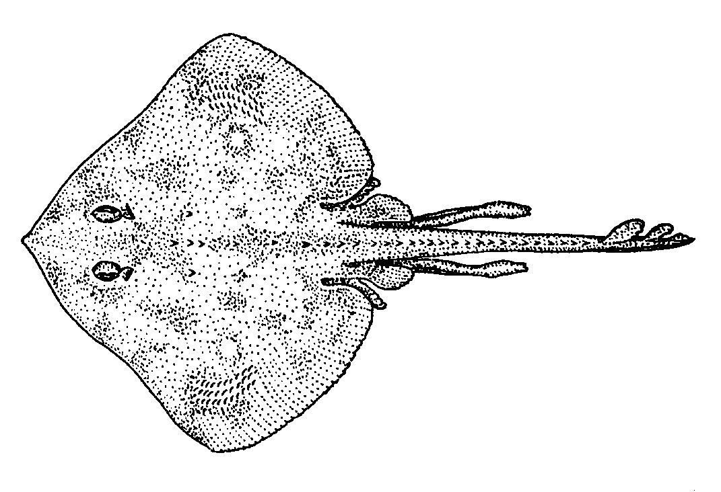
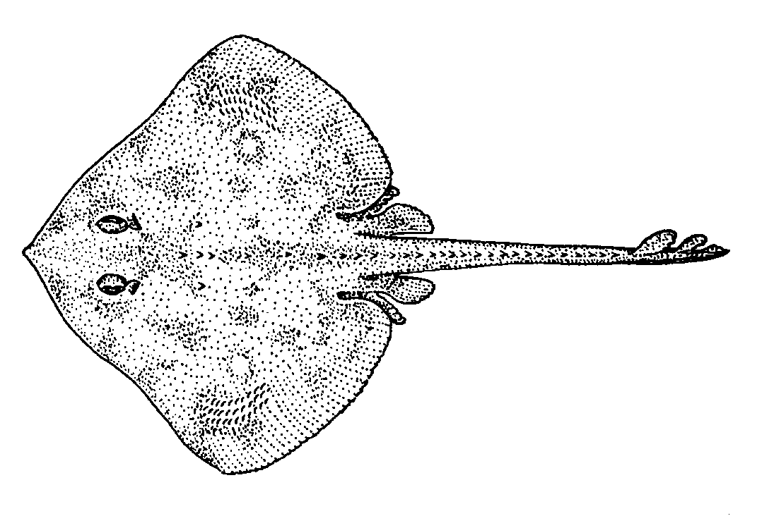

 

6.8.2 Sheephead

Sheephead are protogynous hermaphrodites, meaning they start life as female, and later change to male. Females are mostly pinkish with a white chin. Males are dark at head and tail and reddish in between. Juveniles have a white streak and dark spots in the dorsal and caudal fins, but lose this coloration after they reach about 6 inches or so.

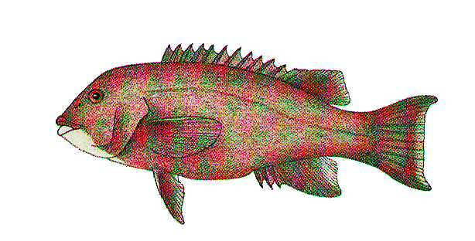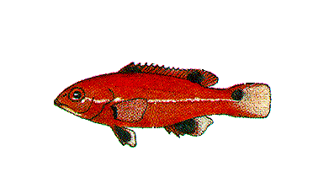
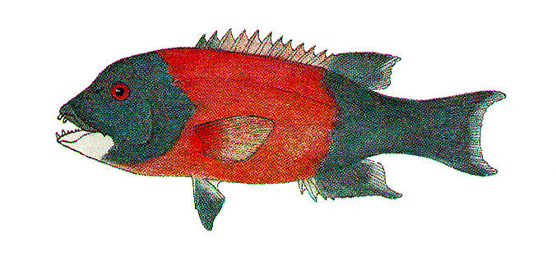

   (juvenile)

6.8.3 Rock Wrasse

Rock wrasse also start life as females. Females are yellow to orange or orangish brown. Males are green to blue-green but occasionally orange and have a blackish or bluish bar behind the pectoral fin. This bar is absent in females.

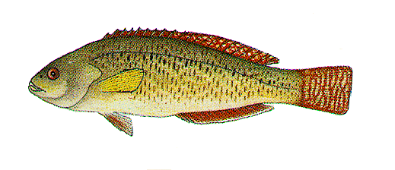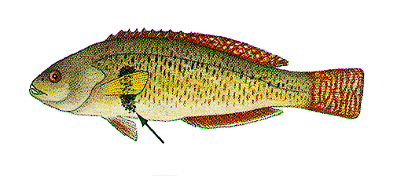

 

6.8.4 Dolphinfish

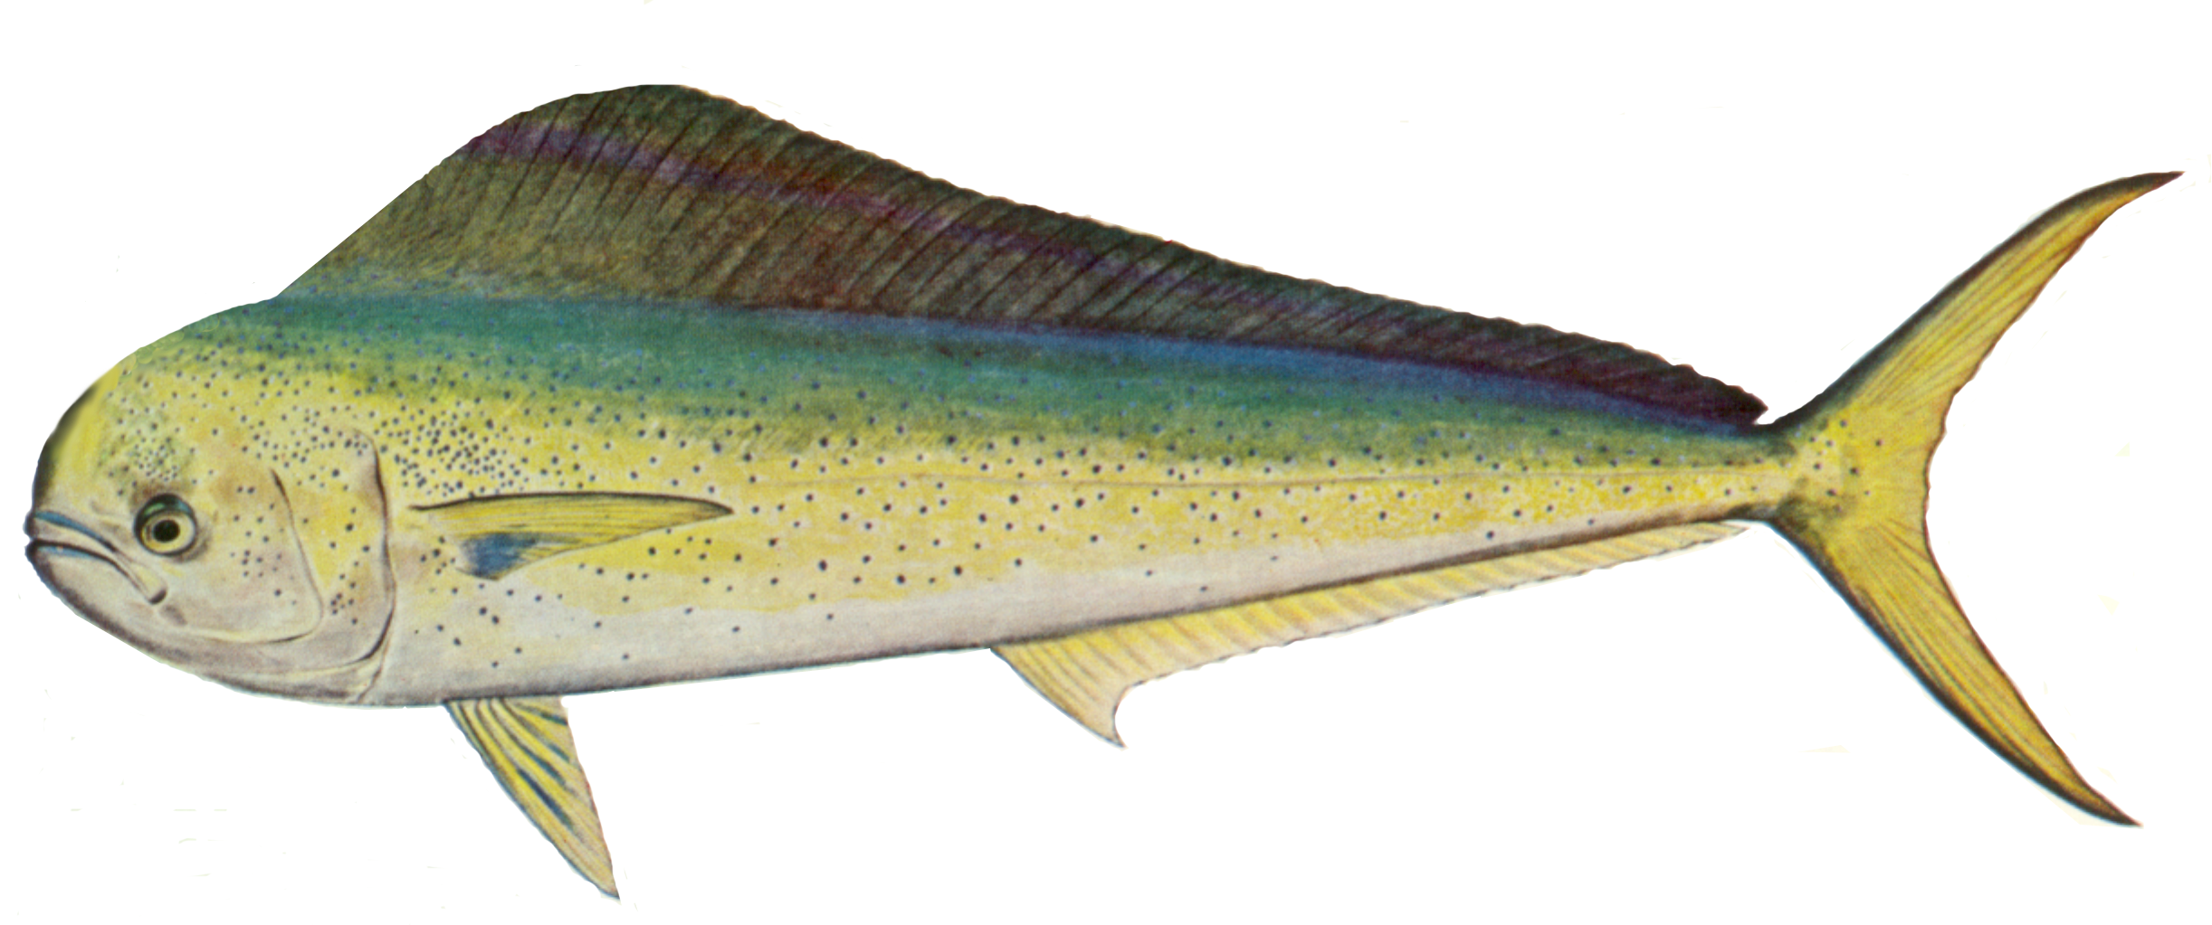
Females have a rounded, torpedo-shaped head and males have a very blunt shaped head. This is true regardless of season.

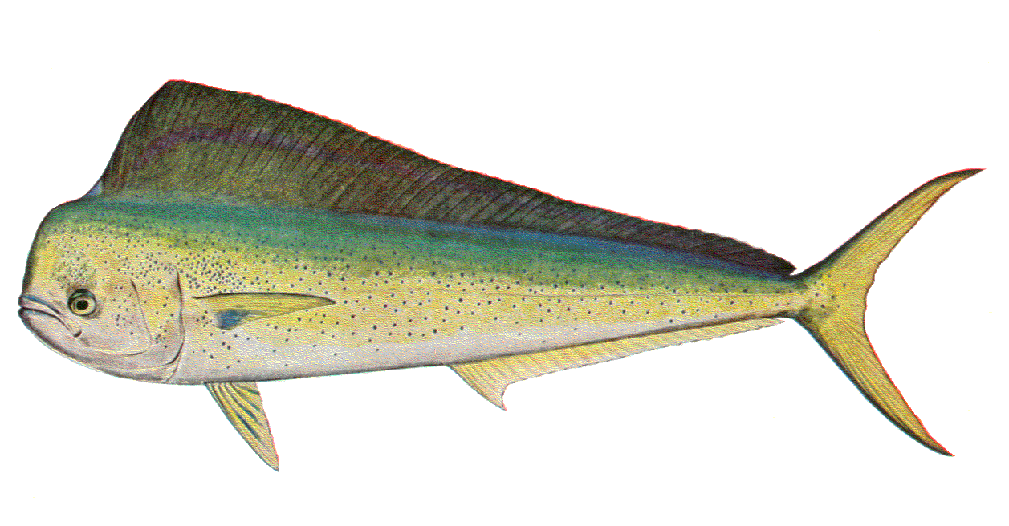
 

6.8.5 Shiner Surfperch

Male and female shiner surfperch differ in coloration only during the breeding season (late spring and early summer). During this time, males will be almost black, with the females being lighter in color with their yellow bars still visible. Males will also have a swollen anal fin (this is true of all male perch during breeding season). Do not record the sex of the fish unless you are absolutely certain you can tell the difference.

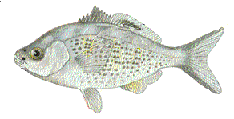
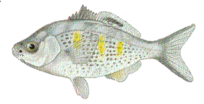

 

6.8.6 Ratfish

Males have a tenaculum (a club-like structure) on their foreheads, and also possess claspers. Females lack both of these appendages.
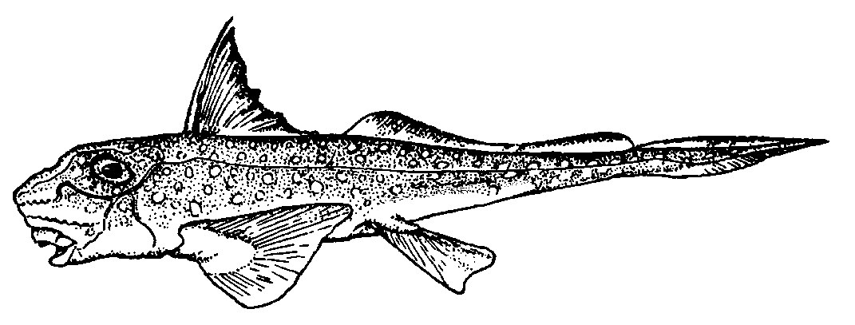
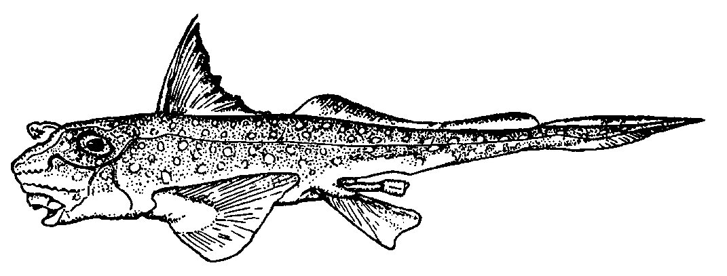

- 

- 

7. ADMINISTRATIVE

7.1 Editing / Mailing Forms

Almost all of your editing should be done in the field. Interviews should be spaced throughout the day such that you are able to edit as you go, with minimal editing later on. Editing in this manner is not only cost effective, but also reduces the chance for errors, since you will be editing while the events of the day are still fresh in your mind. If for some reason you are unable to edit your paperwork the same day, you should take the forms with you the next sampling day, and edit during slack time then. Under no circumstances should you “save up” all your editing until the last minute.

If it is necessary for you to finish your editing at home, your supervisor expects you to make reasonable claims on your Weekly Report regarding your editing time.

Time spent editing is just as important as time spent collecting data. Errors or omissions found after forms are submitted require extra time to investigate and are often difficult to remedy. They also aggravate your supervisor, data entry personnel, and the data analyst, and may imply to your supervisor overall careless work.

Before mailing, make sure you have edited your forms completely. The forms should all be in order by date (with the oldest on top; i.e., in the same order as they appear on your Weekly Report), assignment number, and form number. Make sure that all 0’s, 8’s, and 9’s have been entered where appropriate, and that all state and/or county codes are filled in. All forms with over 24 fish should have two sheets stapled together, with items 1 through 10 filled out on both sheets. Above all, make sure that your handwriting is legible.

Problem areas to be especially careful with:

• All forms MUST have a unique interview time, which MUST be sequential.

• Make notes on the form to explain unusual situations. For example, if the angler’s state of residence is other than California and “days saltwater sportfishing in California” is greater than zero, put a note explaining this apparent discrepancy. At first glance, your supervisor will think that the questions were asked wrong or the information was incorrectly recorded.

• If there is a group catch on an angler form, the form with the fish MUST be before the other form(s). The computer won’t let you reference an interview that hasn’t yet occurred. Refer to Section 5.3, Item 26c, Available Catch.

• Make sure that the angler’s name matches with gender.

• If the angler you’ve interviewed has provided you with their city of residence and neither of you knows the county, leave it blank. Your supervisor will determine the correct county and enter it. Don’t guess and enter a wrong code!

You should make one final check of your paperwork before submitting them to your supervisor at the beginning of the week. This 3-Step technique, the same that your supervisor uses, is very helpful in revealing errors and omissions.

✶ Looking only at the top left box, go through the forms from one assignment and check that:

 there are no blank fields or boxes
- the date is consistent and correct
- the times are in sequence, with no duplicates
- interview numbers are in sequence, with no duplicates
- site and county codes match the site and county where the interview took place

When there is a change in assignment number, check that:

- interview numbering begins with 01 for each assignment
- the date is the same
- the time makes sense

✴ Go through the forms a second time, looking now at the remaining data fields. Check that there are no blank fields and that:

- effort area and boat distance are the same for all anglers fishing in the same boat
- boat distance is 1 or 2 for ocean boats only (not bay)
- the species code(s) for the target species match with the name(s) written
- gear code 1 is not used indiscriminately
- wet gear hours are rounded to the nearest half hour (.0 or .5)
- catch boxes correspond with data on back of form
- group catch is on the leader’s form
- if group catch, the number of Type 3 fish is appropriate (e.g., two people can’t catch one fish)
- dispositions have been recorded for both Type 2 and Type 3 catch
- dispositions are appropriate for Type 2 and Type 3 catch
- GIS format is correct for boat location recorded
- location information is in agreement for all anglers fishing on the same boat (coordinates, GIS format, checked boxes, site name, depth)
- Appropriate location boxes are checked (i.e., match the information provided)
- 1 is not used indiscriminately for “all catch from this location”
- the name of the angler corresponds with gender
- “has phone” is marked 2 if the angler’s phone number has been recorded as 8
- verify the status of the interview is correct

→ Check the Weekly Report, making sure that:

- forms counts by status are correct
- total “good forms” are written in the appropriate column
- the “total anglers” boxes are appropriately filled in
- all appropriate boxes for each assignment have been filled in
- the back of the form has all pertinent information filled in

All forms for the previous week should be mailed to your supervisor on Mondays using regular mail, not “priority mail”, or hand delivered by Wednesday. This is important because your supervisor needs to have them edited and mailed to Portland by Thursday (Friday at the latest). If for some reason you are unable to turn in your paperwork on time you should notify your supervisor. Mail your forms in a strong manila envelope and tape the flaps to prevent the package from opening during transit.

Place your Assignment Summary Form on top of the forms for that assignment, (with the forms in the same order as they occured) and use a rubber band to keep all the forms together. Separating the forms by date (for example, with rubber bands or by turning alternate day’s forms upside down) slows down your supervisor’s editing procedure and is not appreciated. For the end of the month and it is critical that these forms be mailed to your supervisor as soon as you are finished with them.

All paperwork pertaining to that week’s assignment needs to be included with your package. This includes, but is not limited to, pressure check forms, boat information, and any necessary documentation. Your paperwork will be returned to you if you omit any of the necessary forms or other information.

7.3 Time Sheets

Time sheets need to be filled out bimonthly, and are submitted electronically. Each sampler has been provided with a calendar showing the pay periods for the year, and the specific dates the timesheets are required to be submitted.

7.4 Work Schedule / Work Week

It is your responsibility to ensure you do not incur unnecessary overtime. For PSMFC employees (Federal) overtime status is reached when you exceed 40 hours in a workweek. If your schedule is such that overtime is imminent, for example, you have several lengthy boat trips in one week, contact your supervisor so that adjustments to your schedule can be made.

7.5 Expense Claims

Expense claims are to be filled out bimonthly (and signed in ink), and mailed, along with the original receipts, directly to your supervisor in Los Alamitos. Always include all appropriate receipts (faxes, postage, or parking) taped on a separate piece of paper. If no receipt is available (e.g., from an unmanned parking booth) you must indicate this on the expense claim or you will not get reimbursed. Receipts are not necessary for reimbursement of meals on party boats. Use only one line on the form per day.

7.5.1 Reimbursable Expenses

Reimbursable expenses include mileage (see below), faxes, postage, parking, bridge tolls, and meals on partyboats. Get receipts whenever possible. Meals on partyboats are reimbursable only up to a maximum of $1.00 per hour spent sampling, not the total number of hours worked that day.

Do not make the assumption that it is OK to incur unreasonable expenses just because you know that PSMFC will reimburse you.

7.5.1.1 Reimbursable Mileage

Most of your mileage is reimbursable, but PSMFC will not pay for your “commute” miles. To calculate your commute miles, measure the mileage from your home to the closest CRFS site (your supervisor will assist you) and multiply by two. You will subtract this from your daily mileage and record the remainder as reimbursable mileage.

7.5.2 Non-reimbursable Expenses

In general, any supplies that can be obtained from your supervisor are non-reimbursable. This includes, but is not limited to, photocopies, office supplies, first-aid items, and sunscreen. Contact your supervisor when you need these items.

7.6 Use of Privately Owned Vehicle

You will be using your own vehicle to travel to and from your various assignments. Because of this, you must be able to prove that you have insurance, that your vehicle is in safe mechanical condition, and that your vehicle has functional safety belts. Safety belts are to be worn at all times while driving; it’s the law.

7.7 Scheduling Vacation

The request for time off, either through paid or unpaid leave should be made as far in advance as possible. The request must be submitted by email or by submitting a leave request form (see section 7.7.1). Do not phone your supervisor with a request for time off unless it is an emergency. While your supervisor will make every attempt to accommodate your request, you should keep in mind that he or she needs to consider the length of time off requested, staffing levels, time of year, and intercept goals before granting or denying your request. Vacations are highly discouraged between Memorial Day and Labor Day since that is our busiest time.

7.7.1 Leave Request Forms

When requesting time off you must email your supervisor with the information, or fill out a Leave Request Form and submit it to your supervisor for approval in advance of the leave date. The leave will not be considered approved until your supervisor has given you written approval. Requests are made only to your supervisor and Leave Request Forms are not sent to the Portland office.

Examples are provided for you at the back of this addendum.

7.8 Holidays

Samplers are expected to work most weekends and holidays, since that is when most fishing activity occurs. Your supervisor will not schedule assignments on Christmas or Thanksgiving days, primarily because most people do not fish on those days. However, it is expected that you are available to work on all other holidays.

You will receive holiday pay on a prorated basis, for PSMFC observed holidays, regardless of whether or not you actually work on the holiday. Your Personnel Policy Handbook has a list of observed holidays and pay rates.

7.9 Equipment Care and Replacement

It is your responsibility to properly maintain the equipment that has been issued to you. Treat all your gear as if you personally owned it. Remember to clean your measuring board on a regular and frequent basis. When on shore you can usually rinse off the board at a fish cleaning station or by dipping it in the water from shore. When on a boat, you can use the deck hose to rinse off your measuring board at the end of the trip. Measuring scales should be cleaned (i.e., rinsed with fresh water, not salt) and lubricated with WD40 (your supervisor can provide this if necessary) every day they are used. Don’t put them inside any closed container (plastic bag or clipboard) when they are wet with seawater, or they will quickly rust. You should not write in any of your three assigned fish identification books, but you may feel free to make notes in your interviewer manual and addendum. Notify your supervisor as soon as possible if any of your equipment needs to be replaced. You are responsible for replacing items lost or damaged from your own negligence. Your supervisor will replace equipment that wears out through normal use. If you require a new scale or measuring board because yours has worn out, a new one will not be issued to you until the old one is returned.

8. Personnel Matters

8.1 Work Evaluation

In the Reference Manual and Position Description you will find sections that explain, in very general terms, what is expected of you as a sampler. Your supervisor evaluates your performance in part from these stated roles and responsibilities, but also uses additional guidelines. These factors can be divided into “tangible” and “non-tangible” categories. All factors will be considered when evaluating your work performance.

Examples of factors that can be tracked are the number of forms you turn in, the number of errors your paperwork contains, the number of hours you spend in the field, your ability to follow instructions, and the percentage of site assignments that are not met.

Your supervisor looks at the total number of forms you turn in based on the total effort at the site and the number of hours you spent sampling. This is not to imply that your supervisor is only interested in high output. The information your supervisor obtains from this can help to gauge not only your efficiency but also the amount of effort you put into the task and how well you follow instructions.

There are also other factors that are less tangible, that are used by your supervisor to evaluate your work performance. Some examples of these factors would be your willingness to ask for help, how well you communicate field conditions to your supervisor, your ability to make decisions, and the amount of effort your supervisor feels you put into your job.

Your supervisor will provide feedback on your performance in a variety of ways, the most common of which is verbal, but can take the form of an e-mail, handwritten note, a typed memo, or an official performance appraisal. Regardless of the method used, all feedback should be seriously regarded and you should make every attempt to immediately correct any problems if necessary.

8.2 Resources

There is a section of PSMFC’s web-site specifically for the samplers. Go to www.psmfc.org/recfin and then click on “samplers”. The username is fish and the password is count (username and password are case-sensitive so be sure to use lowercase letters). The most useful items in this section are “sampler registry”, “check data entry trapped errors”, and “check goal fulfillment”.

8.2.1 Sampler Registry

When you first go to this page there is a section for you to register, and below that is a list of other samplers that have already registered. This section is intended to be a means of communicating with your co-workers, and your supervisor strongly recommends you utilize this resource.

8.2.1.1 Check Data Entry Trapped Errors

With this section of the web-site you can check the types and numbers of errors by subregion, month, and/or sampler. There is usually about a two-week delay between the time the data are collected in the field and posted to the web-site. You are highly encouraged to check your own errors on a regular basis in case there is a procedural problem that needs to be remedied immediately.

8.2.1.2. Check Goal Fulfillment

This section is basically “FYI”. Annual quotas as well as the number of interviews obtained can be viewed for each subregion.

8.2.2 Other Useful Websites

Fish identification:

www.fishbase.org/
www.id.ucsb.edu/lovelab/index.html Milton Love’s amusing and informative website
http://bajadestinations.com/fishid/fishidphotos.htm
www.afsc.noaa.gov/groundfish/rockfishguide/index.htm

General information:

www.sacemup.org/ Sportfishing Association of California
www.st.nmfs.gov/st1/index.html Fishery statistics and economics
www.oehha.ca.gov/fish/general/index.html Fish consumption advisories
www.uscg.mil/ Coast Guard information
http://www-mlrg.ucsd.edu/ Marine Life Research Group/Scripps Institute/general information about CalCOFI
www.uaf.edu/seagrant/ Alaska Sea Grant
www.pcouncil.org/ Pacific Fisheries Management Council
www.dfg.ca.gov/dfghome.html
www.noaa.gov/
www.sccwrp.org/nsindex.html Southern California Coastal Water Research Project
www.igfa.org/ International Game Fish Association
http://vm.cfsan.fda.gov/~frf/rfe0.html FDA’s fish encyclopedia
http://www-csgc.ucsd.edu/ California Sea Grant
www.fao.org Food and Agriculture Organization (see Fisheries)
http://ceres.ca.gov/ocean/
www.fishnmap.com/
www.fishsniffer.com/
www.biology.ualberta.ca/jackson.hp/IWR/index.php Ichthyology web resources
www.mbayaq.org/ Monterey Bay Aquarium
www.cinms.nos.noaa.gov/
www.asafishing.org/ American Sportfishing Association
www.fisheries.org/index.html American Fisheries Society
http://fishing.fws.gov/ U. S. Fish & Wildlife Service’s site on fishing
http://www-rcf.usc.edu/~scmi/ Southern California Marine Institute
www.cinms.nos.noaa.gov/pdf/soceconov.pdf
www.coastal.ca.gov/ California Coastal Commission
www.csun.edu/~nmfrp/homepage.htm Nearshore Marine Fish Research Program (Cal State Northridge)

Party boat landings:

www.johnthefisherman.com Marina del Rey Sportfishing
www.longbeachsportfishing.com
www.22ndstreet.com
www.laharborsportfishing.com
www.pierpoint.net/lbmsf.html Long Beach Marina Sportfishing
www.pierpoint.net
www.redondosportfishing.com
www.danawharfsportfishing.com
www.newportlanding.com
www.daveyslocker.com
www.seaforthlanding.com
www.hmlanding.com
www.fishermanslanding.com
www.islandiasport.com
www.helgrensportfishing.com
www.sb-sportfishing.com Sea Landing
www.sbhornet.com
www.ciscos.com

Fishing reports:

www.biteson.com
www.sportfishingreport.com
www.pierfishing.com

Administration:

9. Attachments

Position Description
Slang Names List
Weight Conversion Chart
Fish Measuring Procedures
Time Sheet Examples
Travel Claim Examples
Leave Request Form Examples
Interview Form Examples

POSITION DESCRIPTION

TITLE: Fisheries Technician III (CRFS Samplers)

LOCATION: Various field offices (state agencies)

PAY SCALE: Equivalent to Federal GS-5 (General Salary Schedule)

POSITION DESCRIPTION: (October 1998)

These positions are organizationally within Pacific States Marine Fisheries Commission (PSMFC); are administratively supervised by a Marine Recreational Fisheries Statistics Survey (CRFS) Field Supervisor. The primary role of a CRFS Fisheries Technician is to conduct recreational angler interviews for the purpose of collecting data on catch, species composition, lengths and weights, and angler demographic and economic information for the Recreational Fisheries Information Network (RecFIN) System.

RecFIN is a cooperative state and federal system for the collection and management of data on the Pacific coast marine recreational fisheries in order to better meet state and federal fishery management needs.

DUTIES:

- Conducts angler interviews and creel census’ following procedures in the CRFS Sampler Manual, which include:

- Obtaining complete interviews from eligible anglers intercepted;
- Identifying, weighing and measuring fish in the creel;
- Coding all intercept and summary forms completely and legibly;
- Editing forms for quality control and submitting them to their supervisor weekly; and
- Cooperating with state sampling program personnel on other projects.

- Provides information on angler effort in sampling area to Field Supervisor. Gathers effort information by contacting bait shops, charter offices, anglers and others. Determines angler effort for all sites and modes of fishing for weekdays and weekend days. Keeps supervisor current on local fishing issues, effort, and success via Monday morning check-ins and as needed. Completes angling pressure input form each month and submits to supervisor.

- Prepares site sampling form and submits to the supervisor weekly. Submits other reports as directed.

- Assesses sport fishing violations encountered, judges severity and intent of violations, and notifies the appropriate agency personnel as needed.

- Maintains the condition of sampling equipment, e.g. keeping scales oiled and calibrated, measuring boards clean, etc.

- Attends and participates in sampler meetings and training as directed by the supervisor.

- Responds to questions about fishing, sport regulations, and other topics from anglers, charter industry personnel, and others. Distributes updates on sport fishing quotas and regulations, or other materials as needed. Refers questions to supervisor or state agencies as needed.

- Participates in special and add-on CRFS projects such as collecting biological samples or preparing reports, e.g. extracting fish otoliths or carcasses, updating educational or training materials, etc.

- May be required to maintain a motor pool vehicle following motor pool maintenance schedule and arranges to have regular maintenance and needed repairs done by a licensed mechanic. Fills out daily mileage and fuel record forms and submits to supervisor monthly. Follows fisheries agency and state motor pool policies for using a state vehicle.

- Participates in mid-year informal and yearly formal performance evaluations and may develop work plan for self [Not required of seasonal positions].

- Acquires training to improve job performance and may participate in career development opportunities as agreed to by supervisor.

KNOWLEDGE / EXPERIENCE REQUIRED BY THE POSITION:

- Experience in fish identification of typical species caught in marine sport fisheries along the region of the coast assigned.

- Experience completing and filling out detailed or complex forms, especially survey forms.

- Skill in dealing with people of various and diverse backgrounds. Must be able to handle irate fishermen and charter boat personnel in a professional manner.

- Ability and experience working independently and keeping to assigned schedules (scientific sampling dictates this).

- Skill in reading maps and charts, and in locating fishing sites and areas, for example marinas, jetties, beaches, piers, and boat launches.

DESIRED KNOWLEDGE / EXPERIENCE FOR THE POSITION:

- Knowledge of state fishing regulations, catch limits or quotas, and seasonal regulation updates.

- Education and/or practical experience in fisheries biology.

- Knowledge about scientific representative sampling methodology or angler survey methods.

- Good situational judgement skills: A need for common sense judgement when interacting in tense situations and ability to weigh a situation for safety, getting good information, and/or input from the public.

SUPERVISORY CONTROLS:

A CRFS Field Supervisor assigns the sampling schedule based on project requirements. Fulfilling the assignments are directly related to the successful collection of projected numbers of unbiased interviews at assigned collection sites. The employee carries out these duties independently according to established procedures and is responsible for deciding whether to move to new collection sites based on fishing activity. Assignments are reviewed weekly along with other summary reports to be sent to the Field Supervisor. The Field Supervisor makes occasional site visits to give performance feedback and train for deficiencies.

GUIDELINES:

Detailed guidelines are set forth in the CRFS Interviewer Manual, which includes a position description and CRFS information and wave goal. Agency guidelines are provided in the PSMFC and state agency personnel policy handbooks. Other guidelines and policies will include sport-fishing regulations, in-season regulation changes as published, state motor pool manual (if applicable), an employee work plan, state agency ethics, uniform and practiced policies (if applicable).

COMPLEXITY:

The parameters of CRFS sampling are defined in the interviewer manual and employees are to stay within those proven guidelines. Samplers deal with a diverse public which can involve tense or complex situations unless good personal judgement and intuition are used. Ocean tides, weather conditions, charter boat effort, and time of day must be considered in deciding when and where to complete sampling assignments.

SCOPE AND EFFECT:

The purpose of the Marine Recreational Fisheries Statistical Survey project is to collect unbiased fish data from recreational, marine anglers. A central database comprised of the collected data is utilized by councils, federal or state agencies, and tribes for fishery management.

Not properly following the unbiased proven sampling methods outlined in the CRFS interviewer manual could result in poor data collected and in turn improper seasons, limits and regulations set by councils, state and federal agencies, and tribes.

PERSONAL CONTACTS:

Direct contact as required by the sampling schedule with recreational anglers, tackle shops, charter and marina personnel. Weekly or more frequent contact with the supervisor, state employees, occasional contact with enforcement personnel, other CRFS staff, and PSMFC personnel.

PURPOSE OF CONTACTS:

Primarily, the contacts are for obtaining CRFS interview information. Communicating with other personnel and weekly reporting to the supervisor allows the incumbent to be informed on current sampling projects, fishery issues, and angler effort. Occasional contacts with state police/enforcement agents are to report fishing violations.

PHYSICAL DEMANDS:

The work entails walking up and down boat ramps and narrow docks; climbing in and out of boats; climbing jetty rocks; lifting up to 40 pounds; sitting for long periods of time and standing for long periods of time. There is a lot of driving (average 1,000 miles/month) and time spent waiting for anglers to complete their fishing.

WORKING CONDITIONS

CRFS Samplers work around moorage facilities, boat launches and ramps, charter docks, piers, jetties, beaches and banks in all kinds of weather. The work requires handling of saltwater fish that often have sharp spines. Samplers occasionally encounter upset anglers, charter office personnel, and others who may be angry about season restrictions, upcoming closures, management decisions, etc. The work schedule may be irregular, but is based on a 40-hour week or less as specified by the supervisor. Samplers are required to be in the field when anglers are completing their fishing. Work on weekends and holidays is mandatory as high fishing effort occurs at these times.

SLANG NAMES LIST

Common Name Scientific Name Other Common Names

albacore Thunnus alalunga longfin, albie, pigfish
bank rockfish Sebastes rufus bank perch, Florida, Florida
red, Louisiana ridge runner
barracuda Sphyraena argentea barry, log (large), pencils, pinks,
(small), snake, scooter, skinny,
fire hose, stovepipe, alligator
gar
barred sand bass Paralabrax nebulifer sand bass, sandy, grumpy
(large)
black & yellow rockfish Sebastes chrysomelas zurndicky
black croaker Cheilotrema saturnum china croaker
blue rockfish Sebastes mystinus blue bass, reef perch, priestfish
bocaccio Sebastes paucispinis salmon grouper, grouper,
slimey, wormy, redfish, sewer
salmon, minigrouper (small)
bonito Sarda chiliensis Bone head, micronito or mini-
striper (small), bony, boner
bronzespotted rockfish Sebastes gilli Arkansas red, warthog
brown rockfish Sebastes auriculatus chocolate bass, P.D. bass,
cinnamon bass, brown bass
Ca. corbina Menticirrhus undulatus California whiting
Ca. Halibut Paralichthys californicus flatty, door mat, flyswatter
(small), barn door (large)
Ca. scorpionfish Scorpaena guttata sculpin, rattlesnake, scorpion
canary rockfish Sebastes pinniger reds, red snapper, red rockfish
chilipepper Sebastes goodei chili
coho salmon Oncorhynchus kisutch silver salmon
copper rockfish Sebastes caurinus chucklehead, never dies
cowcod Sebastes levis Cow, calf (small), cow rockfish,
moo’s
dolphinfish Coryphaena hippurus dorado, mahi mahi, dolphin
drum family Sciaenidae croakers, drums, roncadors,
ronkies
flag rockfish Sebastes rubrivinctus barberpole
garibaldi Hypsypops rubicundus goldfish
giant sea bass Stereolepis gigas black sea bass, freight train
gopher rockfish Sebastes carnatus rock bass, spotted rock bass
grass rockfish Sebastes rastrelliger rock bass, pepper bass, grass
bass
brown smoothhound Mustelus henlei smoothhound shark, sand shark
gray smoothhound Mustelus californicus smoothhound shark, sand
shark
greenblotched rockfish Sebastes rosenblatti boscos, warthogs, starry eyes
greenspotted rockfish Sebastes chlorostictus boscos, warthogs, starry eyes
greenstriped rockfish Sebastes elongatus poinsettia, strawberry
hake Merluccius productus oatmeal fish
halfmoon Medialuna californiensis Catalina blue perch, blue perch,
Catalina blue, blue wizard,
blooper

SLANG NAMES LIST

Common Name Scientific Name Other Common Names

jack mackerel Trachurus symmetricus Spanish mackerel, Spaniard
kelp bass Paralabrax clathratus calico, calico bass, bull bass
(large), police car,
checkerboard bass
kelp rockfish Sebastes atrovirens sugar bass, oogly-googly
king salmon Oncorhynchus tshawytscha chinook salmon, silver
salmon
lingcod Ophiodon elongatus ling, greenlinger, gator
Mexican rockfish Sebastes macdonaldi Arkansas red, Arkansas
black, Arkansas traveler,
vernon (Dana Pt.)
mexican scad Decapterus hypodus Spanish mackerel, Spaniard
mola Mola mola mola, ocean sunfish, sunfish
ocean whitefish Caulolatilus princeps whitefish, poor man’s
yellowtail
olive rockfish Sebastes serranoides Johnnie bass, Jonathan’s
opaleye Girella nigricans button perch, Jack Benny
Pa. butterfish Peprilus simillimus pompano, butterfish
Pacific mackerel Scomber japonicus greenback, blue mackerel,
tiny tuna, green racer,
cornfed, frog, chub mackerel
Pa. staghorn sculpin Leptocottus armatus staghorn sculpin, bullhead
pink rockfish Sebastes eos Boscos, warthogs, starry
eyes
queenfish Seriphus politus herring, sea trout, brown bait
rainbow trout Salmo gairdnerii steelhead trout
redbanded rockfish Sebastes rubrivinctus barberpole
rockfish genus Sebastes spp. rockcod, red snapper, crotch
cricket (small), scrub (small)
rock wrasse Halichoeres semicinctus iodine fish
rosy rockfish Sebastes rosaceus strawberry, rinkydink,
avocado rockfish
rubberlip seaperch Rhacochilus toxotes rubberlip surfperch,
buttermouth
sablefish Anoplopoma fimbria sable, black cod, butterfish,
zipperfish, sea trout
sargo Anisotremus davidsonii China croaker
senorita Oxyjulis californica iodine fish
sheephead Semicossyphus pulcher goat, sheepie, billygoats (large)
shortfin mako shark Isurus oxyrinchus mako shark, bonito shark
shortspine thornyhead Sebastalobus alascanus channel rockfish
shovelnose guitarfish Rhinobatos productus sand shark
skates & rays Rajidae tendency to be called rays
speckled rockfish Sebastes ovalis Belinda cod (So. of Santa
Monica Bay), J.W. (No. of Pt.
Hueneme), bank perch
spiny dogfish Squalus acanthias pinback, greeneyed grinner,
pinole
splitnose rockfish Sebastes diploproa channel cod
spotfin croaker Roncador stearnsii spotty
spotted sand bass Paralabrax maculatofasciatus bay bass, spotty, spotted bay
bass

SLANG NAMES LIST

Common Name Scientific Name Other Common Names

squarespot rockfish Sebastes hopkinsi mustard perch, Belinda bass
swordspine rockfish Sebastes ensifer hanky panky
treefish Sebastes serriceps convict bass, lipstick bass,
lipstick fish
vermilion rockfish Sebastes miniatus reds, red snapper, red
rockfish
white croaker Genyonemus lineatus tomcod, kingfish, Tommy,
butterbass, Calif. silver bass,
Pasadena, sewer trout, bank
Perch, brown bait
white sea bass Atractoscion nobilis white, bull tomcod, sea trout
widow rockfish Sebastes entomelas Belinda bass
yellowtail Seriola lalandi yellow, tail, mossback (large),
fork tail, yellowtail jack,
yellowtail tuna
yellowtail rockfish Sebastes flavidus Johnnie bass, Jonathon’s

WEIGHT CONVERSION CHART

Lbs. Kg.
- 0.45
1 ¼ 0.56
1 ½ 0.68
1 ¾ 0.79
- 0.91
2 ¼ 1.02
2 ½ 1.13
2 ¾ 1.25
- 1.36
3 ¼ 1.47
3 ½ 1.59
3 ¾ 1.70
- 1.81
4 ¼ 1.93
4 ½ 2.04
4 ¾ 2.15
- 2.27
5 ¼ 2.38
5 ½ 2.49
5 ¾ 2.61
- 2.72
6 ¼ 2.84
6 ½ 2.95
6 ¾ 3.06
- 3.18
7 ¼ 3.29
7 ½ 3.40
7 ¾ 3.52
- 3.63
8 ¼ 3.74
8 ½ 3.86
8 ¾ 3.97
- 4.08
9 ¼ 4.20
9 ½ 4.31
9 ¾ 4.42
- 4.54
10 ¼ 4.65
10 ½ 4.76
10 ¾ 4.88
- 4.99
11 ¼ 5.10
11 ½ 5.22
11 ¾ 5.33
- 5.44
12 ¼ 5.56
12 ½ 5.67
12 ¾ 5.78
- 5.90
13 ¼ 6.01

Lbs. Kg.
13 ½ 6.12
13 ¾ 6.24
- 6.35
14 ¼ 6.46
14 ½ 6.58
14 ¾ 6.69
- 6.80
15 ¼ 6.92
15 ½ 7.03
15 ¾ 7.14
- 7.26
16 ¼ 7.37
16 ½ 7.48
16 ¾ 7.60
- 7.71
17 ¼ 7.82
17 ½ 7.94
17 ¾ 8.05
- 8.16
18 ¼ 8.28
18 ½ 8.39
18 ¾ 8.51
- 8.62
19 ¼ 8.73
19 ½ 8.85
19 ¾ 8.96
- 9.07
20 ¼ 9.19
20 ½ 9.30
20 ¾ 9.41
- 9.53
21 ¼ 9.64
21 ½ 9.75
21 ¾ 9.87
- 9.98
22 ¼ 10.09
22 ½ 10.21
22 ¾ 10.32
- 10.43
23 ¼ 10.66
23 ½ 10.66
23 ¾ 10.77
- 10.89
24 ¼ 11.00
24 ½ 11.11
24 ¾ 11.23
- 10.43

Lbs. Kg.
- 11.79
- 12.25
- 12.70
- 13.15
- 13.61
- 15.88
- 18.14
- 20.41
- 22.68
- 24.95
- 27.22
- 29.48
- 31.75
- 34.02
- 36.29
- 38.56
- 40.82
- 43.09
- 45.36

Oz. Kg.
- 0.03
- 0.06
- 0.09
- 0.11
- 0.14
- 0.17
- 0.20
- 0.23
- 0.26
- 0.28
- 0.31
- 0.34
- 0.37
- 0.40
- 0.43

1 oz. = 0.02835 kg.

1 lb. = 0.4536 kg

CORRECT PROCEDURES FOR MEASURING THE VARIOUS TYPES OF FISHES

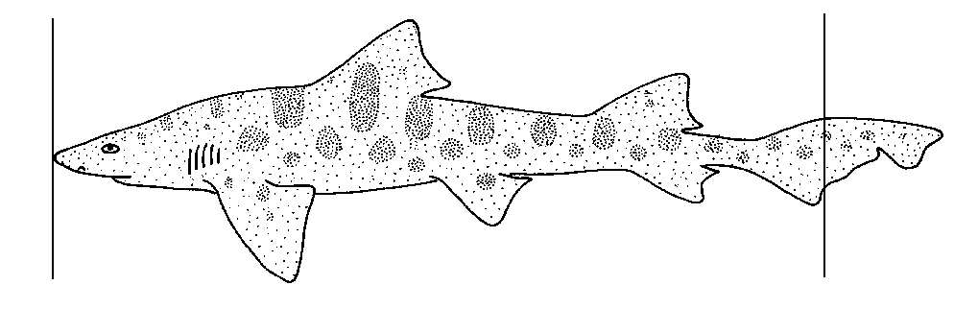
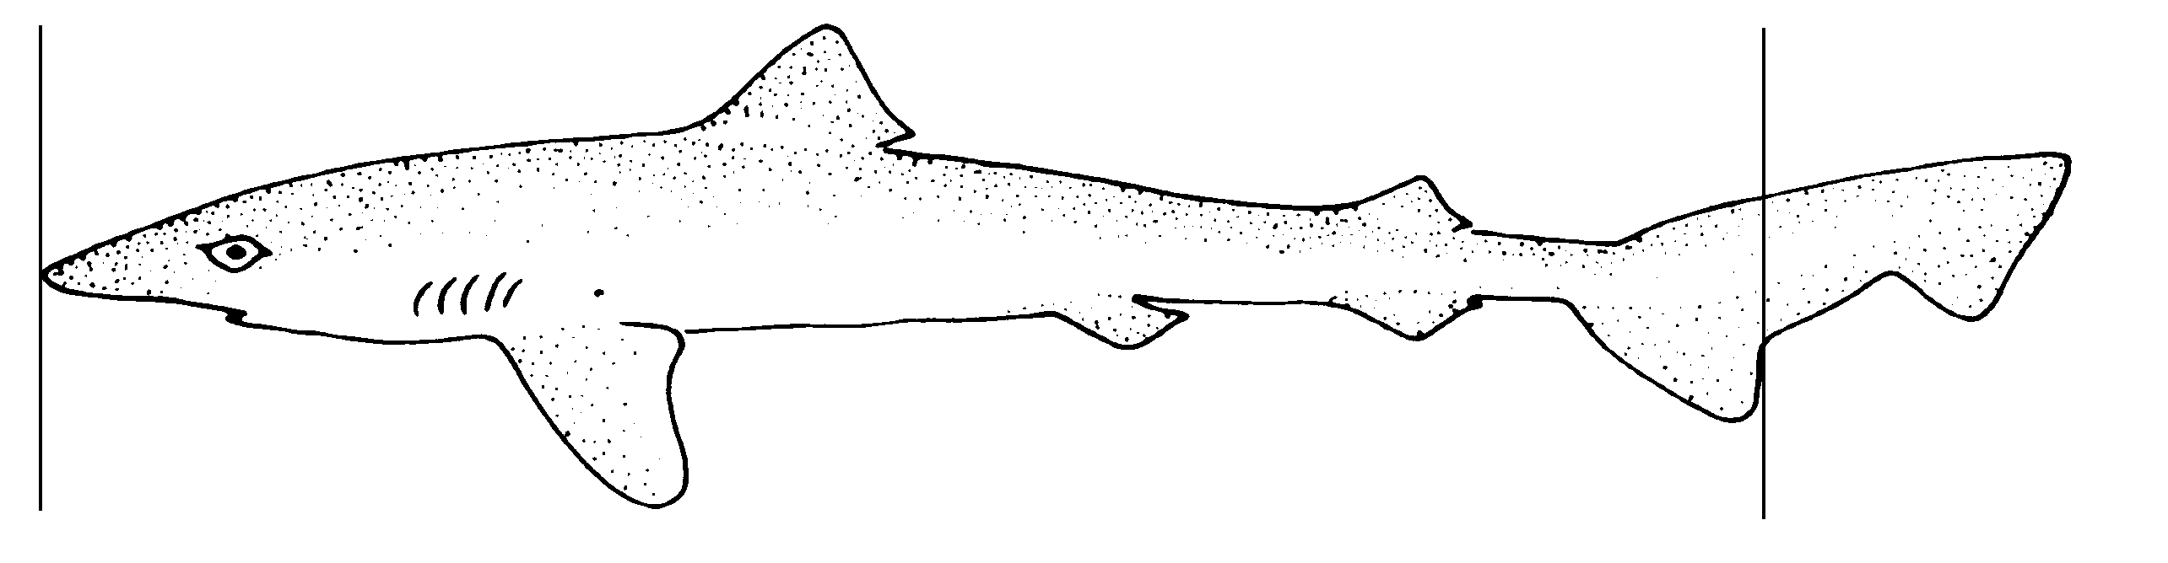
Sharks are measured from the tip of the snout to the center of the fork of the tail. For sharks without a fork, measure to the ventral lobe of the tail.

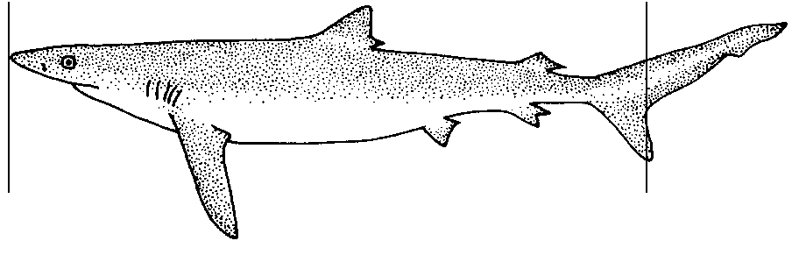

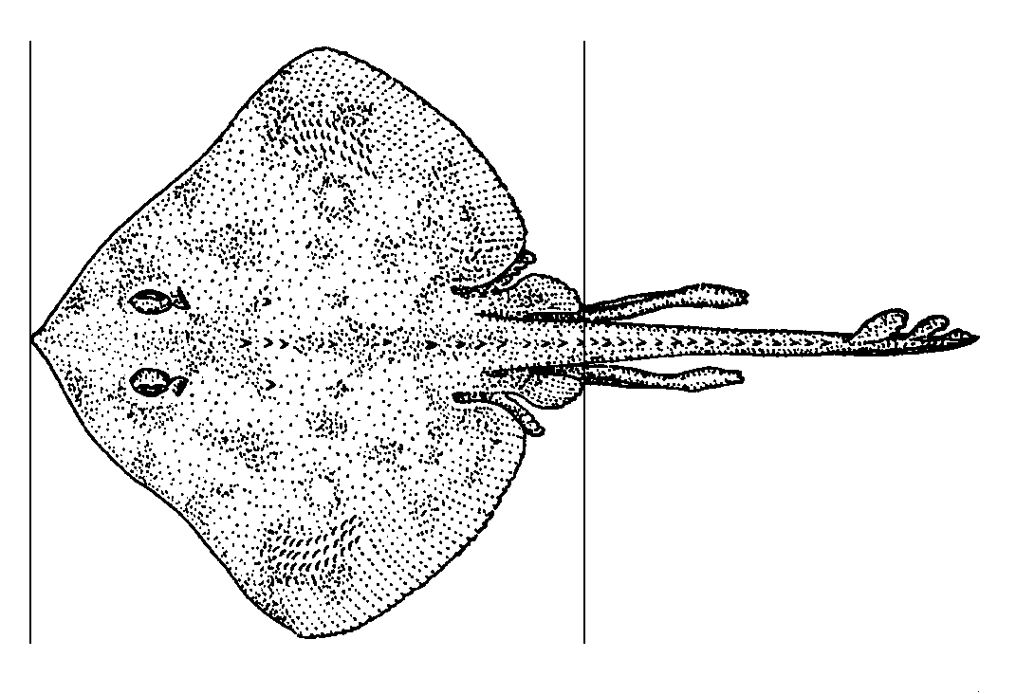
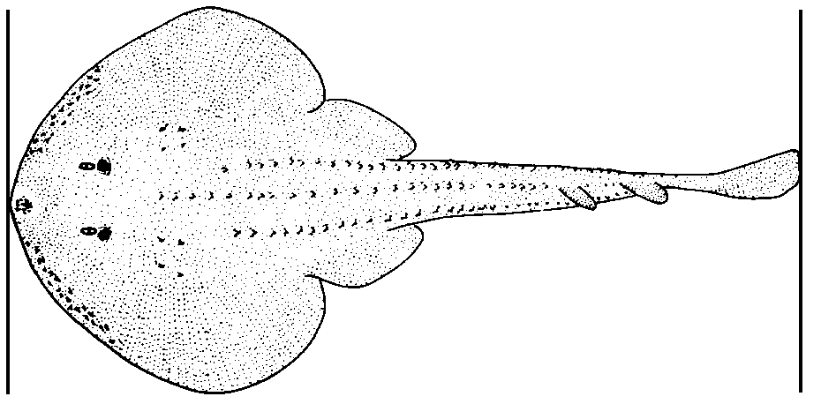
Skates and rays are measured from the tip of the snout to the posterior end of the pelvic fins. Do not include the claspers. When a caudal fin is present, the fish is measured from the tip of the snout to the end of the tail.
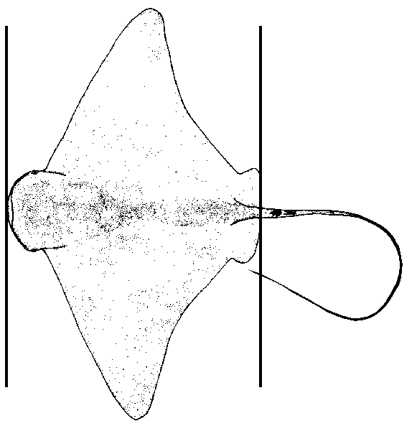

Billfishes and swordfish are measured from the tip of the bill to the center of the fork of the tail.
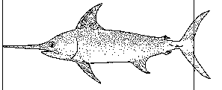

All other species are measured from the most anterior tip of the longest jaw (mouth closed) or end of snout, whichever is terminal, to the posterior tip of the tail at its center line. This procedure is the same whether the tail forks in or protrudes out. The resulting length is therefore a fork length.
